Shafi Agna Rakasiwi Avianto  Technical Lead — Full-Stack Development & UI/UX  Kalisuren, Tajurhalang, Kabupaten Bogor, Jawa Barat 16320, Indonesia  shafiagnadev@gmail.com | +62 8xx-xxxx-xxxx (lengkapi) | 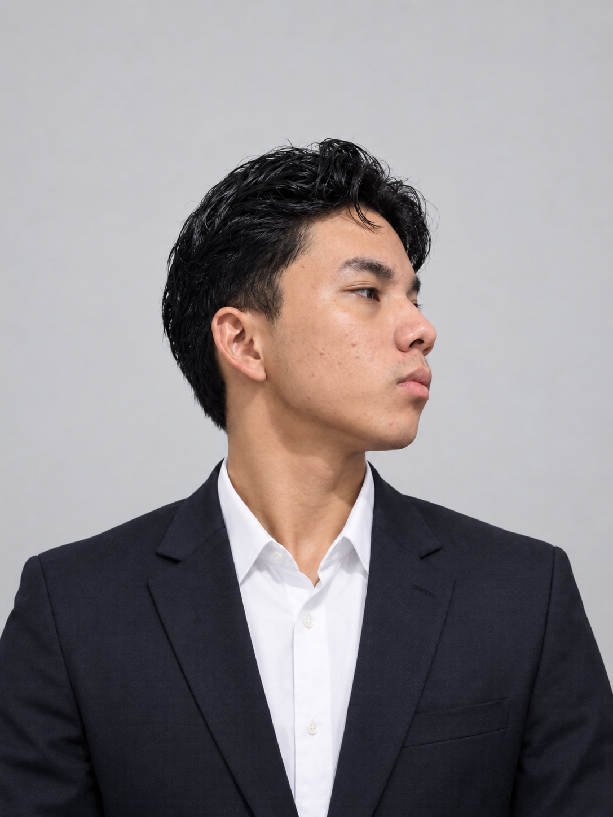

PROFIL  Indonesian  SKILLS  HTML · Master  JavaScript · Advanced  Kotlin · Advanced  Git & GitHub · Advanced  PHP · Upper-Intermediate  Python · Intermediate  SQL · Intermediate  CSS  C# · Elementary  Swift · Elementary  TypeScript · Elementary  Dart · Elementary  C · Elementary  LANGUAGES  English  Indonesian  Japanese (basic)  HOBBIES  Football, reading, swimming | PROFESSIONAL SUMMARY  Curious full-stack developer and UI/UX designer with 8+ years turning ideas into working products — from small-business and F&B websites to Android apps and personal AI experiments. Comfortable owning a project end to end: interface design, front-end build, back-end logic, and deployment. Core toolkit is HTML, JavaScript, React, and PHP, currently expanding into Python and machine learning. Motivated by curiosity — turning “I wonder how this works” into something real people can use.  EMPLOYMENT HISTORY  Full-Stack Developer [Company / Client Name — lengkapi] · Bogor  Jan 2022 — Aug 2026  — Designed, built, and deployed websites and applications for company and client projects across small-business, F&B, and e-commerce use cases.  — Implemented custom UI transitions and animations to improve interface polish and user experience.  NOTABLE PROJECTS  — Personal Portfolio Website — designed and built an interactive full-stack portfolio with an animated skills radar, a categorized live project showcase, and a case-study layout for past work.  — Bakso Tip Top (Wonogiri) — Promotional Website — built a promotional website for a local bakso/mie ayam restaurant in Bogor, from design through deployment.  — AI-Assisted Trading Bot (Hermes Agent) — currently building an automated trading assistant integrating a DeepSeek-based agent with TradingView market data.  EDUCATION  [Confirm program/degree] [Confirm institution name] · Bogor  Jan 2023 — [lengkapi tanggal selesai]  — Served as Head of Division in an in-school student organization, coordinating initiatives and members.  — Developed a Bluetooth-based IoT project: a smartphone-controlled remote system.  COURSES & CERTIFICATIONS  CompTIA A+ CompTIA  Mar 2025

