COMSATS University Islamabad
Department of Computer Science
AIC 380 — Artificial Neural Networks and Deep Learning | Lab Manual
Lab 03

Objective
The objective of this lab is to learn how to implement a perceptron — the basic building block of neural networks — in Python, and to understand how the initial values assigned to a network's weights affect training.

Activity Outcomes
The activities provide hands-on practice with the following topics:
- Implement a perceptron model.
- Train a perceptron using a dataset.
- Understand why weight initialization matters and identify the main initialization schemes (Gaussian, Xavier/Glorot, He/Kaiming, Orthogonal).
- Implement and compare weight initialization techniques in Python/NumPy.

Useful Concepts
Perceptron
A perceptron is a system that learns using labeled examples (i.e., supervised learning) of feature vectors (or raw pixel intensities), mapping these inputs to their corresponding output class labels. In its simplest form, a perceptron contains N input nodes, one for each entry in the input row of the design matrix, followed by only one layer in the network with just a single node in that layer.
There exist connections and their corresponding weights w₁, w₂, …, wᵢ from the input xᵢ's to the single output node in the network. This node takes the weighted sum of inputs and applies a step function to determine the output class label. The perceptron outputs either a 0 or a 1 — 0 for class #1 and 1 for class #2; thus, in its original form, the perceptron is simply a binary, two-class classifier.
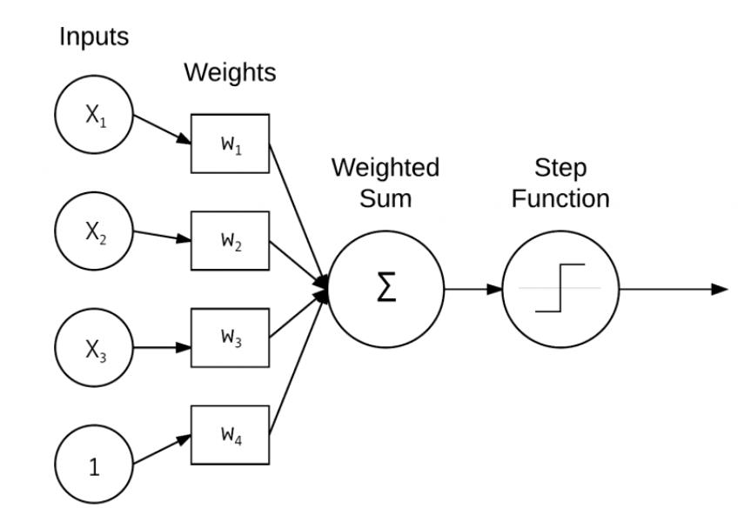
Figure 1: Architecture of perceptron.
Weight Initialization Techniques in Neural Networks
Weight initialization matters because it affects how gradients flow during early training — poor initialization can cause vanishing or exploding gradients, or “dead” neurons, before training even gets going. The strategies below are used to set a network's initial weights before training begins — including the perceptron built later in this lab.
Naive Approaches (and why they fail)
- All zeros / constant values — every neuron in a layer computes the same output and receives the same gradient, so they update identically forever (the “symmetry problem”). Never used for weights in practice, though it is fine for biases.
- Random from a fixed distribution, e.g., N(0, 1) — breaks symmetry, but the variance of activations grows or shrinks uncontrollably across layers. In deep networks this either saturates activations (vanishing gradients) or makes them blow up (exploding gradients).
Gaussian (Normal) Initialization
Weights are sampled from a normal distribution instead of being set to zero or to arbitrary constants: W ~ N(0, σ²). This breaks symmetry but, on its own, does not guarantee stable variance across layers of a deep network.
Xavier / Glorot Initialization
- Designed for layers with symmetric activations such as tanh or sigmoid.
- Draws weights so that variance is preserved across layers:
  - Uniform: W ~ U( −√(6 / (fan_in + fan_out)), √(6 / (fan_in + fan_out)) )
  - Normal: W ~ N( 0, 2 / (fan_in + fan_out) )
- Goal: keep the variance of activations (forward pass) and gradients (backward pass) roughly constant across layers.
He (Kaiming) Initialization
- Designed for ReLU and its variants, which zero out roughly half of their inputs.
- Normal: W ~ N(0, 2 / fan_in)
- Uniform: W ~ U( −√(6 / fan_in), √(6 / fan_in) )
- Accounts for ReLU's non-linearity by doubling the variance compared to Xavier; the default in most modern CNN/ResNet architectures.
Orthogonal Initialization
- Initializes weight matrices as orthogonal matrices (via QR or SVD decomposition).
- Preserves the norm of gradients through very deep or recurrent networks; especially useful in RNNs to combat vanishing/exploding gradients.
Practical Rule of Thumb
Activation | Recommended Initialization
ReLU / Leaky ReLU / GELU (approx.) | He (Kaiming)
Tanh / Sigmoid | Xavier (Glorot)
RNN / LSTM recurrent weights | Orthogonal

Perceptron Training Procedure and the Delta Rule
Training a perceptron is a fairly straightforward operation. The goal is to obtain a set of weights w that accurately classifies every instance in the training set. The network is fed the training data multiple times — each full pass through the training set is called an epoch. It normally takes many epochs until a weight vector w can be learned that linearly separates the two classes of data.
1. Initialize the weight vector w with small random values
2. Until the Perceptron converges:
(a) Loop over each feature vector x_j and true class label d_j in the training set D
(b) Pass x_j through the network: y_j = f(w(t) · x_j)
(c) Update the weights w:
w_i(t+1) = w_i(t) + α(d_j − y_j)x_{j,i} for all features 0 <= i <= n
The learning takes place in steps (b) and (c). The term (d_j − y_j) determines whether the classification is correct: if correct the difference is zero, otherwise it gives the direction in which the weights should move. This difference is multiplied by x_j, and scaled by the learning rate α, which controls how large a step is taken — too large and training can overshoot the optimum; too small and convergence becomes very slow.
Understanding the Implementation of Perceptron in Python
Step 1: Create a file named perceptron.py and define the Perceptron class constructor.
# import the necessary packages
import numpy as np

class Perceptron:
def __init__(self, N, alpha=0.1):
# initialize the weight matrix and store the learning rate
self.W = np.random.randn(N + 1) / np.sqrt(N)
self.alpha = alpha
N is the number of columns in the input feature vectors, and alpha is the learning rate (commonly 0.1, 0.01, or 0.001). Line 7 fills the weight matrix W with random values sampled from a “normal” (Gaussian) distribution with zero mean and unit variance, with N + 1 entries — one per input feature plus one for the bias. The weight matrix is then divided by the square root of the number of inputs, a common scaling technique used to speed up convergence. The full set of initialization strategies — including this scaling trick — is covered in the Weight Initialization Techniques section above.
Step 2: Define the step activation function.
def step(self, x):
# apply the step function
return 1 if x > 0 else 0
Step 3: Define the fit method used to train the perceptron.
def fit(self, X, y, epochs=10):
# insert a column of 1's as the last entry in the feature
# matrix -- this allows us to treat the bias as a trainable
# parameter within the weight matrix
X = np.c_[X, np.ones((X.shape[0]))]

# loop over the desired number of epochs
for epoch in np.arange(0, epochs):
# loop over each individual data point
for (x, target) in zip(X, y):
# take the dot product between the input features
# and the weight matrix, then pass through the step
# function to obtain the prediction
p = self.step(np.dot(x, self.W))

# only perform a weight update if the prediction
# does not match the target
if p != target:
error = p - target
# update the weight matrix
self.W += -self.alpha * error * x
The fit method takes the training data X and target labels y, plus the number of epochs to train for. Line 18 applies the bias trick by inserting a column of ones into the training data. For each epoch, and for each data point, the dot product between the features and W is passed through the step function; if the prediction does not match the target, the weight matrix is nudged in the correct direction, scaled by the learning rate.
Step 4: Define the predict method.
def predict(self, X, addBias=True):
# ensure our input is a matrix
X = np.atleast_2d(X)

# check to see if the bias column should be added
if addBias:
X = np.c_[X, np.ones((X.shape[0]))]

# take the dot product between the input features and the
# weight matrix, then pass the value through the step function
return self.step(np.dot(X, self.W))
Evaluating the Perceptron on Bitwise Datasets
To start, create a file named perceptron_or.py that fits a perceptron to the bitwise OR dataset:
# import the necessary packages
from pyimagesearch.nn import Perceptron
import numpy as np

# construct the OR dataset
X = np.array([[0, 0], [0, 1], [1, 0], [1, 1]])
y = np.array([[0], [1], [1], [1]])

# define our perceptron and train it
print("[INFO] training perceptron...")
p = Perceptron(X.shape[1], alpha=0.1)
p.fit(X, y, epochs=20)

# now that our perceptron is trained we can evaluate it
print("[INFO] testing perceptron...")
for (x, target) in zip(X, y):
pred = p.predict(x)
print("[INFO] data={}, ground-truth={}, pred={}".format(x, target[0], pred))
Output:
$ python perceptron_or.py
[INFO] training perceptron...
[INFO] testing perceptron...
[INFO] data=[0 0], ground-truth=0, pred=0
[INFO] data=[0 1], ground-truth=1, pred=1
[INFO] data=[1 0], ground-truth=1, pred=1
[INFO] data=[1 1], ground-truth=1, pred=1
The same script (only lines 6–7 change) can be used to fit the AND dataset (true only when both x₀ = 1 and x₁ = 1). For the nonlinearly separable XOR function, however, the perceptron cannot learn the relationship:
$ python perceptron_xor.py
[INFO] training perceptron...
[INFO] testing perceptron...
[INFO] data=[0 0], ground-truth=0, pred=1
[INFO] data=[0 1], ground-truth=1, pred=1
[INFO] data=[1 0], ground-truth=1, pred=0
[INFO] data=[1 1], ground-truth=0, pred=0

6) Solved Lab Activities
Sr. No. | Allocated Time (min) | Level of Complexity | CLO Mapping
1 | 25 | Low | CLO-2
2 | 25 | Low | CLO-2
3 | 30 | Medium | CLO-2

Activity 1: Load and Visualize the Dataset
The dataset used to implement the perceptron is the Iris flower dataset. It contains 4 features describing each flower and 3 classes. The last 50 rows (class ‘Iris-virginica’) are stripped, keeping only ‘Iris-setosa’ and ‘Iris-versicolor’, since these two classes are linearly separable and the algorithm is guaranteed to converge to the optimal weights.
Solution:
import numpy as np
import pandas as pd
import matplotlib.pyplot as plt

def load_data():
URL_ = 'https://archive.ics.uci.edu/ml/machine-learning-databases/iris/iris.data'
data = pd.read_csv(URL_, header=None)

# make the dataset linearly separable
data = data[:100]
data[4] = np.where(data.iloc[:, -1] == 'Iris-setosa', 0, 1)
data = np.asmatrix(data, dtype='float64')
return data

data = load_data()

plt.scatter(np.array(data[:50,0]), np.array(data[:50,2]), marker='o', label='setosa')
plt.scatter(np.array(data[50:,0]), np.array(data[50:,2]), marker='x', label='versicolor')
plt.xlabel('petal length')
plt.ylabel('sepal length')
plt.legend()
plt.show()
Output:
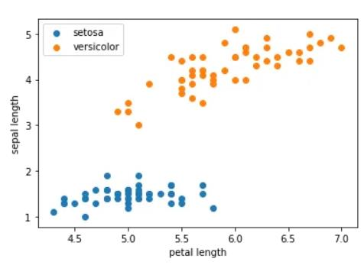
Visualizing the dataset on two of its features shows that the classes can be clearly separated by a straight line — the perceptron's task is to find that line and classify every point correctly.

Activity 2: Implementation of Perceptron
Solution:
def perceptron(data, num_iter):
features = data[:, :-1]
labels = data[:, -1]

# set weights to zero
w = np.zeros(shape=(1, features.shape[1]+1))
misclassified_ = []

for epoch in range(num_iter):
misclassified = 0
for x, label in zip(features, labels):
x = np.insert(x, 0, 1)
y = np.dot(w, x.transpose())
target = 1.0 if (y > 0) else 0.0

delta = (label.item(0, 0) - target)

if delta: # misclassified
misclassified += 1
w += (delta * x)

misclassified_.append(misclassified)
return (w, misclassified_)

num_iter = 10
w, misclassified_ = perceptron(data, num_iter)

epochs = np.arange(1, num_iter+1)
plt.plot(epochs, misclassified_)
plt.xlabel('iterations')
plt.ylabel('misclassified')
plt.show()
A property of the perceptron is that if the dataset is linearly separable, the algorithm is guaranteed to converge — the plot of misclassified points per epoch drops to zero within a few iterations.
Output:
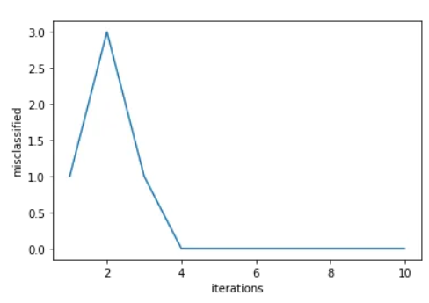

Activity 3: Implementing Weight Initialization Techniques in Python
This activity compares four common weight initialization schemes on the same 4-input, 3-output layer (fan_in = 4, fan_out = 3, except where noted), using NumPy directly.
Part A — Xavier Uniform Initialization
import numpy as np

# Set seed for reproducible results
np.random.seed(42)

# Number of input and output neurons
fan_in = 4
fan_out = 3

# Xavier/Glorot uniform limit
limit = np.sqrt(6 / (fan_in + fan_out))

# Initialize weights
weights = np.random.uniform(-limit, limit, size=(fan_out, fan_in))

print("Xavier Uniform Weight Initialization:")
print(weights)
print("\nMinimum weight:", weights.min())
print("Maximum weight:", weights.max())
print("Mean:", weights.mean())
print("Standard deviation:", weights.std())
Output:
Xavier Uniform Weight Initialization:
[[-0.0813 0.5280 -0.5561 0.0264]
[ 0.1711 -0.8398 0.1991 -0.6101]
[-0.8054 0.8312 0.8622 0.5710]]

Minimum weight: -0.8398
Maximum weight: 0.8622
Mean: 0.050...
Standard deviation: 0.58...
Part B — Gaussian (Normal) Initialization
import numpy as np

np.random.seed(42)

fan_in = 4
fan_out = 3
mean = 0
std = 0.1

# Gaussian weight initialization
weights = np.random.normal(loc=mean, scale=std, size=(fan_out, fan_in))

print("Gaussian (Normal) Weight Initialization:")
print(weights)
print("\nMean:", weights.mean())
print("Standard Deviation:", weights.std())
print("Minimum:", weights.min())
print("Maximum:", weights.max())
Output:
Gaussian (Normal) Weight Initialization:
[[ 0.0497 -0.0138 0.0648 0.1523]
[-0.0234 -0.0234 0.1579 0.0767]
[-0.0469 0.0543 -0.0463 -0.0466]]

Mean: approximately 0.025
Standard Deviation: approximately 0.075
Minimum: approximately -0.047
Maximum: approximately 0.158
Part C — Orthogonal Weight Initialization
import numpy as np

np.random.seed(42)

fan_in = 4
fan_out = 4

# Step 1: Generate a random matrix
A = np.random.randn(fan_out, fan_in)

# Step 2: Perform QR decomposition
Q, R = np.linalg.qr(A)

# Step 3: Use Q as the weight matrix
weights = Q

print("Orthogonal Weight Initialization:")
print(np.round(weights, 4))

# Check orthogonality
print("\nW × Wᵀ:")
print(np.round(weights @ weights.T, 4))
Output:
Orthogonal Weight Initialization:
[[-0.6579 -0.2264 0.2605 0.6676]
[ 0.4950 -0.7216 0.4214 0.2489]
[-0.2077 0.6539 0.7155 0.1615]
[-0.5270 -0.0861 0.4789 -0.6990]]

W × Wᵀ:
[[ 1. 0. 0. 0.]
[ 0. 1. 0. 0.]
[ 0. 0. 1. 0.]
[ 0. 0. 0. 1.]]
W × Wᵀ equals the identity matrix, confirming the rows of Q are orthonormal.
Part D — He (Kaiming) Initialization
import numpy as np

np.random.seed(42)

fan_in = 4
fan_out = 3

# He initialization
std = np.sqrt(2 / fan_in)

# Generate weights from a normal distribution
weights = np.random.normal(loc=0, scale=std, size=(fan_out, fan_in))

print("He (Kaiming) Weight Initialization:")
print(np.round(weights, 4))
print("\nMean:", round(weights.mean(), 4))
print("Standard Deviation:", round(weights.std(), 4))
Output:
He (Kaiming) Weight Initialization:
[[ 0.7025 -0.1956 0.9168 2.1551]
[-0.3312 -0.3312 2.2345 1.0856]
[-0.6637 0.7679 -0.6549 -0.6591]]

Mean: 0.419
Standard Deviation: 0.98
Comparing the four outputs: Gaussian(0, 0.1) keeps weights tightly clustered near zero regardless of layer size; Xavier widens the range in proportion to fan_in + fan_out, which suits tanh/sigmoid layers; He produces a visibly larger spread (note the larger mean/std above) to compensate for ReLU zeroing out negative activations; and Orthogonal is the only scheme that guarantees the weight rows are perfectly uncorrelated (W × Wᵀ = I), which is why it is preferred for RNN/LSTM recurrent weight matrices.

7) Graded Lab Tasks
The purpose of this lab task is to help students understand, implement, and train a perceptron in Python, and to apply appropriate weight initialization.
Lab Task 1: Loading dataset — load a dataset from Kaggle or the UCI Machine Learning repository and visualize it.
Lab Task 2: Implement a perceptron on the dataset, train it using the training algorithm, and plot the learning curve and final weights.
Lab Task 3: Re-initialize the perceptron's weights using Xavier and He initialization (instead of the default scaling in Step 1), retrain on the same dataset, and compare the number of epochs each initialization takes to converge.

