Shahjalal University of Science & Technology, Sylhet



**Assignment on Application of Remote Sensing in Land Cover Detection**

**Course Code: GEE 352**

**Course Title: Introduction to Remote Sensing (Lab)**

**Submitted to Rony Basak**

**Assistant Professor**

**Department of Geography and Environment Shahjalal University of Science & Technology, Sylhet**

**Submitted By**

**Shafikur Rahaman Reg. No: 2020135060**

**Semester: 3rd Year, 1st Semester Session: 2020-2021**

**Department of Geography and Environment Shahjalal University of Science & Technology, Sylhet**

**Date of Submission: 04 December 2024**

Table of Contents

**Introduction 3**

**Study area 4**

**Materials and methods 5**

**Data Collection 5**

**Satellite selection 5**

**Base map Collection. 5**

**Band Combination/Band Selection and Uses. 5**

**Band Composition of Landsat 8 6**

**Spectral Signature 6**

**Meta data 6**

**Spectral Meta data/ Bands 7**

**Sensor Metadata 7**

**Processing and Analysis of Satellite Image 7**

**NDVI Analysis 7**

**Table –Area change by NDVI 9**

**NDWI Analysis 10**

**Table- Area change by NDWI 11**

**Result and Discussion 12**

**Land Cover map 2019 & 2024 12**

**Change Detection 14**

**Conclusion 15**

**Detection of Land Cover Change Applying Remote Sensing Techniques in Chakaria, Cox’s Bazar**

***Shafikur Rahaman***

***Student of Geography and Environment,***

***Shahjalal University of Science and Technology, Sylhet***

|  |  |  |
| --- | --- | --- |
| ***KEYWORDS*** |  | ABSTRACT |
| Chakaria Landsat NDVI NDWI  Land Cover Change |  | Land cover change detection is a process for understanding the dynamics of natural and human-induced transformations on Earth's surface. This study focuses on detecting land cover changes in Chakaria Upazila, Cox's Bazar, using remote sensing techniques. Both pre-classification and post classification change detection approach was used to assess the change result 2019 and 2024. In pre-classification approach NDVI and NDWI analysis were implemented to assess the change scenario. Iso Cluster Unsupervised classification technique was performed to create the signature class of significant land cover category water body, vegetation, agriculture, salt field, shrimp enclosure and settlement. The integration of Geospatial tools enhances the accuracy of spatial analyses and enables a detailed assessment of the environmental impacts. This study underscores the utility of remote sensing as a cost-effective and efficient tool for land cover detection and provides critical insights for policymakers and planners aiming to balance development with ecological preservation in Chakaria Upazila. |

# Introduction

Chakaria Upazila, located in Cox's Bazar District of Bangladesh, represents a dynamic region characterized by its diverse land cover, ecological richness, and socio-economic activities. Geographically Chakaria is nestled between the Matamuhuri River to the east and the Bay of Bengal to the south, offering a unique interplay of terrestrial and coastal ecosystems. The upazila spans a significant area with a mix of forested hills, agricultural lands, settlements, wetlands, and mangrove patches.

Over the past decades, Chakaria has witnessed substantial transformations in its land cover driven by rapid urbanization, agricultural expansion, deforestation, and climate-induced impacts such as salinity intrusion and cyclonic activity. This dynamic alteration poses significant implications for biodiversity

conservation, agricultural productivity, and disaster resilience. The region is particularly notable for the historical presence of the 'Chakaria Sundarbans', an important mangrove ecosystem that has been severely degraded due to anthropogenic pressures. The focus on land cover change detection in Chakaria Upazila is crucial for understanding the extent and nature of these transformations, assessing their drivers, and identifying sustainable management strategies. By analyzing temporal satellite imagery and geospatial data, this study aims to map changes, quantify land cover transitions, and evaluate the socio-environmental consequences of such changes. Given Chakaria's vulnerability to natural hazards and its strategic location within the coastal belt of Bangladesh, this research holds significance for informing regional planning, conservation initiatives, and climate adaptation measures.

# Study area

## **Absolute location:** Chakaria Upazila is situated at approximately 21°46' to 21°56' North latitude and 91°55' to 92°05' East

## longitude. This precise geographic coordinate positions it in the southeastern part of Bangladesh, within Cox's Bazar District in the Chittagong Division.

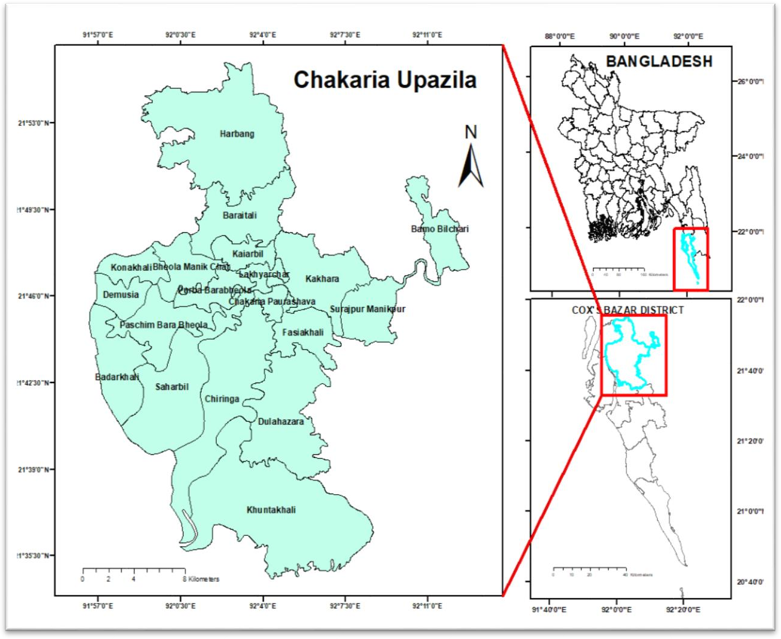

**Figure 01: Study Area**

**Relative Location:** Chakaria is relatively located in north of the Cox's Bazar district headquarters, which is about 50 kilometers away. It lies south of the Bandarban district, a region known for its hills and natural beauty. Natural Boundaries and Features. To the east, the upazila is bordered by the Matamuhuri River, which originates in the hilly areas of Bandarban and flows through Chakaria before

emptying into the Bay of Bengal. The Bay of Bengal lies to its southwest, influencing its climate and livelihoods, particularly fishing and aquaculture. Chittagong-Cox's Bazar Highway runs through Chakaria. The upazila is about 110 kilometers southeast of Chittagong city, a major commercial hub in Bangladesh.

Its position along the highway enhances trade and tourism. The proximity to the Bay of

Bengal supports fishing and salt production. Chakaria is famous for shrimp fish and salt

product iron. The presence of rivers and low- lying coastal areas makes Chakaria vulnerable to flooding and cyclones, a common issue in southeastern Bangladesh. The interplay between its absolute and relative location

defines Chakaria’s environmental characteristics, economic activities, and strategic importance within the region.

# Materials and methods

## Data Collection

## **Satellite selection:** Secondary data is used in this study. As secondary data, the Landsat 8-9 OLI/TIRS (The Operational Land Image and The Thermal Infrared Sensors) C2 L2 (Collection 2 Level-2)

Image was taken from USGS (United States Geological Survey website (<https://earthexplorer.usgs.gov/>). Where cloud cover is less than 5% and download images dated 2024/11/13 and 2019/11/16 using the data range.

|  |  |  |  |  |
| --- | --- | --- | --- | --- |
| Satellite ID | Sensor name | Path/raw | Acquisition date | Spatial resolution  (m) |
| Landsat 8 | OLI/TIRS | 136/45 | 2024/11/13 | 30 |
| Landsat 8 | OLI/TIRS | 136/45 | 2019/11/16 | 30 |

## Base map Collection: As a base map I use Google Earth pro. Where I can see images of the recent period and images of the past. For the image analysis of 2019, it is necessary to see features of that period. So I connect Google earth pro with ArcMap while working as a base map.

## **Band Combination/Band Selection and Uses:** For the detection of land cover changes and analysis of specific indices such as NDVI (Normalized Difference Vegetation Index), NDWI (Normalized Difference Water Index), and the creation of a land cover map, specific bands of Landsat 8 are selected based on their spectral properties. These combinations and selections are essential for distinguishing different surface features and enhancing analysis accuracy.

1. NDVI (Normalized Difference Vegetation Index)

Formula:

NDVI = (Band 5 – Band 4) / (Band 5 + Band 4) (NDVI= (NIR-Red) / (NIR+ Red)\)

Bands Used:

NIR (Band 5): Reflects healthy vegetation strongly.

Red (Band 4): Absorbed by vegetation; weak reflectance for stressed vegetation.

Purpose:

* NDVI values range from -1 to +1. Higher values indicate dense, healthy vegetation, while lower values indicate water or barren land.
* Used to assess vegetation health and distribution in Study area.

1. NDWI (Normalized Difference Water Index)

Formula:

(NDWI) is NDWI = (Green – NIR) / (Green + NIR)

Bands Used:

Green (Band 3): Reflects water strongly.

NIR (Band 5): Absorbed by water; shows minimal

(c). Land Cover Mapping Band Combination:

Natural Color (RGB): Bands 4 (Red), 3 (Green), 2 (Blue).

## Band Composition of Landsat 8

|  |  |
| --- | --- |
| Composite Name | Bands |
| Natural Color | 432 |
| False Color (Urban) | 762 |
| Color Infrared (vegetation) | 543 |
| Agriculture | 652 |
| Healthy Vegetation | 562 |
| Land/Water | 564 |
| Shortwave Infrared | 754 |
| Vegetation Analysis | 654 |

NDVI was calculated by Raster calculation with band 5 and Band 4. NDWI was calculated by Raster calculation with Band 3 and Band 5. Besides, in the case of land cover map, composite with band (1-7). Later extract to

# Spectral Signature

Spectral Signature is the variation of reflectance with respect to wavelengths. A

mask and separate the study area and use composite band. So that different objects are highlighted and detected.

Signature spectrum refers to the unique pattern of reflectance Electromagnetic Radiation (EMR) by different materials as a function of wavelength

.

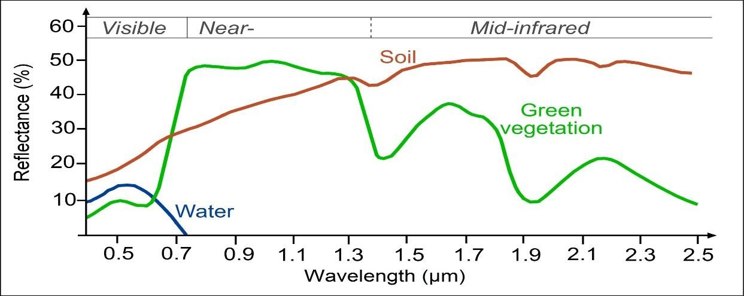

# Meta data

Landsat Scene Id

= "Lc81360452019320lgn00"

Spacecraft Id = "Landsat_8" Number of Bands = 11

Band List = (1, 2, 3, 4, 5, 6, 7, 8, 9, 10, 11)

Ellipsoid Axes = (6378137.000000, 6356752.314200)

Map Projection = "UTM" Projection Units = "Meters"

Datum = "WGS84" Ellipsoid = "WGS84" UTM Zone = 46 Launch Date:

Landsat 8: February 11, 2013;

Landsat 9: September 27, 2021

Orbit: Sun-synchronous, near-polar orbit Altitude: Approximately 705 kilometers Repeat Cycle: 16 days

Data Level: Level-1 (raw data) and Level-2 (processed data)

### Spectral Meta data/ Bands:

Landsat 8 provides 11 spectral bands, including

9 multispectral bands (OLI) and 2 thermal bands (TIRS).

Wavelength ranges for key bands:

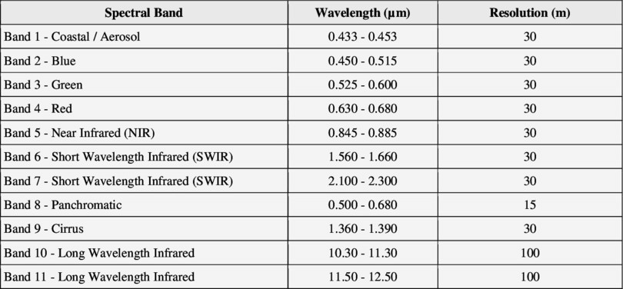

### Sensor Metadata:

Operational Land Imager (OLI): Multispectral imagery across 9 bands.

.

# Processing and Analysis of Satellite Image

Image processing are three categories of the present study’s procedure, as displayed in remote sensing techniques using software namely, ArcGIS 10.8 we were applied to accomplish the methods of this study.

Thermal Infrared Sensor (TIRS): Thermal data in 2 bands for surface temperature measurement

Remote sensing techniques, such as the Normalized Difference Vegetation Index (NDVI) and the Normalized Difference Water Index (NDWI), are powerful tools for assessing vegetation health, land cover changes, and water body dynamics. These indices leverage spectral data from satellite or aerial imagery to provide insights into environmental conditions, aiding in ecological monitoring, agricultural planning, and resource management.

NDVI & NDWI Range

|  |  |  |  |
| --- | --- | --- | --- |
| Classes | NDVI Interval | Classes | NDWI Interval |
| Water | -0.28 – 0.015 | Non Water Surface | -1 – 0.2 |
| Buildup Area | 0.015 – 0.14 |
| Barren Land | 0.14 – 0.18 | Shallow Water | 0.2 – 0.5 |
| Shrub’s and Grassland | 0.18 – 0.27 |
| Sparse Vegetation | 0.27 - 0.36 | Deep Water | 0.5 – 0.1 |
| Dense Vegetation | 0.36 – 0.8 |

## 

**NDVI Analysis**

NDVI is widely used to evaluate vegetation vigor and monitor plant health. It is calculated using the red (R) and near-

infrared (NIR) bands of the electromagnetic spectrum, following the formula:

NDVI= (Band 5 – Band 4) / (Band 5 + Band 4)

**NDVI Analysis of Chakaria Upazila 2019 & 2024**

|  |  |
| --- | --- |
|  |  |

|  |  |
| --- | --- |
|  |  |

|  |  |  |  |  |  |
| --- | --- | --- | --- | --- | --- |
| Value | Name | Area of 2019 | Area of 2024 | Changes | Percentage |
| 1 | Water | 55.7496 | 61.0515 | -5.3019 | Increase 9.5% |
| 2 | Buildup Area | 65.7135 | 70.5906 | -4.8771 | Increase 7.42% |
| 3 | Barren Land | 21.798 | 17.806 | 3.992 | Decrease  18.31% |
| 4 | Shrub’s and Grassland | 61.3269 | 57.1194 | 4.2075 | Decrease 6.86% |
| 5 | Sparse  Vegetation | 130.3794 | 132.0507 | -1.6713 | Increase 1.28% |
| 6 | Dense  Vegetation | 142.9794 | 139.2939 | 3.6855 | Decrease  2.58% |
|  | Total | 477.9468 | 477.9468 |  |  |

## Table –Area change by NDVI

The NDVI analysis revealed major transformations in the land cover of the study area. Water bodies grew by 9.5%, and built-up structures increased by 7.42%. On the other hand, barren land reduced by 18.31%, sparse vegetation increased by 1.28%, and shrubs/grassland and dense vegetation decreased by 6.86% and 2.58%, respectively. The results above speak of the complicated interplay between natural processes and human impacts on the landscape.

An NDVI (Normalized Difference Vegetation Index) analysis for Chakaria Upazila revealed significant changes in land use and land cover, thereby indicating a vivid expression of the environmental dynamics and human activities exerted in the area. The major findings are summarized as follows:

1. Increase in Water Bodies (9.5%):

An important increase in water-covered areas signifies either natural processes, like seasonal flooding, or human-induced changes such as aquaculture expansion and reservoir development.

1. Increase in Built-Up Area (7.42%):

An increase in the urbanized or developed area indicates continued processes of urbanization, infrastructure development, and population growth in the area.

1. Decrease in Barren Land (18.31%):

Such a marked reduction in barren land signifies an appropriation toward more productive land uses, including the growth of vegetation, agriculture, or infrastructure.

1. Increase in Sparse Vegetation (1.28%):

A slight increase in sparse vegetation indicates that some degraded lands have started to recover, possibly as a result of afforestation, improved land management practices, or natural regrowth of the vegetation.

1. Decrease in Shrubs and Grasslands (6.86%): The decline in shrubs and grassland may indicate land conversion to agriculture, urbanization, or other developmental activities.
2. Decrease in Dense Vegetation (2.58%): Whether deforestation, agricultural expansion, or some other land-clearing activities could be the explanation of forest loss is hinted by the decrease in dense vegetation.

These changes highlight the complex interaction of natural forces and human influences in determining the landscape of Chakaria Upazila. The findings further call for a land-use plan that is sustainable to develop well without harming the ecology.

## NDWI Analysis

NDWI focuses on detecting water content in vegetation and delineating water bodies. Two common formulations of NDWI exist:

NDWI= (Band 3 – Band 5) / (Band 3 – Band 5)

|  |  |  |  |  |  |
| --- | --- | --- | --- | --- | --- |
| Value | Name | Area of 2019 (Sq_km) | Area of 2024 (Sq_km) | Changes | Percentage |
| 1 | Non Water  Surface | 211.4361 | 259.0515 | -47.6154 | Increase 22.52% |
| 2 | Shallow Water | 206.955 | 110.9529 | 96.0021 | Decrease 46.39% |
| 3 | Deep Water | 59.5557 | 107.9424 | -48.3867 | Increase 81.24% |
|  | Total | 477.9468 | 477.9468 |  |  |

**NDWI Analysis of Chakaria Upazila 2019 & 2024**

|  |  |
| --- | --- |
|  |  |
|  |  |

## Table- Area change by NDWI

NDWI Analysis for Water Surface Change Detection in Chakaria Upazila the Normalized Differential Water Index (NDWI) assessment for Chakaria Upazila gives a good understanding of the changes that have occurred in the distribution and dynamics of the water surface across the years of study. The findings are as follows: 1. Increase in Non- water Surface Area (22.52): The increase in non-water surfaces explain the loss of shallow water and areas that are most likely transformed into land due to siltation, reclaiming of land or due to constructions normally due to urbanization or agriculture activities. 2. Decrease in Shallow water (46.46): The high loss of shallow water indicates drastic changes in hydrological conditions which could be as a

result of drainage activities, sediment deposition, shift to deeper water bodies or dry land. This transformation could also other seasonal changes or human activities. 3. Increase in Deep Water Area (81.24%): The remarkable widening of deep water leads to the conclusion of more storability of water probably increased due to natural cause like high and low rainfall or the expansion of reservoir, aquaculture ponds, and other water management facilities. Such dynamics demonstrate land use and management changes in Chakaria Upazila which can also be attributed to other natural factors as well as human factor interactions which are energy intensive.

# Result and Discussion

## Land Cover map 2019 & 2024

**Land Cover Analysis of Chakaria Upazila 2019 & 2024**

|  |  |
| --- | --- |
|  |  |

|  |  |  |  |  |  |
| --- | --- | --- | --- | --- | --- |
| Value | Name | Area of 2019 (Sq_km) | Area of 2024 (Sq_km) | Changes | Percentage |
| 1 | Deep Water | 77.1921 | 66.7188 | 10.4733 | Decrease 13.57% |
| 2 | Shallow Water | 76.5864 | 77.3118 | -0.7254 | Increase 1% |
| 3 | Settlement | 70.7454 | 125.3925 | -54.6471 | Increase 77% |
| 4 | Sparse Vegetation | 131.6769 | 137.5524 | -5.8755 | Increase 4.4% |
| 5 | Dense Vegetation | 121.7493 | 70.965 | 50.7843 | decrease 41.7% |
|  | Total | 477.9501 | 477.9405 |  |  |

**Table- Land Cover Area Change by Iso Cluster Unsupervised Classification**

The land cover change analysis for Chakaria Upazila reveals great transformations in the other land categories evidently the interactions of man and nature processes. These key findings are as follows:

1. Reduction in Deep Water (13.57%): It is possible that deep water areas were drained, filled with sediments or reclaimed as suggested by the changes in deep water areas. This reduction could be as a result of human activities such as land conversion for industrial or agricultural use.
2. Reduction in Shallow Water (1%): A minimal change on the shallow waters is observed with shallow water areas decreasing which may cause destruction in water bodies as season changes, which leads to land reclamation.
3. Increase in Settlements (77%): Increased settlement areas is a pointer to great improvement in urbanization which in turn leads to infrastructural improvements over a short time period. Such changes are most likely associated with population growth, increased economic activities, and urban sprawl/extension of the built environment over natural/agricultural spaces.
4. Increase in Sparse Vegetation (4.4%): As sparse vegetation increases in vegetative cover, such areas must have been bare or have had some soil degradation in the past. This could be as a result of effective management practices or first consumers in the vegetative succession sequence.
5. Decrease in Dense Vegetation (41.7%): The significant reduction in dense vegetation points to deforestation, agricultural expansion, or land clearing for settlements and infrastructure development. This trend raises concerns about the loss of biodiversity and ecosystem services in the region.

These changes reveal a dynamic transformation in Chakaria Upazila's land cover, influenced by both natural factors and increasing human activities. The findings underscore the need for sustainable land use planning and environmental conservation to balance development with ecological integrity.

## Change Detection

Sparse

Shallow Vegetatio

nt

Water

n

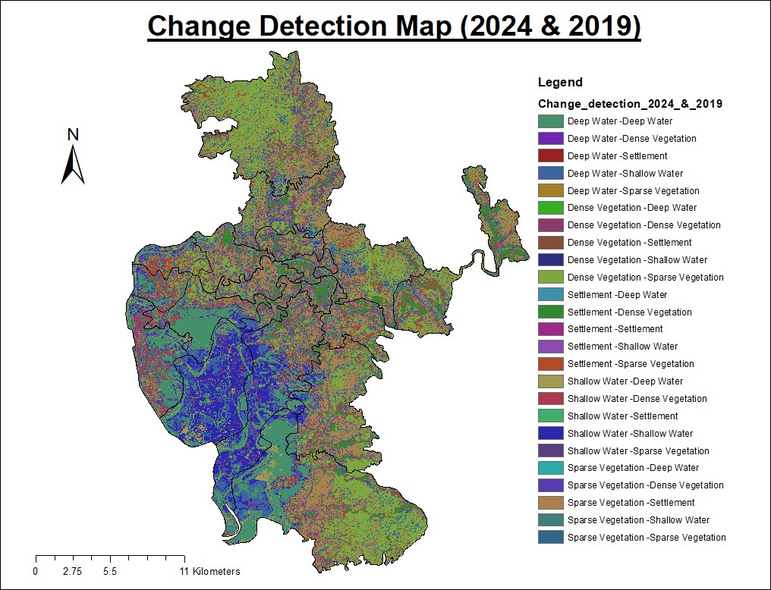

Total

Shallow Water

Deep Water Formula3

Sparse Vegetation Dense Vegetation

Formula4 Formula1 Settlement Formula5 Formula2 Shallow Water Deep Water Formula3

Sparse Vegetation Dense Vegetation

Formula4 Formula1

Total

0 20 40 60 80 100

Graph- Change Detection of various Features

Dense

Deep Vegetatio Settleme

Water

n

|  |  |
| --- | --- |
| **Change Detection** | **Change Detection_(Sq_m)** |
| Deep Water-Deep Wat | 53.207004 |
| Deep Water -Dense Vegetation | 0.892333 |
| Deep Water -Settlement | 0.388915 |
| Deep Water -Shallow | 22.697451 |
| Deep Water -Sparse Vegetation | 0.12546 |
| Dense Vegetation -Deep water | 0.304361 |
| Dense Vegetation -Dense vegetation | 10.775441 |
| Dense Vegetation -Settlement | 16.815103 |
| Dense Vegetation -Shallow water | 0.470909 |
| Dense Vegetation -Sparse vegetation | 93.938282 |
| Settlement-Deep Water | 0.698553 |
| Settlement-Dense Vegetation | 36.314819 |
| Settlement-Settlement | 16.021268 |
| Settlement-Shallow Water | 3.573033 |
| Settlement-Sparse Vegetation | 13.03429 |
| Shallow Water-Deep water | 12.184269 |
| Shallow Water-Dense vegetation | 6.534936 |
| Shallow Water-Dense vegetation | 8.340092 |
| Shallow Water -Shallow water | 47.683473 |
| Shallow Water-Sparse vegetation | 1.005807 |
| Sparse Vegetation -Dense vegetation | 0.30063 |
| Sparse Vegetation -Settlement | 84.240313 |
| Sparse Vegetation -Shallow water | 2.696544 |
| Sparse Vegetation -Sparse vegetation | 30.249625 |
|  |  |

# Conclusion

The pattern of land cover change of Chakaria Upazila as depicted by the results reveals that changes have occurred in the landscape of the region as a result of natural forces and anthropogenic activities. An outstanding change is the growth in the size of the settlement areas by 77%, which represents urban and infrastructural development. This development, however, is at the cost of the natural resources of the region as the area of dense vegetation has reduced by 41.7%, pointing to severe deforestation or land being cleared for developmental activities.

Also the 13.57% decrease in the area covered by deep water beds and 1% reduction in area covered by shallow water also indicate the

hydrological changes, probably as a result of reclamation of land, sedimentation or other anthropogenic activities. The area of sparse vegetation is showing moderate growth by 4.4% which suggests some recovery and growth in some areas but it is not enough to compensate the loss in area of dense vegetation.

It is imperative for the policies to be devised and implemented in order to manage land in a sustainable manner which allows for development whilst protecting the environment. As stated, there is an urgent need to address deforestation, conserve any available water resources and develop forests in order to revegetate Chakaria Upazila in the most economical and environment friendly basis.