***Ahsanullah University of Science & Technology***

Department of Computer Science & Engineering



Seba-NGO Management System

# Information System Design &

Software Engineering Lab

**CSE-3224**

**Final Report**

**Quest**

**Submitted By**

# Ashfaq Ali Shafin 14.01.04.111

# Irtiza Abir 14.01.04.122

# Abid Hasan Prottoy 14.01.04.125

**Table of Contents**

Executive Summary2

Project Goals ……………………………………………………………………………………………………..…………………..3

Project Feasibilities & Requirements……………………………………………………………….………………………4

Data Flow Diagram …………………………………………………………………………………………..…………………….5

Activity List ………………………………………………………………………………………….……………………5

Context Level ………………………………………………………………………………………………………….…6

DFD Level 0 ……………………………………………………………………………………………………………....6

DFD Level 1 ………………………………………………………………………………………………………………7

Process Decomposition ……………………………………………………………………………………………..8

Use Case Modeling……………………………………………………………………………………………….………………..9

Actor……………………………………………………………………………………………………….…….…………..9

Use Case Diagram (Overview)……………………………………………………………………….……………9

Use Case Modeling: Visitor …………………………………………………………………………….………...10

Use Case Modeling: Donor……………………………………………………………………………….……….10

Use Case Modeling: Admin……………………………………………………………………………….………11

Use Case Modeling: Employee………………………………………………………………………….………13

Use Case Modeling: Customer………………………………………………………………………….……….14

Entity Relationship Diagram……………………………………………………………………………………….……….16

Database Tables, Attributes and Types………………………………….………………………….………17

Testing Result………………………………………………………………………………….………………………….………19

Opportunities for Development…………………………………………………………………………………….……..19

Benchmarking……………………………………………………………………………………………………………….……20

Conclusion…………………………………………………………………………………………………………………….……20

# Summary of the Project:

Seba is a Non-Governmental organization working for the under developed people of Bangladesh. The prime objective of this organization is to reduce poverty and increase the rate of education. So two prime programs are currently running by this organization. These are the Micro-Finance Program and the Education Program.

**MICRO-FINANCE program of** Seba is considered the most efficient model of micro lending in the organization for its specialty in scaling up with sustainability and steady growth. Currently, seven million people of Bangladesh are deriving benefit from the Micro-finance program of different NGOs. Besides, the organization has been extending technical assistance and consultancies for implementing micro-finance operation to a number of NGOs.

**EDUCATION** Program of Seba is dedicated to prevent dropout from the primary schools and offer learning assistance to the underprivileged students in coping with studies.  Mainly, kids of preschool, grade-1 and grade-2 are being provided tuition by the program thus helping them meaningfully in performing better in daily classes and in school exams. About 300,000 children are benefiting from this program currently by the NGOs.

So the management software for this organization focuses on these Programs to ensure the automation of the whole system. It looks upon the Micro-Finance Program as well as the Education Program to run swiftly and easily. This software ensures the maximum reliability and easy usability for the employers of the organization in order to cope with the highest efficiency of the users.

## **Project Goals:**

* Web Based UI: User Interface of this project will contain a website to interact with the users. This will help users to easily understand the events and the features of the project.
* Micro-Finance Management: Micro-Finance management will help the organization to track the lone and amount of the loan. It will also perform the task of due date of loan submission and calculate the interest rate.
* Education Management: Education management will keep the information of the current Education Programs and the previous programs that were successfully completed by the organization. Customers who have enrolled in this activity will have a schedule for their weekly basis routine.
* Registration Process: Organization will be dealing with a large number of people for various events. Registration process will track those users according to the events they are currently performing.
* Activities Time Schedule: Current & Upcoming events of the organization will be described in this section. So users can check their regular performance. Users can also look up for their upcoming activities which they are interested about.
* Previous Successful Activities: This section will keep track of the previous activities that has been completed successfully by the organization
* Employer Management: Current employee of the organization will be tracked and according to their designation the monthly allowance will be paid. Employee who are in the field position will be assigned to a project.
* Donation Management: As the Education Program is based on donation, donation management will manage the Donor information and their donation process.
* Admin Panel: This section will add new customers, employees and projects. It will also update and delete these sections as needed.

## **Project Feasibilities & Requirements:**

* Programming Language: C#, ASP.net, HTML, JavaScript
* Style: CSS
* IDE: Bracket, MS Visual Studio
* Database: MsSQL
* Operating System: Windows 10

1. Technical Feasibility

* As developers have used personal laptops and computers which has decreased the project cost drastically.
* All the softwares, we have used is free or open sourced from Microsoft Student Partner. So the project will demand no cost for these softwares.
* As Windows is the most common operating system in the current era, this will conduct a good value to the customers and the client.

The above arguments show clear aspect of feasibility in technical section

1. Economic Feasibility

* Cost of the H/W & S/W is greatly reduced because of personal laptops and free Softwares that we needed to perform our dedicated job.
* Resources collected from the companies was nearly zero as we had connection with several NGOs.
* We acted as a system analyst to reduce the cost.
* No professionals were hired to update the content of the website as an admin.

1. Operational Feasibility

* As most of the users of this project are amateurs, we constructed the website as their requirements
* User Interface is simple for the novice users but we will not compromise with the efficiency as well
* Maintenance was very short run and optimized
* As users are amateurs, we will be covered the validation process to make sure users do not perform anything unusual.

**Data Flow Diagram (DFD):**

**Activity List:**

|  |  |  |
| --- | --- | --- |
| **Micro Credit** | **Education** | **Administration** |
| Customer Request | Customer Request | Content |
| to be assigned in | to be assigned in | Modification |
| Micro-Credit Project | Education Project | (add/delete/modify) |
|  |  | Donation Procedure |
|  |  |  |
|  |  |  |
| Feedback of the | Feedback of the | Keeping Track of |
| Request | Request | Donation |
|  |  |  |
| Loan Assignment |  | Task assignment for |
|  |  | Employee |
|  |  |  |
| Loan Receiving | Admission in | Keeping Track of |
|  | Program | Employees’ Work |
|  |  |  |

**Main Process**: Ngo Management System

**Sub Process**: Micro-Credit, Education, Administration

**Entity**: Customer, Donor, Admin, Employee

**DFD- Context LEVEL:**

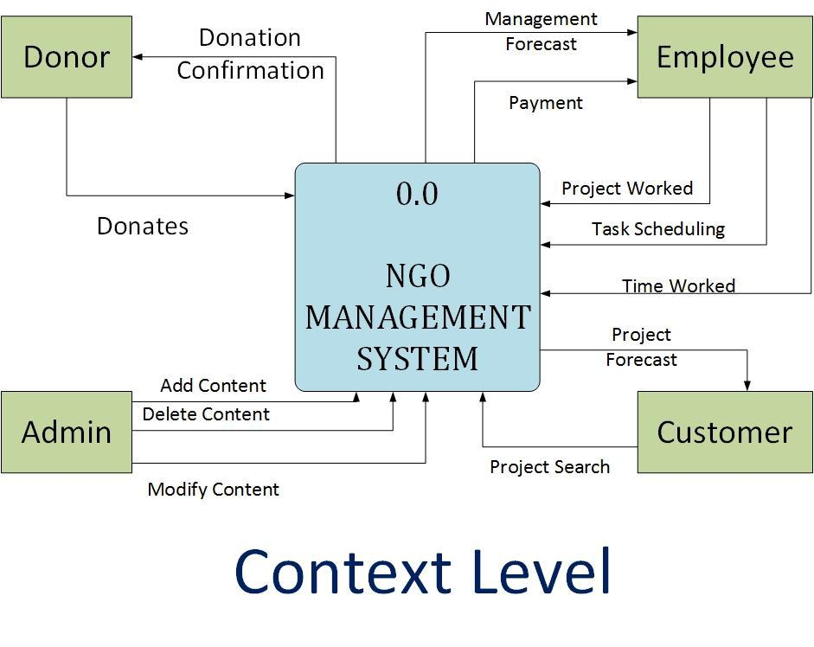

**DFD Level 0:**



## **DFD Level 1:**

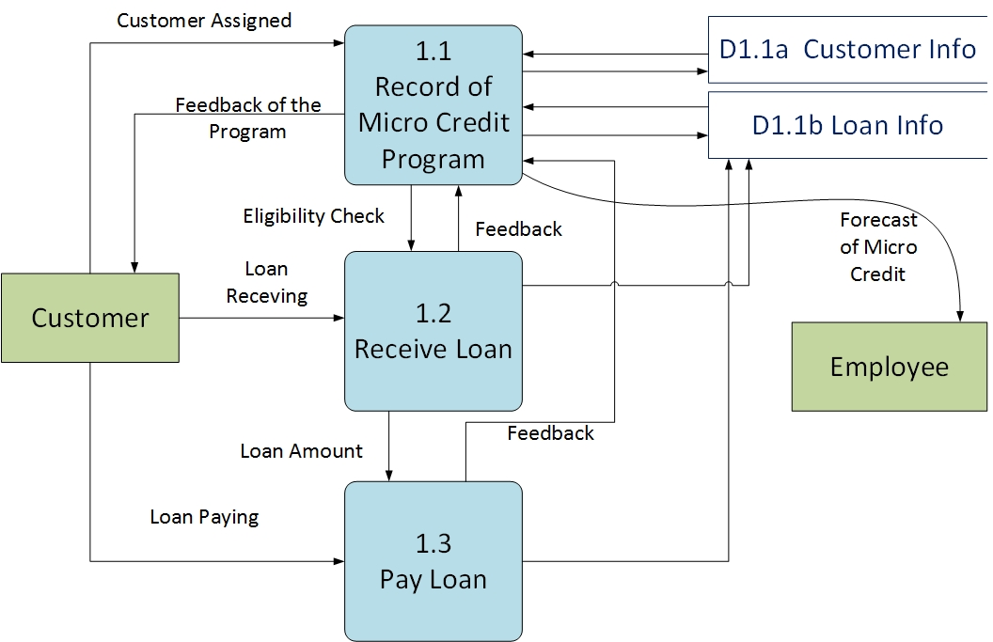

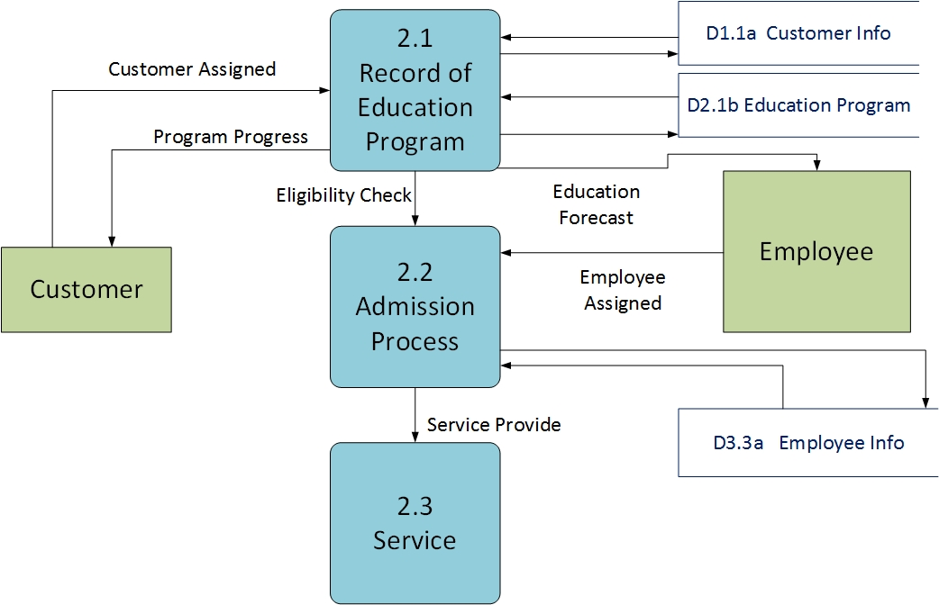



**Process Decomposition:**

|  |  |  |
| --- | --- | --- |
| **Context Level** | **Level -0** | **Level-1** |
|  |  |  |
|  | 1.0 Micro-Credit | 1.1 Record Micro-Credit Program |
|  |  |  |
|  |  | 1.2 Receive Loan |
|  |  |  |
|  |  | 1.3 Pay Loan |
|  |  |  |
|  | 2.0 Education | 2.1 Record Education Program |
|  |  |  |
| NGO Management |  | 2.2 Admission |
|  |  |
| System |  |  |
|  | 2.3 Service |
|  |  |
|  |  |  |
|  | 3.0 Administration | 3.1 Content Process |
|  |  |  |
|  |  | 3.2 Donation |
|  |  |  |
|  |  | 3.3 Employee Work Process |
|  |  |  |

**Use Case Modelling:**

**Actors:**

1. Visitor
2. Donor
3. Admin
4. Employee
5. Customer

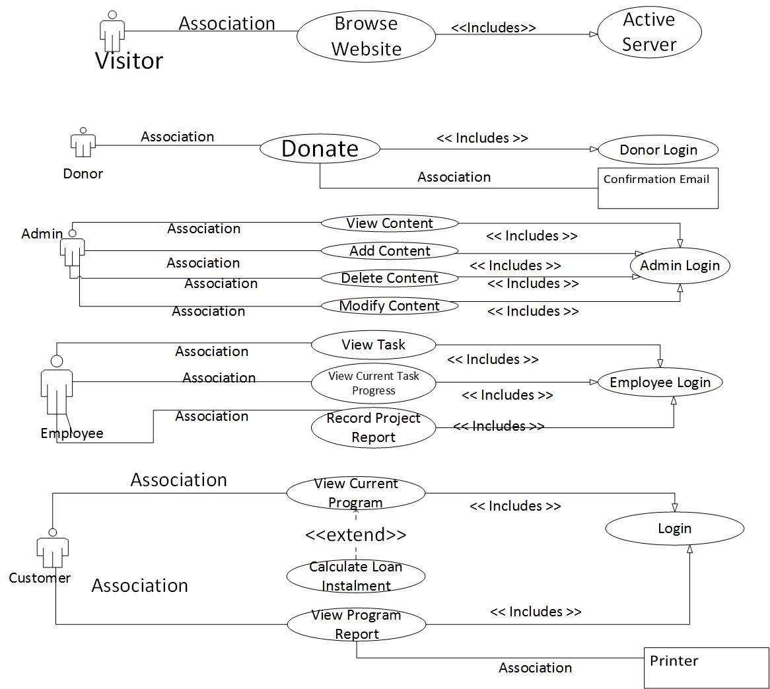**Use Case Diagram:**

## **Use Case Modeling:** Visitor



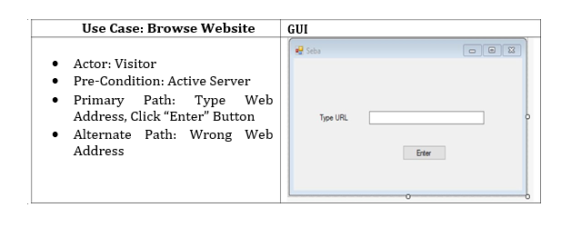

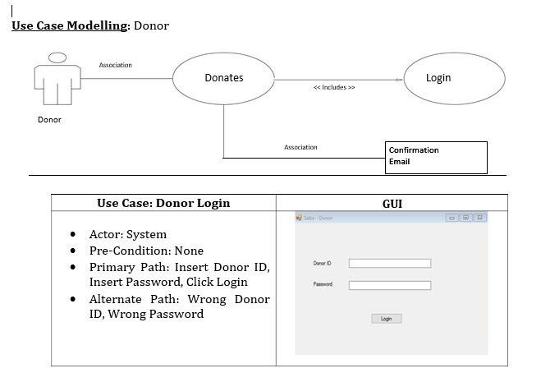

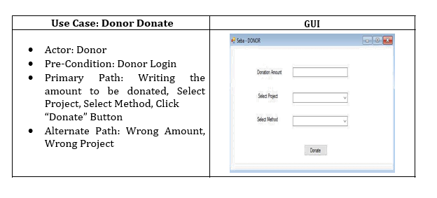

**Use Case Modelling: Admin**



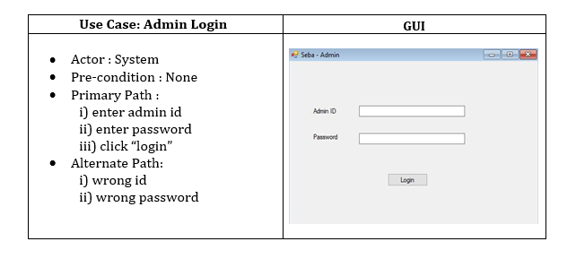

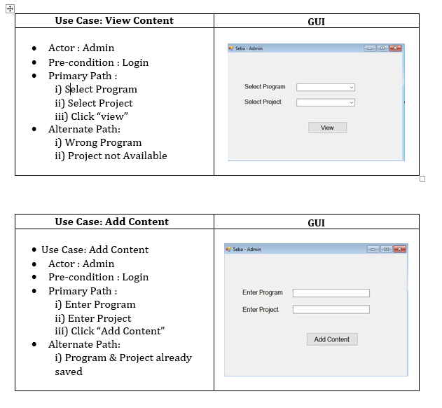

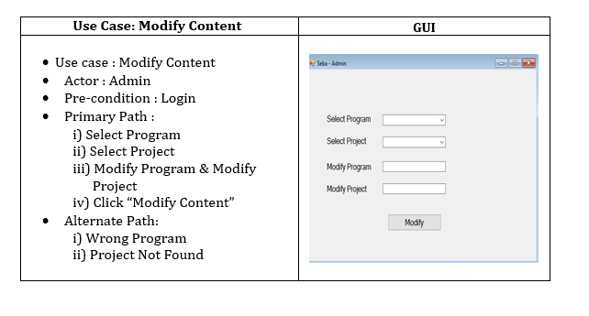

**Use Case Modelling: Employer**



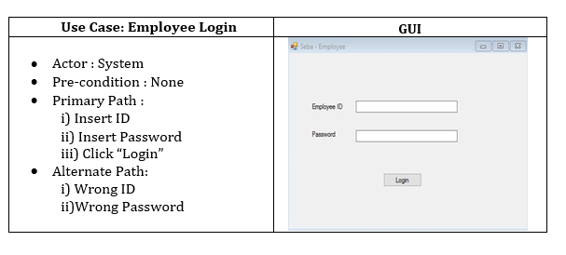

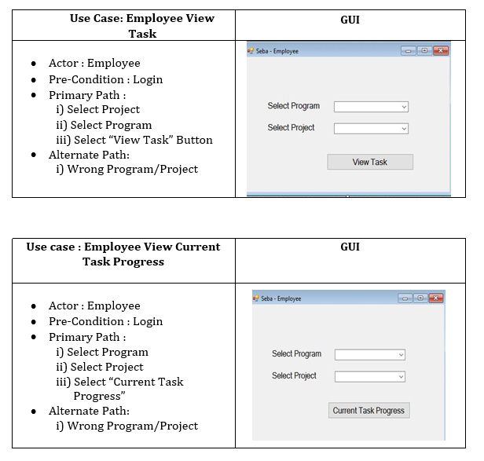

## **C:\Users\Ashfaq Ali Shafin\Desktop\em3.png**

## **Use Case Modelling: Customer**



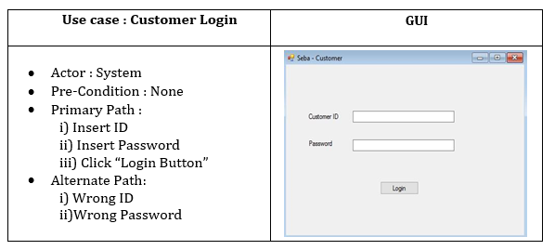

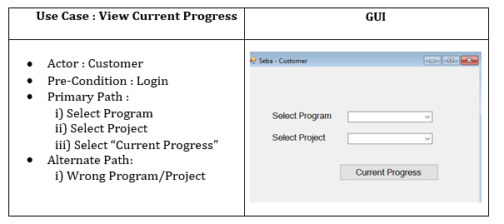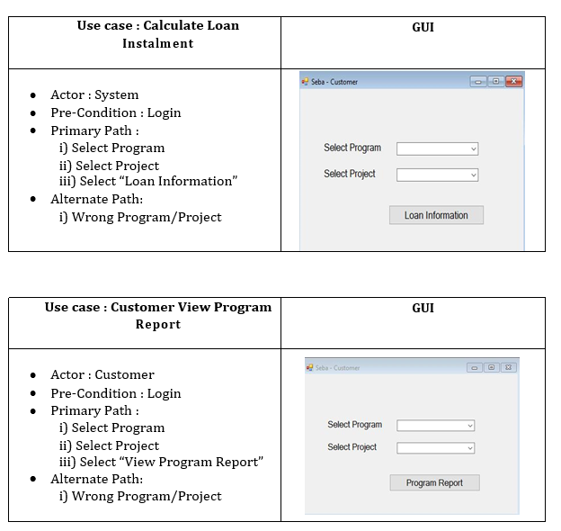

## **Entity Relation Diagram:**

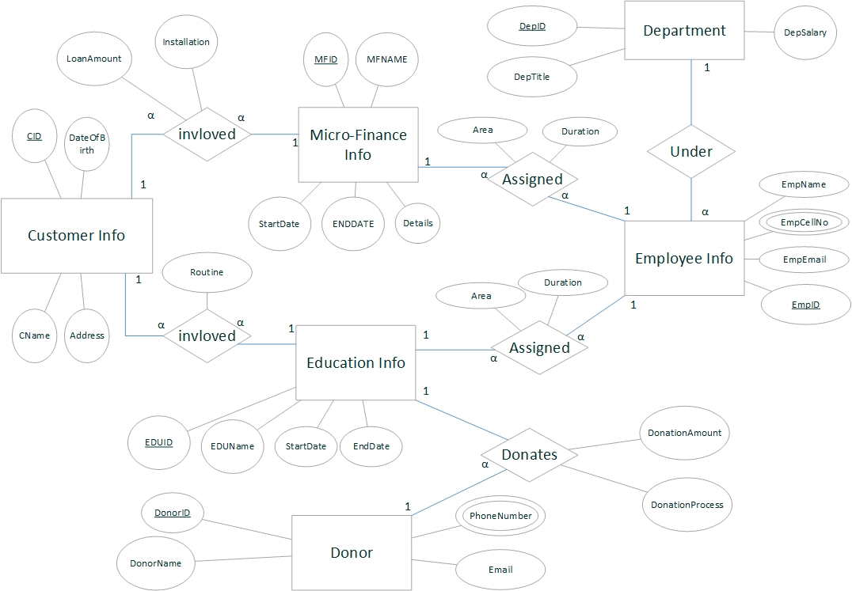

**Database Tables, Attributes & Data Type:**

|  |  |  |
| --- | --- | --- |
| Table Name | Attribute | Data Type |
| MicroFinance_Info | **MFID** | **INT (Primary Key)** |
| MFName | Varchar(100) |
| StartDate | Date |
| EndDate | Date |
| Details | Varchar(1000) |
| Education_Info | **EDUID** | **INT (Primary Key)** |
| EDUNAME | Varchar(100) |
| StartDate | Date |
| EndDate | Date |
| Customer_Info | **CID** | **INT (Primary Key)** |
| CName | VarChar(100) |
| DateOfBirth | Date |
| Address | VarChar(1000) |
| Donor_Info | **DonorID** | **INT (Primary Key)** |
| DonorName | Varchar(100) |
| PhoneNumber (Multivalued) | Varchar(100) |
| Email | Varchar(100) |
| Department | **DeptID** | **INT (Primary Key)** |
| DeptTitle | Varchar(100) |
| DeptSalary | Float |
| Employee_Info | **EmpID** | **INT (Primary Key)** |
| EmpName | Varchar(100) |
| EmpCellNo (Composite Value) | Varchar(100) |
| EmpMail | Varchar(100) |
| Table Name | **Attribute** | **Data Type** |
| Donation | *DonorID* | *INT (Foreign Key)* |
| *EDUID* | *INT (Foreign Key)* |
| DonationAmount | Float |
| Donation Process | Varchar(100) |
| **DonorID, EDUID** | **(Primary Key)** |
| CustomerUnder  Education | *CID* | *INT (Foreign Key)* |
| *EDUID* | *INT (Foreign Key)* |
| Routine | Varchar(70) |
| **CID,EDUID** | **(Primary Key)** |
| CustomerUnder  MicroFinace | *CID* | *INT (Foreign Key)* |
| *MFID* | *INT (Foreign Key)* |
| LoanAmount | Float |
| Installation | Float |
| **CID,MFID** | **(Primary Key)** |
| EducationAssigned  Employee | *EDUID* | *INT (Foreign Key)* |
| *EmpID* | *INT (Foreign Key)* |
| Area | Varchar(100) |
| Duration | Varchar (10) |
| **EDUID, EmpID** | **(Primary Key)** |
| MicroFinanceAssigned  Employee | *CFID* | *INT (Foreign Key)* |
| *EmpID* | *INT (Foreign Key)* |
| Area | Varchar(100) |
| Duration | Varchar (10) |
| **CFID, EmpID** | **(Primary Key)** |

**Testing Result of the Project:**

**Opportunities of Developments:**

* As the software is not fully completed (80% completed), in the future we will complete the software.
* We will make the website responsive for every media device such as mobile, tablet etc.
* Some features are not added as they were described in the project proposal. We will add those missing features.
* Later we will create an android application for the field works to collect data from customers and add them directly to the database.
* Opportunities for the best customers will be provided by the software.
* Email Notification for the Donor to confirm his donation.
* Monthly newsletter will be provided via mail to the employee and the donor.

**Benchmarking:**

Ashfaq Ali Shafin (14.01.04.111): 35%

Irtiza Ahsan (14.01.04.122): 30%

Abid Hasan Prottoy (14.01.04.125): 35%

**Conclusion:**

This concludes the final report of the NGO Management System. This is report as well as the full project helped us to realize how software development is done in the real life. This is will be a fundamental learning for us in the future.