**COMSATS University Islamabad, Lahore Campus**

**Fall 2024 – Assignment 1**

|  |  |  |  |  |  |  |
| --- | --- | --- | --- | --- | --- | --- |
| Course Title: | Computer Vision | Course Code: | | CSC455 | Credit Hours: | 3(3,0) |
| Course Instructor/s: | Dr. Zulfiqar Habib, Professor | Programme Name: | | BS Computer Science | | |
| Topic | Fundamentals of Computer Imaging/Vision  Section: | | | Max Marks: | 10 | |
| Out Date: | 30-09-24 | **Due Date:** | | | **7-10-24** | |
| Student’s Name: | **SHAFIN-UZ-ZAMAN** | Reg. No. | SP22-BCS-063 | | | |
| **Instructions:**   1. You may use AI tools to help understand the concepts. 2. However, the answers must be in your own words and show your understanding of the topics. 3. Copying answers directly from any source, including AI tools, is not allowed. 4. Your assignment will be evaluated & graded through a leading Quiz   **Submission Guidelines:**  Submit your assignment on this sheet via Google Classroom. | | | | | | |

**Problem Statement:**

Take a picture of five transparent bottles, where some are partially filled with a coloured drink and others are fully filled, using your own camera. Then, write a program that identifies, counts, and labels the partially filled bottles.

**Bonus:** If you can calculate the exact percentage fill for each bottle and label it, you will receive extra credit.

**Program Code**

import cv2

import numpy as np

import matplotlib.pyplot as plt

from skimage.filters import threshold_multiotsu

# Convert the input image to grayscale

def convert_to_grayscale(image):

    return cv2.cvtColor(image, cv2.COLOR_BGR2GRAY)

# Display an image using matplotlib; if it's grayscale, show in gray colormap

def show_image(image, is_gray=False):

    plt.figure(figsize=(6, 6))

    if is_gray:

        plt.imshow(image, cmap='gray')

    else:

        plt.imshow(cv2.cvtColor(image, cv2.COLOR_BGR2RGB))

    plt.axis('off')  # Turn off axis for a cleaner display

    plt.show()

# Sharpen the image by applying a kernel that enhances edges

def sharpen_image(image):

    # Define sharpening kernel to enhance edges

    sharpening_kernel = np.array([[0, -1, 0],

                                  [-1, 5, -1],

                                  [0, -1, 0]])

    return cv2.filter2D(image, -1, sharpening_kernel)

# Apply multi-level Otsu thresholding to segment the image into three classes

def apply_multi_otsu_threshold(image):

    # Get the thresholds using multi-Otsu for three classes

    thresholds = threshold_multiotsu(image, classes=3)

    t1, t2 = thresholds  # Two thresholds for separating three regions

    # Create binary masks based on the thresholds

    bL = np.where(image > t1, 1, 0)  # Lower threshold for the lighter region (liquid)

    bH = np.where(image > t2, 1, 0)  # Higher threshold for darker regions

    # Subtract the high and low regions to isolate the middle region (liquid)

    liquid_mask = bL - bH

    return (liquid_mask * 255).astype(np.uint8)  # Return as binary mask

# Apply morphological closing to remove small gaps in the image

def apply_morphology(image):

    kernel = np.ones((5, 5), np.uint8)  # Define kernel for morphology

    return cv2.morphologyEx(image, cv2.MORPH_CLOSE, kernel)  # Morphological closing

# Further refine contours using erosion and dilation for better shape detection

def refine_contours(mask):

    # Step 1: Apply closing to fill small gaps in the mask

    kernel = np.ones((5, 5), np.uint8)

    closed_mask = cv2.morphologyEx(mask, cv2.MORPH_CLOSE, kernel)

    # Step 2: Apply erosion to smooth the edges of the contours

    refined_mask = cv2.erode(closed_mask, kernel, iterations=2)

    return refined_mask

# Detect and label glasses based on their liquid height percentage

def detect_and_label_glasses(original_image, liquid_mask, glass_height):

    # Find contours of liquid in the binary mask

    contours, _ = cv2.findContours(liquid_mask, cv2.RETR_EXTERNAL, cv2.CHAIN_APPROX_SIMPLE)

    glass_count = 0  # Initialize glass count

    # Loop over each contour representing a glass

    for contour in contours:

        area = cv2.contourArea(contour)

        # Ignore small contours that may be noise

        if area < 1000:

            continue

        # Get bounding box of the detected glass contour

        x, y, w, h = cv2.boundingRect(contour)

        # Extract the region of interest within the bounding box

        glass_region = liquid_mask[y:y+h, x:x + w]

        # Find the highest and lowest points where liquid is detected

        non_zero_rows = np.any(glass_region > 0, axis=1)

        if np.any(non_zero_rows):

            highest_liquid_level = np.argmax(non_zero_rows)  # First row with liquid

            lowest_liquid_level = len(non_zero_rows) - np.argmax(non_zero_rows[::-1])  # Last row with liquid

            liquid_height = lowest_liquid_level - highest_liquid_level  # Calculate height of the liquid

        else:

            liquid_height = 0  # If no liquid is detected

        # Calculate the fill percentage based on liquid height relative to glass height

        fill_percentage = (liquid_height / glass_height) * 100

        # Label the glass based on fill percentage

        if fill_percentage >= 90:

            label = f"Fully Filled: {fill_percentage:.1f}%"

        elif fill_percentage == 0:

            label = "Empty"

        else:

            label = f"Partially Filled: {fill_percentage:.1f}%"

        glass_count += 1  # Increment glass count

        # Draw bounding box and label on the original image

        cv2.rectangle(original_image, (x, y), (x + w, y + h), (0, 255, 0), 2)

        cv2.putText(original_image, f"{label}", (x, y - 10),

                    cv2.FONT_HERSHEY_SIMPLEX, 0.7, (0, 255, 0), 2)

    # Display the final labeled image

    show_image(original_image)

    # Output the total number of glasses detected

    print(f"Total liquid Detected glasses : {glass_count}")

# Get the average height of the glass based on contours from thresholded image

def get_avg_glass_height(grayscale_image):

    # Apply multi-Otsu threshold to detect glass regions

    thresholds = threshold_multiotsu(grayscale_image, classes=3)

    t1, t2 = thresholds

    glass_mask = np.where(grayscale_image > t1, 1, 0)

    glass_mask = (glass_mask * 255).astype(np.uint8)

    # Find contours of glasses in the image

    glass_contours, _ = cv2.findContours(glass_mask, cv2.RETR_EXTERNAL, cv2.CHAIN_APPROX_SIMPLE)

    total_height = 0  # Sum of glass heights

    glass_count = 0  # Count of detected glasses

    # Loop over each detected glass contour

    for contour in glass_contours:

        area = cv2.contourArea(contour)

        if area < 1000:  # Filter out small, irrelevant contours

            continue

        x, y, w, glass_height = cv2.boundingRect(contour)

        total_height += glass_height

        glass_count += 1

    # Calculate the average height of the glasses

    if glass_count == 0:  # Handle case where no glass is detected

        return 0

    avg_glass_height = total_height / glass_count

    print(f"Total Glasses Detected: {glass_count}")

    print(f"Average Glass Height: {avg_glass_height} pixels")

    return avg_glass_height

# Main processing function to handle the image processing pipeline

def process_image(image_path):

    # Step 1: Load the image

    image = cv2.imread(image_path)

    # Step 2: Convert the image to grayscale

    grayscale_image = convert_to_grayscale(image)

    show_image(grayscale_image, True)

    # Step 3: Sharpen the grayscale image to enhance features

    sharpened_image = sharpen_image(grayscale_image)

    show_image(sharpened_image, True)

    # Step 4: Apply Gaussian blur to smooth the image and reduce noise

    blurred = cv2.GaussianBlur(sharpened_image, (3, 3), 0)

    show_image(blurred, True)

    # Step 5: Use multi-Otsu thresholding to segment the liquid in the image

    liquid_mask = apply_multi_otsu_threshold(blurred)

    show_image(liquid_mask, True)

    # Step 6: Refine contours by applying further morphological operations

    refined_mask = refine_contours(liquid_mask)

    show_image(refined_mask, True)

    # Step 7: Detect the average glass height from the image

    glass_height = int(get_avg_glass_height(grayscale_image)) - 10 # Subtract a small buffer

    # Step 8: Detect and label glasses based on their liquid fill level

    detect_and_label_glasses(image, refined_mask, glass_height)

# Run the image processing pipeline on the provided image file

process_image('main4.png')

**Input**

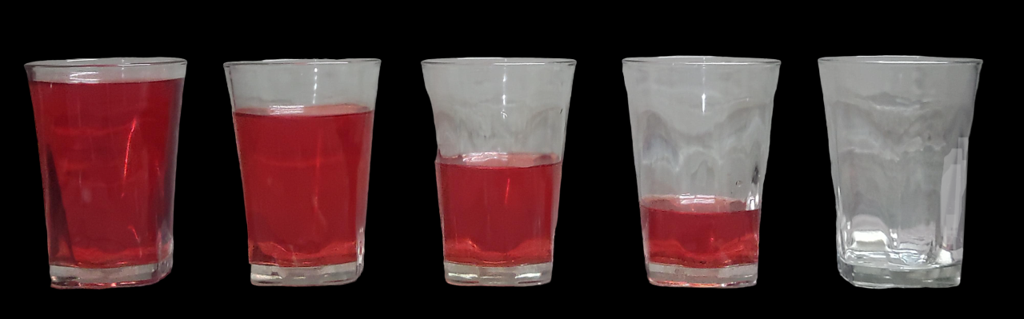

**Output**

**Grayscale:**

**Sharpen img:**

**Blur img (For noice reduction):**

**Thresholding (to detect glasses):**

**Morphological operation (to detect liquid):**

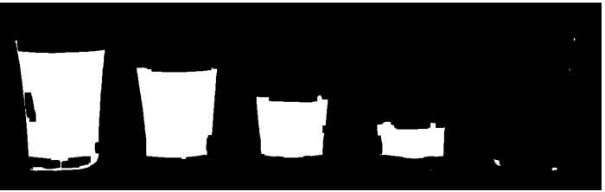

**Final result:**



