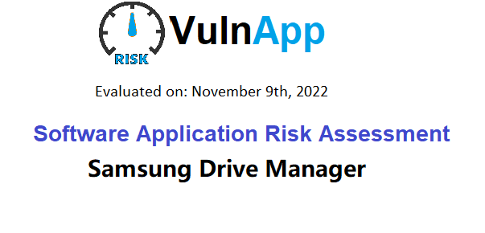

**Executive Summary**

The purpose of this report to systematically identify if **‘**Samsung Drive Manager**’ has malicious binaries, vulnerabilities or threats’ and analyze the risk it may pose to you or your organization.**

**Application Overview**

**Latest release**

Samsung Drive Manager 2.0.109

**Software Description**

Samsung Drive Manager is the software bundled with Samsung external drives. It is an upgraded tool that provides users with a unified user interface to adjust settings for various features.

Features include Backup, SecretZone, and Drive Lock (for drives that support the feature). System requirements: Windows 8, Windows 7, Windows Vista, or Windows XP.

**Older versions**

Samsung Drive Manager 1.0.175

**Alternatives**

FurMark, Intel, CPU-Z, Magician, Intel, RAM Disk, DiskInfo, FPS Monitor

**Security Verification**



**No sandbox has detected malicious behaviour**

**SHA256:**

**Vulnerabilities**

**This report identifies security risks that could have a significant impact on your day-to-day business operations.**

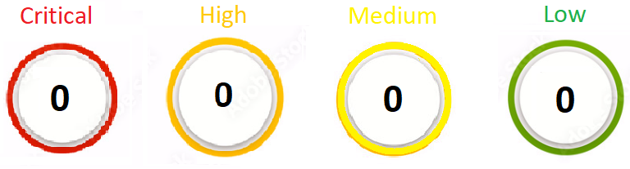

**Published: 05/10/22**

**CVE-2021-39373**

**Description** Samsung Drive Manager 2.0.104 on Samsung H3 devices allows attackers to bypass intended access controls on disk management. WideCharToMultiByte, WideCharStr, and MultiByteStr can contribute to password exposure

**Reference URL that may be of interest to you:**

**https://github.com/bosslabdcu/Vulnerability-Reporting/security/advisories/GHSA-j3f7-346q-97f4**

.

**Exploitable Threats**

**POC identified in the wild or threats associated to ‘**Samsung Drive Manager**’**

**No known threats that could be exploited.**

**Additional Information**

Open-Source Community YARA rules

n/a

Signatures from anti-virus vendors that were flagged:

n/a

**Risk Analysis**



Vulnapp derives a result by analyzing the software function as well as other factors such as industry practice. The analysis indicates 'Samsung Drive Manager' carries a ‘High’ risk from a security operation perspective. A review of internal security controls, remediation/mitigation, or internal red teaming/penetration testing can change the level of risk.

**Conclusion:**

A vulnerability was found in Samsung Drive Manager 2.0.104. Affected by this issue is the function WideCharToMultiByte/WideCharStr/MultiByteStr of the Disk Management component. There is no information about possible countermeasures known. It may be suggested to replace the affected object with an alternative product.