

North South University
Department Electrical and Computer Engineering
Project Title: NSU Mini Campus Network
Course Code: CSE438L
Course Title: Data Communication & Network
Section: 02
Date of Submission: 28th August, 2026

Student Name: Shafin Rahman
ID: 223 3146 642
Course Instructor: Dr. Rajesh Palit
Submitted to: F. M Abir Hossain

Contents
A. Introduction: 3
B. Network Diagram 3
Department A - Computer Science 4
Department B - IT Services 4
Department C – Administration 4
C. Configuration: 5
PC Configuration: 6
Subnet 1: 6
Subnet 2: 6
Subnet 3: 6
DHCP Configuration: 6
DNS configuration: 7
HTTP Configuration: 7
Router Configuration: 8
Router 0 8
Router 1: 9
Router 2: 10
OSPF Configuratoin: 11
D. Testing Result: 12
PCs in 3 subnets receiving DHCP IP 12
Ping to DNS server: 13
Ping to websites 14
Opening in browser www.nsu.com & www.project.com: 15
E. Conclusion 17
Challenges Encountered 17

A. Introduction:
The aim of this project is to design and set up a functional, miniature campus network that serves the three major divisions of North South University (NSU): Computer Science (Department A), IT Services (Department B), and Administration (Department C).

Each department will be assigned to an unique subnet and a dedicated router. The network is being constructed to provide access to essential services, including Dynamic Host Configuration Protocol (DHCP), Domain Name System (DNS) and HTTP hosting for two specific websites: www.project.com and www.nsu.com.

The core objective is to ensure that all departments can communicate effectively with one another, reach their respective internal servers, and utilize all necessary network services.
Each department's network will be self-contained with its own resources:

Department A will host the DHCP server for automatic IP allocation along with HTTP server for hosting www.project.com.

Department B will host the DNS server, resolving domain names across the campus network.

Department C will host the HTTP server for the official NSU website, www.nsu.com.

Utilizing the Open Shortest Path First (OSPF) protocol in Area 0 will allow the routers to share routing data, thereby guaranteeing uninterrupted communication across the three departmental subnets. The objective of this work is to establish a reliable and high-performing network capable of supporting critical campus services and facilitating effective communication among all departments involved.

B. Network Diagram
Network diagram consists of 3 departments, each department has its own router, switch, PC, and servers, configured as follows:

Department A - Computer Science
  - Router0: Connected to the core network and manages routing for this department.
  - Switch0: Connects the PC and server in this department.
  - PC0 & PC1: Student PCs in this department.
- Server1: A server hosting the DHCP and HTTP services (providing the website www.project.com). DHCP IP address is (192.168.1.2) and dynamically send IP address to all pcs.

Department B - IT Services
  - Router1: Interconnects with the core network and manages routing for this department.
  - Switch1: Connects the PCs and server.
  - PC2 & PC3: Staff PCs in this department.
  - Server2: A server hosting the DNS service for the campus. DNS IP is (192.168.2.2)

Department C – Administration
  - Router3: Interconnects with the core network and handles routing for this department.
  - Switch3: Connects the PCs and server.
  - PC4 & PC5: Admin PCs in this department.
  - Server3: A server hosting the HTTP service (providing the website www.nsu.com) IP address is 192.168.3.2

The routers are linked in a linear configuration using OSPF routing, which guarantees connectivity across all subnets. Within the departments, the client computers (PCs) are set up to automatically receive their IP addresses from a DHCP server and are able to translate domain names using the DNS server.

The OSPF protocol facilitates unrestricted communication throughout the entire network of subnets. Client machines (PCs) in every subnet are capable of accessing shared services like DHCP, DNS, and HTTP, enabling them to effectively interact with the hosted websites and other server-based applications.

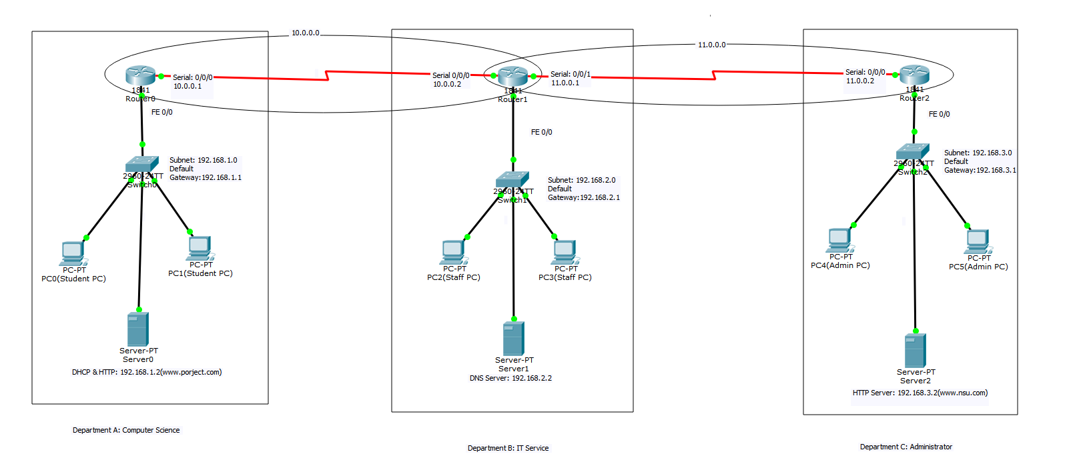

C. Configuration:

PC Configuration:

Subnet 1:
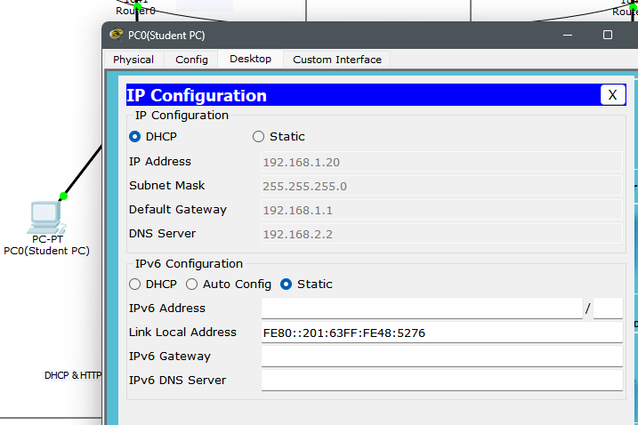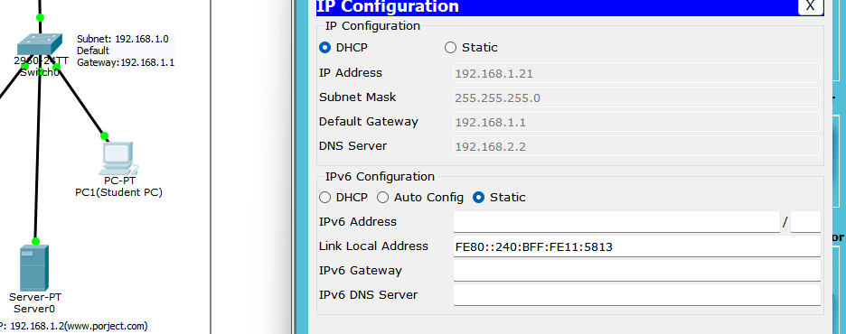

Subnet 2:
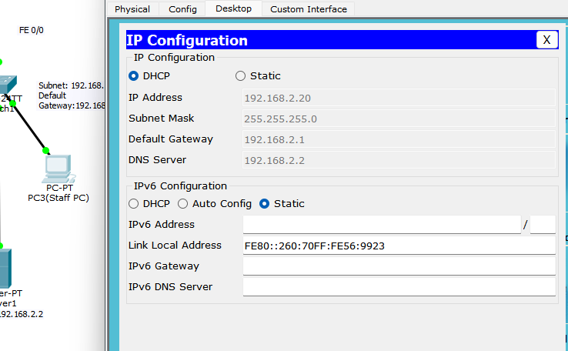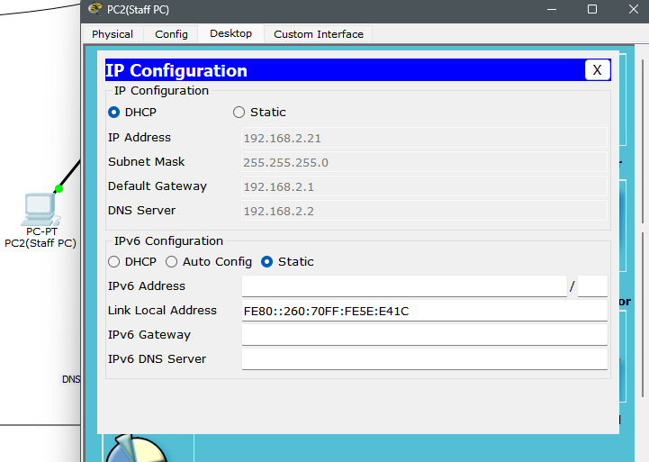

Subnet 3:
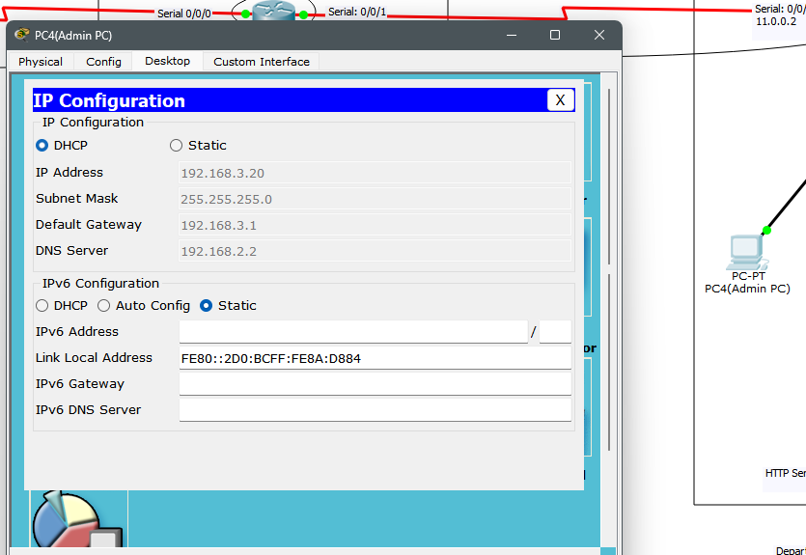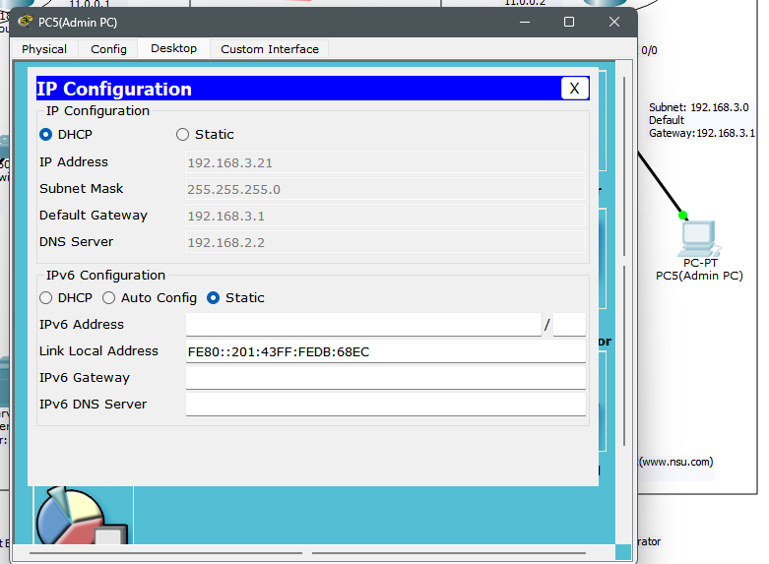

DHCP Configuration:
. 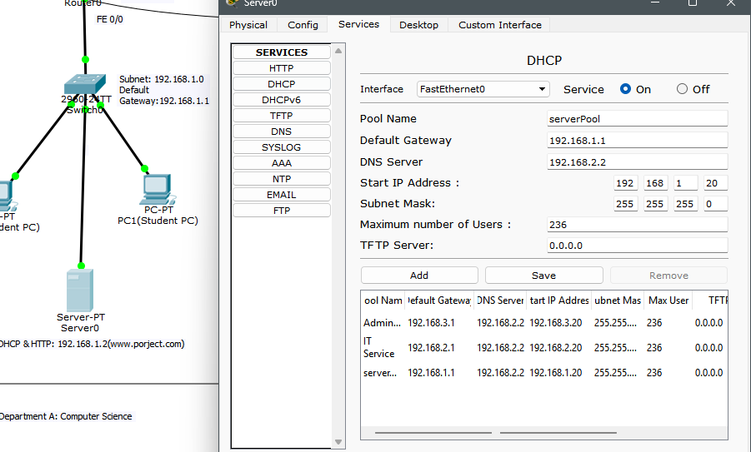

DNS configuration:
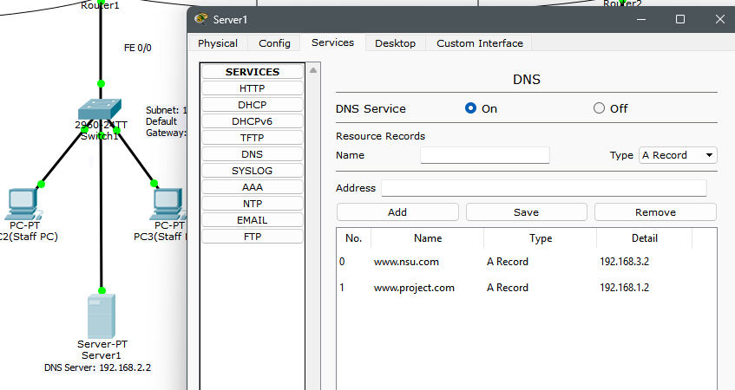

HTTP Configuration:
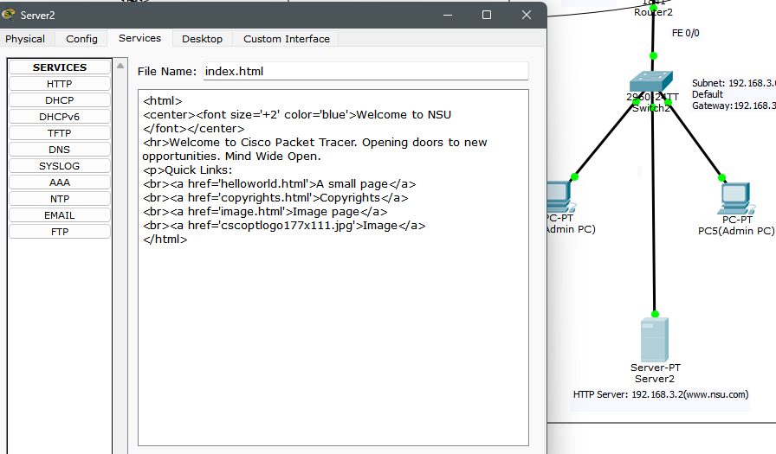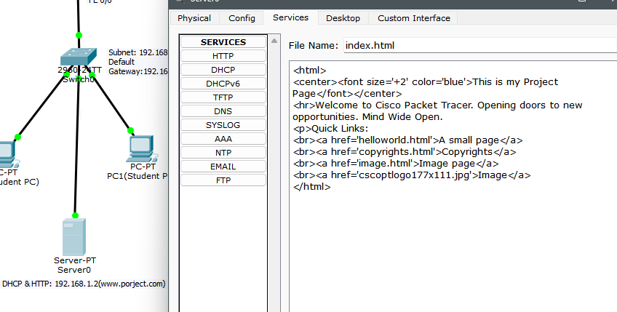

Router Configuration:

Router 0:

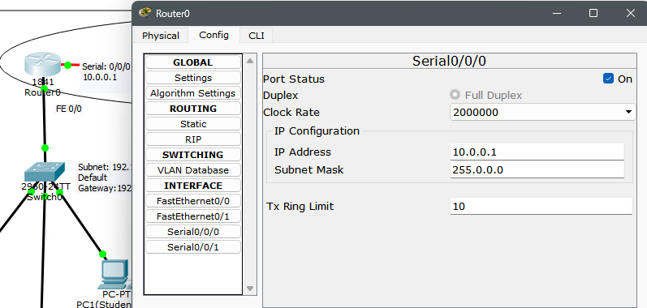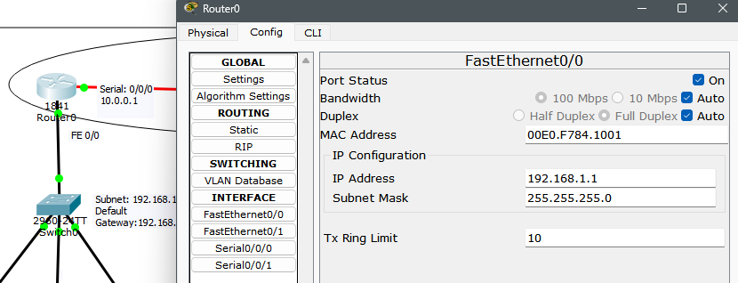

Router 1:
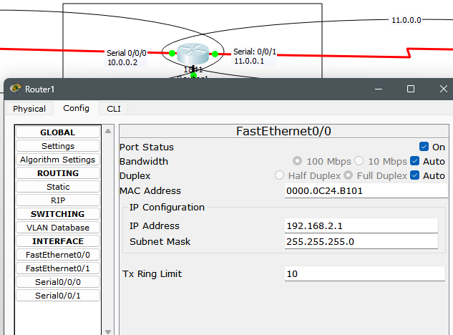

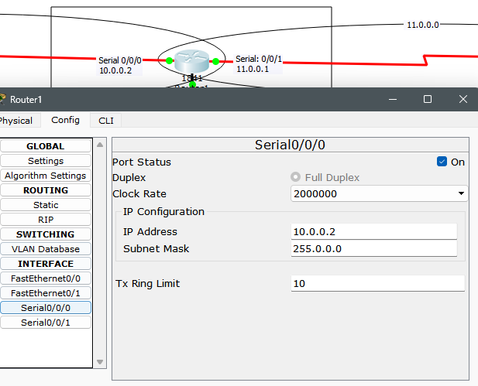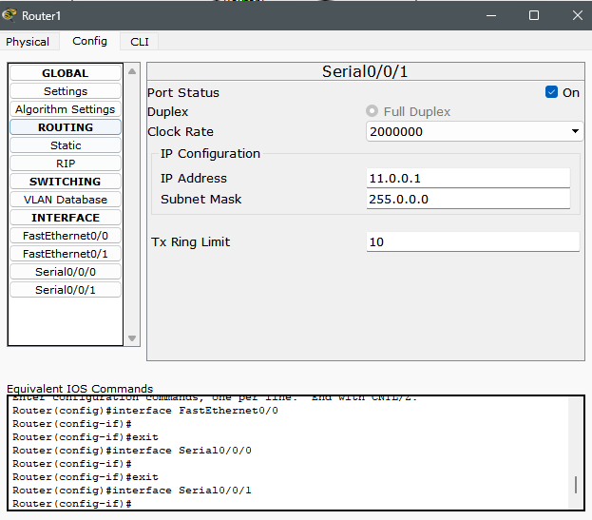

Router 2:
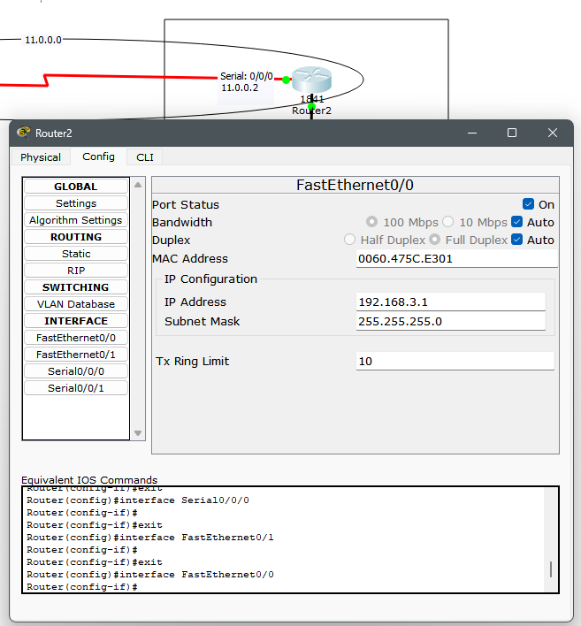

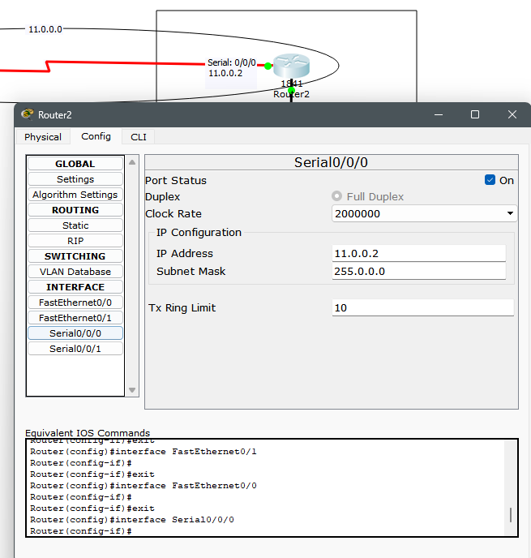

OSPF Configuratoin:
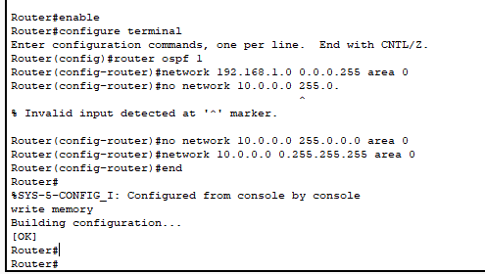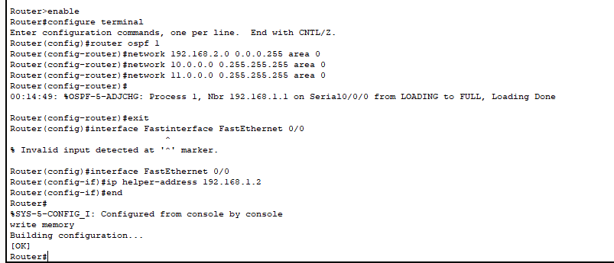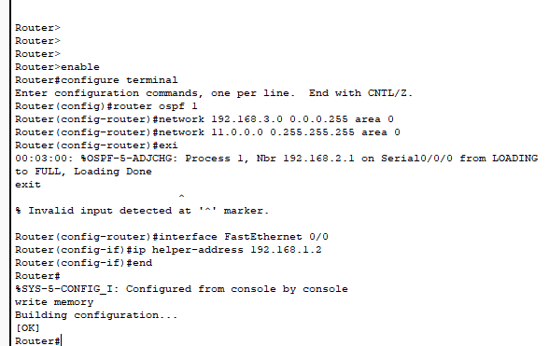

D. Testing Result:
PCs in 3 subnets receiving DHCP IP

Here PC from 3 subnet gets DHCP request Successfully. which means DHCP can dynamically send IP in all pc and pc’s get IP address.

Ping to DNS server:
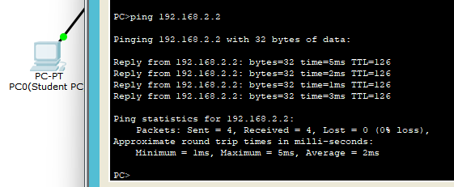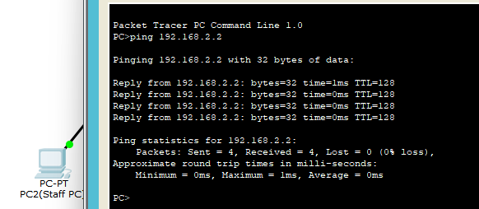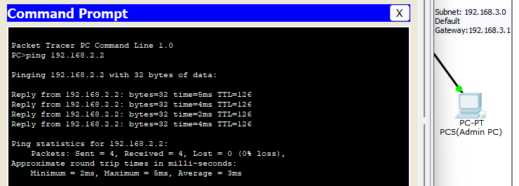

Here, When we try to reach DNS (192.168.2.2) server our pc gets reply. That means Successfully reach DNS server.

Ping to websites

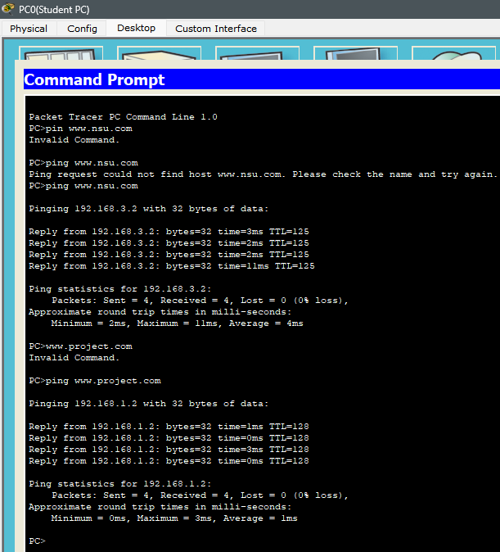

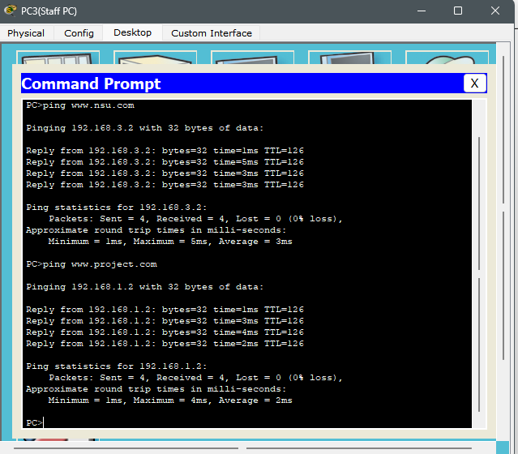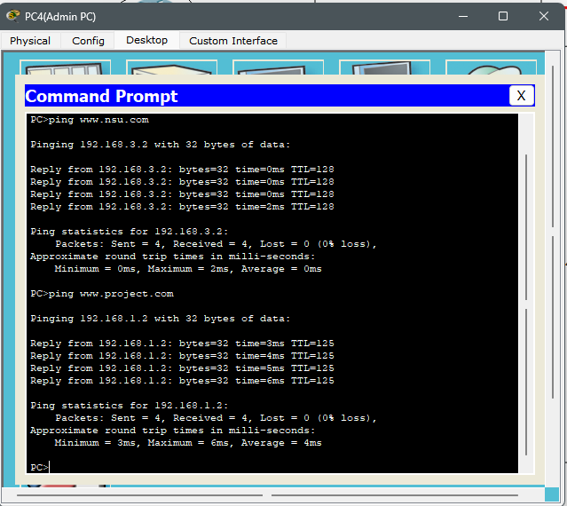

Here when We command ping www.project.com and www.nsu.com packets that is send to browser and then receive those. And last When we send our ping www.project.com that time pc gets reply from this site. indicating that the client was able to reach the website successfully.

Opening in browser www.nsu.com & www.project.com:

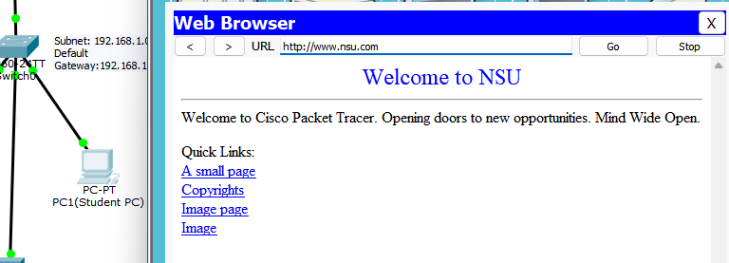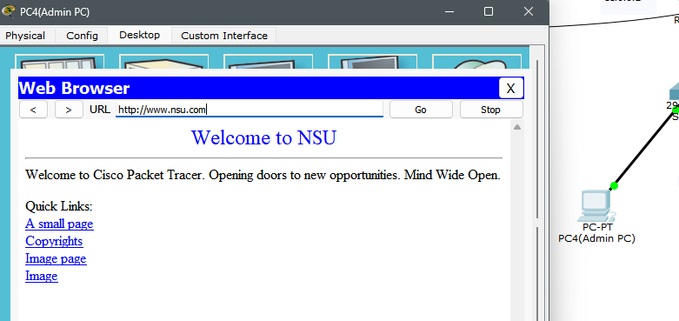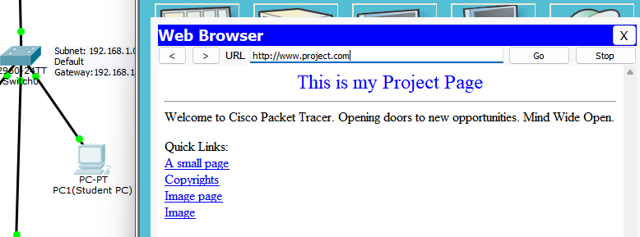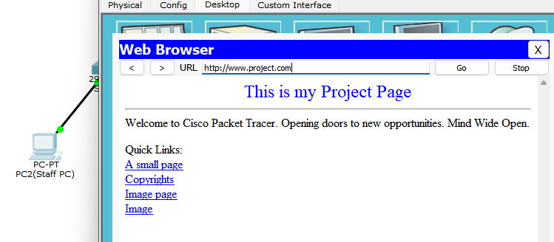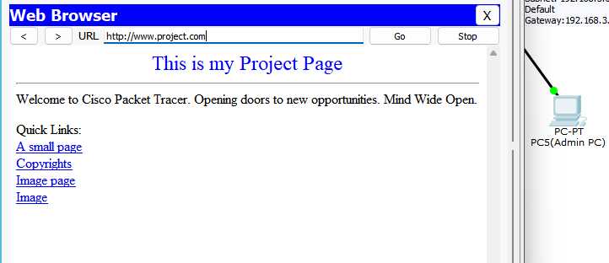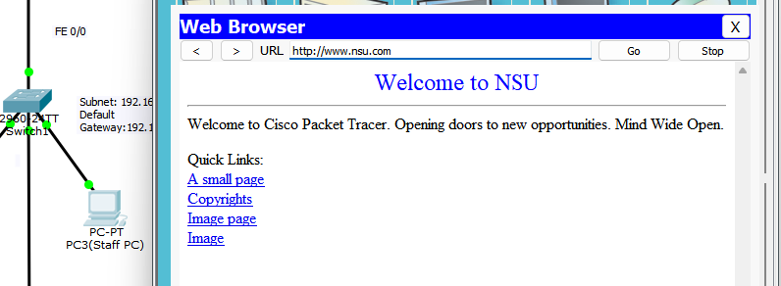

pc from 3 subnet can browse www.nsu.com, www.project.com

E. Conclusion
This project successfully simulated a functional, subnetted academic campus network using Cisco Packet Tracer, demonstrating critical real-world design insights. We established three distinct departmental networks, each with dedicated server infrastructure and proven services (DHCP, DNS, HTTP). The use of OSPF ensured efficient and dynamic routing between subnets, resulting in a stable, interconnected environment where all departmental servers and clients could communicate properly.

Challenges Encountered
I faced 2 challanges that really took a lot of time, one was I couldn’t understand how to assign DHCP for other PCs as well I made simpel DNS server configuration mistakes which took a lot of time to figure that out. But the realization that I need to add subnet pools on the DHCP server, and use router’s CLI (ip helper-address cmd) to turn the DHCP server into a DHCP relay. And the second challange where I lost track of time was obviously OSPF configuration little mistakes took lot of time to figure out and complete the project in the end it was rewarding

Lastly, the project has provided an opportunity for me to utilize the knowledge I’ve gained throughout the course, along with new insights on building and maintaining real life networks.

