# adust-logo.gif

**Project Report**

**On**

**“Online Library Management System**”

|  |  |
| --- | --- |
| **Submitted By:** | **Supervised By:** |
| **1. Abdur Rakib** | **Md. Shafiq Islam**  **Lecturer**  **Department of Computer Science and Engineering**  **Faculty of Science & Technology**  **Atish Dipankar University of Science & Technology.** |

## COMPUTER SCIENCE & ENGINEERING

# ATISH DIPANKAR UNIVERSITY OF SCIENCE & TECHNOLOGY (ADUST)

## 2017

**Letter of Transmittal**

To

The Supervisor

**Md. Shafiq Islam**

**Lecturer**

Faculty of Science & Technology

Atish Dipankar University of Science & Technology

**Subject: Submission of Project Report.**

Dear Sir,

I have the pleasure to submit my report myself I feel myself delighted to get the opportunity to work with myself I have gathered a vast knowledge and practical experience from the project. I have given my full concentration into the work with the hope to prepare a precise report from the arena I have experienced and from your kind direction.

I will always be ready to respond if there is any point in this report that needs further clarification.

Sincerely Yours

Abdur Rakib

ID: 131-0195-401

Program: B.Sc

Dept:Computer Science & Engineering

Faculty of Science & Technology

AtishDipankar University of Science & Technology

**Letter of Acceptance**

Abdur Rakib, ID: 131-0195-401, CSE program, Department of Science & Technology,Atish Dipankar University of Science & Technology has completed internship report under my supervision. He has done this report on myself **.**

I have gone through the report and found it a well written report. I wish him every success in life.

Best regards,

**…………………….**

**Md. Shofiqul Islam**

**Lecturer**

**Faculty of Science & Technology**

**Atish Dipankar University of Science & Technology**

Library Management System

ACKNOWLEDGEMENT

#### We take this occasion to thank God, almighty for blessing us with his grace and taking our endeavor to a successful culmination. We extend our sincere and heartfelt thanks to our esteemed guide, Assistant Professor, for providing us with the right guidance and

#### advice at the crucial junctures and for showing me the right way. We also take this opportunity to

express a deep sense of gratitude to our class coordinators **Md. Shafiq Islam**

#### and

**Md. Shafiq Islam**

#### for their cordial support, valuable suggestions and guidance. We extend our

sincere thanks to our respected Head of the division **Md. Shafiq Islam**

#### for

#### allowing us to use the facilities available. We would like to thank the other faculty members also,

#### at this occasion. Last but not the least, we would like to thank our friends and family for the

#### support and encouragement they have given us during the course of our work.

Online Library Management System

ABSTRACT

#### Library management system is a project which aims in developing a computerized system to

#### maintain all the daily work of library .This project has many features which are generally not

#### availiable in normal library management systems like facility of user login and a facility of

#### teachers login .It also has a facility of admin login through which the admin can monitor the

#### whole system .It also has facility of an online notice board where teachers can student can put

#### up information about workshops or seminars being held in our university or nearby university and

#### librarian after proper verification from the concerned institution organizing the seminar can

#### add it to the notice board . It has also a facility where student after logging in their accounts

#### can see list of books issued and its issue date and return date and also the students can request

#### the librarian to add new books by filling the book request form. The librarian after logging into

#### his account ie admin account can generate various reports such as student report , issue

#### report, teacher report and book report Overall this project of ours is being developed to help

#### the students as well as staff of library to maintain the library in the best

#### way possible and also reduce the

#### human efforts.

Online Library Management System

Table of Contents

### ABSTRACT 2

### 

ACKNOWLEDGEMENT 3

**1. INTRODUNTION 5**

### 1.1. PROJECT AIMS AND OBJECTIVES 6

### 1.2.BACKGROUND OF PROJECT 7

### 2. SYSTEM ANALYSIS 9

### 2.1 SOFTWARE REQUIREMENT SPECIFICATION 12

### 2.2 EXISTING VS PROPOSED SYSTEM 13

### 2.3 SOFTWARE TOOL USED 14

#### 2.4 . DRAWBACKS OF PRESENT SYSTEM 15

### 3. SYSTEM DESIGN 18

### 3.1 Data Tables

### 4. Screen Shots Of Form 20

### 5. CONCLUSION & FUTURE SCOPE 48

### 6. REFERENCES 54

Online Library Management System

CHAPTER 1

INTRODUCTION

This chapter gives an overview about the aim , objectives ,background and operation environment of the system.

1.1 PROJECT AIMS AND OBJECTIVES

The project aims and objectives that will be achieved after completion of this project are discussed in this subchapter. The aims and objectives are as follows:

• Online book issue Request column for librarian for providing new

• A separate column for digital library

• Student login page where student can find books issued by .

• A search column to search availability of books

• A teacher login page where teacher can add any events being

• and important suggestions regarding books. **(1)**

Online Library Management System

1.2 BACKGROUND OF PROJECT

Library Management System is an application which refers to library systems which are generally small or medium in size. It is used by librarian to manage the library using a computerized system where he/she can record various transactions like issue of books, return of books, addition of new books, addition of new students etc.

Books and student maintenance modules are also included in this system which would keep track of the students using the library and also a detailed description about the books a library contains. With this computerized system there will be no loss of book record or member record which generally happens when a non computerized system is used.

In addition, report module is also included in Library Management System. If user’s position is admin, the user is able to generate different kinds of reports like lists of students registered, list of books, issue and return reports.

All these modules are able to help librarian to manage the library with more convenience and in a more efficient way as compared to library systems which are not computerized [1].

Online Library Management System

CHAPTER 2

SYSTEM ANALYSIS

System Analysis is a detailed study of the various operations performed by a system and their relationships within and outside of the system. Here the key question is- what all problems exist in the present system what must be done to solve the problem Analysis begins when a user or manager begins a study of the program using existing system. In our existing system all the transaction of books are done manually, So taking more time for a transaction like borrowing a book or returning a book and also for searching of members and books. Another major disadvantage is that to preparing the list of books borrowed and the available books in the library will take more time, currently it is doing as a one day process for verifying all records. So**.**

2.1 SOFTWARE REQUIREMENT SPECIFICATION

2.1.1 GENERAL DESCRIPTION

PRODUCT DESCRIPTION:

Library Management System is a computerized system which helps user(librarian) to manage the library daily activity in electronic format. It reduces the risk of paper work such as file lost, file damaged and time consuming. It can help user to manage the transaction or record more effectively and timesaving

PROBLEM STATEMENT: The problem occurred before having computerized system includes:

• File lost

When computerized system is not implemented file is always lost because of human environment.Some times due to some human error there (Rloss of records. File damaged When a computerized system is not there file (2)

Online Library Management System

• Difficult to search record

• When there is no computerized system there is always a difficulty in searching of records if the records are large in number . Space consuming

• After the number of records become large the space for physical storage of file and records also increases if no computerized system is implemented. Cost consuming

• As there is no computerized system the to add each record paper will be needed which will increase the cost for the management of library.

2.1.2 SYSTEM OBJECTIVES

• Improvement in control and performanceThe system is developed to cope up with the current issues and problems of library .The system can add user, validate user and is also bug free. Save cos

• After computerized system is implemented less human force will be required to maintain the library thus reducing the overall cost. Save time

• Librarian is able to search record by using few clicks of mouse and few search keywords thus saving his valuable time. Option of online Notice board

• Librarian will be able to provide a detailed description of workshops going in the college as well as in nearby colleges Lecture Notes

• Teacher have a facility to upload lectures notes in a pdf file having size not more than (2)

Online Library Management System

2.1.3 SYSTEM REQUIREMENTS

2.1.3.1 NON FUNCTIONAL REQUIREMENTS

• Product Requirements

EFFICIENCY REQUIREMENT

When a library management system will be implemented librarian and user will easily acess library as searching and book transaction will be very faster .

RELIABILITY REQUIREMENT

The system should accurately performs member registration ,member validation , report generation, book transaction and search

USABILITY REQUIREMENT

The system is designed for a user friendly environment so that student and staff of library can perform the various tasks easily and in an effective way.

ORGANIZATIONAL REQUIREMENT IMPLEMENTATION REQUIREMNTS

In implementing whole system it uses html in front end with php as server side scripting language which will be used for database connectivity and the backend ie the database part is developed using mysql. DELIVERY REQUIREMENTS The whole system is expected to be delivered in six months of time with a weekly evaluation by the project guide. (3)

Online Library Management System

2.1.3.2 FUNCTIONAL REQUIREMENTS

1. NORMAL USER

1.1 USER LOGIN

Description of feature

This feature used by the user to login into system. They are required to enter user id and password before they are allowed to enter the system .The user id and password will be verified and if invalid id is there user is allowed to not enter the system. Functional requirements -user id is provided when they register -The system must only allow user with valid id and password to enter the system -The system performs authorization process which decides what user level can acess to. -The user must be able to logout after they finished using system.

1.2 REGISTER NEW USER

Description of feature This feature can be performed by all users to register new user to create account. Functional requirements -System must be able to verify information -System must be able to delete information if information is wrong

1.3 REGISTER NEW BOOK

Description of feature This feature allows to add new books to the library Functional requirements -System must be able to verify information -System must be able to enter number of copies into table. - System must be able to not allow two books having same book id(3)

Online Library Management System

2.2 EXISTING VS PROPOSED SYSTEM

i. Existing system does not have any facility of teachers login or student login where as proposed system will have a facility of student login as well as teacher’s login

ii. Existing system does not have a facility of online reservation of books whereas proposed system has a facility of online reservation of books

iii. Existing system does not have any facility of online notice board where description of workshops happening in our college as well as nearby colleges is being provided.

iv. Existing system does not has any option of lectures notes uploaded by teachers whereas proposed system will have this facility

v. Existing system does not have any facility to generate student reports as well book issue reports whereas proposed system provides librarian with a tool to generate reports

vi. Existing system does not has any facility for book request and sugeestions where as in proposed system after logging in to their accounts student can request books as well as provide suggestions to improve (4)

Online Library Management System

PROJECT AIMS AND OBJECTIVES

#### The project aims and objectives that will be achieved after completion of this project are

#### discussed in this subchapter. The aims and objectives are as follows:

#### • Online book issue

#### • Request column for librarian for providing new books

#### • A separate column for digital library

#### • Student login page where student can find books issued by him/her and date of return.

#### • A search column to search availability of books

#### • A teacher login page where teacher can add any events being organized in the college

#### and important suggestions regarding books(4)

Online Library Management System

DRAWBACKS OF PRESENT SYSTEM

## •Some of the problems being faced in manual system are as follows:

## 1. Fast report generation is not possible.

## 2. Tracing a book is difficult.

## 3. Information about issue/return of the books are not properly maintained. 4. No central database can be created as information is not available in database.

## PROPOSED SYSTEM

## •There will be three major components :

## 1. Stock maintenance.

## 2. Transaction entry.

## 3. Reports.

## Proposed system provides with following solutions :

## 1. It provides "better and efficient" service to members.

## 2. Reduce the workload of employee.

## 3. Faster retrieval of information about the desired book.

## 4. Provide facility for proper monitoring reduce paper work

## 5. All details will be available on a click(5)

Online Library Management System

OPERATION ENVIRONMENT

The whole Project is divided in two parts the front end and the back end.

**2.3 SOFTWARE TOOLS USED**

**•Front end:**

The front end is designed using of HTML , PHP ,CSS, JAVA SCRIPT LARAVEL Framework Bootstrap

• **HTML- HTML or Hyper Text Markup Language:** is the main markup

language for creating web pages and other information that can be displayed in a web browser.HTML is written in the form of HTML elements consisting of tags enclosed in angle brackets (like ), within the web page content. HTML tags most commonly come in pairs like

# and

, although some tags represent empty elements and so are unpaired, for example Error! Filename not specified.. The first tag in a pair is the start tag, and the second tag is the end tag (they are also called opening tags and closing tags). In between these tags web designers can add text, further tags, comments and other types of text-based content. The purpose of a web browser is to read HTML documents and compose them into visible or audible web pages. The browser does not display the HTML tags, but uses the tags to interpret the content of the page.HTML elements form the building blocks of all websites. HTML allows images and objects to be embedded and can be used to create interactive forms. It provides a means to create structured documents by denoting structural semantics for text such as headings, paragraphs, lists, links, quotes and other items. It can embed scripts written in languages such as JavaScript which affect the behavior of HTML web pages(5)_

Online Library Management System

•**CSS- Cascading Style Sheets (CSS)** is a style sheet language used for describing the look and formatting of a document written in a markup language. While most often used to style web pages and interfaces written in HTML and XHTML, the language can be applied to any kind of XML document, including plain XML, SVG and XUL. CSS is a cornerstone specification of the web and almost all web pages use CSS style sheets to describe their presentation.CSS is designed primarily to enable the separation of document content from document presentation, including elements such as the layout, colors, and fonts. This separation can improve content accessibility, provide more flexibility and control in the specification

of presentation characteristics, enable multiple pages to share formatting, and reduce complexity and repetition in the structural content (such as by allowing for table less web design).CSS can also allow the same markup page to be presented in different styles for different rendering methods, such as on-screen, in print, by voice (when read out by a speech-based browser or screen reader) and on Braille-based, tactile devices. It can also be used to allow the web page to display differently depending on the screen size or device on which it is being viewed. While the author of a document typically links that document to a CSS file, readers can use a different style sheet, perhaps one on their own computer, to override the one the author has specified. However if the author or the reader did not link the document to a specific style sheet the default style of the browser will be applied.CSS specifies a priority scheme to determine which style rules apply if more than one rule matches against a particular element. In this so-called (6)

Online Library Management System

•**JAVA SCRIPT- JavaScript (JS)** is a dynamic computer programming language. It is most commonly used as part of web browsers, whose implementations allow client-side scripts to interact with the user, control the browser, communicate asynchronously, and alter the document content that is displayed. It is also being used in server-side programming, game development and the creation of desktop and mobile applications. JavaScript is a prototype-based scripting language with dynamic typing and has firstclass functions. Its syntax was influenced by C. JavaScript copies many names and naming conventions from Java, but the two languages are otherwise unrelated and have very different semantics. The key design principles within JavaScript are taken from the Self and Scheme programming languages. It is a multiparadigm language, supporting object-oriented, imperative, and functional programming styles. The application of JavaScript to use outside of web pages—for example, in PDF documents, site-specific browsers, and desktop widgets—is also significant. Newer and faster JavaScript VMs and platforms built upon them (notably Node.js) have also increased the popularity of JavaScript for server-side web applications. On the client side, JavaScript was traditionally implemented as

an interpreted language but just-in-time compilation is now performed by recent (post-2012) browsers. PHP- PHP is a server-side scripting language designed for web development but also used as a general-purpose programming language. •**PHP** is now installed on more than 244 million websites and 2.1 million web servers. Originally created by Rasmus Lerdorf in 1995, the reference implementation of PHP is now produced by The PHP Group. While PHP originally stood for Personal Home Page, it now stands for PHP: Hypertext Preprocessor, a recursive backronym.PHP code is interpreted by a web server with a PHP processor module, which generates the resulting web page: PHP commands ca(6)

Online Library Management System

servers and also as a standalone shell on almost every operating system and platform, free of charge.

• **BACK END**- The back end is designed using mysql which is used to design the databases

**MYSQL**- MySQL ("My S-Q-L", officially, but also called "My Sequel") is (as of¬ July 2013) the world's second most widely used open-source relational database management system (RDBMS). It is named after co-founder Michael Widenius daughter, My. The SQL phrase stands for Structured Query Language. The MySQL development project has made its source code available under the terms of the GNU General Public License, as well as under a variety of proprietary agreements. MySQL was owned and sponsored by a

single forprofit firm, the Swedish company MySQL AB, now owned by Oracle Corporation .MySQL is a popular choice of database for use in web applications, and is a central component of the widely used LAMP open source web application software stack (and other 'AMP' stacks). LAMP is an acronym for "Linux, Apache, MySQL, Perl/PHP/Python." Free-software-open source projects that require a full-featured database management system often use MySQL. For commercial use, several paid editions are available, and offer additional functionality. Applications which use MySQL (7)

Online Library Management System

**CHAPTER 3 SYSTEM DESIGN**

Data Tables

**•**Table : Student

|  |  |  |  |  |  |
| --- | --- | --- | --- | --- | --- |
| Sl.no | | Name | Types | NULL | Default |
| 1 | | id | Int(10) | No | None |
| 2 | | name | varchar(100) | No | None |
| 3 | | images | varchar(150) | No | None |
| 4 | | roll | varchar(50) | No | None |
| 5 | | Phone_no | varchar(50) | No | None |
| 6 | | dob | date | No | None |
|  | 7 | admission_date | date | No | None |
|  | 8 | gendar | enum('Female', 'Male') | No | None |
|  | 9 | age | smallint(6) | No | None |
|  | 10 | paren_Incom | |  |  | | --- | --- | | decimal(9,2) |  | | No | None |
|  | 11 | address | |  |  | | --- | --- | |  | tex | | No | None |
|  | 12 | about_student | |  |  | | --- | --- | |  | tex | | No | None |
|  | 13 | create_at | timestamp | Yes | NULL |
|  | 14 | update_at | timestamp | Yes | NULL |
|  | 15 | Delete_at | timestamp | Yes | NULL |

Online Library Management System

**•**Table : Add Books

|  |  |  |  |  |
| --- | --- | --- | --- | --- |
| sl.no. | Name | Types | Null | Default |
| 1 | Id | Int(10) | No | None |
| 2 | name | varchar(255) | No | None |
| 3 | images | varchar(255) | No | None |
| 4 | create_at | timestamp | Yes | NULL |
| 5 | update_at | timestamp | Yes | NULL |
|  |  |  |  | |
|  |  |  |  | |

Online Library Management System

**•**Table: Adition

|  |  |  |  |  |
| --- | --- | --- | --- | --- |
| Sl .no | Name | Types | Null | Default |
| 1 | id | Int(10) | No | None |
| 2 | name | |  |  | | --- | --- | | varchar(255) |  | | No | None |
| 3 | create_at | timestamp | Yes | NULL |
| 4 | update_at | timestamp | Yes | NULL |

•Table:User

|  |  |  |  |  |
| --- | --- | --- | --- | --- |
| sl.no. | Name | Types | Null | Default |
| 1 | id | Int(10) | No | Null |
| 2 | name | Varchar(50) | NO | Null |
| 3 | email | Varchar(255) | No | Null |
| 4 | password | Vacher(255) | No | Null |
| 5 | Remember_token | Varcher(255) | No | Null |
| 6 | Statas_id | Int(10) | NO | Null |

Online Library Management System

**CHAPTER 4**

**SYSTEM IMPLEMENTATION**

**4.1Screenshot:**

•**Screenshot for homepage:**

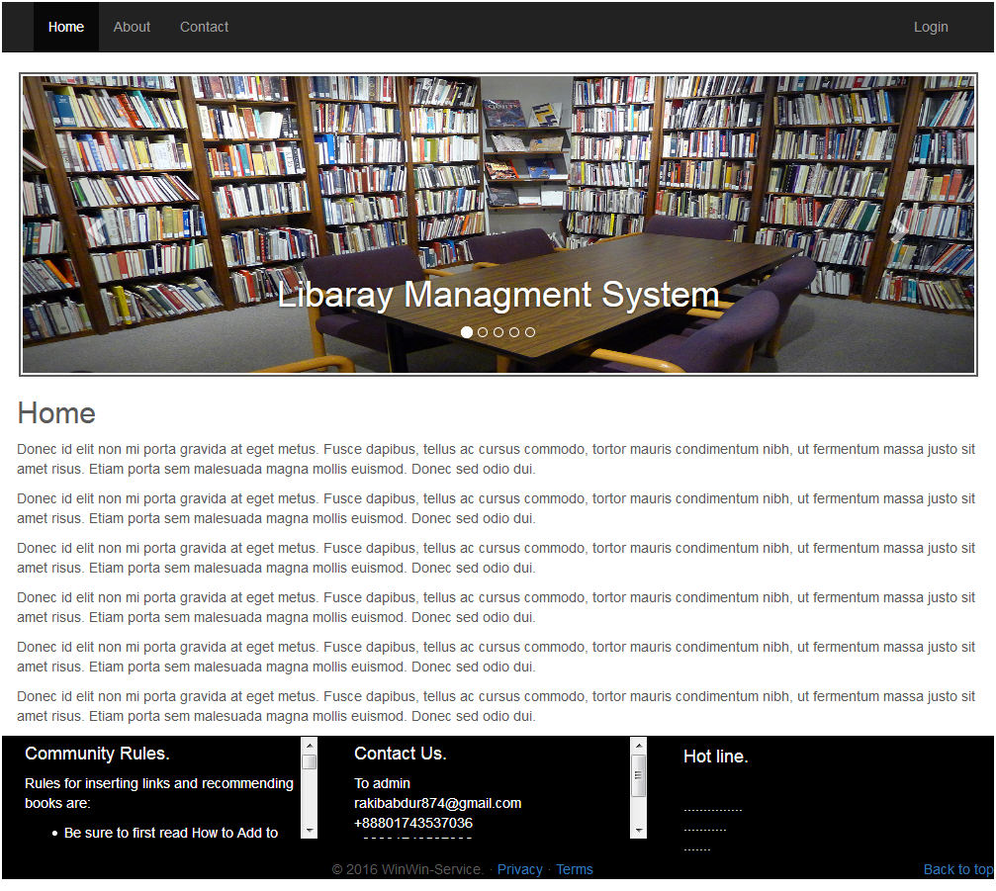

Online Library Management System

**Admin**

**Login**

**REGISTRATION**

**Book Editions**

**Student Book**

**4.1**•**Code for Home Pages:**

<!DOCTYPE html>

<html lang="en">

<head>

<meta charset="utf-8">

<meta http-equiv="X-UA-Compatible" content="IE=edge">

<meta name="viewport" content="width=device-width, initial-scale=1">

<!-- The above 3 meta tags *must* come first in the head; any other head content must come *after* these tags -->

<meta name="description" content="">

<meta name="author" content="">

<link rel="icon" href="../../favicon.ico">

<title>Carousel Template for Bootstrap</title>

<!-- Bootstrap core CSS -->

<link href=" ./css/bootstrap.min.css" rel="stylesheet">

<!-- IE10 viewport hack for Surface/desktop Windows 8 bug -->

<link href=" ./css/workaround.css" rel="stylesheet">

Online Library Management System

@yield('content')

@include('_layouts.partials.content')

@include('_layouts.partials.footer')

<!-- Bootstrap core JavaScript

================================================== -->

<!-- Placed at the end of the document so the pages load faster -->

<script src="https://ajax.googleapis.com/ajax/libs/jquery/1.12.4/jquery.min.js"></script>

<script>window.jQuery || document.write('<script src="../../assets/js/vendor/jquery.min.js"><\/script>')</script>

<script src=" ./js/bootstrap.min.js"></script>

<!-- Just to make our placeholder images work. Don't actually copy the next line! -->

<script src=" ./js/vendor/holder.min.js"></script>

<!-- IE10 viewport hack for Surface/desktop Windows 8 bug -->

<script src=" ./js/workaround.js"></script>

</body>

</html>

Online Library Management System

**4.2**•**Screenshot for Footer:**

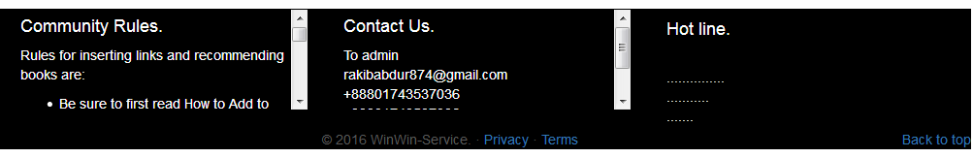

•**Code for Footer Pages:**

<!-- FOOTER -->

<div class="containar" style="background-color: #000;">

<footer>

<div class="row" style="margin-top: 5px; margin-left: 2px; margin-right: 2px;">

<div class="col-sm-6 col-md-4">

<div class="thumbnail" style="height: 105px; overflow: auto; border-width: 1px; border-style: solid; border-color: #000; padding: 0px 5px 0px 5px; background-color: #000;">

<h4 style="margin-top: 7px; color: #fff;">Community Rules.</h4>

<p style="color: #fff;">Rules for inserting links and recommending books are:</p>

<ul style="color: #fff;">

<li>Be sure to first read How to Add to the Library, if you have not yet done so.</li>

<li>New link must be directly to free substantive information</li>

<li>Information must be within purpose of Library. See the "About Library" section referenced in the sidebar.</li>

</ul>

</div>

</div>

Online Library Management System

<div class="col-sm-6 col-md-4">

<div class="thumbnail" style="height: 105px; overflow: auto; border-width: 1px; border-style: solid; border-color: #000; padding: 0px 5px 0px 5px; background-color:#000; ">

<h4 style="margin-top: 7px; color: #fff;">Contact Us.</h4>

<p style="color: #fff;">

To admin

<br>

rakibabdur874@gmail.com

<br>

+88801743537036

<br>

+88801743537036

<br>

...............

<div class="col-sm-6 col-md-4">

<div class="thumbnail" style="height: 105px; border-width: 1px; border-style: solid; border-color: #000; padding: 0px 5px 0px 5px; background-color: #000">

<h4 style="color: #fff;">Hot line.</h4>

<p style="color: #fff;">

<p class="pull-right"><a href="#">Back to top</a></p>

<p style="text-align: center;">&copy; 2016 WinWin-Service. &middot; <a href="#">Privacy</a> &middot; <a href="#">Terms</a></p>

</div><!-- /.container -->

Online Library Management System

**4.3**•**Screenshot for Register Pages:**

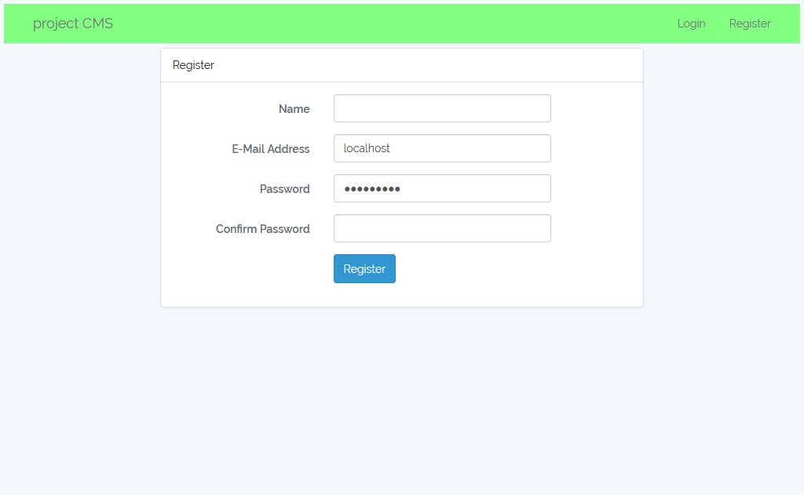

•**Code for Register Pages:**

@extends('layouts.app')

@section('content')

<div class="container">

<div class="row">

<div class="col-md-8 col-md-offset-2">

Online Library Management System

<div class="panel panel-default">

<div class="panel-heading">Register</div>

<div class="panel-body">

<form class="form-horizontal" role="form" method="POST" action="{{ url('/register') }}">

{{ csrf_field() }}

<div class="form-group{{ $errors->has('name') ? ' has-error' : '' }}">

<label for="name" class="col-md-4 control-label">Name</label>

<div class="col-md-6">

<input id="name" type="text" class="form-control" name="name" value="{{ old('name') }}" required autofocus>

@if ($errors->has('name'))

<span class="help-block">

<strong>{{ $errors->first('name') }}</strong>

</span>

@endif

</div>

</div>

<div class="form-group{{ $errors->has('email') ? ' has-error' : '' }}">

<label for="email" class="col-md-4 control-label">E-Mail Address</label>

Online Library Management System

<div class="col-md-6">

<input id="email" type="email" class="form-control" name="email" value="{{ old('email') }}" required>

@if ($errors->has('email'))

<span class="help-block">

<strong>{{ $errors->first('email') }}</strong>

</span>

@endif

</div>

</div>

<div class="form-group{{ $errors->has('password') ? ' has-error' : '' }}">

<label for="password" class="col-md-4 control-label">Password</label>

<div class="col-md-6">

<input id="password" type="password" class="form-control" name="password" required>

@if ($errors->has('password'))

<span class="help-block">

<strong>{{ $errors->first('password') }}</strong>

</span>

@endif

Online Library Management System

<div class="form-group">

<label for="password-confirm" class="col-md-4 control-label">Confirm Password</label>

<div class="col-md-6">

<input id="password-confirm" type="password" class="form-control" name="password_confirmation" required>

</div>

</div>

<div class="form-group">

<div class="col-md-6 col-md-offset-4">

<button type="submit" class="btn btn-primary">

Register

</button>

</div>

</div>

</form>

</div>

</div>

@endsection

Online Library Management System

**4.4**•**Screenshot for Login Pages:**

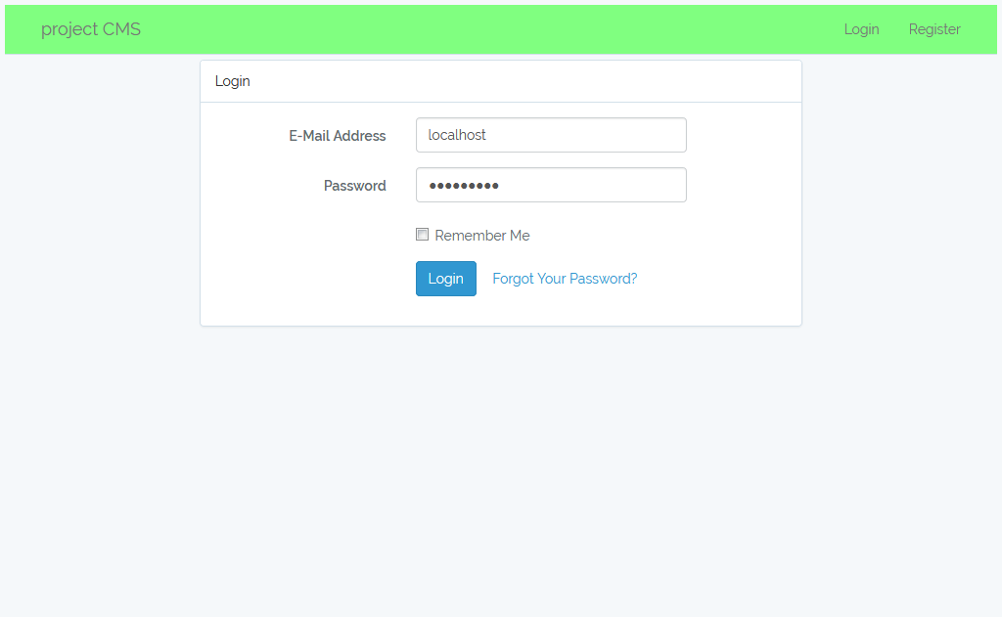

•**Code for Login Pages:**

@extends('layouts.app')

@section('content')

<div class="container">

<div class="row">

<div class="col-md-8 col-md-offset-2">

<div class="panel panel-default">

<div class="panel-heading">Login</div>

<div class="panel-body">

<form class="form-horizontal" role="form" method="POST" action="{{ url('/login') }}">

Online Library Management System

{{ csrf_field() }}

<div class="form-group{{ $errors->has('email') ? ' has-error' : '' }}">

<label for="email" class="col-md-4 control-label">E-Mail Address</label>

<div class="col-md-6">

<input id="email" type="email" class="form-control" name="email" value="{{ old('email') }}" required autofocus>

@if ($errors->has('email'))

<span class="help-block">

<strong>{{ $errors->first('email') }}</strong>

</span>

@endif

</div>

</div>

<div class="form-group{{ $errors->has('password') ? ' has-error' : '' }}">

<label for="password" class="col-md-4 control-label">Password</label>

<div class="col-md-6">

<input id="password" type="password" class="form-control" name="password" required>

Online Library Management System

@if ($errors->has('password'))

<span class="help-block">

<strong>{{ $errors->first('password') }}</strong>

</span>

@endif

<div class="form-group">

<div class="col-md-6 col-md-offset-4">

<div class="checkbox">

<label>

<input type="checkbox" name="remember" {{ old('remember') ? 'checked' : ''}}> Remember Me

<div class="form-group">

<div class="col-md-8 col-md-offset-4">

<button type="submit" class="btn btn-primary">

Login

<a class="btn btn-link" href="{{ url('/password/reset') }}">

Forgot Your Password?

</a>

</div>

@endsection

Online Library Management System

**4.5**•**Screenshot for Student List Pages:**

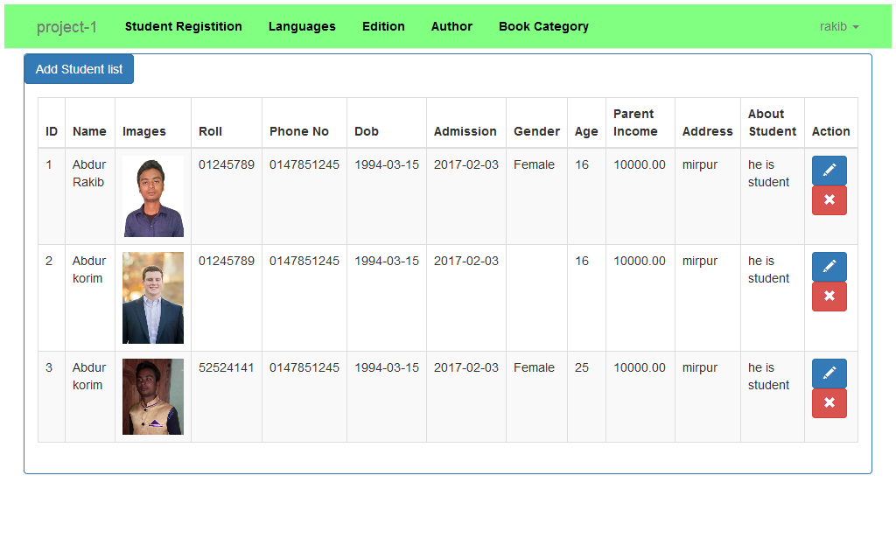

•**Code for Student List Pages:**

@extends('layouts.app')

@section('content')

<div class="container">

<div class="row">

<div class="">

<div class="panel panel-primary">

<a href="{{ route('student.create') }}" class="btn btn-primary">Add Student list</a>

Online Library Management System

<div class="panel-body">

@if (session()->has('message'))

<div class="alert alert-success" role="alert">

{{ session()->get('message') }}

</div>

@endif

{{ $students->links() }}

<table class="table table-striped table-hover table-bordered" id="sample_1">

<thead>

<tr>

<th>ID</th>

<th>Name</th>

<th>Images</th>

<th>Roll</th>

<th>Phone No</th>

<th>Dob</th>

<th>Admission</th>

<th>Gender</th>

<th>Age</th>

<th>Parent Income</th>

<th>Address</th>

Online Library Management System

<th>About Student</th>

<th>Action</th>

</tr>

</thead>

<tbody>

@foreach ($students as $student)

<tr>

<td>{{ $loop->iteration}}</td>

<td>{{ $student->name }}</td>

<td><img src="{{ asset('/uploads/categories/'.$student->image) }}" style="width: 70px;" alt="no images"></td>

<td>{{ $student->roll }}</td>

<td>{{ $student->phone_no }}</td>

<td>{{ $student->dob }}</td>

<td>{{ $student->admission_date }}</td>

<td>{{ $student->gender }}</td>

<td>{{ $student->age }}</td>

<td>{{ $student->parent_income }}</td>

<td>{{ $student->address }}</td>

<td>{{ $student->about_student }}</td>

<td>

<a class="btn btn-primary pull-left" href="{{ route('student.edit', ['student' => $student->id]) }}"><i class="glyphicon glyphicon-pencil"></i></a>

Online Library Management System

<form action="{{ route('student.destroy', ['student' => $student->id]) }}" method="post">

{{ csrf_field() }}

<input type="hidden" name="_method" value="DELETE">

<button type="submit" class="btn btn-danger pull-left" value="Delete"><i class="glyphicon glyphicon-remove"></i></button>

</form>

</td>

</tr>

@endforeach

</tbody>

</table>

</div>

<div class="clearfix"></div>

</div>

</div>

</div>

</div>

@endsection

Online Library Management System

**4.6**•**Screenshot for Books List Pages:**

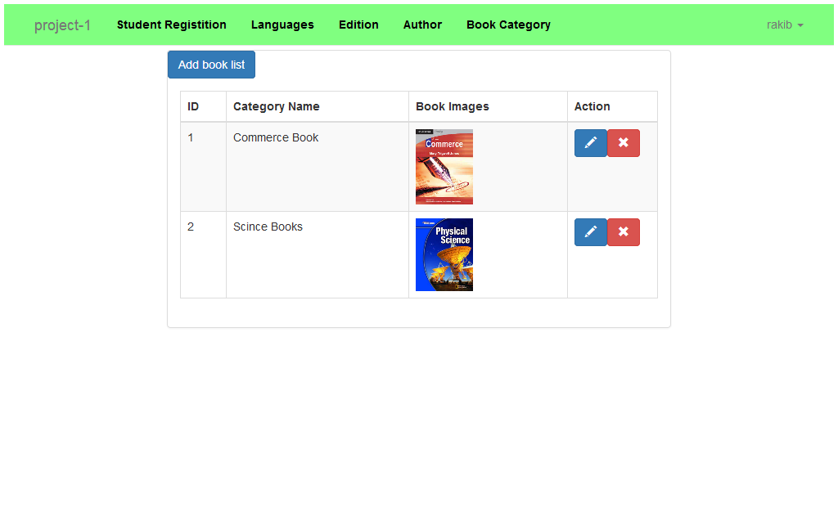

•**Code for Books List Pages:**

@extends('layouts.app')

@section('content')

<div class="container">

<div class="row">

<div class="col-md-8 col-md-offset-2">

<div class="panel panel-default">

<a href="{{ route('bookcategory.create') }}" class="btn btn-primary">Add book list</a>

Online Library Management System

<div class="panel-body">

@if (session()->has('message'))

<div class="alert alert-success" role="alert">

{{ session()->get('message') }}

</div>

@endif

{{ $bookcategories->links() }}

<table class="table table-striped table-hover table-bordered" id="sample_1">

<thead>

<tr>

<th>ID</th>

<th>Category Name</th>

<th>Book Images</th>

<th>Action</th>

</tr>

</thead>

<tbody>

@foreach ($bookcategories as $bookcategory)

<tr>

<td>{{ $loop->iteration}}</td>

<td>{{ $bookcategory->name }}</td>

Online Library Management System

<td><img src="{{ asset('/uploads/categories/'.$bookcategory->image) }}" style="width: 70px;" alt="no images"></td>

<td>

<a class="btn btn-primary pull-left" href="{{ route('bookcategory.edit', ['bookcategory' => $bookcategory->id]) }}"><i class="glyphicon glyphicon-pencil"></i></a>

<form action="{{ route('bookcategory.destroy', ['bookcategory' => $bookcategory->id]) }}" method="post">

{{ csrf_field() }}

<input type="hidden" name="_method" value="DELETE">

<button type="submit" class="btn btn-danger pull-left" value="Delete"><i class="glyphicon glyphicon-remove"></i></button>

</form>

</td>

</div>

</div>

</div>

</div>

@endsection

Online Library Management System

**4.7**•**Screenshot for Languages List Pages:**

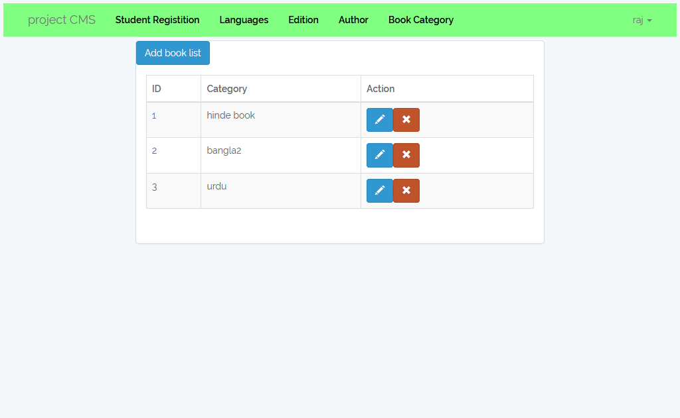

**•Code for Languages List Pages:**

@extends('layouts.app')

@section('content')

<div class="container">

<div class="row">

<div class="col-md-8 col-md-offset-2">

<div class="panel panel-default">

<a href="{{ route('languages') }}" class="btn btn-primary">Add book list</a>

Online Library Management System

<div class="panel-body">

@if (session()->has('message'))

<div class="alert alert-success" role="alert">

{{ session()->get('message') }}

</div>

@endif

{{ $languages->links() }}

<form action="#" method="post">

<fieldset class="form-group">

<table class="table table-striped table-hover table-bordered" id="sample_1">

<thead>

<tr>

<th>ID</th>

<th>Category</th>

<th>Action</th>

</tr>

</thead>

<tbody>

@foreach ($languages as $languages)

<tr>

<td>{{ $loop->iteration}}</td>

<td>{{ $languages->name }}</td>

Online Library Management System

<td>

<a class="btn btn-primary pull-left" href="{{ route('languages.edit', ['id' => $languages->id]) }}"><i class="glyphicon glyphicon-pencil"></i></a>

<form action="{{ route('languages.destroy', ['id' => $languages->id]) }}" method="post">

{{ csrf_field() }}

<input type="hidden" name="_method" value="DELETE">

<button type="submit" class="btn btn-danger pull-left" value="Delete"><i class="glyphicon glyphicon-remove"></i></button>

</form>

</td>

</tr>

@endforeach

</tbody>

</table>

</fieldset>

</form>

</div>

</div>

</div>

Online Library Management System

**4.8**•**Screenshot for Edition List Pages:**

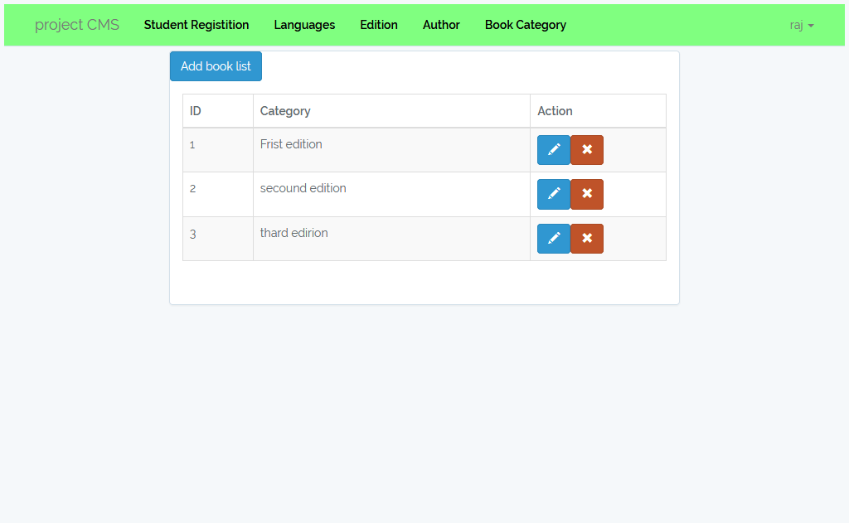

**•Code for Edition List Pages:**

@extends('layouts.app')

@section('content')

<div class="container">

<div class="row">

<div class="col-md-8 col-md-offset-2">

Online Library Management System

<div class="panel panel-default">

<a href="{{ route('edition') }}" class="btn btn-primary">Add book list</a>

<div class="panel-body">

@if (session()->has('message'))

<div class="alert alert-success" role="alert">

{{ session()->get('message') }}

</div>

@endif

{{ $editions->links() }}

<form action="#" method="post">

<fieldset class="form-group">

<table class="table table-striped table-hover table-bordered" id="sample_1">

<thead>

<tr>

<th>ID</th>

<th>Category</th>

<th>Action</th>

</tr>

</thead>

<tbody>

@foreach ($editions as $edition)

Online Library Management System

<td>{{ $loop->iteration}}</td>

<td>{{ $edition->name }}</td>

<td>

<a class="btn btn-primary pull-left" href="{{ route('edition.edit', ['id' => $edition->id]) }}"><i class="glyphicon glyphicon-pencil"></i></a>

<form action="{{ route('edition.destroy', ['id' => $edition->id]) }}" method="post">

{{ csrf_field() }}

<input type="hidden" name="_method" value="DELETE">

<button type="submit" class="btn btn-danger pull-left" value="Delete"><i class="glyphicon glyphicon-remove"></i></button>

</form>

</td>

</tr>

@endforeach

</tbody>

</table>

</fieldset>

</form>

</div>

Online Library Management System

**4.9**•**Screenshot for Author List Pages:**

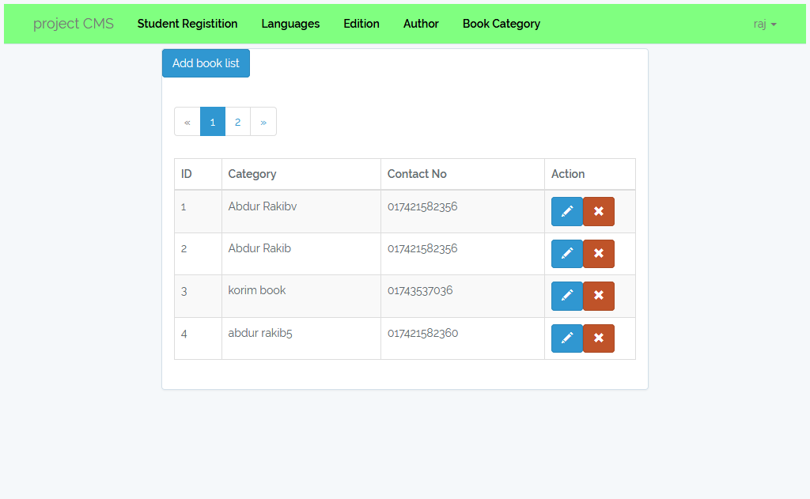

**•Code for Author List Pages:**

@extends('layouts.app')

@section('content')

<div class="container">

<div class="row">

<div class="col-md-8 col-md-offset-2">

<div class="panel panel-default">

<a href="{{ route('author-category') }}" class="btn btn-primary">Add book list</a>

Online Library Management System

<div class="panel-body">

@if (session()->has('message'))

<div class="alert alert-success" role="alert">

{{ session()->get('message') }}

</div>

@endif

{{ $authorcategories->links() }}

<table class="table table-striped table-hover table-bordered" id="sample_1">

<thead>

<tr>

<th>ID</th>

<th>Category</th>

<th>Contact No</th>

<th>Action</th>

</tr>

</thead>

<tbody>

@foreach ($authorcategories as $authorcategory)

<tr>

<td>{{ $loop->iteration}}</td>

<td>{{ $authorcategory->name }}</td>

Online Library Management System

<td>{{ $authorcategory->contact_no }}</td>

<td>

<a class="btn btn-primary pull-left" href="{{ route('author-category.edit', ['id' => $authorcategory->id]) }}"><i class="glyphicon glyphicon-pencil"></i></a>

<form action="{{ route('author-category.destroy', ['id' => $authorcategory->id]) }}" method="post">

{{ csrf_field() }}

<input type="hidden" name="_method" value="DELETE">

<button type="submit" class="btn btn-danger pull-left" value="Delete"><i class="glyphicon glyphicon-remove"></i></button>

</form>

</td>

</tr>

@endforeach

</tbody>

</div>

Online Library Management System

**CHAPTER - 5**

**CONCLUSION & FUTURE SCOPE**

**6.1•Future Scope FUTURE SCOPE OF APPLICATION :**

This application can be easily implemented under various situations. We can add new features as and when we require. Reusability is possible as and when require in this application. There is flexibility in all the modules.

**•** **SOFTWARE SCOPE:**

**• Extensibility:** This software is extendable in ways that its original developers may not expect. The following principles enhances extensibility like hide data structure, avoid traversing multiple links or methods, avoid case statements on object type and distinguish public and private operations.

• **Reusability:** Reusability is possible as and when require in this application. We can update it next version. Reusable software reduces design, coding and testing cost by amortizing effort over several designs. Reducing the amount of code also simplifies understanding, which increases the likelihood that the code is correct. We follow up both types of reusability: Sharing of newly written code within a project and reuse of previously written code on new (8)

Online Library Management System

**• Understandability:**

A method is understandable if someone other than the creator of the method can understand the code (as well as the creator after a time lapse). We use the method, which small and coherent helps to accomplish this.

**• Cost-effectiveness:** Its cost is under the budget and make within given time period. It is desirable to aim for a system with a minimum cost subject to the condition that it must satisfy the entire requirement.

Scope of this document is to put down the requirements, clearly identifying the information needed by the user, the source of the information and outputs expected from the system(8)

Online Library Management System

**completion**

From a proper analysis of positive points and constraints on the component, it can be safely concluded that the product is a highly efficient GUI based component. This application is working properly and meeting to all user requirements. This component can be easily plugged in many other systems.

**CHAPTER – 6**

**REFERENCES**

**1.** https://www.google.com/search?q=456456%2F20library+management+

system&ie=utf-8&oe=utf-8&client=firefox-b-ab

**2**. https://docs.google.com/file/d/0Bz0hEyoBIA1kR3ZfeFFFV1dFcjA/edit

**3.**https://www.google.com/search?q=project-online+library+management+system&ie=utf-8&oe=utf-8&client=firefox-b-ab

**4.**https://www.slideshare.net/smitpatel10192/library-management-system-presentation

**5.** http://www.startertutorials.com/uml/resources/lms/LMS6.pdf

**6.**https://www.slideshare.net/jimmykhan/library-mangement-system-project-srs-documentationdoc

**8**. https://www.smartsheet.com/s/manage-projects-online

**9.** https://www.slideshare.net/VarshaSarkar/online-library-management

**10.** http://web.iiit.ac.in/~sireesh/pr_5/library.html

**11.** http://myhsi.dlshsi.edu.ph/lms/

**12**. https://en.wikipedia.org/wiki/Integrated_library_system

**13.** https://www.scribd.com/doc/51646835/online-library-management-system-S

**14**.https://sourceforge.net/directory/os:windows/?q=online+library+managemen**15.** https://www.bitrix24.com/features/tasks.php?gclid=Cj0KEQjwldzHBRCfg_aImKrf7N4BEiQABJTPKH8RqwIJqQzqxBiWhNesn9eh7kNnSTgu_yFCssaXCUoaAhet8P8HAQ