**TASK & PROJECT MANAGEMENT**

**SYSTEMS FOR TELECOMMUTING**

**IN A MOBILE ENVIRONMENT**

**introduction**

Millions of people now have the option of working from home, either full- or part-time. Managing tasks while employees are working from home is difficult in a big organization with thousands of employees. As an added challenge, selecting the ideal worker for a situation requiring many skillsets might be difficult if there is no way to know for sure who will be available. When work is split into teams of workers who are selected as parts of the work to be done in the division process, this task and project management system application is designed for usage. It is possible to streamline the process of generating, allocating, and completing tasks with the help of task and project management software. Each of these tools has been made available to help project managers maximize the productivity of their teams. They also help teams work together more effectively and increase output speed. As a result, it was developed as an Android app rather than a Windows software. What are the benefits of using a task and project management system?

**Put all of the tasks on one platform:** Project managers may be able to merge their operations onto a single platform by using the appropriate task management tool included inside this task and project management system. This allows for rapid assignment of tasks and quick solution of any problems that arise.

**Make tasks important-based priorities:** It's important to complete every task. But do they each hold the same weight? No. It is possible for project managers and teams to utilize a task management tool to set priorities and complete the most urgent activities first before moving on to the less important ones.

**Increased teamwork:** Components of project management software such as in-task comments and report issues enhance communication amongst team members working towards a shared goal.

**Assist remotely to the teams:** All team members have access to a current project management document that outlines each individual's tasks. This saves them the hassle of asking their supervisors or other team members, or doing their own search, to determine what they're meant to be doing. This is particularly important for hybrid or remote teams, whose members may be in various time zones and have variable work schedules.

The fundamental purpose of this project is to create a centralized, organized, and communicative information system to manage the activities and projects of these distant personnel. It enables rapid and simple access to real-time data regardless of location. There is a need for apps that can assist these remote workers, such as alert systems that allow users to receive notifications and communicate through in-app chat. The primary goal of the system's development will be to create a task and project management system tailored exclusively for remote workers. A mobile system is excellent as we are working with teleworkers.

## **Scope of the Project**

This project intends to provide a task and project management system tailored for telecommuting and at-home professionals. It is essential to understand task and project management in order to manage the time, effort, resources, and output of teleworkers more effectively.

**Requirements**

The project manager and team will utilize the task and project management application. Two people will simultaneously access the system. These individuals constitute the staff and high management. As determined by the project manager, only information from accounts belonging to other Users is permitted to be gathered. This program may be used for routine, monotonous chores. The five components comprise the whole of the system. Some of their names are Input Module, Registration Module, Message Module, Notification Module, Task Module, and Complaint Module. The Task and Project Management System will allow us to perform project-related duties more quickly. In this application, the task and project management system is planned and deployed. The software offers both a data-programming framework and a task-assignment mechanism. Firebase is necessary for both the front-end and the back-end when designing an Android application using Android Studio.

### Features

* Task Scheduling

A competent task management system will enable you to build and adjust schedules according to their preferences fast and effectively. Monthly, weekly, or daily scheduling of tasks makes them simpler to complete and less likely to be forgotten.

* Notifications

Using the alerts and reminders given by your task and project management system, you may more efficiently organize your workday. Not only do these alerts keep you informed, but they also discourage you from devoting too much time to any one work.

* Priority

Many tasks on the listing, it is difficult to sort out the task on priority. An efficient and effective task and project management tool can assist by allowing the option for prioritizing tasks. Tasks are typically prioritized primarily based at the urgency stage of the project itself or the dependency of other tasks. our task and project management tool have to be able to offer a mechanism to specify such priorities along with the tasks. This allows for finishing the most important work first.

* Collaboration

Our task and project management application is effective and efficient collaboration in a task management platform. The employee and manager would be able to exchange statistics, proportion tasks, and receive project updates. Be it report attachments or elaborating on assigned duties, the group would be capable to communicate on time and with ease.

**Context diagram**

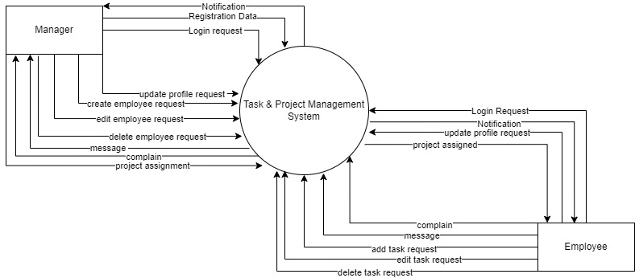

**DFD diagram**

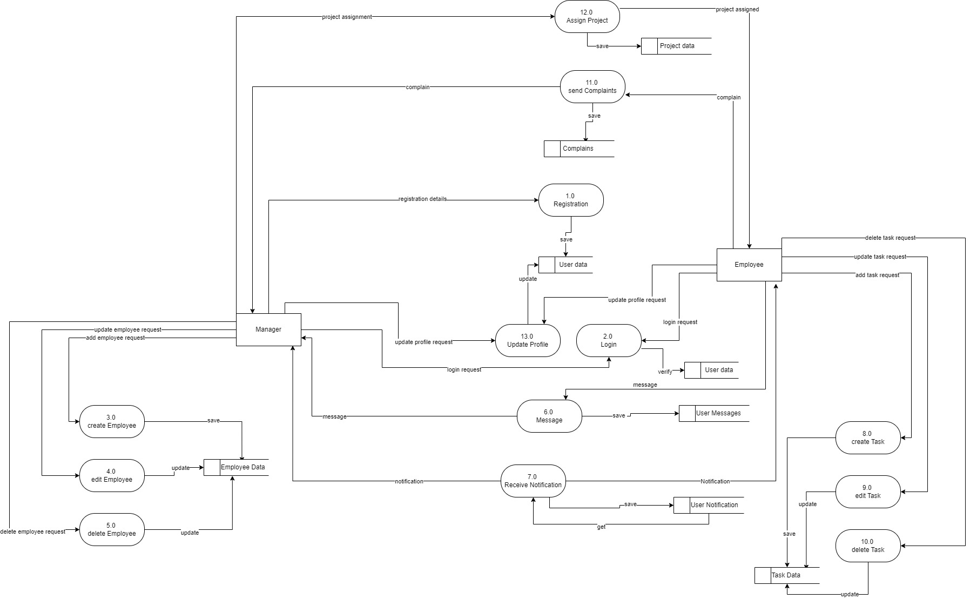

Use case diagram

1. **Manager**: Manager will manage the whole project and also can manage the employee record. Like create project, assign task, manage employee, assign developer, etc.
2. **Employee:** employee will do his related task like, make to-do-list, view message, notification, update profile etc.
3. **\*\* progress bar for the task.**

