Project overview:

Many TV channels have a sliding bar at the bottom of the screen that accepts SMS and MMS that will be displayed on the screen.

Similarly, our project is going to handle the same scenario for Websites were each website is going to have its own BottomToolBar (BTB) and will be customized to have show that it is really related for each website… below is the detailed description of this customization..

Detailed description of the BottomToolBar (BTB):

- BTB should always be at the bottom of web browser.
- BTB should always be on top of everything of the website.
- BTB will read text from a server and will display it on the BTB as sliding from right to left or left to right (we will customize each BTB from the control panel)
- Every BTB will separate the text by a defined image that we will provide (basically website logo)
- BTB should accept smilies similary to MSN smilies.
- In case we received an MMS with picture, the picture should appear similar as the text or similar as when some one login to MSN new small box will appear and disappear after few seconds.
- The Site user is allowed to move the tag to put it wherever he want maybe at the beginning of the screen..or middle..
- We need to Track the number of people who are seeing each tag
- Allow users to close the tag and we need to track how many users closed it.
- We need to show a message that will say (Would you like to see BTB- or Chat bar-? The options are Yes, No, No only once) if the user clicks yes then –cookies can be used- the tag will appear, if No, the tag will not appear, No only once the tag will disappear but will appear next time he opens the site again..the user also should be able to change his option.. ( a solution can be to make active by default and when the user click the x button to close the BTB this window will appear, but how it will be active if it was no and want to make it yes, then this is open problem..)
- Images and text could be clickable and open the site in a new window.

In the control Panel:
- We will define each tag for each website (dynamic creation of tags)
- We will define the image separator for text.
- We will define how many times the text will appear in the BTB (lets say 3 times only)
- We will define the iteration direction (rtl or ltr)
- We will define the background color for each script
- The source from where it will read the text and images.
- The location of the image (right, left, moving)
- How many seconds the image will appear
- We might make this as a separate site and let people login and generate their code..
- Admin needs to approve the messages based on priviliges..

Examples:

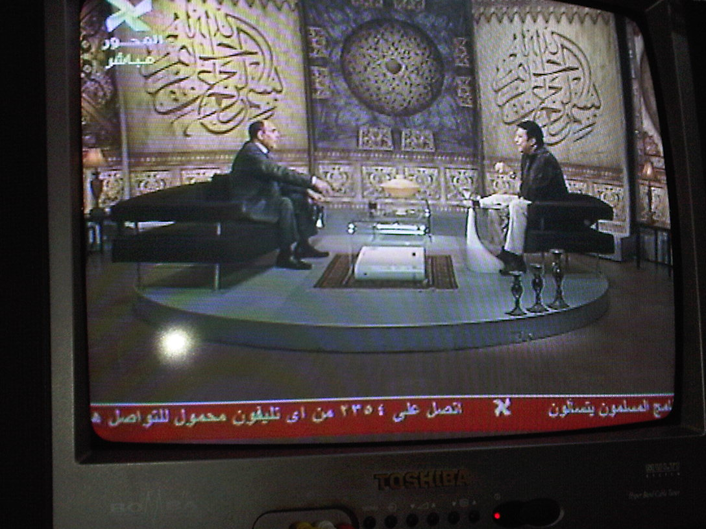

Gmail Chat on web browser (the chat is always ontop of everything on the pages)

