- Abstract
- Introduction
  - Organization Profile
- System Analysis
  - Existing system
  - Problem Definition
  - Proposed System
  - Requirement Analysis
  - Requirement Specifications
  - Feasibility study
4. System Design
  - Project Modules
  - Data Dictionary
  - Data Flow Diagrams
  - E-R Diagrams
  - Hardware And Software Requirements
- System Testing
- Software Tools Used
7 Technical Notes
  - Introduction to .Net
  - Introduction to SQL Server
8. Conclusion
- Bibliography

ABSTRACT
E-care is customer care management system. E-care is called as E-desk or Help Desk System. It is so called as Help Desk System because it tries to solve all the HD (helpdesk) problems, which are coming from the users of E-care. E-care will take care of every request coming from their users and try to solve and produce the solution of the particular request. E-care also will store the responses for the future use.

E-care contains six main members who play very important role in this Help Desk System. They include super user, level1 administrator, level2 administrator, level3 administrator, corporate client user and corporate user (or end-user).

Super user is the chief head of the organization that assigns first level, second level, and third level administrators. The super user is responsible for all the three level administrators including the corporate clients. The Super user is the sole person who is responsible for creating categories, modules and the support team.

Super user creates new categories only if HD problems don’t belong to those categories present in E-care and similarly with the creation of modules. When the super user creates new categories and modules he will label these categories and modules as levels and appoint one administrator for each of them. When the super user gets the HD problem as request he can modify the request or can answer it by sending solution to the level3 or the support team who is responsible for messaging the response or the solution to the end-user (corporate user).
Corporate client is the one who buys E-care product for his business purpose. He can create corporate users for his product. Corporate user is the one who has to register himself to the corporate client before he submits the HD problems to the super user and corporate user is the actual end-user of the product or service.

Corporate user will register to the corporate client and corporate client sends all the registration details to the super user, and after the registration the end-user will submit the HD problems to the super user. When the super user gets the HD problems he will check the details of the end-user and send the responses to the support team who will message the responses to the corporate users.

E-care is very useful for the corporate clients who want their business to extend world wide i.e., by keeping contact and good relation with the corporate users who buy their products. The corporate clients who buy E-care for their business can know what are the various problems of their product which are coming from their users so that they improve their products to the user needs. Any user who knows a little about of the computer can handle e-care.

GALAXIE SOFTWARE SOLUTIONS

Galaxy Software Solutions is an IT solution provider for a dynamic environment where business and technology strategies converge. Their approach focuses on new ways of business combining IT innovation and adoption while also leveraging an organization’s current IT assets. Their work with large global corporations and new products or services and to implement prudent business and technology strategies in today’s environment.

Galaxy’s range of expertise includes :

- Software Development Services
- Engineering Services
- Systems Integration
- Customer Relationship Management
- Product Development
- Electronic Commerce
- Consulting
- IT Outsourcing
We apply technology with innovation and responsibility to achieve two broad objectives:

- Effectively address the business issues our customers face today.
- Generate new opportunities that will help them stay ahead in the future.

This approach rests on :
- A strategy where we architect, integrate and manage technology services and solutions - we call it AIM for success.
- A robust offshore development methodology and reduced demand on customer resources.
- A focus on the use of reusable frameworks to provide cost and times benefits.

They combine the best people, processes and technology to achieve excellent results - consistency. We offer customers the advantages of:

Speed:
They understand the importance of timing, of getting there before the competition. A rich portfolio of reusable, modular frameworks helps jump-start projects. Tried and tested methodology ensures that we follow a predictable, low - risk path to achieve results. Our track record is testimony to complex projects delivered within and evens before schedule.

Expertise:
Our teams combine cutting edge technology skills with rich domain expertise. What’s equally important - they share a strong customer orientation that means they actually start by listening to the customer. They’re focused on coming up with solutions that serve customer requirements today and anticipate future needs.

A full service portfolio:
They offer customers the advantage of being able to Architect, integrate and manage technology services. This means that they can rely on one, fully accountable source instead of trying to integrate disparate multi vendor solutions.
Services:
GSS is providing it’s services to Sain Medicaments Pvt. Ltd. Grace Drug’s and Pharmaceuticals Pvt. Ltd, Alka Drugs and Pharmaceuticals Pvt. Ltd, Hi-tech Steels, Real Foods, Ravi Foods, to name a few. With their rich expertise and experience and information technology they are in best position to provide software solutions to distinct business requirements.
SYSTEM ANALYSIS

System Analysis is first stage according to System Development Life Cycle model. This System Analysis is a process that starts with the analyst.

Analysis is a detailed study of the various operations performed by a system and their relationships within and outside the system. One aspect of analysis is defining the boundaries of the system and determining whether or not a candidate should consider other related systems. During analysis, data is collected from the available files, decision points, and transactions handled by the present system.

Logical system models and tools are used in analysis. Training, experience, and common sense are required for collection of the information needed to do the analysis.

Existing System

This project mainly deals with automating the task of the E- care system that helps many end-users to know the solutions for their request within no time. E-care can be done manually but there may be problems that have to be faced so to overcome such problems we need to automate the Help Desk System.
If the system is maintaining the list of all the details of corporate users and corporate clients manually it will take a lot of time to retrieve even single information such as retrieving or deleting single information becomes very difficult task.

The updations for the list such as creating a new end-user details or creating new corporate client details and including the details of the categories and the modules that are created newly by the super user becomes very difficult manually. Once all information is provided manually it become quit difficult for updating the records with new information manually, so we automate the system to overcome all such difficulties.

E-care, which is developed manually, is the existing system. This system generates and delivers the services to the end-users, which depends on the response provided by the support team who actually message the responses to the corporate users for their requests.
By manually the Help Desk System will face difficulties while updations and it is time consuming and leads more errors. E-care automates the tedious job of maintaining the corporate user details or corporate client details and manages the updations and see that the responses are sent to the corporate user as soon as possible. It includes main members like:
- Super user
- Corporate client
- Corporate user
- Level1 administrator
- Level2 administrator
- Level3 administrator or support team.

Super user will manage the entire organization that includes corporate clients, corporate users, and level administrators and also he can create the new categories and also modules.

3.2 Problem Statement
This project mainly deals with automating the task of the E-care system that helps many end-users to know the solutions for their request within no time. E-care can be done manually but there may be problems that have to be faced so to overcome such problems We need to automate the Help Desk System.

If the system is maintaining the list of all the details of corporate users and corporate clients manually it will take a lot of time to retrieve even single information such as retrieving or deleting single information becomes very difficult task.

The updations for the list such as creating a new creating new end-user details or creating new corporate client details and including the details of the categories and the modules that are created newly by the super user becomes very difficult manually. Once all information is provided manually it become quit difficult for updating the records with new information manually, so we automate the system to overcome all such difficulties.
E-care, which is developed manually, is the existing system. This system generates and delivers the services to the end-users, which depends on the response provided by the support team who actually message the responses to the corporate users for their requests.
By manually the Help Desk System will face difficulties while updations and it is time consuming and leads more errors. E-care automates the tedious job of maintaining the corporate user details or corporate client details and manages the updations and see that the responses are sent to the corporate user as soon as possible. It includes main members like:

Super user
Corporate client
Corporate user
Level1 administrator
Level2 administrator
Level3 administrator or support team.

Super user will manage the entire organization that includes corporate clients, corporate users, and level administrators and also he can create the new categories and also the modules.
Proposed System
Proposed system are those that are automated, so that it is easy to retrieve the responses from the system fastly and updating the details once the response or services are provided to the end-users upon their request without any difficulty and saves time.

REQURIEMENTS ANALYSIS

The requirement phase basically consists of three activities:

1.Requirement Analysis
2.Requirement Specification
3.Requirement Validation

Requirement Analysis:

Requirement Analysis is a software engineering task that bridges the gap between system level software allocation and software design. It provides the system engineer to specify software function and performance, indicate software’s interface with the other system elements and establish constraints that software must meet.

The basic aim of this stage is to obtain a clear picture of the needs and requirements of the end-user and also the organization. Analysis involves interaction between the clients and the analysis. Usually analysts research a problem from any questions asked and reading existing documents. The analysts have to uncover the real needs of the user even if they don’t know them clearly. During analysis it is essential that a complete and consistent set of specifications emerge for the system. Here it is essential to resolve the contradictions that could emerge from information got from various parties.

This is essential to ensure that the final specifications are consistent.
It may be divided into 5 areas of effort.
1. Problem recognition
2.Evaluation and synthesis
3.Modeling
4.Specification

Review

Each Requirement analysis method has a unique point of view. However all analysis methods are related by a set of operational principles. They are:
1.The information domain of the problem must be represented and understood.
2.The functions that the software is to perform must be defined.
3.The behavior of the software as a consequence of external events must be defined.
4.The models that depict information, function and behavior must be partitioned in a hierarchical or layered fashion.
5.The analysis process must move from essential information to implementation detail.

REQUIREMENT SPECIFICATION
Specification Principles:
Software Requirements Specification plays an important role in creating quality software solutions. Specification is basically a representation process. Requirements are represented in a manner that ultimately leads to successful software implementation.
Requirements may be specified in a variety of ways. However there are some guidelines worth following: -
- Representation format and content should be relevant to the problem
- Information contained within the specification should be nested
- Diagrams and other notational forms should be restricted in number and consistent in use.
- Representations should be revisable.

Software Requirements Specifications:

The software requirements specification is produced at the culmination of the analysis task. The function and performance allocated to the software as a part of system engineering are refined by establishing a complete information description, a detailed functional and behavioral description, and indication of performance requirements and design constraints, appropriate validation criteria and other data pertinent to requirements.
An outline of the Software Requirements Specification:
A simplified outline can be given for the framework of the specifications. This is according to the IEEE Standards.

FEASIBILITY STUDY

All projects are feasible, given unlimited resources and infinite time. But the development of software is plagued by the scarcity of resources and difficult delivery rates. It is both necessary and prudent to evaluate the feasibility of a project at the earliest possible time.
Three key considerations are involved in the feasibility analysis.

Economic Feasibility:

This procedure is to determine the benefits and savings that are expected from a candidate system and compare them with costs. If benefits outweigh costs, then the decision is made to design and implement the system. Otherwise, further justification or alterations in proposed system will have to be made if it is to have a chance of being approved. This is an ongoing effort that improves in accuracy at each phase of the system life cycle.

Technical Feasibility:

Technical feasibility centers on the existing computer system (hardware, software, etc.,) and to what extent it can support the proposed addition. If the budget is a serious constraint, then the project is judged not feasible.

Operational Feasibility:

People are inherently resistant to change, and computers have been known to facilitate change. It is understandable that the introduction of a candidate system requires special effort to educate, sell, and train the staff on new ways of conducting business.

FEASIBILITY STUDY IN THIS PROJECT

Technical Feasibility
E-Care is the product that is designed mainly on Java. The main reason behind choosing the Java environment is that, as the users. In order to post the queries to related Organization always require Input screen which usually provides services all around the time. Such environment that always gives instant reply to the users should support input screen. These requirements are satisfied by Java, as it is multi platform environment supports Web Browser where as other languages lack these features.
In order user to continuously communicate he/she needs a reliable protocol i.e., is TCP/IP protocol. This protocol frequently transfers messages between client and user. Communication Standards such as HTTP is used .An HTTP is a client/server interaction consists of a single request/reply interchange, it user-friendly environment.
Economic Feasibility
As E-care is help desk system which provides continuous communication to users at the front end ,provides solutions to different queries to various different problems as get from the use of different product. And the solutions for their queries are sent to them by messaging to their sites within the expiry time or the time mentioned i.e., within 12hrs or 24hrs.
Operational Feasibility
Operations done in the E-care are very fast and are able to succeed in sending the responses very fastly. Updations are done very quickly that the modified data is stored in the database in no time. E-care supports up to five hundred simultaneously users against the central database at any given time. E-care must be able to complete 80% of all transactions within two minutes.

SYSTEM DESIGN

The most creative and challenging phase of the life cycle is system design. The term design describes a final system and the process by which it is developed. It refers to the technical specifications that will be applied in implementations of the candidate system. The design may be defined as “the process of applying various techniques and principles for the purpose of defining a device, a process or a system with sufficient details to permit its physical realization”.

The designer’s goal is how the output is to be produced and in what format. Samples of the output and input are also presented. Second input data and database files have to be designed to meet the requirements of the proposed output. The processing phases are handled through the program Construction and Testing. Finally, details related to justification of the system and an estimate of the impact of the candidate system on the user and the organization are documented and evaluated by management as a step toward implementation.
The importance of software design can be stated in a single word “Quality”. Design provides us with representations of software that can be assessed for quality. Design is the only way where we can accurately translate a customer’s requirements into a complete software product or system. Without design we risk building an unstable system, that might fail if small changes are made. It may as well be difficult to test, or could be one who’s quality can’t be tested. So it is an essential phase in the development of a software product.

PROJECT MODULES

E-Care [help desk system] is a customer care management system. The following are the modules related to E-Care [help desk system] are as follows: -
- User module
- Super User module
- Administration module

User Module

In this module user can register themselves to the e-Care if they are new users, otherwise they can login directly and can then post their queries to e-Care or e-desk. First user has to register with corporate client. In order to send request the end-user has to login and the login details are stored in the database maintained by e-Care system. Database checks the details of the user, if he is valid then allows the user to access the help desk system.
Super User module
In this module Super user is the chief head of the Organization who assigns 1st level and 3rd level administrators. The super user is responsible for all the three levels administrators including the corporate clients. The super user is the sole person who is responsible for creating categories, modules and support team.

Super User will take all the registration details of the Corporate Users so as to check with the queries which in turn consist of the query and also the userid.

Super user has the right to remove any level or add any level and also responsible for creating modules and categories .

Administration module
Depending upon categories and modules created by super user the three levels are allotted. They are three types of administrator:

Level 1 Administrator: the first level administrator is the one who can add HD problems to a category created by the super user.

Level 2 Administrators: The second level administrator is the one who can add HD problems to the modules.

Level 3 Administrators: The third level administrator is a member of the support team who provides services to the

Corporate clients and corporate users.

Corporate Client user: A corporate client user is the one who buys e-desk products. He can create corporate users for his product.

Corporate User: Corporate user is the one who registers himself with the corporate client and who is the actual end-user of the product/service.

The product features are as follows:

- Create & maintain levels
- Create & maintain categories
- Create & maintain administrators
- Create sub category
- Create support team
- Assign 1st level administrator to a category
- Assign 2nd level administrator to a sub category
- Assign 3rd level members to support team
- Create corporate client
- Activate or inactivate all e-desk members
- Check for HD problems submissions
- Check solutions in repository
- Scheduling of tasks.

ENTITY-RELATIONSHIP DIAGRAMS
E-R (Entity-Relationship) Diagram is used to represents the relationship between entities in the table.

The symbols used in E-R diagrams are:
SYMBOL PURPOSE
Represents Entity sets.

Represent attributes.

Represent Relationship Sets.

Structured analysis is a set of tools and techniques that the analyst. To develop a new kind of a system:
The traditional approach focuses on the cost benefit and feasibility analysis, Project management, and hardware and software selection an personal considerations.

The tools for structured analysis are:

1. Data Flow Diagrams.
2. E-R Diagrams.

E-R DIAGRAMS OF e-Care

user
IdUidId
name
password
username
Registers as customer
Corporate
client
Company
name
IdCidId
IdUidId
IdUidId
password
Registers
Super User
Ticketno

IdCidId
Category
name

Module
name
IdSidId
password

Flow for Posting Query
user
IdUidId
password
name
username
Post
query
Super User
Ticket no

IdUidId
IdCidId
Category
name

Module
name
Support
Team
name
IdSidId
password
QUERYDETAILS
Query date
Ticket no

Query_des
Description of
query

Flow for forwarding the query to the levels
Super User
Ticket no

Module name

Id U

Id C

Id S

Category
name

Categorisation
And modularize
And messaging the solution
HD LevelS
levelid
Levelname

Solutions
User

DATAFLOW DIAGRAMS(DFD)

The data flow diagram is used for classifying system requirements to major transformation that will become programs in system design. This is starting point of the design phase that functionally decomposes the required specifications down to the lower level of details. It consists of a series of bubbles joined together by lines.

Bubbles: Represent the data transformations.
Lines: Represents the logic flow of data.

Data can trigger events and can be processed to useful information. System analysis recognizes the central goal of data in organizations. This dataflow analysis tells a great deal about organization objectives are accomplished.

Dataflow analysis studies the use of data in each activity. It documents this finding in DFD’s. Dataflow analysis give the activities of a system from the viewpoint of data where it originates how they are used or hanged or where they go, including the stops along the way from their destination. The components of dataflow strategy span both requirements determination and system’s design. The first part is called dataflow analysis.
As the name suggests, we didn’t use the dataflow analysis tools exclusively for the analysis stage but also in the designing phase with documentation.

NOTATIONS USED IN DATA FLOW DIAGRAMS

The logic dataflow diagrams can be drawn using only four simple notations i.e., special symbols or icons and the annotation that associates them with a specific system. Since the choice of notation we follow, does not affect impede or catalyze the system process; we used three symbols from YOURDON notation and one from Gain and Sarson notation as specified below.

Element References symbols

Data Flow Process

Process

Data Store

Source or Sink

Description:
Process: describes how input data is converted to output
Data
Data Store: Describes the repositories of data in a system

Data Flow: Describes the data flowing between process, Data stores and external entities.
Sources: An external entity causing the origin of data.
Sink: An external entity, which consumes the data.

Context Diagram:

The top-level diagram is often called a “context diagram”. It contains a single process, but it plays a very important role in studying the current system. The context diagram defines the system that will be studied in the sense that it determines the boundaries. Anything that is not inside the process identified in the context diagram will not be part of the system study. It represents the entire software element as a single bubble with input and output data indicated by incoming and outgoing arrows respectively.
Types of data flow diagrams
DFDs are two types
1. Physical DFD
Structured analysis states that the current system should be first understand correctly. The physical DFD is the model of the current system and is used to ensure that the current system has been clearly understood. Physical DFDs shows actual devices, departments, people etc., involved in the current system

- Logical DFD
Logical DFDs are the model of the proposed system. They
clearly should show the requirements on which the new system
should be built. Later during design activity this is taken as the
basis for drawing the system’s structure charts.

Context Level:-
User
User
id,password and query
Response
of
query
E-Care

First Level:-
User
User
User Database
Login
process
Client
Process
Administration
Process
Corporate
User
Process
User id
Super
User
Solved
Query
User
details
Password
Update
Invalid id
1.0
2.0
3.0
4.0

Second Level

Client
process
2.0
2.1
2.2
2.3
3.0
Administration Database
Add/Delete
/Modify
Users
Add/
Delete
Query
Company
Profile
Administration
process
Adninistration
Details
User details
Query no
Company
details
Update
User
Status
Update
Update
Profile

Third Level:-

user
database administration
creat
2nd level
creat
1st level
query
status
1st level
admin
3rd level
admin
messaging
system
2nd level
admin
new catagory
module
unsolved query
catagory name
module
name
resolved
3.2
3.2.4
3.2.5
3.2.1
3.2.2
3.2.3
3.3
DICTIONARY
The logical characteristics of current systems data stores, including name, description, aliases, contents, and organization, identifies processes where the data are used and where immediate access to information required, Serves as the basis for identifying database requirements during system design.

Uses of Data Dictionary:

- To manage the details in large systems.
- To communicate a common meaning for all system elements.
- To Document the features of the system.
- To facilitate analysis of the details in order to evaluate characteristics and determine where system changes should be made.
- To locate errors and omissions in the system.

E-care consists of various tables like registration, hdcategories, hdmodules, Problem_master, Problem_solution,
NOTE: Primary key is denoted by “* “ for all the database tables.

Registration:-
---------------

Field Name | Field Type
User Name | Varchar
Address | Varchar
Phone Number | Int
City | Varchar
State | Varchar
Country | Varchar
Gender | Varchar
Zip/Pin code | Int
E_mai id | Varchar
User id | Varchar
Password | Varchar
Hint question | Varchar
Answer | varchar

Hdcatagories:-
----------------

Field Name | Field Type
CatagoryCode | Varchar
CategoryName | Varchar
Description | Varchar
Status | Varchar

Hd Modules:
--------------

Field Name | Field Type
ModuleCode | Varchar
ModuleName | Varchar
CatagoryCode | Varchar
Description | Varchar
Status | Varchar

Problem_Master:
-------------------
Field Name | Field Type
Problem id | Int
Categorycode | Varchar
Modulecode | Varchar
Subject | Varchar
Problem | Varchar
User id | Varchar
Status id | Varchar

Problem Solution:-
----------------------
Field Name | Field Type
Problem id | Int
Solution | Varchar
Solution By | Varchar
User id | Varchar
Status | varchar

HARDWARE AND SOFTWARE REQUIREMENTS

Hard ware Specification:

Processor : Intel P-III based system

Processor Speed : 250 MHz to 833MHz

RAM : 64MB to 256MB

Hard Disk : 2GB to 30GB

Key Board : 104 keys

Software Specification:
Language : .Net (VB.Net)

Technology : ASP.Net

Database : SQL Server

Operating System : WindowsNT/95/98/2000

Microsoft.NET Framework
The .NET Framework is a new computing platform that simplifies application development in the highly distributed environment of the Internet. The .NET Framework is designed to fulfill the following objectives:
- To provide a consistent object-oriented programming environment whether object code is stored and executed locally, executed locally but Internet-distributed, or executed remotely.
- To provide a code-execution environment that minimizes software deployment and versioning conflicts.
- To provide a code-execution environment that guarantees safe execution of code, including code created by an unknown or semi-trusted third party.
- To provide a code-execution environment that eliminates the performance problems of scripted or interpreted environments.
- To make the developer experience consistent across widely varying types of applications, such as Windows-based applications and Web-based applications.
- To build all communication on industry standards to ensure that code based on the .NET Framework can integrate with any other code.
The .NET Framework has two main components: the common language runtime and the .NET Framework class library. The common language runtime is the foundation of the .NET Framework. You can think of the runtime as an agent that manages code at execution time, providing core services such as memory management, thread management, and remoting, while also enforcing strict type safety and other forms of code accuracy that ensure security and robustness. In fact, the concept of code management is a fundamental principle of the runtime. Code that targets the runtime is known as managed code, while code that does not target the runtime is known as unmanaged code. The class library, the other main component of the .NET Framework, is a comprehensive, object-oriented collection of reusable types that you can use to develop applications ranging from traditional command-line or graphical user interface (GUI) applications to applications based on the latest innovations provided by ASP.NET, such as Web Forms and XML Web services.
The .NET Framework can be hosted by unmanaged components that load the common language runtime into their processes and initiate the execution of managed code, thereby creating a software environment that can exploit both managed and unmanaged features. The .NET Framework not only provides several runtime hosts, but also supports the development of third-party runtime hosts.
For example, ASP.NET hosts the runtime to provide a scalable, server-side environment for managed code. ASP.NET works directly with the runtime to enable Web Forms applications and XML Web services, both of which are discussed later in this topic.
Internet Explorer is an example of an unmanaged application that hosts the runtime (in the form of a MIME type extension). Using Internet Explorer to host the runtime enables you to embed managed components or Windows Forms controls in HTML documents. Hosting the runtime in this way makes managed mobile code (similar to Microsoft® ActiveX® controls) possible, but with significant improvements that only managed code can offer, such as semi-trusted execution and secure isolated file storage.
The following illustration shows the relationship of the common language runtime and the class library to your applications and to the overall system. The illustration also shows how managed code operates within a larger architecture.

Features of the Common Language Runtime
The common language runtime manages memory, thread execution, code execution, code safety verification, compilation, and other system services. These features are intrinsic to the managed code that runs on the common language runtime.
With regards to security, managed components are awarded varying degrees of trust, depending on a number of factors that include their origin (such as the Internet, enterprise network, or local computer). This means that a managed component might or might not be able to perform file-access operations, registry-access operations, or other sensitive functions, even if it is being used in the same active application.
The runtime enforces code access security. For example, users can trust that an executable embedded in a Web page can play an animation on screen or sing a song, but cannot access their personal data, file system, or network. The security features of the runtime thus enable legitimate Internet-deployed software to be exceptionally feature rich.
The runtime also enforces code robustness by implementing a strict type- and code-verification infrastructure called the common type system (CTS). The CTS ensures that all managed code is self-describing. The various Microsoft and third-party language compilers
Generate managed code that conforms to the CTS. This means that managed code can consume other managed types and instances, while strictly enforcing type fidelity and type safety.
In addition, the managed environment of the runtime eliminates many common software issues. For example, the runtime automatically handles object layout and manages references to objects, releasing them when they are no longer being used. This automatic memory management resolves the two most common application errors, memory leaks and invalid memory references.
The runtime also accelerates developer productivity. For example, programmers can write applications in their development language of choice, yet take full advantage of the runtime, the class library, and components written in other languages by other developers. Any compiler vendor who chooses to target the runtime can do so. Language compilers that target the .NET Framework make the features of the .NET Framework available to existing code written in that language, greatly easing the migration process for existing applications.
While the runtime is designed for the software of the future, it also supports software of today and yesterday. Interoperability between managed and unmanaged code enables developers to continue to use necessary COM components and DLLs.
The runtime is designed to enhance performance. Although the common language runtime provides many standard runtime services, managed code is never interpreted. A feature called just-in-time (JIT) compiling enables all managed code to run in the native machine language of the system on which it is executing. Meanwhile, the memory manager removes the possibilities of fragmented memory and increases memory locality-of-reference to further increase performance.
Finally, the runtime can be hosted by high-performance, server-side applications, such as Microsoft® SQL Server™ and Internet Information Services (IIS). This infrastructure enables you to use managed code to write your business logic, while still enjoying the superior performance of the industry's best enterprise servers that support runtime hosting.

.NET Framework Class Library
The .NET Framework class library is a collection of reusable types that tightly integrate with the common language runtime. The class library is object oriented, providing types from which your own managed code can derive functionality. This not only makes the .NET Framework types easy to use, but also reduces the time associated with learning new
features of the .NET Framework. In addition, third-party components can integrate seamlessly with classes in the .NET Framework.
For example, the .NET Framework collection classes implement a set of interfaces that you can use to develop your own collection classes. Your collection classes will blend seamlessly with the classes in the .NET Framework.
As you would expect from an object-oriented class library, the .NET Framework types enable you to accomplish a range of common programming tasks, including tasks such as string management, data collection, database connectivity, and file access. In addition to these common tasks, the class library includes types that support a variety of specialized development scenarios. For example, you can use the .NET Framework to develop the following types of applications and services:
- Console applications.
- Scripted or hosted applications.
- Windows GUI applications (Windows Forms).
- ASP.NET applications.
- XML Web services.
- Windows services.
For example, the Windows Forms classes are a comprehensive set of reusable types that vastly simplify Windows GUI development. If you write an ASP.NET Web Form application, you can use the Web Forms classes.

Client Application Development
Client applications are the closest to a traditional style of application in Windows-based programming. These are the types of applications that display windows or forms on the desktop, enabling a user to perform a task. Client applications include applications such as word processors and spreadsheets, as well as custom business applications such as data-entry tools, reporting tools, and so on. Client applications usually employ windows, menus, buttons, and other GUI elements, and they likely access local resources such as the file system and peripherals such as printers.
Another kind of client application is the traditional ActiveX control (now replaced by the managed Windows Forms control) deployed over the Internet as a Web page. This application is much like other client applications: it is executed natively, has access to local resources, and includes graphical elements.
In the past, developers created such applications using C/C++ in conjunction with the Microsoft Foundation Classes (MFC) or with a rapid application development (RAD) environment such as Microsoft® Visual Basic®. The .NET Framework incorporates aspects of these existing products into a single, consistent development environment that drastically simplifies the development of client applications.
The Windows Forms classes contained in the .NET Framework are designed to be used for GUI development. You can easily create command windows, buttons, menus, toolbars, and other screen elements with the flexibility necessary to accommodate shifting business needs.
For example, the .NET Framework provides simple properties to adjust visual attributes associated with forms. In some cases the underlying operating system does not support changing these attributes directly, and in these cases the .NET Framework automatically recreates the forms. This is one of many ways in which the .NET Framework integrates the developer interface, making coding simpler and more consistent.
Unlike ActiveX controls, Windows Forms controls have semi-trusted access to a user's computer. This means that binary or natively executing code can access some of the resources on the user's system (such as GUI elements and limited file access) without being able to access or compromise other resources. Because of code access security, many applications that once needed to be installed on a user's system can now be safely deployed through the Web. Your applications can implement the features of a local application while being deployed like a Web page.

Client Application Development
Client applications are the closest to a traditional style of application in Windows-based programming. These are the types of applications that display windows or forms on the desktop, enabling a user to perform a task. Client applications include applications such as word processors and spreadsheets, as well as custom business applications such as data-entry tools, reporting tools, and so on. Client applications usually employ windows, menus, buttons, and other GUI elements, and they likely access local resources such as the file system and peripherals such as printers.
Another kind of client application is the traditional ActiveX control (now replaced by the managed Windows Forms control) deployed over the Internet as a Web page. This application is much like other client applications: it is executed natively, has access to local resources, and includes graphical elements.
In the past, developers created such applications using C/C++ in conjunction with the Microsoft Foundation Classes (MFC) or with a rapid application development (RAD) environment such as Microsoft® Visual Basic®. The .NET Framework incorporates aspects of these existing products into a single, consistent development environment that drastically simplifies the development of client applications.
The Windows Forms classes contained in the .NET Framework are designed to be used for GUI development. You can easily create command windows, buttons, menus, toolbars, and other screen elements with the flexibility necessary to accommodate shifting business needs.
For example, the .NET Framework provides simple properties to adjust visual attributes associated with forms. In some cases the underlying operating system does not support changing these attributes directly, and in these cases the .NET Framework automatically recreates the forms. This is one of many ways in which the .NET Framework integrates the developer interface, making coding simpler and more consistent.
Unlike ActiveX controls, Windows Forms controls have semi-trusted access to a user's computer. This means that binary or natively executing code can access some of the resources on the user's system (such as GUI elements and limited file access) without being able to access or compromise other resources. Because of code access security, many applications that once needed to be installed on a user's system can now be safely deployed through the Web. Your applications can implement the features of a local application while being deployed like a Web page.

Server Application Development
Server-side applications in the managed world are implemented through runtime hosts. Unmanaged applications host the common language runtime, which allows your custom managed code to control the behavior of the server. This model provides you with all the features of the common language runtime and class library while gaining the performance and scalability of the host server.
The following illustration shows a basic network schema with managed code running in different server environments. Servers such as IIS and SQL Server can perform standard operations while your application logic executes through the managed code.
Server-side managed code
ASP.NET is the hosting environment that enables developers to use the .NET Framework to target Web-based applications. However, ASP.NET is more than just a runtime host; it is a complete architecture for developing Web sites and Internet-distributed objects using managed code. Both Web Forms and XML Web services use IIS and ASP.NET as the publishing mechanism for applications, and both have a collection of supporting classes in the .NET Framework.
XML Web services, an important evolution in Web-based technology, are distributed, server-side application components similar to common Web sites. However, unlike Web-based applications, XML Web services components have no UI and are not targeted for browsers such as Internet Explorer and Netscape Navigator. Instead, XML Web services consist of reusable software components designed to be consumed by other applications, such as traditional client applications, Web-based applications, or even other XML Web services. As a result, XML Web services technology is rapidly moving application development and deployment into the highly distributed environment of the Internet.
If you have used earlier versions of ASP technology, you will immediately notice the improvements that ASP.NET and Web Forms offers. For example, you can develop Web Forms pages in any language that supports the .NET Framework. In addition, your code no longer needs to share the same file with your HTTP text (although it can continue to do so if you prefer). Web Forms pages execute in native machine language because, like any other managed application, they take full advantage of the runtime. In contrast, unmanaged ASP pages are always scripted and interpreted. ASP.NET pages are faster, more functional, and easier to develop than unmanaged ASP pages because they interact with the runtime like any managed application.
The .NET Framework also provides a collection of classes and tools to aid in development and consumption of XML Web services applications. XML Web services are built on standards such as SOAP (a remote procedure-call protocol), XML (an extensible data format), and WSDL ( the Web Services Description Language). The .NET Framework is built on these standards to promote interoperability with non-Microsoft solutions.
For example, the Web Services Description Language tool included with the .NET Framework SDK can query an XML Web service published on the Web, parse its WSDL description, and produce C# or Visual Basic source code that your application can use to become a client of the XML Web service. The source code can create classes derived from classes in the class library that handle all the underlying communication using SOAP and XML parsing. Although you can use the class library to consume XML Web services directly, the Web Services Description Language tool and the other tools contained in the SDK facilitate your development efforts with the .NET Framework.
If you develop and publish your own XML Web service, the .NET Framework provides a set of classes that conform to all the underlying communication standards, such as SOAP, WSDL, and XML. Using those classes enables you to focus on the logic of your service, without concerning yourself with the communications infrastructure required by distributed software development.
Finally, like Web Forms pages in the managed environment, your XML Web service will run with the speed of native machine language using the scalable communication of IIS.
Active Server Pages.NET
ASP.NET is a programming framework built on the common language runtime that can be used on a server to build powerful Web applications. ASP.NET offers several important advantages over previous Web development models:
- Enhanced Performance. ASP.NET is compiled common language runtime code running on the server. Unlike its interpreted predecessors, ASP.NET can take advantage of early binding, just-in-time compilation, native optimization, and caching services right out of the box. This amounts to dramatically better performance before you ever write a line of code.
- World-Class Tool Support. The ASP.NET framework is complemented by a rich toolbox and designer in the Visual Studio integrated development environment. WYSIWYG editing, drag-and-drop server controls, and automatic deployment are just a few of the features this powerful tool provides.
- Power and Flexibility. Because ASP.NET is based on the common language runtime, the power and flexibility of that entire platform is available to Web application developers. The .NET Framework class library, Messaging, and Data Access solutions are all seamlessly accessible from the Web. ASP.NET is also language-independent, so you can choose the language that best applies to your application or partition your application across many languages. Further, common language runtime interoperability guarantees that your existing investment in COM-based development is preserved when migrating to ASP.NET.
- Simplicity. ASP.NET makes it easy to perform common tasks, from simple form submission and client authentication to deployment and site configuration. For example, the ASP.NET page framework allows you to build user interfaces that cleanly separate application logic from presentation code and to handle events in a simple, Visual Basic - like forms processing model. Additionally, the common language runtime simplifies development, with managed code services such as automatic reference counting and garbage collection.
- Manageability. ASP.NET employs a text-based, hierarchical configuration system, which simplifies applying settings to your server environment and Web applications. Because configuration information is stored as plain text, new settings may be applied without the aid of local administration tools. This "zero local administration" philosophy extends to deploying ASP.NET Framework applications as well. An ASP.NET Framework application is deployed to a server simply by copying the necessary files to the server. No server restart is required, even to deploy or replace running compiled code.
- Scalability and Availability. ASP.NET has been designed with scalability in mind, with features specifically tailored to improve performance in clustered and multiprocessor environments. Further, processes are closely monitored and managed by the ASP.NET runtime, so that if one misbehaves (leaks, deadlocks), a new process can be created in its place, which helps keep your application constantly available to handle requests.
- Customizability and Extensibility. ASP.NET delivers a well-factored architecture that allows developers to "plug-in" their code at the appropriate level. In fact, it is possible to extend or replace any subcomponent of the ASP.NET runtime with your own custom-written component. Implementing custom authentication or state services has never been easier.
- Security. With built in Windows authentication and per-application configuration, you can be assured that your applications are secure.

Language Support

The Microsoft .NET Platform currently offers built-in support for three languages: C#, Visual Basic, and JScript.

What is ASP.NET Web Forms?
The ASP.NET Web Forms page framework is a scalable common language runtime programming model that can be used on the server to dynamically generate Web pages.
Intended as a logical evolution of ASP (ASP.NET provides syntax compatibility with existing pages), the ASP.NET Web Forms framework has been specifically designed to address a number of key deficiencies in the previous model. In particular, it provides:
- The ability to create and use reusable UI controls that can encapsulate common functionality and thus reduce the amount of code that a page developer has to write.
- The ability for developers to cleanly structure their page logic in an orderly fashion (not "spaghetti code").
- The ability for development tools to provide strong WYSIWYG design support for pages (existing ASP code is opaque to tools).
ASP.NET Web Forms pages are text files with an .aspx file name extension. They can be deployed throughout an IIS virtual root directory tree. When a browser client requests .aspx resources, the ASP.NET runtime parses and compiles the target file into a .NET Framework class. This class can then be used to dynamically process incoming requests. (Note that the .aspx file is compiled only the first time it is accessed; the compiled type instance is then reused across multiple requests).
An ASP.NET page can be created simply by taking an existing HTML file and changing its file name extension to .aspx (no modification of code is required). For example, the following sample demonstrates a simple HTML page that collects a user's name and category preference and then performs a form postback to the originating page when a button is clicked:
ASP.NET provides syntax compatibility with existing ASP pages. This includes support for <% %> code render blocks that can be intermixed with HTML content within an .aspx file. These code blocks execute in a top-down manner at page render time.

Code-Behind Web Forms
ASP.NET supports two methods of authoring dynamic pages. The first is the method shown in the preceding samples, where the page code is physically declared within the originating .aspx file. An alternative approach--known as the code-behind method--enables the page code to be more cleanly separated from the HTML content into an entirely separate file.
Introduction to ASP.NET Server Controls
In addition to (or instead of) using <% %> code blocks to program dynamic content, ASP.NET page developers can use ASP.NET server controls to program Web pages. Server controls are declared within an .aspx file using custom tags or intrinsic HTML tags that contain a runat="server" attribute value. Intrinsic HTML tags are handled by one of the controls in the System.Web.UI.HtmlControls namespace. Any tag that doesn't explicitly map to one of the controls is assigned the type of System.Web.UI.HtmlControls.HtmlGenericControl.
Server controls automatically maintain any client-entered values between round trips to the server. This control state is not stored on the server (it is instead stored within an <input type="hidden"> form field that is round-tripped between requests). Note also that no client-side script is required.
In addition to supporting standard HTML input controls, ASP.NET enables developers to utilize richer custom controls on their pages. For example, the following sample demonstrates how the <asp:adrotator> control can be used to dynamically display rotating ads on a page.
- ASP.NET Web Forms provide an easy and powerful way to build dynamic Web UI.
- ASP.NET Web Forms pages can target any browser client (there are no script library or cookie requirements).
- ASP.NET Web Forms pages provide syntax compatibility with existing ASP pages.
- ASP.NET server controls provide an easy way to encapsulate common functionality.
- ASP.NET ships with 45 built-in server controls. Developers can also use controls built by third parties.
- ASP.NET server controls can automatically project both uplevel and downlevel HTML.
- ASP.NET templates provide an easy way to customize the look and feel of list server controls.
- ASP.NET validation controls provide an easy way to do declarative client or server data validation.

Crystal Reports
Crystal Reports for Visual Basic .NET is the standard reporting tool for Visual Basic.NET; it brings the ability to create interactive, presentation-quality content — which has been the strength of Crystal Reports for years — to the .NET platform.
With Crystal Reports for Visual Basic.NET, you can host reports on Web and Windows platforms and publish Crystal reports as Report Web Services on a Web server.
To present data to users, you could write code to loop through recordsets and print them inside your Windows or Web application. However, any work beyond basic formatting can be complicated: consolidations, multiple level totals, charting, and conditional formatting are difficult to program.
With Crystal Reports for Visual Studio .NET, you can quickly create complex and professional-looking reports. Instead of coding, you use the Crystal Report Designer interface to create and format the report you need. The powerful Report Engine processes the formatting, grouping, and charting criteria you specify.
Report Experts
Using the Crystal Report Experts, you can quickly create reports based on your development needs:
- Choose from report layout options ranging from standard reports to form letters, or build your own report from scratch.
- Display charts that users can drill down on to view detailed report data.
- Calculate summaries, subtotals, and percentages on grouped data.
- Show TopN or BottomN results of data.
- Conditionally format text and rotate text objects.

ACTIVE X DATA OBJECTS.NET

ADO.NET Overview
ADO.NET is an evolution of the ADO data access model that directly addresses user requirements for developing scalable applications. It was designed specifically for the web with scalability, statelessness, and XML in mind.
ADO.NET uses some ADO objects, such as the Connection and Command objects, and also introduces new objects. Key new ADO.NET objects include the DataSet, DataReader, and DataAdapter.
The important distinction between this evolved stage of ADO.NET and previous data architectures is that there exists an object -- the DataSet -- that is separate and distinct from any data stores. Because of that, the DataSet functions as a standalone entity. You can think of the DataSet as an always disconnected recordset that knows nothing about the source or destination of the data it contains. Inside a DataSet, much like in a database, there are tables, columns, relationships, constraints, views, and so forth.
A DataAdapter is the object that connects to the database to fill the DataSet. Then, it connects back to the database to update the data there, based on operations performed while the DataSet held the data. In the past, data processing has been primarily connection-based. Now, in an effort to make multi-tiered apps more efficient, data processing is turning to a message-based approach that revolves around chunks of information. At the center of this approach is the DataAdapter, which provides a bridge to retrieve and save data between a DataSet and its source data store. It accomplishes this by means of requests to the appropriate SQL commands made against the data store.
The XML-based DataSet object provides a consistent programming model that works with all models of data storage: flat, relational, and hierarchical. It does this by having no 'knowledge' of the source of its data, and by representing the data that it holds as collections and data types. No matter what the source of the data within the DataSet is, it is manipulated through the same set of standard APIs exposed through the DataSet and its subordinate objects.
While the DataSet has no knowledge of the source of its data, the managed provider has detailed and specific information. The role of the managed provider is to connect, fill, and persist the DataSet to and from data stores. The OLE DB and SQL Server .NET Data Providers (System.Data.OleDb and System.Data.SqlClient) that are part of the .Net Framework provide four basic objects: the Command, Connection, DataReader and DataAdapter. In the remaining sections of this document, we'll walk through each part of the DataSet and the OLE DB/SQL Server .NET Data Providers explaining what they are, and how to program against them.
The following sections will introduce you to some objects that have evolved, and some that are new. These objects are:
- Connections. For connection to and managing transactions against a database.
- Commands. For issuing SQL commands against a database.
- DataReaders. For reading a forward-only stream of data records from a SQL Server data source.
- DataSets. For storing, remoting and programming against flat data, XML data and relational data.
- DataAdapters. For pushing data into a DataSet, and reconciling data against a database.
When dealing with connections to a database, there are two different options: SQL Server .NET Data Provider (System.Data.SqlClient) and OLE DB .NET Data Provider (System.Data.OleDb). In these samples we will use the SQL Server .NET Data Provider. These are written to talk directly to Microsoft SQL Server. The OLE DB .NET Data Provider is used to talk to any OLE DB provider (as it uses OLE DB underneath).
Connections
Connections are used to 'talk to' databases, and are respresented by provider-specific classes such as SQLConnection. Commands travel over connections and resultsets are returned in the form of streams which can be read by a DataReader object, or pushed into a DataSet object.
Commands
Commands contain the information that is submitted to a database, and are represented by provider-specific classes such as SQLCommand. A command can be a stored procedure call, an UPDATE statement, or a statement that returns results. You can also use input and output parameters, and return values as part of your command syntax. The example below shows how to issue an INSERT statement against the Northwind database.
DataReaders
The DataReader object is somewhat synonymous with a read-only/forward-only cursor over data. The DataReader API supports flat as well as hierarchical data. A DataReader object is returned after executing a command against a database. The format of the returned DataReader object is different from a recordset. For example, you might use the DataReader to show the results of a search list in a web page.
DataSets and DataAdapters
DataSets
The DataSet object is similar to the ADO Recordset object, but more powerful, and with one other important distinction: the DataSet is always disconnected. The DataSet object represents a cache of data, with database-like structures such as tables, columns, relationships, and constraints. However, though a DataSet can and does behave much like a database, it is important to remember that DataSet objects do not interact directly with databases, or other source data. This allows the developer to work with a programming model that is always consistent, regardless of where the source data resides. Data coming from a database, an XML file, from code, or user input can all be placed into DataSet objects. Then, as changes are made to the DataSet they can be tracked and verified before updating the source data. The GetChanges method of the DataSet object actually creates a second DatSet that contains only the changes to the data. This DataSet is then used by a DataAdapter (or other objects) to update the original data source.
The DataSet has many XML characteristics, including the ability to produce and consume XML data and XML schemas. XML schemas can be used to describe schemas interchanged via WebServices. In fact, a DataSet with a schema can actually be compiled for type safety and statement completion.
DataAdapters (OLEDB/SQL)
The DataAdapter object works as a bridge between the DataSet and the source data. Using the provider-specific SqlDataAdapter (along with its associated SqlCommand and SqlConnection) can increase overall performance when working with a Microsoft SQL Server databases. For other OLE DB-supported databases, you would use the OleDbDataAdapter object and its associated OleDbCommand and OleDbConnection objects.
The DataAdapter object uses commands to update the data source after changes have been made to the DataSet. Using the Fill method of the DataAdapter calls the SELECT command; using the Update method calls the INSERT, UPDATE or DELETE command for each changed row. You can explicitly set these commands in order to control the statements used at runtime to resolve changes, including the use of stored procedures. For ad-hoc scenarios, a CommandBuilder object can generate these at run-time based upon a select statement. However, this run-time generation requires an extra round-trip to the server in order to gather required metadata, so explicitly providing the INSERT, UPDATE, and DELETE commands at design time will result in better run-time performance.
- ADO.NET is the next evolution of ADO for the .Net Framework.
- ADO.NET was created with n-Tier, statelessness and XML in the forefront. Two new objects, the DataSet and DataAdapter, are provided for these scenarios.
- ADO.NET can be used to get data from a stream, or to store data in a cache for updates.
- There is a lot more information about ADO.NET in the documentation.
- Remember, you can execute a command directly against the database in order to do inserts, updates, and deletes. You don't need to first put data into a DataSet in order to insert, update, or delete it.
- Also, you can use a DataSet to bind to the data, move through the data, and navigate data relationships

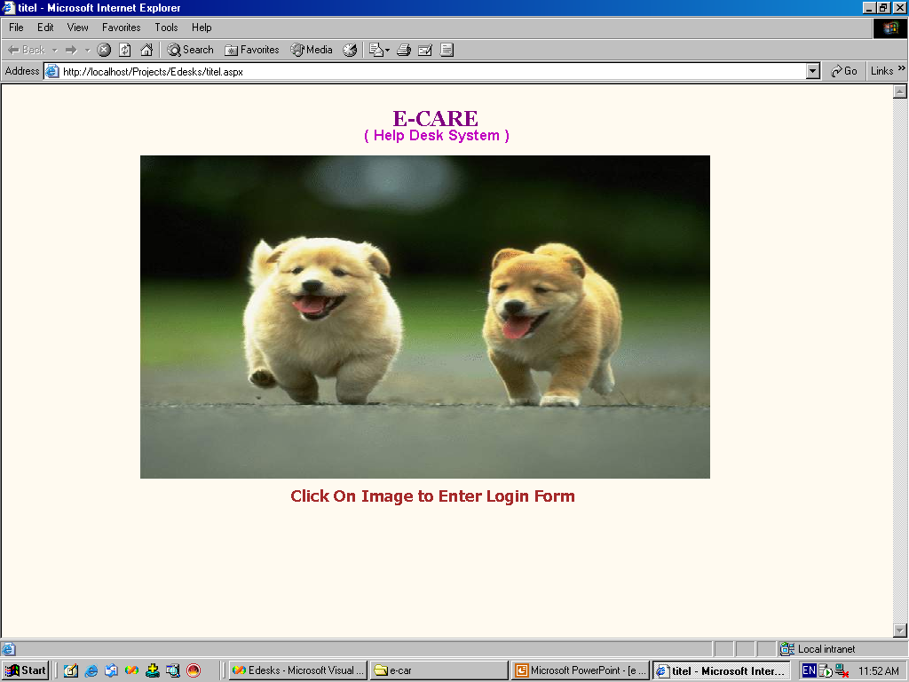

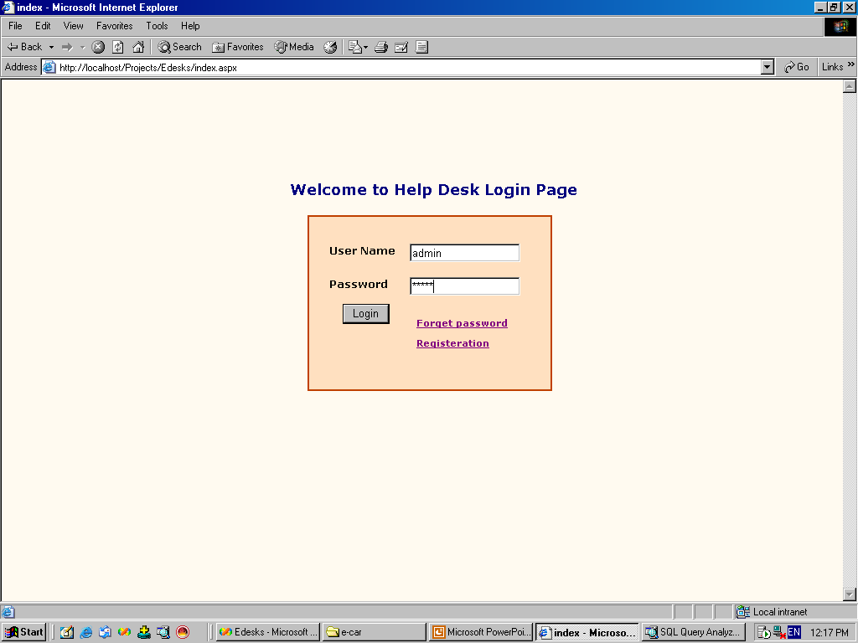

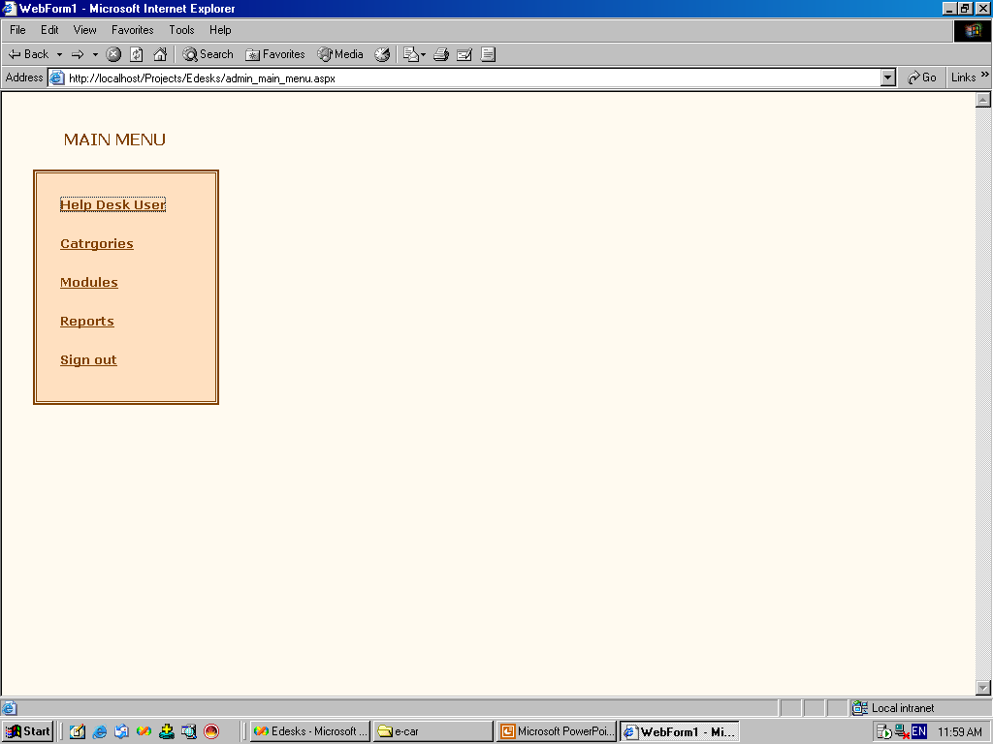

SQL Server:-

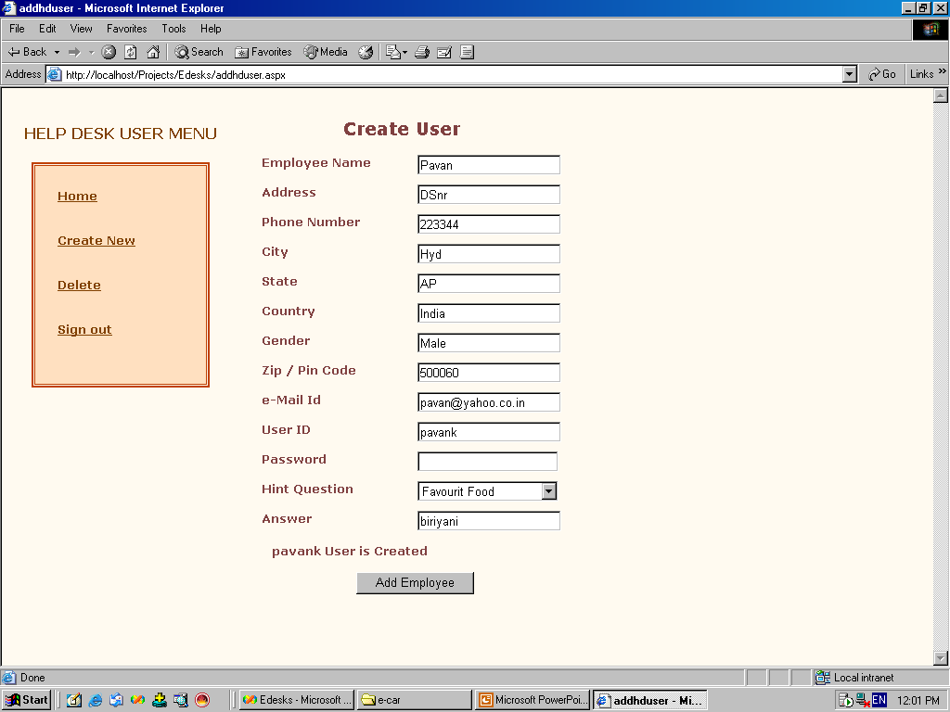

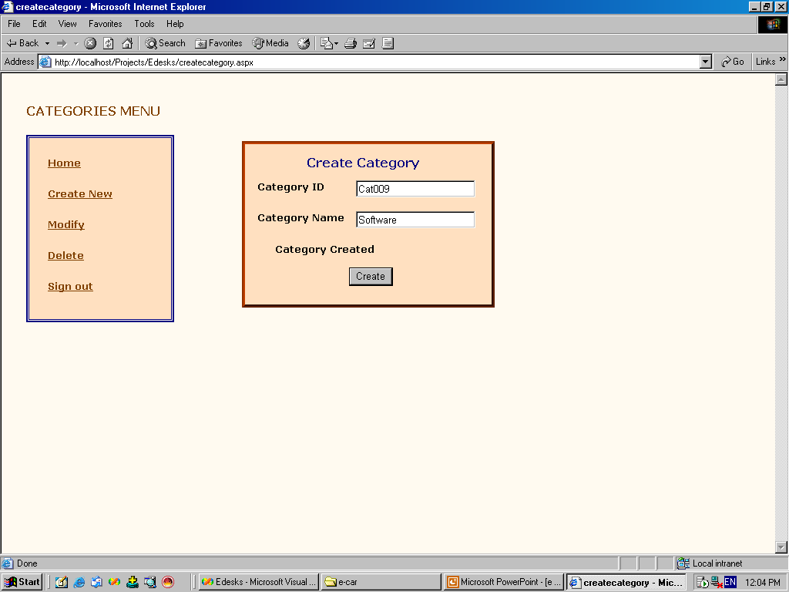

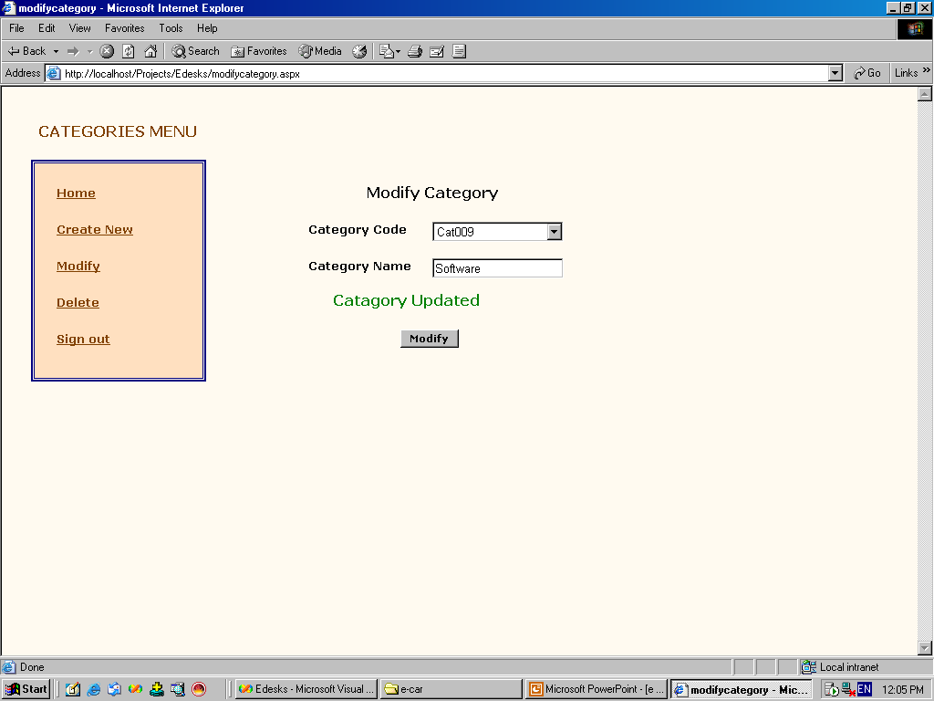

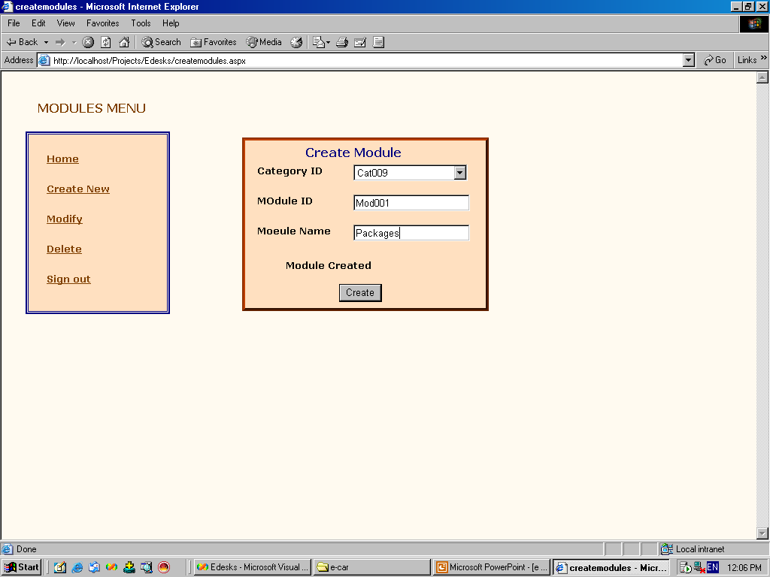

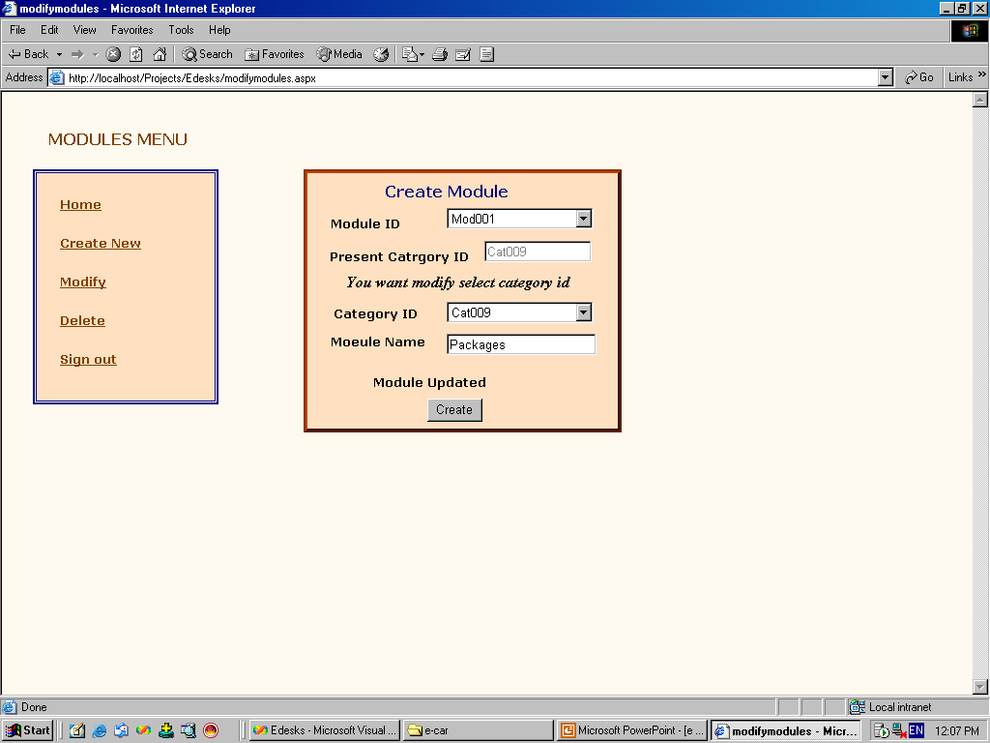

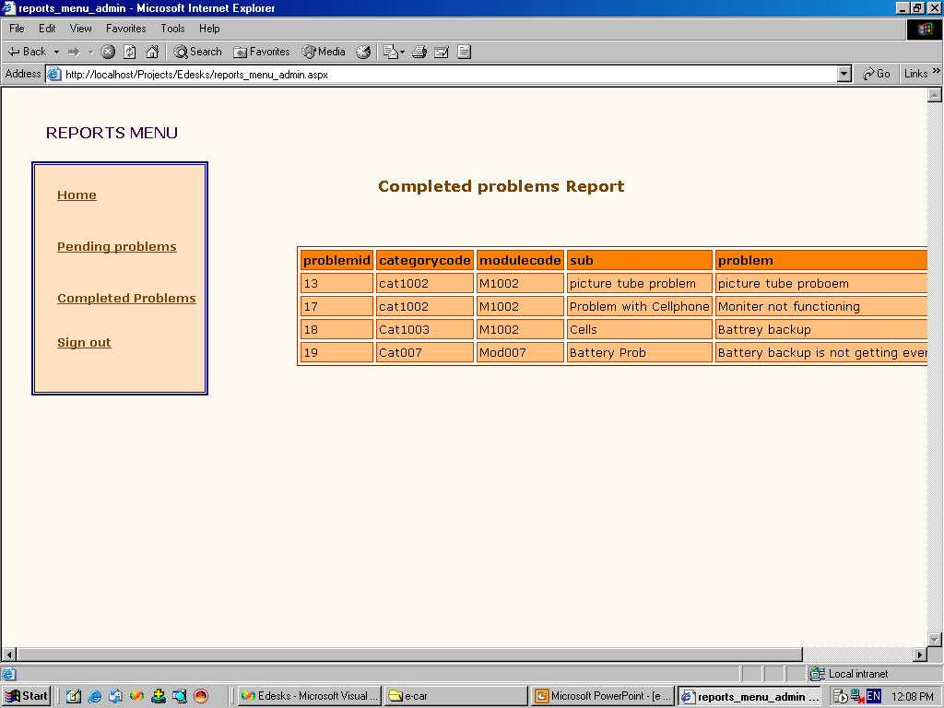

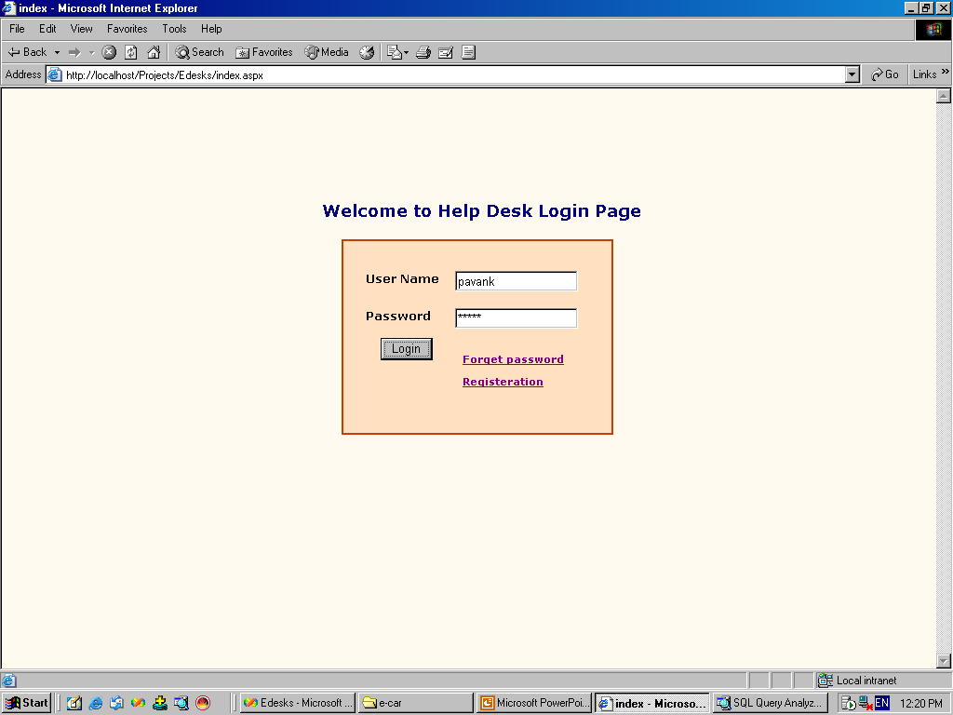

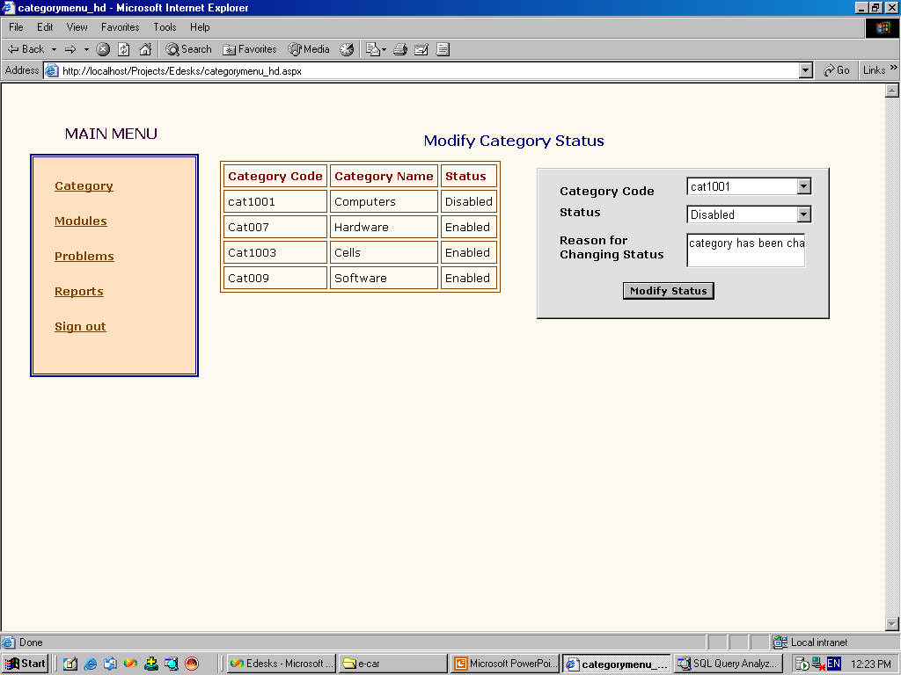

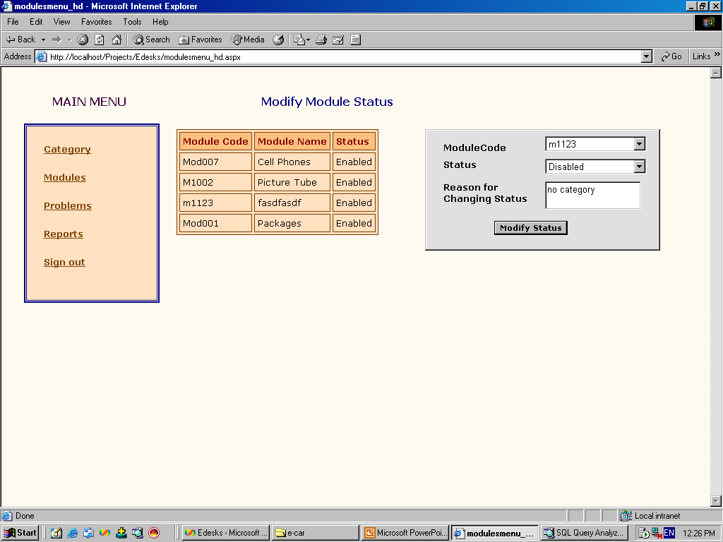

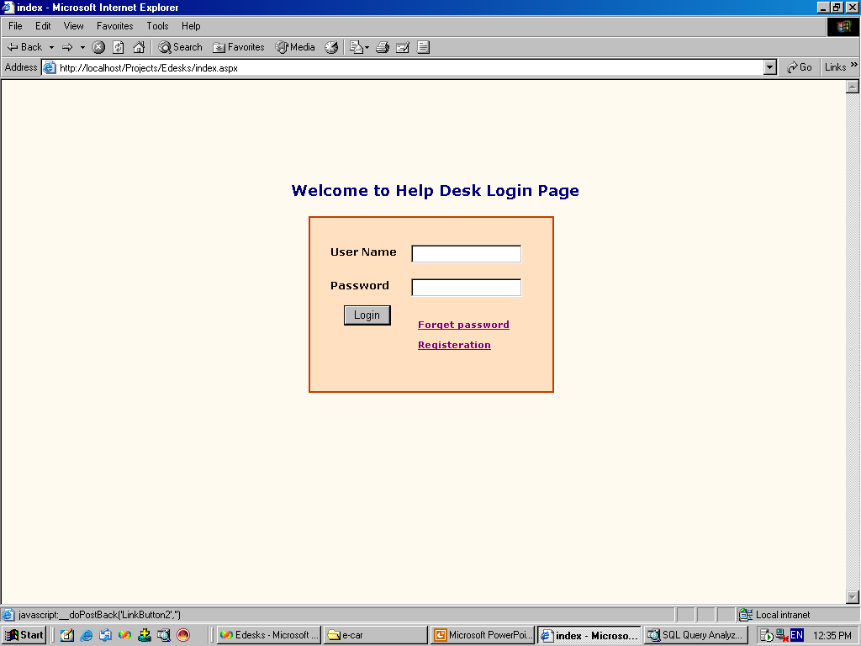
S

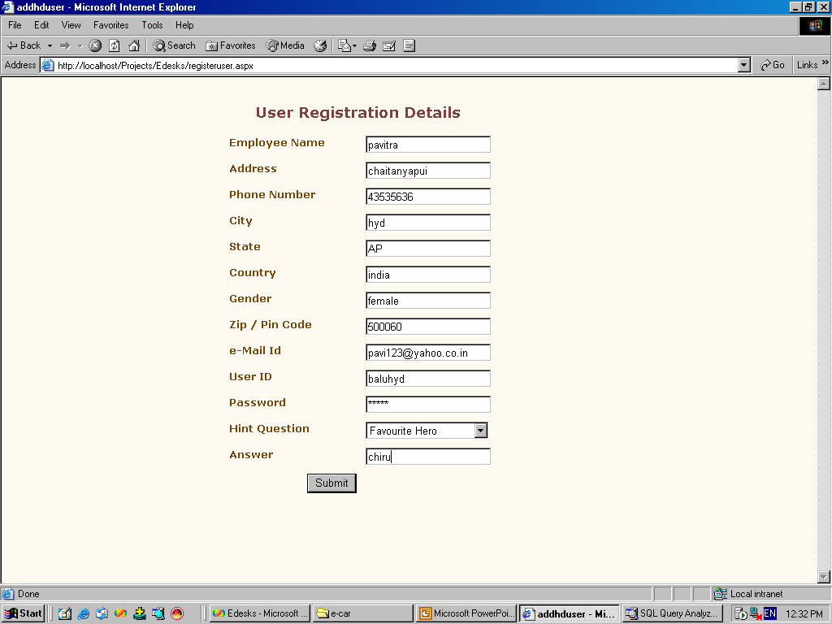

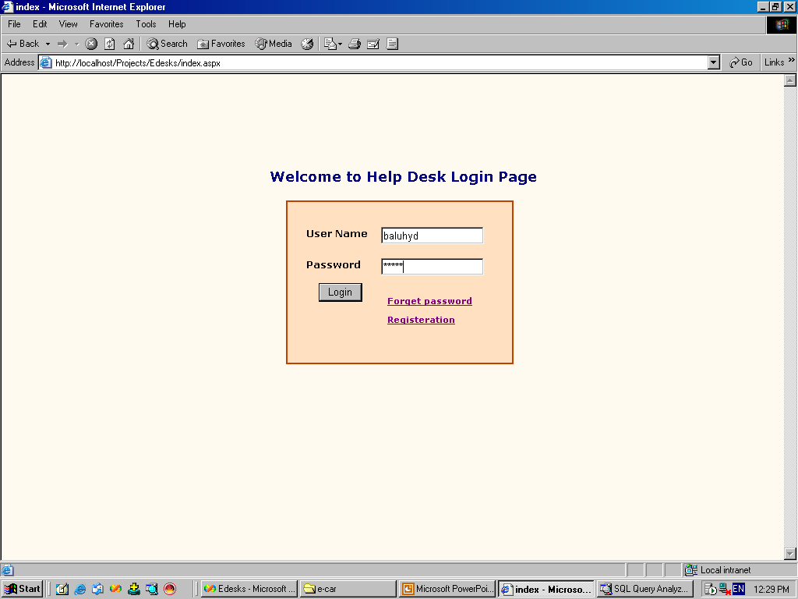

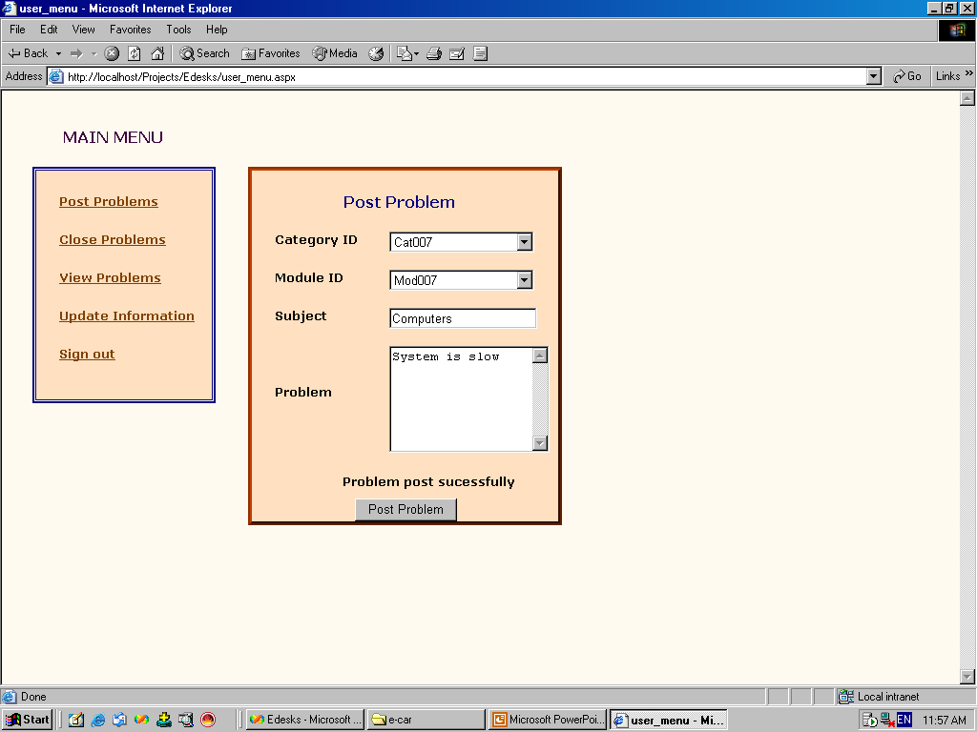

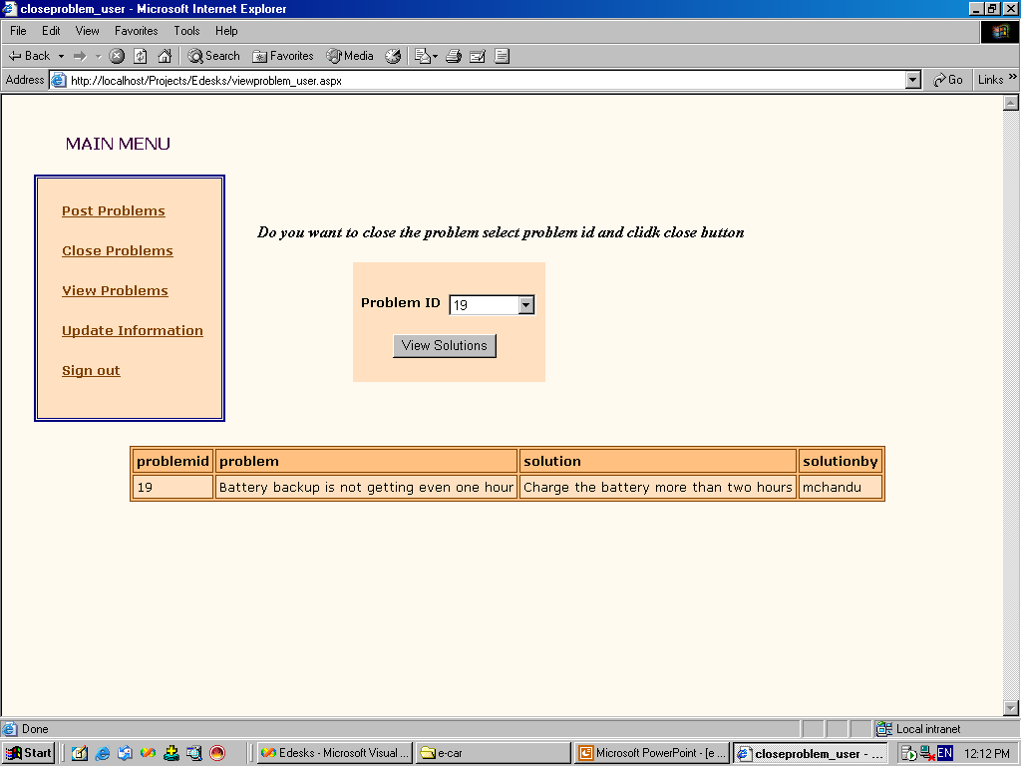

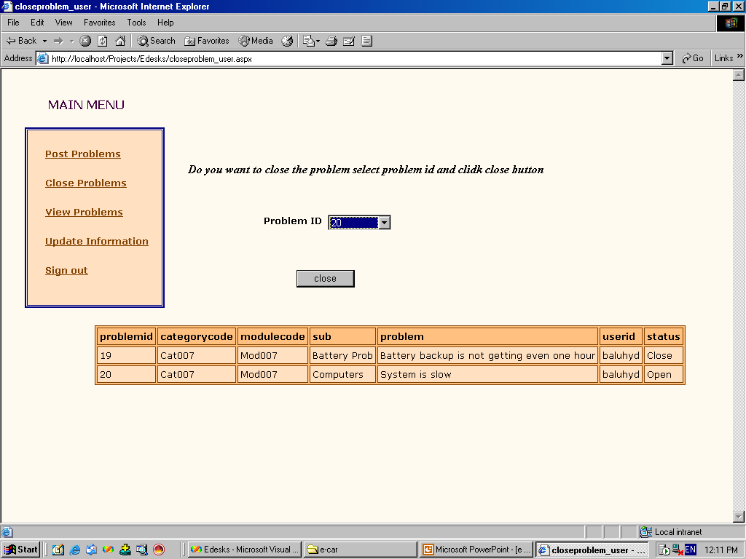

SOFTWARE TES TING

Software Testing is a critical element of software quality assurance and represents the ultimate review of specification, design and coding, Testing presents an interesting anomaly for the software engineer.

Testing Objectives include:

- Testing is a process of executing a program with the intent of finding an error
- A good test case is one that has a probability of finding an as yet undiscovered error
- A successful test is one that uncovers an undiscovered error

Testing Principles:

- All tests should be traceable to end user requirements
- Tests should be planned long before testing begins
- Testing should begin on a small scale and progress towards testing in large
- Exhaustive testing is not possible
- To be most effective testing should be conducted by a independent third party

TESTING STRATEGIES:

A Strategy for software testing integrates software test cases into a series of well planned steps that result in the successful construction of software. Software testing is a broader topic for what is referred to as Verification and Validation. Verification refers to the set of activities that ensure that the software correctly implements a specific function. Validation refers he set of activities that ensure that the software that has been built is traceable to customer’s requirements
Unit Testing:
Unit testing focuses verification effort on the smallest unit of software design that is the module. Using procedural design description as a guide, important control paths are tested to uncover errors within the boundaries of the module. The unit test is normally white box testing oriented and the step can be conducted in parallel for multiple modules.
Integration Testing:
Integration testing is a systematic technique for constructing the program structure, while conducting test to uncover errors associated with the interface. The objective is to take unit tested methods and build a program structure that has been dictated by design.
Top-down Integration:
Top down integrations is an incremental approach for construction of program structure. Modules are integrated by moving downward through the control hierarchy, beginning with the main control program. Modules subordinate to the main program are incorporated in the structure either in the breath-first or depth-first manner.

Bottom-up Integration:

This method as the name suggests, begins construction and testing with atomic modules i.e., modules at the lowest level. Because the modules are integrated in the bottom up manner the processing required for the modules subordinate to a given level is always available and the need for stubs is eliminated.

Validation Testing:
At the end of integration testing software is completely assembled as a package. Validation testing is the next stage, which can be defined as successful when the software functions in the manner reasonably expected by the customer. Reasonable expectations are those defined in the software requirements specifications. Information contained in those sections form a basis for validation testing approach.

System Testing:
System testing is actually a series of different tests whose primary purpose is to fully exercise the computer-based system. Although each test has a different purpose, all work to verify that all system elements have been properly integrated to perform allocated functions.

Security Testing:
Attempts to verify the protection mechanisms built into the system.

Performance Testing:
This method is designed to test runtime performance of software within the context of an integrated system.

