INTRODUCTION

Staying Online

Back in the '80s the Bee Gees crooned "Staying' Alive". In today's parlance, this would be best said as "Staying' Online"! Corny references apart, the fact is that being online and creating a strong web presence are the two most important things for personal and professional gains.

What is web presence? Is it just acquiring an e-mail address? Is it putting up a site? Is it your online conduct? As a matter of fact, it's all of these things and much more. It's almost like creating your identity online, like in the offline world.

Like in the real world, the internet also provides you various platforms to express yourself, interact, argue and learn. Some of these places can be found easily, others need you to be part of a network that is possible only after spending substantial amount of time with members of such networks. The advantages here are enormous.

Like with personal life, your professional life could also receive a major fillip with a good web presence. Being part of networking sites that are set up for professional reasons and even getting work online are ways of making proper use of your online identity.

But how does one do this? What is proper online conduct? How do I put up my site? Isn't it costly? Questions such as these must be running through your mind. Don't worry! We have attempted here to answer almost everything you may want to know.

Topics in our project range from creating your web presence to how you can use it best to becoming members of forums, why to set up your own blog and how you can benefit from it.

What is the correct way to communicate? How should you compose e-mails? Is there a wrong way to do it? Yes, there is. Netiquettes (Etiquettes to be followed online) are crucial. Additionally, topics like setting up and designing your own Web site will enable you to create a professional web presence.

But remember, like in the real world, you are only as good as your reputation. Work hard at maintaining it. And you will be welcomed with open arms into the web world.

1.

You and the Internet



Whether man can live in space or Mars is still debatable. But life in cyberspace is already a reality. Like in the real world, though, for existence in the virtual world, it is important that you create your identity, a track record, a reputation—and maintain it. In this chapter, we try to find ways to do just this.

1.1 Creating Your Online Presence
Cyberspace is a vast sea of people... real people in the virtual world. Everyone is welcome, but who to trust is something no-one can say for sure. "Sheep in wolfs clothing" holds true more often than not here. The key to creating your online presence is ensuring you do not become one of these sheep: that you manage to declare and define honestly who you are.
There are many ways you can announce your arrival in cyberspace: e-mail, Instant Messenger IDs, your own Web site or blog, or by becoming part of a community or forum that matches your interests.
The challenge in becoming a part of a forum or community is finding one that interests you, and then slowly but steadily making your presence felt. Treat it like a new college you've just taken admission into. Naturally you are apprehensive because you don't know anybody. You don't know where to go... but you walk around and familiarize yourself with your surroundings and the campus.
An online community is just that—a campus. Take your time finding out about all that exists and what activities happen here. Find out about existing members and their likes and dislikes. Know what would be offensive to other members and avoid doing that.
As you spend more time, more members would start noticing you and approaching you... much like it happened in college. There you have your first set of friends. From there on, it's how you take it further. 2.
More on online communities and forums in some of the later chapters.

1.2 IMs for Contacts and Business
Instant Messengers (IMs) have evolved into a communications and business tool. You need to be signed up to use a particular service—for instance; you cannot use Yahoo! Messenger with a Hotmail account and vice-versa. Although there are some IM clients that allow any account to be used, those aren't the best ones.
So there are two options here—sign up for all available IMs, or decide the one you want to use and stick to it. We recommend the first since it costs nothing, and it doesn't hurt to have an ID even if you rarely use it.
IMs are a great tool for communicating with friends, whether they're sitting a few cubicles or a few continents away! Just make sure you match your time with their time zones! IMs also allow you to share files and photos as you chat and play games with the other person. It's as good as being there. To be honest, you are-just that it's virtual.
An IM can also be a good business tool, and including your ID on your business card is a good idea. Whether you are a self-employed professional or a businessman or an employee of a company, using IMs for business can save your company (or you) a lot of money for communication. But how is this better than e-mail? For one, instant messaging happens in real-time. If you have to coordinate with a client sitting in another city or country, you could save on long distance calls by using an Instant Messenger.
Some of the popular IMs are MSN Messenger and Yahoo! Messenger. To be able to use these, all you need to do is sign up. The services are free, and you also get an e-mail address upon signup. In the case of MSN, it's Hotmail that gives you a 25 MB mailbox initially (it's about 250 MB if you're in the US), and Yahoo! gives you a 1 GB mail account. Logically, you would rush to sign up for Yahoo!, but it's worthwhile checking up on which of the two is more used within your contacts.

1.3 Using E-Mail
E-mailing is a great tool for keeping in touch and widening you business. But there is a fine line between spamming and being persistent when e-mailing.
Spamming is illegal in most countries, and if your e-mail account is found to be one of those that is spamming, you could well be blocked out by the recipient's mail server, making your efforts futile. Worse still, your own email provider could block you out.

A widely-accepted definition of spamming is "the use of any electronic communications medium to send unsolicited messages in bulk". While this definition is normally limited to indiscriminate bulk mailing and not any targeted marketing, the term 'spam' can refer to any commercially-oriented, unsolicited bulk mailing that can be perceived as being excessive, and more importantly, undesired.
In the popular eye, the most common form of spam is the one delivered in e-mail as a form of commercial advertising. However, during the short history of electronic media, things comparable to spamming for non-commercial purposes in media other than e-mail have also been recorded.
Over the years, a variety of spamming techniques have been developed. These vary by media: e-mail spam, IM spam, Usenet newsgroup spam, Web search engine spam, weblogs spam, and mobile phone messaging spam.
It is important that you desist from all the above forms, and understand what could qualify as spamming before you decide to send out a mass mailer telling the world about your business— or even your arrival on the WWW.
Because the entry barrier for spamming is so low, the volume of unsolicited mail has produced other costs which are borne by the public (in terms of lost productivity and fraud) and by Internet service providers, which must add extra capacity to cope with the deluge.
Spamming is generally reviled, and has been the subject of legislation in a number of jurisdictions, including the United States' CAN-SPAM Act of 2003.

3.

1.4 Netiquette
When communicating with others on the Internet, observe the following common-sense net-etiquettes. These 'netiquettes' should be observed whether you are writing an e-mail message, participating in a chat session, or posting a message on a Bulletin Board.

Below are some basics you need to be minimally familiar with in order to be taken seriously in your online communications.
1. Do not type in all caps. Typing in all caps is considered yelling or screaming online. Those who type in all caps are perceived as lazy and not being considerate of those who will have to read their e-mail. Various studies on the topic reflect that it is more difficult and takes longer to read text that is typed in all caps.
2. Do not leave the 'Subject' field blank. Fill it in with a brief and concise description of the content of your e-mail. This is very important in helping those you communicate with, helping them organize and manage their e-mail. Avoid using all caps or all small case, terms such as 'Hi', 'Help' or 'Please Respond', or the recipient's name in the subject field, as you may be misidentified as a spammer, and your e-mail automatically deleted.
3. Refrain from formatting your e-mail with colored text and background colors or images in your day-to-day communications. Your color and formatting choices can make your e-mails impossible to read. In addition, formatting could make your e-mails difficult to reply to without having to go through a procedure to convert your e-mail to plaintext first.
Often, when people click 'Reply', they have to deal with your formatting carrying over to their reply, which makes communicating with you unnecessarily more difficult. Why would you expect people to convert your e-mail just to read and respond to you? They probably will not!
Using large background graphics that take forever to download, especially if you have a dial-up connection (which is still more common than most of us may like to believe) is simply inconsiderate. If you do feel the uncontrollable need to use any type of formatting in your daily communications, do so sparingly.
4. On those rare occasions where it is necessary to send a group of people the very same e-mail, as a courtesy to those you are sending the mail to, list all the recipients' e-mail addresses in the BCC (Blind Carbon Copy) field. When an e-mail address is designated in the BCC field, the recipient will get a copy of the e-mail while their e-mail address remains invisible to the other recipients of the e-mail-some or all of whom they may or may not know.
Long lists of e-mail addresses at the beginning of any e-mail is an immediate sign that the sender is either a novice/Newbie—or doesn't care to respect other's privacy. None of which, we're sure you'll agree, are complimentary perceptions! E-mail addresses are like phone numbers. Only the owner of the e-mail address or phone number should be able to authorize who they want to have it and make it public to.
Most people prefer to decide for themselves who has their e-mail address. By sending mass mails to a list, you have made that decision for them—and that is a breach of assumed privacy when communicating. Let those you correspond with determine for themselves who they will make their e-mail address known to-do not make that decision for them!
5. If you are new online, raise your right hand and repeat:

A. "I will not forward any dumb joke, 'chain letter' or unimportant e-mails to my friends without their permission."

B. "I understand that by doing so I may fill up their inbox, use oth ers' resources unnecessarily, and may cause other, important e-mail to bounce."

C. "I understand that most people have seen these e-mails a million times and find them annoying."

D. "I know that by forwarding these so-called humorous e-mails
I may offend or tick off people who do not share my sense of humor or who are sick of having stupid e-mails forwarded to them each time a Newbie hops online."

4.

There! Now, that wasn't too bad, was it? Hopefully, you will no longer be tempted to forward those jokes, untruthful or frivolous e-mail that instruct you to forward them to your friends! And you'll avoid looking silly and uninformed in the process. Read them if you must, then hit 'Delete'. You don't believe those e-mails that state that certain things will happen simply by you forwarding the e-mail to 10 friends, do you?

In addition, many of these e-mails are hoaxes or downright bogus. Before you forward an e-mail that appears good-intentioned with an incredible story that instructs you to "read and share" with everyone you know, you might want to first check www.snopes.com to see if the story is legitimate in the first place. Not doing so can have you eating crow when everyone you e-mail is informed you just forwarded a hoax without knowing better. And, don't get mad at someone if they point out to you that you were uninformed by perpetuating a hoax! If you don't know for a fact that the e-mail you're forwarding is accurate and specifically apropos to the person you are forwarding to and you know they will want to receive it—all you have to do is ask first.
6. Never give out phone numbers or personal information without confirming you are communicating with a reputable party. Never give out personal contact information of others without their specific permission to do so.
7. Make a reasonable effort to search a Web site for the information you are looking for—'Frequently Asked Questions' or
'About Us' sections may give you the answers you seek before you waste the site owner's time by e-mailing for information that is readily available on their site.
If a Web site owner takes the time to provide information, read it. No one person's time is more important than another's, and common courtesy includes respecting this fact. If you do not find what you are looking for, search for the appropriate contact area for your question. Don't just click on the first e-mail link you come across and blurt out your question(s). If you do, don't be surprised if your e-mail goes unanswered if the information is easily found on the site.
It is important to understand the focus of each Web site as well. Each site cannot be everything to everyone, or be what you perceive it should be. Be sure to review the information provided to double-check that what you seek would even be covered by the site you are visiting.
8. Do not use Return Receipt Request (RR) for each and every personal e-mail you send because you like 'knowing' when someone opens your e-mail. Not only is this annoying to the recipient, this feature is intrusive! How would you like it if every time you heard a voice mail, answering machine message, or opened a postal letter from a friend, it was immediately reported back to them that you had heard/opened their communications? The recipient should have the privacy to determine when/if they want to open, read and reply—period. RRs should be reserved for those instances where it is critical to knowing whether the e-mail was opened. Such instances would include legal and important business issues. Keep in mind that opened doesn't mean read, and that the recipient can decline an RR request so you will not be notified.
9. Understand that you will be on a continual learning curve. All of us are. The online world is changing constantly. The only constant is change! If you do not have the desire to learn and do not make the effort to understand the 'culture' of the technology in which you are participating, you will not be taken seriously by your fellow Netizens. You also may get terse e-mails from other Netizens pointing such issues out to you— some may not be as nice as others. Do not fire back at them! Use such situations as an opportunity to learn what you are doing wrong so you do not anger others.
10. If you receive a nasty e-mail, do not respond immediately—if at all. People are bold and overly critical on the other side of this screen. They tend to not hesitate to point out what they think you need improvement on while not bothering to notice the good or positive points on the very same issue.
Many times, these people are simply trying to get a rise out of you (this is called trolling) or
5.
are trying to make themselves feel self-important. Many times, they're just jerks. If you do not have something nice or constructive to say, or at the very least sternly professional—just hit 'Delete'.
11. Keep in mind that all private e-mail is considered to be copyrighted by the author. If you post private e-mail to a public list or board, or forward it to an outside party in whole or in part, you must include the author's permission to post the material publicly. Not doing so can get you into trouble legally or with your friends and associates.
12. Always compress or 'zip' large files before sending. Many people who are new to the online world do not realize how large documents, graphics or photo files are. Guess what—they are large enough to fill someone's e-mail box and cause their other mail to bounce! Get in the habit of compressing anything over 200,000 bytes. (You can view file sizes in Windows Explorer. Simply right-click on the file name and choose 'Properties'.)

There are several types of file compression software available for these purposes. Do not send unannounced, large attachments to others because you think that photo or file is cute or cool. Ask first! More importantly, when sending business files, do so only during business hours—and always compress and ask permission first!
Many onliners still have to wait up to 30 minutes or more to open overly large files due to their connection speed. Most of those online do not have cable or DSL connections, they are on dial-up—many only @ 28.8 Kbps!
Another way of reducing the size of your attachments is to manipulate them using graphics software. Minimizing a photo or graphic's physical size to no larger than 600 pixels in width will make them e-mailable—nothing need be larger than that size to view anyway. Or you could be really courteous and learn how to use the free Web space offered by your ISP to upload photos, and simply send the link to friends and family to view. And if you do not know how to do any of these things, all you have to do is learn!

To send large files that take a long time to download may not respect the other person's time; the files may not reflect their sense of humor or point of view, and may even max out their e-mail box. This is being inconsiderate and lazy.

E-mail Woes
Unfortunately, the advancement of technology has its negatives. It is now possible to get a virus without even opening an e-mail—that started with W32.Nimda.A@mm (or simply, Nimda) in September 2001, which merely required you click on the subject of the e-mail in your mail program (or in some mail clients, have the preview pane on).
Several of the latest viruses actually use e-mail addressed farmed out of your address book or inbox to send the virus and propagate itself to all those listed, with your name in the 'From' field. The latest viruses can send themselves out with your friend's names in the 'From' field, or any combination of e-mail addresses found on your system!
The need for a 24/7 real-time virus protection software is no longer a choice—it is your responsibility to remain virus-free. You will also need to update your virus files regularly. Check for updates every time you log on so that your computer is protected using the latest virus definitions.

The Basics of Virus Protection
o Get an active program that is always 'On'. This will catch any viruses as they are being downloaded, so they can immediately be quarantined and cannot infect your system.
o Update your virus definitions daily, or every time you log on. These updates can be downloaded from the Web site of your virus software manufacturer. Most have a scheduler to tell your computer to do this automatically.
You need to ensure your system is protected from any viruses that may have just been discovered since you were last online. New viruses are identified daily!
o Never click on any attachment or a .exe (examples: "Happy99.exe", "free stuff, "click here" or "ILOVEYOU") file attached within an e-mail without making sure the attachment has been
6.

checked for viruses. This holds even if the mail appears to come from someone you know well! The attachment may be virus-generated, and may have plucked your friend's e-mail address off the infected computer of someone they communicated with. Or your friend may unknowingly be infected and not aware of the virus on his or her system, which has just spawned an e-mail that has their name on it and is addressed to you. The e-mail may look like it is from your friend just to get you to open it when in fact
it is generated by a virus.

The Benefits of Being Online
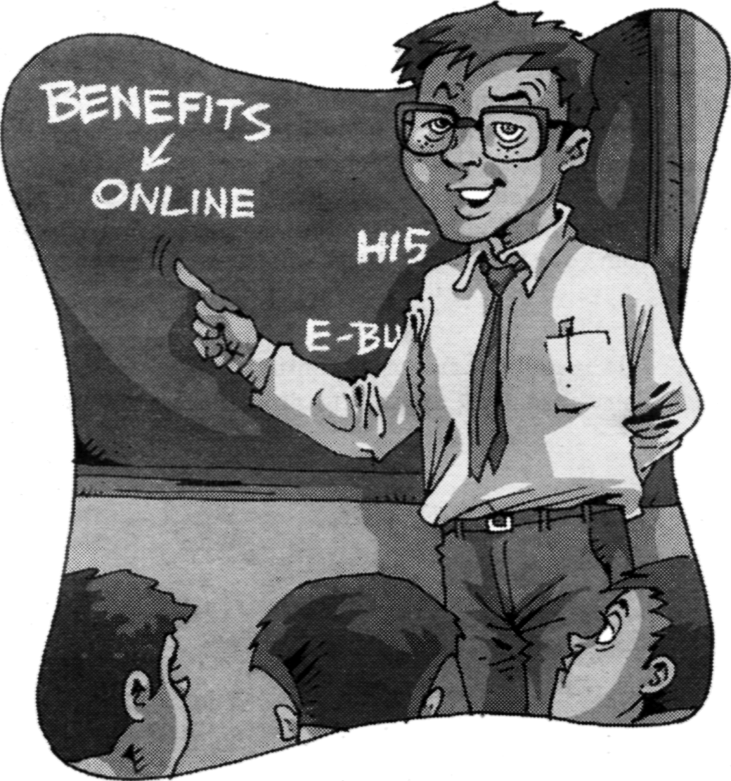
Being online today is more of a norm than a trend. Most people including businesspeople and students alike rattle off their e-mail addresses right after their phone numbers. One of the biggest benefits of being online is the possibility of reaching out to the entire world—quite literally. It's a bit like putting up your shingle outside an office; the only difference is, the passers-by include the entire world.


2.1 Personal gains of being online
I our lives have come to revolving around our professional goals, and this start right from high school or college. We are so swamped by work, submissions and other related stuff that we have no time for friends, and we slowly drift away—leaving ourselves with just our colleagues as friends.

But being online and being active can mean that you are no longer kept apart from your friends. What's better, you could even make new ones. You can also catch up with your friends from school and college and no longer feel isolated. Just how can you do this? Web sites that specialize in 'networking' is the answer.
7.

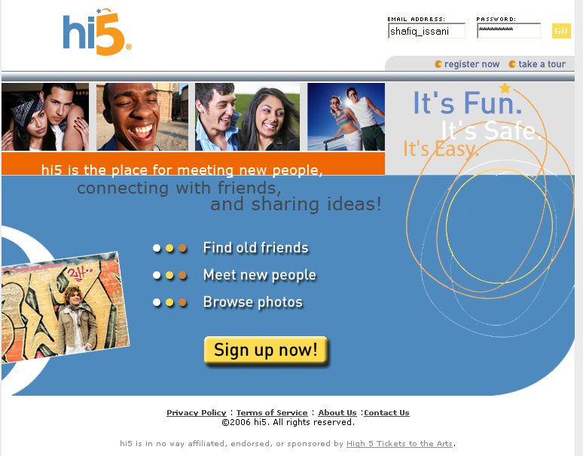
2.1.1 Online Social Networking
You may have heard some of your friends or acquaintances talk about sites such as Orkut, Hi5,
Friendster, or Yahoo! 360. These are what are popularly known as online social networking sites.
While they all claim to have the 'most active' or the 'widest' network in the world, you need to first check on where your friends are. Last thing you'd want is to be in one place while your friends are in
another! It can also be compared with your friends being at the movies while you are waiting for them at the coffee shop.
Getting online with almost all these social networking sites is as simple as a free sign-up and registration. In the case of some
sites such as Yahoo! 360, though, you may need an invite from an existing member.

2.1.2 How Does It Work?
Most such sites work on a simple principle. You can search for people based on common interests, hobbies, location, age, and any other criterion that suits you! One of the greatest things this does is eliminate boundaries of distance. You can also make new pen pals and keep in touch using the same forum.
Like with everything online, however, there are some pitfalls in the online friendship game. There are a lot of fraudsters out there who may win over your confidence and then try to misuse it.
Once you sign up with a social networking site, you can send invites to non-members to join and keep in touch with them using the Web site. Moreover, you can also find existing members and request them to 'connect' with you and share information and likes and dislikes.
As time passes, your network would grow, and before you know it, you would be part of a community where members share common interests and keep in touch. So not having time outside the office is no longer a reason to not have friends.
In a lot of cases, members often meet outside the online presence if there is a large enough community within a geographical area and get to know each other better.

2.1.3 Telecommuting
Although some may consider this to be a new way of working, telecommuting has been around for a while, and offers a great new way to work for the best companies in the world. As an aspiring professional, you need to keep an eye out for any company that may have a requirement for a telecommute job. These jobs allow you to work from home, and pay well, too. In some cases, the employer also sets up the infrastructure including the Internet connection and other necessities so that the employee is at par with the infrastructure at office.
For this, though, you need to really be aware of what is being offered and not miss out. Having your own site/blog could further aid your hunt in this as well.

8.

2.1.4 Your Global Office
Every professional and businessman dreams of making it big. But how do you do it? As a start-up or a small, growing organisation, you won't always have the required finances or the manpower to go and meet all potential clients. Moreover, not all your potential clients would be in your city.
The Web and other online tools (e-mail, forums etc.) let your business reach new shores. Imagine yourself as a dealer of Indian handicrafts: your biggest potential market is the western world, but how many mailers can you send out? How many phone calls and samples can you send? Countless, to have any kind of impact and justify the expense of sending out the mailers in the first place.
Options like eBay that are now available allow you to list your product(s) in all English-speaking countries while sitting here in India. Isn't that a world opening up to you? Other, similar services are equally effective, and can have a greatly positive impact on your business. It's just a question of getting online and finding the right solution for you.
Summing up, having an online presence can help you eliminate costs, appeal to a wider marketplace, and further your personal and professional causes.



It's the chic new thing so far, but blogs—short for Web log—are the thing to have today. And sure enough, just about everyone has one (or more!). But what is blogging and what are its advantages? How is it different from a Web site? Fret no more... we will answer all this and more.

What Are Blogs?
Simply put, a blog is a compilation of thoughts, ideas, facts, news or whatever you will that someone has decided to put online! Called posts, each article on a blog can be connected with the previous or not. That's the thing. There are no rules and there are no restrictions. It's your playground to experiment.
Blogs are usually structured, organized by category and are updated often; in most cases, daily. The owner (and in some cases, moderators) of the blog has the rights to control the content.
The term 'blog' was coined back in 1999, and ever since, blogs have caught the fancy of online dwellers. At last count, there were roughly about 10 million blogs on the Internet!

9.

Creating A Blog
It's not necessary for you to know HTML inside out if you want to create a blog. You just need to be able to find your way across cyberspace and know the basics of Internet browsing.
Available for free, there are numerous tools you could use to create a blog. You can use an HTML editor like Dreamweaver or FrontPage Express to create your blog's look and feel and to create posts. You could then send the content via FTP to a Web server.
However, if you're unfamil-iar with HTML editors and using FTP programs, there are a lot of services that offer free blog-ging tools. Some of the more pop-ular ones are Blogger (www. blogger.com),

Blogsome (www.blogsome.com), and Typepad (www.typepad.com), to name a few.
When you set up a blog, you create a login name and password (similar to creating an e-mail account), select a template that will house your information and also create a nickname (optional) to sigh all your posts. Once you have the blog set up, you can post whatever information you like, whenever you want and as often as you want to.

3.1 The Benefits And Advantages Of Blogs

Easy to maintain and easy to start
If you don't know HTML, using a template from one of the many tools available makes it easy to start off. You just post your info into the template and your account is created.
In most cases, the options within the template as offered by the service are extensive and allow you to categorise your posts. You can also link your blog to other blogs or sites to announce your arrival and popularise your space.

Post as often as you like
Post as much and as often as you like. None of the free blogging tools restrict the number of entries you can put up or the length of an entry. Heck, they are also offering free photo upload facili-ties now to brighten up your blog!

Blogs are highly interactive
Interactivity and quick! Most posts, depending on the number of regular visitors to your blog, would have a comment or two hundred soon after the post has been uploaded.
Blogs may also use a TrackBack' system that allows a visitor to see who has written the original post and any other entry concerning it. Some blogs can also alert you when new or updated content is added.
Blogging gives a writer all the freedom he/she could ever hope for. While there is no censorship on the Internet, remember to be responsible with your writing. Also, take responsibility for what you write since your readers will comment on your writing and expect clarifications or explanations. This is the very thread that defines blogging and if you do not want it to be interactive, disable the comments on your blog.
The TrackBack option typically appears below a blog entry, and shows a summary of what has been written on the target blog, together with a URL and the blog name.

No lists or spam filters to maintain
E-mail spam filters do not block blogs because they are not an e-mail communication. With the advent of spam filters and the increasing refinement in the way they filter e-mails, delivery of newsletters and e-zines has become difficult.
Blogs are not delivered to any inbox and therefore, no methods of defeating filters are needed. Bottomline is that no one can shut you out simply because they are now searching you out!

10.

The number of blogs you can create is limitless
You can create as many blogs as you like, on as many subjects as you'd like.
So if your fancy has suddenly shifted to Indian Classical Music, go on, write about it. You could even upload samples of the music. Who knows how many people might be interested in what you have to say or sing!

They're search engine friendly
Search engines are constantly searching for new content and blogs match this requirement perfectly thanks to the constantly-changing content daily.
There are numerous Web sites that act as 'blog search engines' as well. Do not forget to submit your blogs to these sites, so as to increase your exposure. This will also help with your page rank on general search engines.
Here are some of the places to list your blog:
o Technorati: www.technorati.com
o Blog search engines: www.blogstreet.com
o Globe of Blogs: www.globeofblogs.com
o Blog Universe: www.bloguniverse.corn
o Blog Search Engine: www.blogsearchengine.com

They're economical
Actually you could get them for free! Since no lists are to be maintained, there are no list server costs. Blogging software and services are also very reasonably priced.
In most cases, they are free, but then you need to let them maintain a link back to them on your page. If you don't want that, you could opt for a paid service and do what you will with the page and yet continue to use their content management module.
Some blogging services charge people to read, while others charge writers to write, but overall, the monthly charges are rather minimal either way.

They're educational
Yes, there are some that are focussed and can be very educational. There's such a variety of informative and educational blogs avail-

The average person reads 200 words per minute - The speed reading record is 1347 wpm. In 96 seconds they will read 320 words. So keep things short and to the point. This may sound crazy but these stats show that longer posts are often largely ignored.
able now that a search for any subject usually turns up hundreds of offerings.
For a view into popular blogs in many categories, just visit www.blogit.com or do a search at www.technorati.com.

You can get syndication
Syndication (RSS) is a great way to ensure that your writing and your views are exposed to as much of the general public as possible.
In most cases, Syndi-cation is now included in blogging services and this has drawn a great number of writers to this new medium.
For an example of a blog service that features syndication, visit www.typepad.com or www.blogger.com

Reading A Blog
o No special tools are needed to visit a blog or to read a post or leave a comment. You can use your existing Web browser like Firefox, Opera, Mozilla, Netscape or Internet Explorer. Blogs normally have addresses like http://blogname.blogser-vice.com where blogname is the name of the blog as defined by the owner of the blog and blogservice is the host or the tool being
11.
used to maintain that blog. So a blog on Blogger would have an address like http://digit.blogspot.com.
o Use a RSS (Really Simple Syndication) reader. You can subscribe to whichever blogs you want and they become immediately available in the reader. Using an RSS reader allows you to have all the blogs that interest you in one place—you don't have to surf all over the Internet to read them.
What's better is that everytime a new post is made, you would be notified within the reader and a link to the complete post would also be available. How convenient, isn't it?
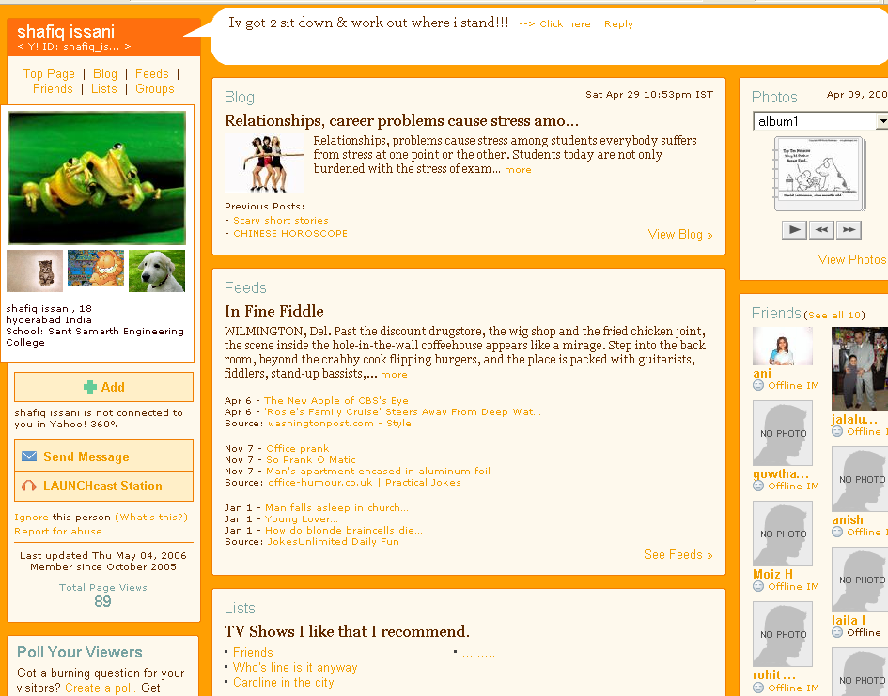

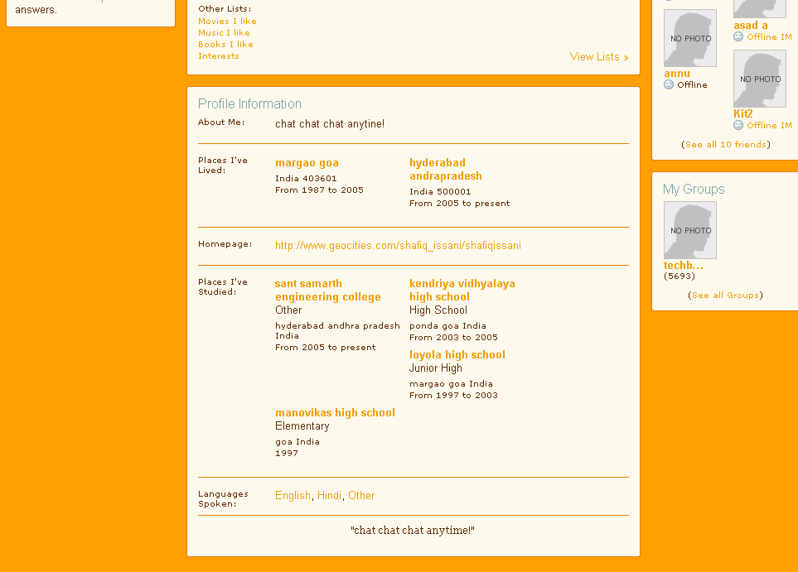

A sample “Yahoo 360” page.

12.

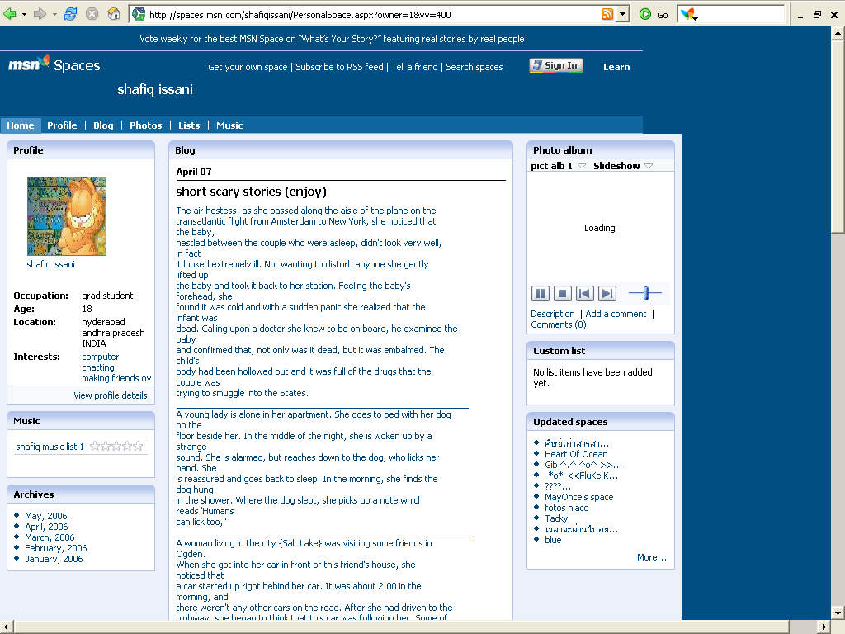
A sample “MSN spaces” page.

3.2 Blogs and Your Business
If blogs are all about expressing and making a point, how could they fit into a business? Here's how:
Blogs provide great supplemental content and direct attention to areas of your business that you want to feature or highlight. More than that, blogs lend themselves to many other uses such as:
o Communicate with colleagues, partners, suppliers, and existing or potential customers
o Showcase industry/company news, introduce new products, services or marketing promotions, and provide tips
o Establish a company's or individual's reputation or brand
o Improve operations (e.g., project management or tech support knowledge-sharing)
o Demonstrate expertise
o Establish competitive differentiation
o Simplify and accelerate the publishing process!

The Marketing Potential
Blogs can be used as highly strategic desktop tools that are here for the long term. In addition to putting down your thoughts and creating a corporate presence, think of the potential for your e-newsletter strategies:
o Articles within newsletters can be linked to a blog, extending life and creating a massive conversation giving you a clearer idea of what your customer is really thinking
o You can offer a bi-directional forum to customers to get true, personal opinions on your
13.

products and services; something no survey with just numbers can guarantee
o Company experts can start a blog and become industry experts, helping your company edge out the competition. This, however, will need a great deal of work to go in the background.
o You can layer your blog with editorial controls and ensure nothing you wouldn't want ever goes up there!

3.3 Exploitation of Blogs
Since its birth and over the last few years when it has grown in stature and reach, the Internet has become all-encompassing to the extent that we are more likely to say "Google it" than "let's check out the library" if we are looking for information.
Despite this, though, we still haven't dreamed of all the ways we'll use it five years from now. But there are certainly indications that we're going to have to be vigilant in recognising the difference between honest business practice and the misuse of the net.
With blogs, since everyone has opinions, and we all now get a chance to offer our opinions up to worldwide scrutiny, we've recognised that it offers us an easy way to achieve our 15 minutes of fame! Guaranteed? Not quite.
Most people are using their newfound recognition to offer up their best: their interesting opinions, their hidden theories, their
creative thoughts. The passionate and opinionated now have an avenue to vent.
We find these people through mutual areas of interest—we can do a search and find them, or go to the standard blog-direct-ing sites and choose our favourite obsession to either read about or add some material to.
In either case, we feel like we're part of a community of like-minded souls. On a movie-goers' blog, we can rant and rave about the merits of why Sarkar is better than Black or whether Saif Ali Khan really deserved the National Award for a routine role in Hum Turn. It's your playground. Say what you will!
But we belong to this community because of our substantial knowledge in the field, our love of the ideas or genre, and our beliefs of ourselves as amateur experts.
In any case, we're in good—albeit possibly annoying—company. It's become fun to find people and thoughts we would never have met otherwise but can immediately bond with.
Unfortunately, there is a downside to this also. There are people who are using the blogging world for fame and gain—and we have no way of knowing the difference between opinions and sleaze.

Link to other weblogs. Your readers may enjoy being introduced to the weblogs you most enjoy reading. The Web is a democratic medium and bloggers amplify each other's voices when they link to each other. Generously linking to other weblogs enlarges the grassroots network of information sharing and social alliances we create together on the Web.

We Told You So...
There are people who expect nothing less of the Net, though. Their belief is that no one on the Net is to be trusted, that every comment or idea or opinion is self-serving—and therefore untrustworthy. These people just shrug at the mention of the 'sleaze marketing'. Of course, they say. The entire Internet is sleaze marketing.
Is this true? Like in the offline world, though, there are some unscrupulous elements that hurt the usability and the credibility of the Internet. Unfortunately, these are spoken about more and are always in the limelight even if for the wrong reasons giving rise to the negative image of the Internet.
But not all of us believe that. For some of us, the Internet is a global arena that encompasses the group brain, where we can find answers to questions we haven't asked, ideas that we haven't thought yet, feedback in areas we had never challenged. It is our friend, foe, conscience, teacher and ability to touch base with people we could never meet or know of otherwise.
14.
Of course, not all available data is accurate or conscionable or wise. But like in the offline world where you steer clear of shady characters and associate with the good ones, the Web is a place to practise your discretion.
Blogs are allegedly the revolutionary new media, and are fast becoming increasingly difficult to ignore for those who spend time online. They are increasingly being recognised by businesses as a powerful communication tool. In fact, the medium has become so important that Bill Gates has a Web site of his own!
Be patient. Most webtog audiences are small, but with time and regular updates your audience will grow. You may never have more than a few hundred readers, but the people who return to your site regularly will come because they are interested in what you have to say.
Researching information, finding answers and making contacts are the main reasons people in business log onto the Internet. A blog can aid in this process, resulting in online networking opportunities. Having a business blog can be a good way for your customers to communicate with you, as well as between themselves, and in the process, form new relationships. While this may sound too esoteric, it's happening right now on the WWW.
Blogging is fast, low-cost and offers a highly effective publishing, marketing and content management tool. However, before adding 'blogging' to your marketing mix, you should be sure you're clear why you're blogging and what you want to get out of it. Do you want your customer's views about certain matters? Do you want to encourage communication between customers and your business?
Once these issues have been addressed, you need to find someone to host your blog. This is a straightforward process, and is virtually free.
If you just search for 'blogging' in Google, you could have a tough time choosing!
Although new, the success of blogging has given rise to a new industry; entrepreneurial media companies have introduced 'blog monitoring', where they scour the net to advise brands on how their name is being talked about online, away from the traditional print and broadcast media
The idea behind this emerging service industry is simple. While there were only 130,000 blogs four years ago, today, there are about 10 million. These Web pages can make or break a company's reputation because they provide links to each other and allow people to comment on postings—in other words, the blog is a huge image-making network that cannot be ignored. Even if you, as a company are ignoring it, others that may be using your products or services
are blogging about it. Wouldn't you want to know?
However, it is not only large companies that can benefit from blogs. Blogs are a useful tool for companies of all sizes. Especially for the smaller ones.
Why not start with a private, in-house blog, which is password-protected, so that it can only be seen by certain users, for example a project team or company division? Staff can use inhouse or intranet-based blogs for diary management, project tracking, arranging meetings, collecting comments and publishing documents.
The key to success is to pick the areas in your business where blogs can solve communication problems, then train the blog owners to anticipate and deal with issues in advance. With many blogs reaching thousands of people daily, many of whom also blog, it is time for blogging to be taken seriously in the marketing mix.
So what's your URL?

15.

Forums

The usefulness of online communities is best represented by looking at various forums. It's the simplest way for like-minded people, or people with a common interest, to come together and share their thoughts and opinions—in true online style, without having to take the trouble to actually meet anyone. This chapter will look at forums to see what benefits they can bring to you as an individual, and we'll use our own forum (www.thinkdigit.com/ forum) as an example.

4.1 The Importance Of Forums
Forums are simple to understand, and are, in certain respects, very close to communities in real life. The fact that they are very easy to use also increases their popularity—anyone who can manage to connect to the Internet, open a browser and type in a URL will find it easy to click on a link to a forum, and then register and post their thoughts.
Forums, unlike blogs, exist because of a group of people, and tend to reflect the sentiments of the community as a whole. Though a lot of people think a person loses his individuality on a forum, the fact is that forums breed better individuals. Take the case of a school, where students are further segregated into groups based on the class they are in. To an outsider, all the students of the school are alike-they wear the same uniform, and are generally all seen in the same place. There are no individuals visible to the outsider. Once the outsider joins the school, he finds there are various groups that interest him, and within those groups, there are people who are intelligent, people who are funny, and even some who seem just plain silly! That's exactly how forums work.
Take the example of the Digit forum (www.thinkdigit. com/forum): this is a place where members are as diverse as it can get. People from all parts of the world—all over India, the US and the UK—come together with one common bond: they all read, or used to read, Digit! Everyone on the forum loves technology, and most members love Digit magazine. Yes, just as in life, there is the dissenting minority here, but they are as welcome as the others, merely because it is a community, an online society, where acceptance is a must.
Some would go so far as to say that only forums and online communities can mimic real life in the otherwise fantasyland that is the Web. In fact, some might opine that it is even better than real life, as everyone expresses themselves openly, merely because they need not fear ridicule, as in, "So a few people online hate my guts... big deal!"
Whether forums build better people is something that is beyond the scope of this book, and perhaps a conclusion best left to psychiatrists and forum members to thrash about. However, there's no denying that the right forum can help you develop your skill sets.

16.

4.2 Forum Activity
Forums are not just places where people who love to argue get together and play one-upmanship games. Yes, this does happen often, and quite a few members on each forum are there specifically to build their egos by winning arguments, or showing off their superior knowledge, but they still aren't the majority.
Members in a forum can be broadly classified into the following groups:
1. One-time Visitors
2. Occasional Browsers
3. Regular Contributors
4. Forum Addicts
5. Troublemakers
6. Moderators/Administrators
Read on to find out which group you probably belong to, and which you 'should' belong to.

One-time Visitors
This group is simple to comprehend: they find your site via Google or from a friend. They decide to pay it a visit when they're bored, or when they need quick answers, visit the forum a couple of times, and then forget all about its existence.
On the Digit forum, these members comprise about 15 per cent of the registered members. They register only because they stumbled across the site and it sparked interest, but that spark was fleeting. Other users who make up this group are those with PC or technology problems: they're stuck and need a solution quickly. They visit well-known technology forums, register, post their question and then wait a while.
There's nothing really wrong with being a one-time visitor, and one can't blame people for trying to find solutions to their problems. However, netiquette demands that users check back on their questions a few days later and see if there are any replies. Even if you didn't find the answer to your question at a forum, and found it elsewhere instead, return to all the places you posted the question at and give those people the answer. This at least enriches other forums with the right answers.

Occasional Browsers
These are generally users who are not particularly interested in a forum, but like to come back to see if there's anything interesting happening. The reason for their infrequent visits might be lack of time. However, there are two very distinct personalities of people who fit into this category-those who come to learn a few tips now and then, and those who come to impart knowledge when they're bored.
At the Digit forum, this group comprises less than five per cent of the overall member population. The reason is simple: because we are a monthly, almost all the members have something new to talk about each month. This breathes fresh life into every regular contributor's typing fingers—whether it's to criticize or praise is not important.
At Digit's forum, most members fall into one of the other categories: they either don't care and are one-timers, or are hooked and come back at least a few times a month.

Regular Contributors
These members are the mainstay of any successful forum, and visit and contribute at least a few times a week. They have a genuine interest in the topics discussed on the forum, and enjoy the company of their peers.
On the Digit forum, the majority of members (about 60 per cent) fall into this category. Most members of this category look towards developing their technology skills, and also help those in need of answers. It is these members that contribute most towards the growth in popularity of a forum, and word generally spreads through them.
Needless to say, it is vital that the majority of forum members fall into this category for a forum to become successful or popular. A shift in balance towards any other category will spell certain doom for any forum.
17.

Addicts
It's hard to start anything online today without getting a few thousand people addicted, and forums are no exception. There are always a group of people who can derive enough fun out of absolutely anything to get permanently hooked.
These are people who post several times a day-as many as a thousand posts by a single member in two weeks on our forum! Such folks look forward to getting home and on the forum as much as some

people need coffee or tea every morning.
It may seem that these members contribute the most to a forum, and thus are perhaps significantly responsible for its growth, but in truth, it is the other way round. Forum addicts so badly need to post their views that they sometimes do not care whether their views will be appreciated.
On our forum, for example, forum addicts are not necessarily the most technologically sound members, and often end up making frivolous posts about inane topics that only make other members cry out in disbelief. Often, such posts lead to heated discussions and name-calling.
Addicts generally get called names such as 'spammer', 'lamer' and 'nOOb' (short for newbie). Other very colorful names and variants of those names are also thrown about at random by the majority. This happens because members see the same people butting in everywhere with comments or questions, very often in threads or topics that they know nothing about, when in fact they would be better off waiting and reading posts by members who do have the knowledge to reply.
Just as we hate chatterboxes in real life, who never let you finish a sentence and interrupt you all the time, addicts tend to be disliked by the majority.

Troublemakers
The terrorists of the online world, troublemakers have only one agenda-to disrupt everyday life on a forum. These people will do absolutely anything to shock and repulse members, and even enjoy the abuses hurled at them.
Unlike in real life, where such people can be caught and punished, anonymity in the online world is not hard to come by. Forums are not made to be fortresses, and whatever security measures are taken are hardly a deterrent to a troublemaker.
Sometime in late 2004, the Digit forum was attacked by a few such troublemakers: some were intent on spreading hate, others were trying to hack the forum, and one even went as far as posting filthy abuse and pornography. Thankfully, our members were mature enough to ignore it all, and recognised the immaturity and pointlessness of the troublemakers.
No matter how many IPs were banned, and how many e-mail addresses blocked, the troublemakers returned. In the end it was the members of the forum that got rid of these unwanted few. How? Just by ignoring everything they did. Nothing hurt more than the lack of confrontation and the sheer indifference they were shown.
Forums all over the world have stumbled across the same brilliant solution. Online life, at least, proves that if you ignore it long enough, it will go away!

Moderators/Administrators
This is a group that everyone else wants to join—until they actually do! The post of "Forum Moderator" or "Forum Administrator" is often much coveted, especially since they carry an aura of power. However, to shamelessly quote a popular comic strip, "with great power comes great responsibility", and these positions of power can be thankless.
No, we don't mean to compare forum staff to superheroes, but as is well known, when a hobby becomes a job, it ceases to be fun!
The Digit forum has a handful of members who were elevated to the coveted post of Moderator, and were initially thrilled with the opportunity. However, they soon learnt that what at one time was fun, was now the cause of exasperation.
18.

Perhaps the best thing any member of a forum can do is to recognise the amount of work that complete strangers put in just to develop the community. They reply to every little query, resolve disputes, ensure that the forum's rules are adhered to, and, overall, improve the quality of the forum.
Even members who aspire to become moderators, or people who want to start their own forum, should remember that they need to lead by example. If you can earn respect when you have no power, then you are fit to wield that power. If you just want to go on a power trip, you will end up being ostracised by your online community, and voted out like an unpopular politician!
If you start a forum, remember to award power only to the deserving. Remember that you may have a hundred friends, but not all of them will be suitable as moderators for your forum.
Before you start a forum, or, for that matter, join one, ask yourself the following questions:
o What are my interests?
o Do I want other opinions and thoughts on these interests?
o Will I benefit from meeting people with the same interests?
o What about those who disagree with my point of view?
o Can I handle criticism?
o Will I be able to make time to visit a forum regularly?
o Will/does this forum help people gain any knowledge?
Your answers should lead you to the right decision.

19.

CONCLUSION

Gaining Respect

Being online today is more of a norm than a trend. Most people including businesspeople and students alike rattle off their e-mail addresses right after their phone numbers. One of the biggest benefits of being online is the possibility of reaching out to the entire world—quite literally. It's a bit like putting up your shingle outside an office; the only difference is, the passers-by include the entire world.

The rush to get online is, at least for the time being, over, evidenced by the plateau in the growth of the public Web. Maintaining a Web presence has become a routine, and in many cases, necessary activity for organizations of all descriptions.

Who should I be? There is no fixed answer to this question: who you are largely dictates who you will be in an online community. Depending on which of the previously mentioned categories best describes you, or interests you the most, you could be anyone. Perhaps the best way to contribute to a community is to join a forum that interests you. Not only should you be able to garner knowledge from a forum, you should also be qualified and willing to impart some.

In order to enhance your skill and knowledge, you need to gain respect and be polite. Treat a forum and its members like you would if all this was happening in the "real world". Just as you would be polite in a meeting, and not interrupt a speech, you should read and understand first and ask questions later. Perhaps the role of a Regular Contributor is ideal, and that's where you should aim to stay!

If you're planning on starting a forum, or have recently been given moderator powers, remember how it felt to be a new member. Exercise patience and understanding, and most importantly, lead by example.

Rules are important, and though the Internet has thrived because of the fact that it has no rules, your forum will not. Once you join or start a forum that caters to a segment of human interest, stick to it. Changing focus often leads to something that is neither here nor there, and as a result, isn't too popular. Setting rules is the first step towards keeping your focus, and enforcing those rules is an even bigger step.

The past five years have witnessed extraordinary validation of the Web as "proof of concept". Hopefully, the next five years will witness equally remarkable progress in fine-tuning the Web to enhance both the scope of its users, and the utility of its content.

20.

Bibliography



There are books about everything. And in recent years, books have also been written on topics such as Web hosting, blogging and so on. If you're interested in any of these—for example, if you want to design a really professional-looking blog—you'd do well to read a book about it. This is not to say that there are no good Web sites out there that give you valuable information on such topics. Hence, in this chapter we've selected few books and Web sites for your reference.

21.

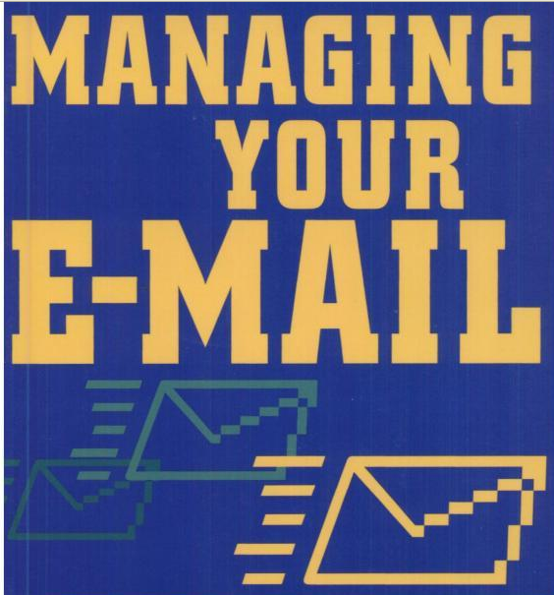
Managing Your E-Mail: Thinking Outside The inbox
by Christina Cavanagh
E-mail is one of the most useful and efficient business applications ever developed. However, many people today dread the chore of sorting through an inbox crammed with messages that don't concern them and spam they don't want. This book is a straightforward guide dedicated to helping workers and organizations tame the e-mail monster and take back their time.
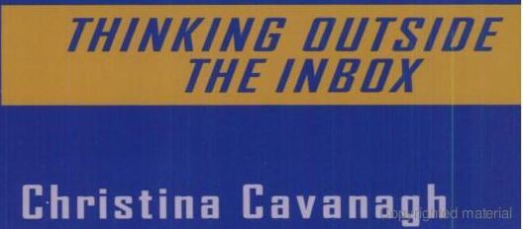
Managing Your E-mail is a simple, accessible reference for workers and organizations that want to get the most out of this ubiquitous and sometimes overwhelming method of communication. With new strategies for dealing with e-mail inefficiencies and practical tips on getting and staying organized, it will free up hours of time each week for what's really important. It examines the categories and patterns of e-mail misuse and presents practical, research-based explanations, solutions, and quick tips on topics such as best practices for responding to e-mail, when to choose more traditional communication methods over e-mail, how to structure an e-mail for high-impact, how to craft more readable and understandable messages, legal pitfalls to avoid, and more.

The Weblog Handbook: Practical Advice on Creating and Maintaining Your Blog
by Rebecca Blood

Weblogs—frequently updated, independently produced, and curiously addictive—have
become some of the most popular sites on the Web today. The Weblog Handbook is the first book to explain how weblogs work and explore their impact on the media landscape.
There is no formula for creating a superb weblog—but there are lessons to be drawn from maintaining one. In The Weblog Handbook, Rebecca Blood draws on her experience as an early participant in the weblog community to share what she has learned in three years of "living online."

With a clear and engaging voice, Rebecca explains how to choose among the available tools, even walking the beginner through the process of creating their first weblog. Along the way she answers commonly asked questions concerning weblog etiquette, how to attract readers, and the qualities that make a weblog stand out, alerting the novice to considerations—and pitfalls—they didn't know to ask about.
Finally, the author examines how the weblog community has grown and changed, the dangers confronting it, and the ways in which weblogs are affecting and affected by both online and offline culture. 22.
Blogging: Genius Strategies for instant Web Content
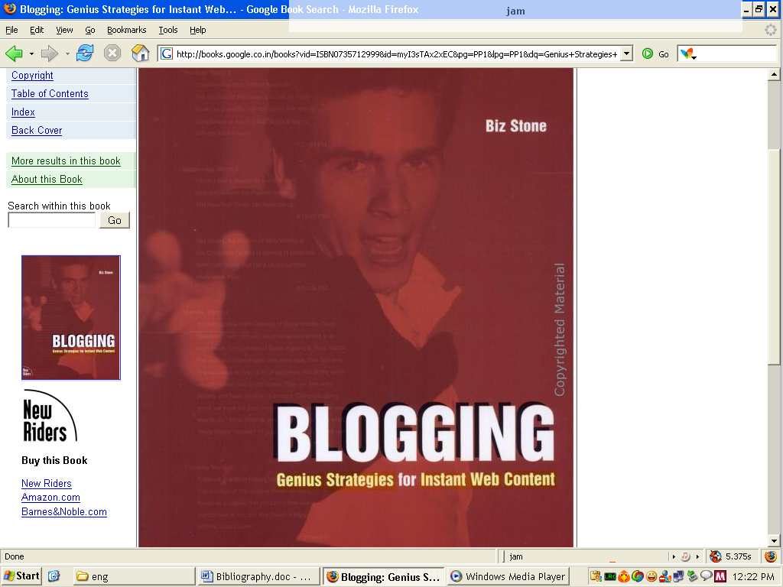
by Biz Stone
Turn your home page into a microportal with fresh content that will keep readers coming back. The first hands-on book on building blogs, this is an excellent tutorial for new bloggers, and includes many advanced techniques for veteran bloggers. Simply put, blogging is an easy way of updating a web page via a browser without the hassle of launching an FTP client or HTML editor. With all the templates, add-ons, and extra features associated with building this microportal, the blog is a new take on the home page. The blog brings the voice of its creator to the surface, builds it into the design, and keeps the content fresh and meaningful. This book features hands-on tutorials for building a blog, adding a user based commenting system, adding team members, syndicating with JavaScript, adding searches to a site, and much more. This is the book for creative web-enthusiasts looking for the 'next thing' and it's the first book of new ideas and advanced tutorials for bloggers already numbering in the hundreds of thousands.

Essential Blogging
by Shelley Powers, Cory Doctorow, J Scott Johnson, Mena G Trott,
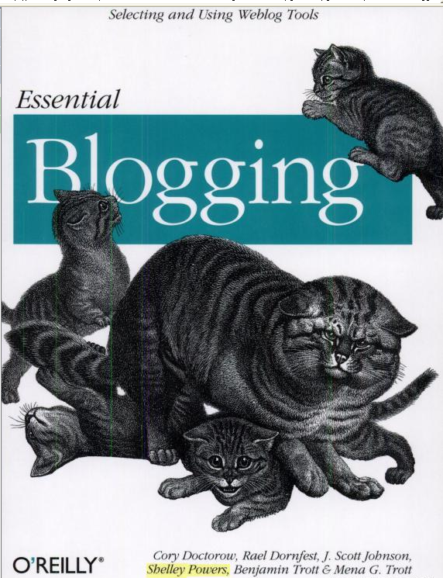
Benjamin Trott, Rael Dornfest
Anyone can run a blog. From personal diaries to political commentary and technology observations, bloggers are making their voices heard around the world. Essential Blogging helps you select the right blogging software for your needs and show how to get your blog up and running.
You'll learn the ingredients of a successful blog, and then get detailed installation, configuration and operation instructions for the leading blogging software: Blogger, Radio Userland, Movable Type, and Blosxom. After showing you how to acquire, set-up, and run these leading software packages. Essential Blogging takes you through the more advanced features, so that by the time you finish, you'll be up and blogging with the best of them.

Written by prominent bloggers and authors of blogging tools, Essential Blogging is a no-nonsense guide to the technology of blogging.
23.

www.webfoot.com/advice/email.top.html

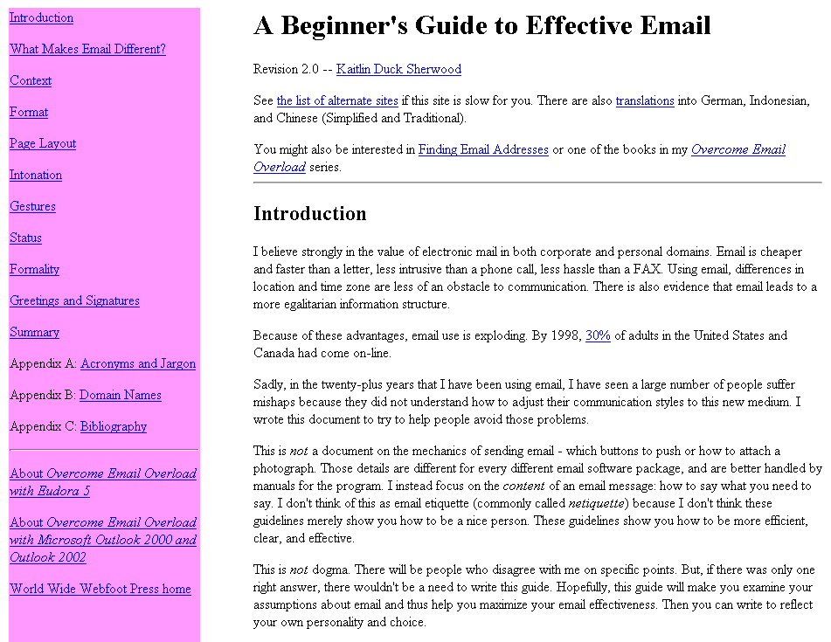

From the page: "This is not a document on the mechanics of sending e-mail—which buttons to push or how to attach a photograph. Those details are different for every different email software package, and are better handled by manuals for the program. I instead focus on the content of an e-mail message: how to say what you need to say. I don't think of this as e-mail etiquette (commonly called netiquette) because I don't think these guidelines merely show you how to be a nice person. These guidelines show you how to be more efficient, clear, and effective."

24.

www.dtcc.edu/cs/rfc1855.html

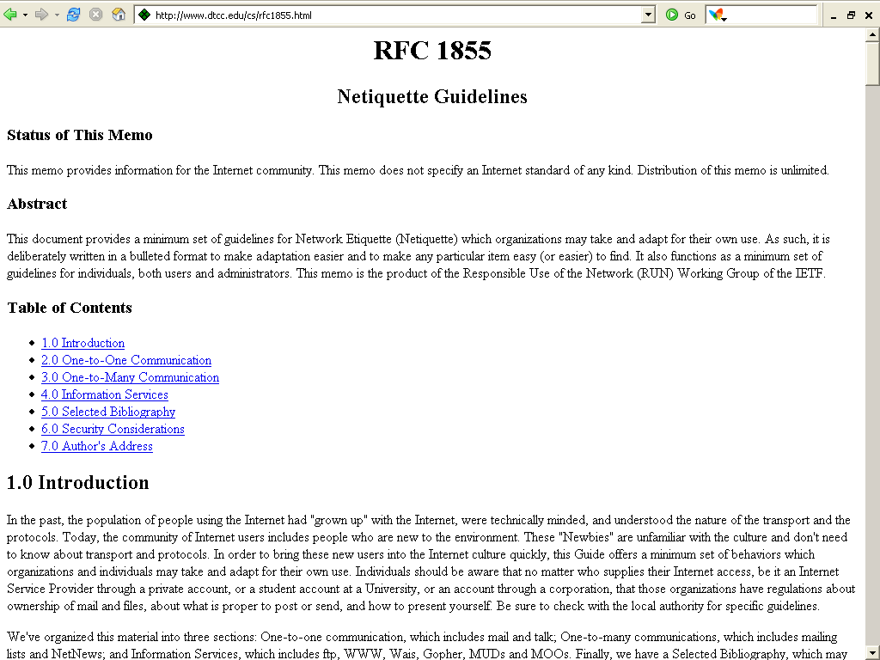

This document provides a minimum set of guidelines for Network Etiquette (Netiquette) which organisations may take and adapt for their own use. As such, it is deliberately written in a bulleted format to make adaptation easier and to make any particular item easy (or easier) to find. It also functions as a minimum set of guidelines for individuals, both users and administrators. This memo is the product of the Responsible Use of the Network (RUN) Working Group of the IETF (the Internet Engineering Task Force).

25.

www.thinkofit.com/webconf/afcnart.htm

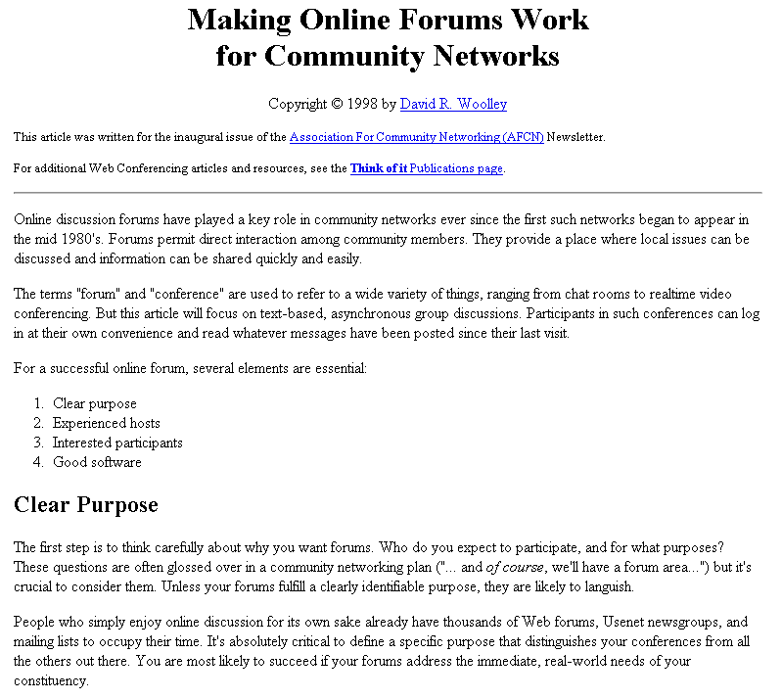

This page is actually a single article, with resources at the end. The article begins, "Online discussion forums have played a key role in community networks ever since the first such networks began to appear in the mid 1980s. Forums permit direct interaction among community members. They provide a place where local issues can be discussed and information can be shared quickly and easily. The terms 'forum' and 'conference' are used to refer to a wide variety of things, ranging from chat rooms to real-time video conferencing. But this article will focus on text-based, asynchronous group discussions. Participants in such conferences can log in at their own convenience and read whatever messages have been posted since their last visit..."

26.

