GIT SETUP

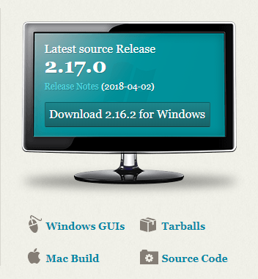

<https://git-scm.com/> - Download

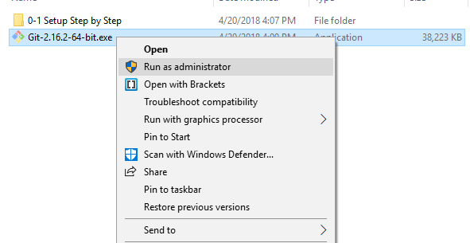

Run Git installer

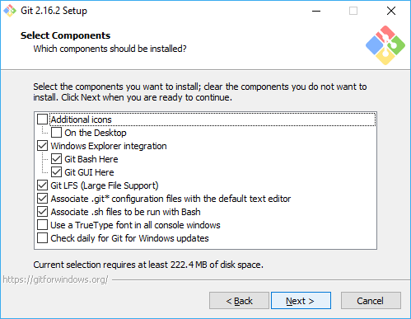

Next

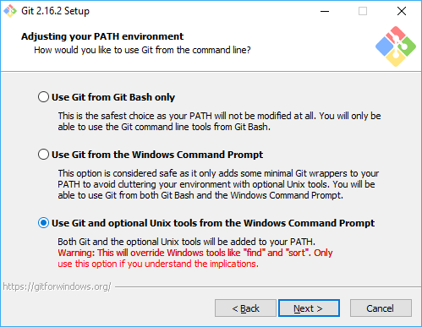

Next

GITHUB

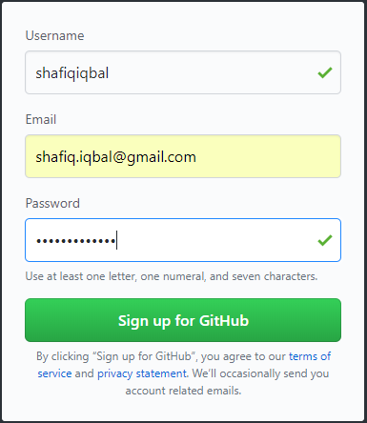

<https://github.com/> - sign up

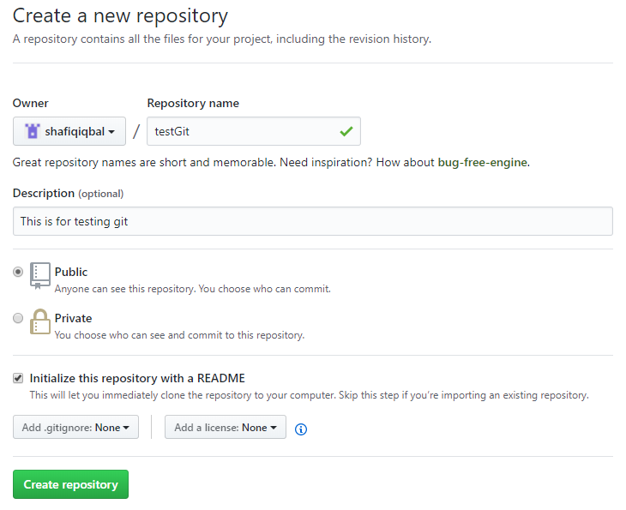

Create repository

Launch Git Bash

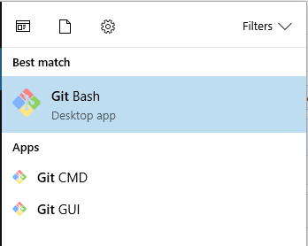

Open Git Bash

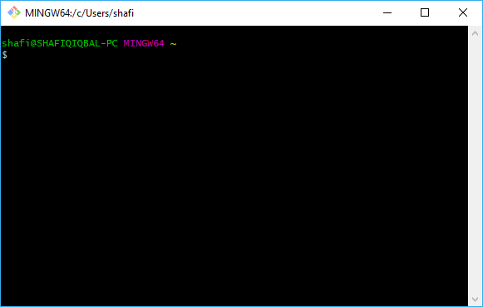

Git Bash is opened

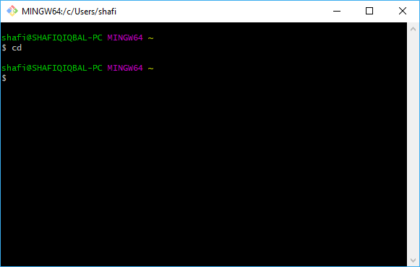

cd (change directory)

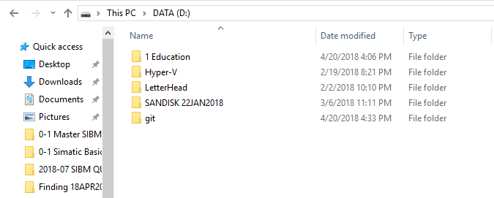

Create new folder – git

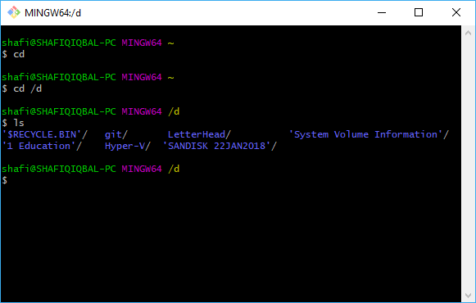

cd /d [change directory to D partition]

ls [list all files in D paratition]

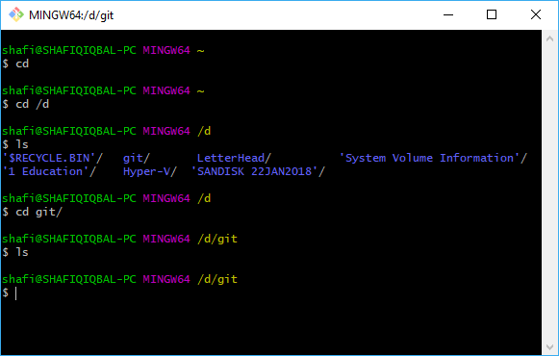

cd git/ [to go inside git folder]

ls [to list all files inside git folder]

Configure git account for github repository

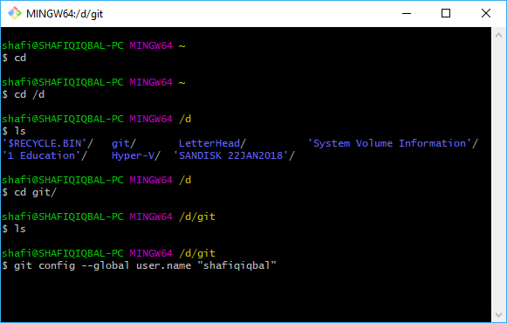

git config --global user.name “shafiqiqbal”

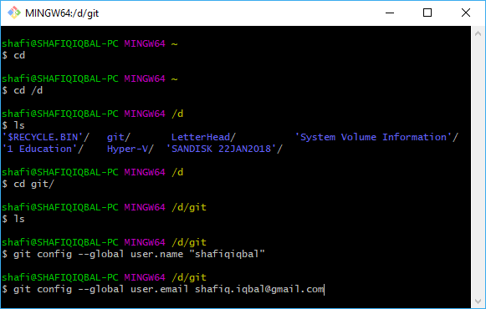

git config --global user.email [shafiq.iqbal@gmail.com](mailto:shafiq.iqbal@gmail.com)

Clone Repository in the Git folder

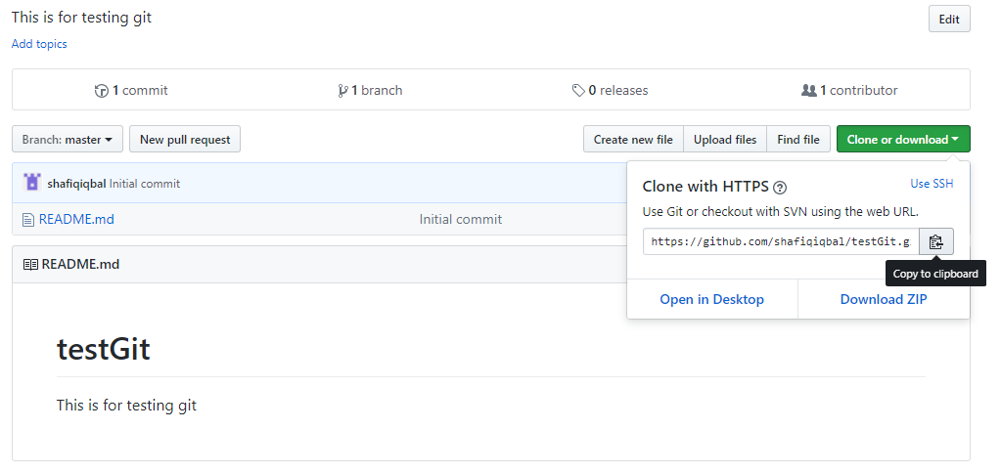

<https://github.com/shafiqiqbal/testGit> - Clone or download – Copy to clipboard

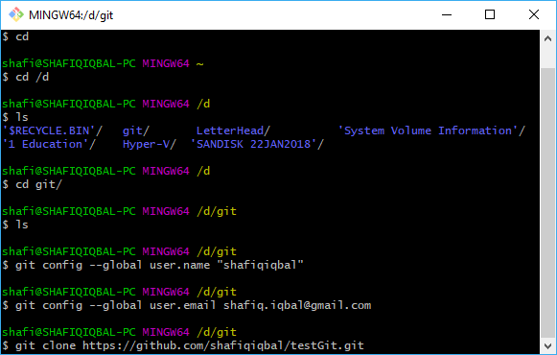

git clone <https://github.com/shafiqiqbal/testGit.git>

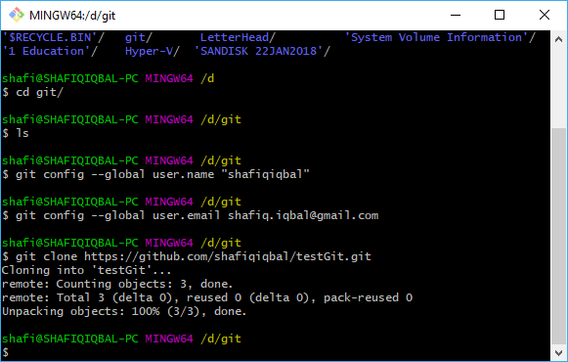

Repository is cloned

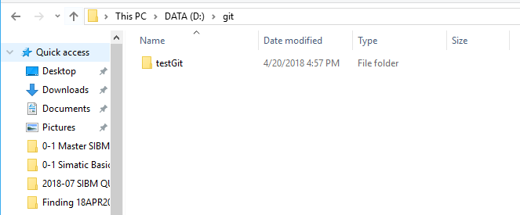

testGit folder (as per repository created in github) is created in git folder at laptop

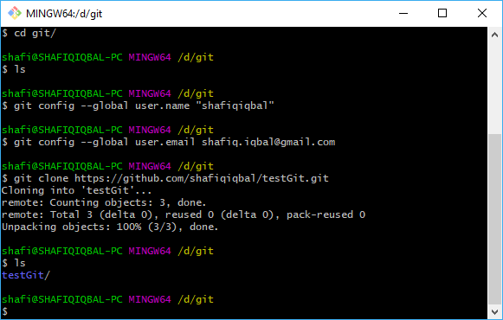

Verify through Git Bash

ls [list all files in testGit folder]

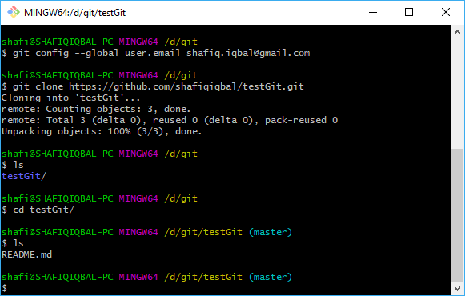

cd testGit/ [Go inside testGit folder]

ls [list all files inside testGit folder]

Create some file inside testGit folder at laptop

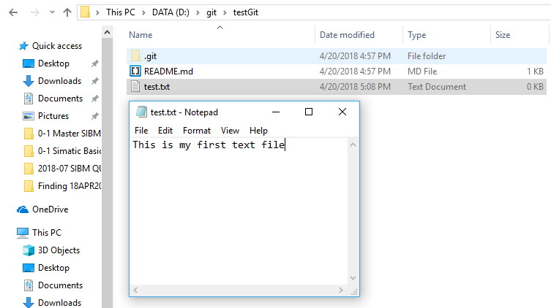

Create test.txt file

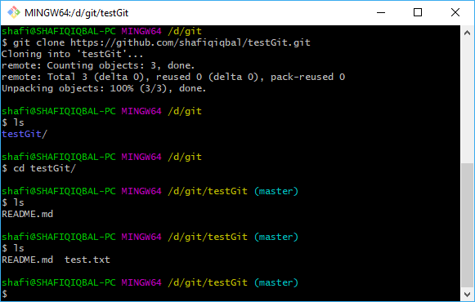

Verify through Git Bash

ls [list again all file in testGit folder – test.txt is there]

Uploading file (in this case test.txt) to github

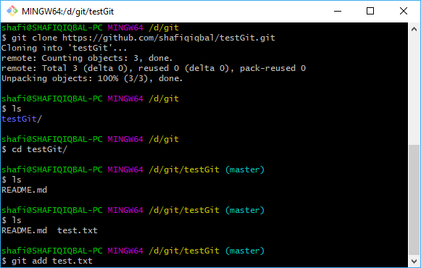

git add test.txt

Check status of the uploaded file through Git Bash

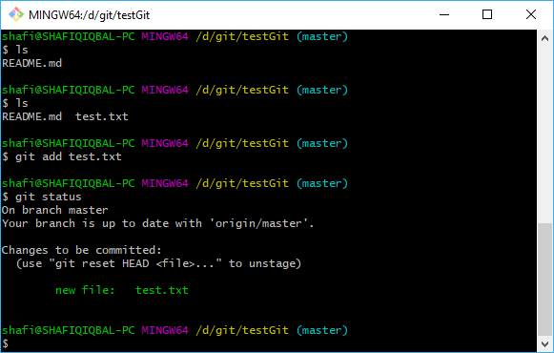

new file: test.txt

“Commit” to confirm uploading to github

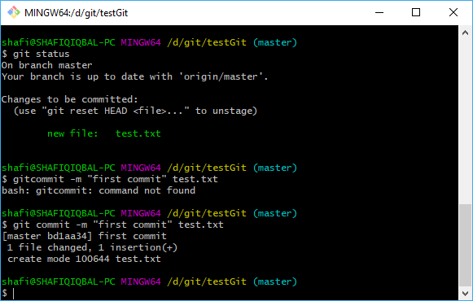

git commit -m “first commit” test.txt

Transferring test.txt file into github account

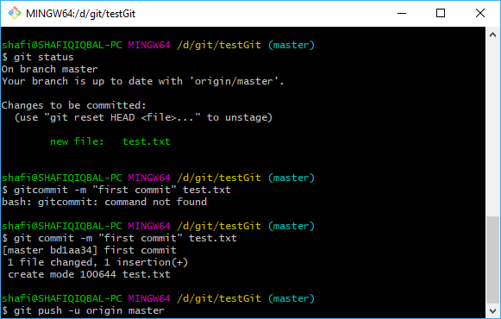

git push –u origin master

[-u = username]

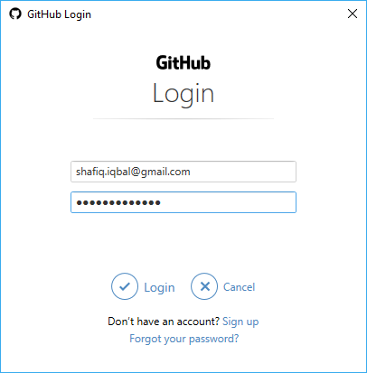

Key in github credential

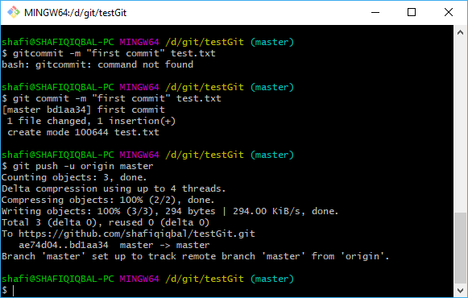

File test.txt is transferred to github account

Verification at github account repository

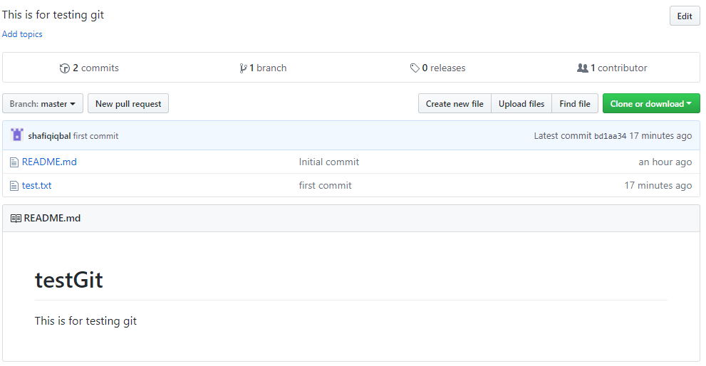

test.txt file is uploaded to github