|  |  |  |  |
| --- | --- | --- | --- |
| Matriculation Physics (SP015) | | | |
| Study Notes  &  Exercises | | | |
|  | Shafiq R |

Table of Contents

Chapter 1: Physical Quantities & Measurements 1

Dimensions 1

Scalars and Vectors 2

Multiplication of a vector 3

Unit Conversion 3

On Significant Figures 4

Chapter 2: Kinematics of Linear Motion 5

Instantaneous and Average Velocity (or acceleration) 5

Kinematic Equations 7

Derivation by calculus 7

Geometric Derivation 8

Projectile Motion (Motion in 2 Dimensions) 9

Chapter 3: Dynamics of Linear Motion 12

Types of Forces 12

Newton’s Law of Motion 14

Momentum 15

Chapter 4: Work, Energy and Power 19

Work 19

Work Energy Theorem 21

Energies 21

Power 22

Chapter 5: Circular Motion 23

Uniform Circular Motion 23

The case for conical pendulum 25

The case for vertical pendulum 26

Chapter 6: Rotation of Rigid Body 28

Revisions & Definitions 28

Analogy to linear kinematics 29

Rotational Dynamics 29

Chapter 7: Oscillations & Waves 35

Part 1: Simple Harmonic Motion 36

Kinematics of SHM 36

Energy in SHM 37

Case study 38

Part 2: Waves 40

Progressive Wave 40

Principle of Wave Superposition 41

Standing Wave 41

Travelling Wave Solution for String 41

Sound Waves 42

Chapter 8: Physics of Matter 46

Part 1: Material Changes due to Force 47

Stress 47

Strain 47

Young’s Modulus 48

Graph 48

Part 2: Material Changes due to Heat 50

Heat Conduction 50

Heat Expansion 52

Chapter 9: Kinetic Theory of Gases & Thermodynamics 54

Molecular Kinetic Theory 55

Kinetic Theory of Gases 55

Kinetic & Internal Energy 57

Thermodynamics 58

Zeroth law of Thermodynamics 58

First Law of Thermodynamics 58

Thermodynamical Processes 58

# Chapter 1: Physical Quantities & Measurements

**Learning Outcomes**

1. Define dimension, scalar and vector quantities.
2. Determine:
   1. the dimensions of derived quantities.
   2. resultant of vectors. (remarks: limit to three vectors only).
3. Verify the homogeneity of equations using dimensional analysis.
4. Resolve vector into two perpendicular components (*x* and *y* axes).

## Dimensions

Dimensions refer to the physical nature of a quantity. Regardless of the unit used, the physical nature of a quantity remains the same. For example, a distance, measured in the unit of metres, or feet, is still a measurement of length. This measurement, therefore has the dimensions of length, most commonly represented by **L.** In this instance, the equation is simply states that “The dimension of *d* is length (**L**)”. The following table shows some selected physical quantities and its dimensions:

|  |  |  |  |
| --- | --- | --- | --- |
| **Base Quantities** | | | |
| **Quantity** | **Symbol** | **S.I. Base Unit** | **Dimensions** |
| Length | *L* | metre (m) | L |
| Mass | *M* | kilogram (kg) | M |
| Time | *T* | second (s) | T |
| Electric Current | *I* | ampere (A) | I |
| Temperature | *T* | Kelvin (K) |  |
| Amount of substance | *n* | mole (mol) | N |
| Luminosity | *L* | candela (cd) | J |
| **Derived Quantities** | | | |
| **Quantity** | **Symbol** | **S.I. Base Unit** | **Dimensions** |
| Velocity |  |  |  |
| Acceleration |  |  |  |
| Momentum |  | Ns |  |
| Angular acceleration |  |  |  |
| Electric Charge |  | Coulomb (A s) |  |
| Energy |  | Joule () |  |

Once you understand what dimensions are and how to work with them, you can apply it to **verify the homogeneity of equations.** The word ‘homogeneity’ refers to ‘of the same kind’. Let us consider the equation where is displacement of a body, *t* is time taken for the displacement of the body, *u* is the initial velocity of the body and *a* is the acceleration of the body. To ‘verify homogeneity’, we can compare the dimensions the terms on the left-hand side and the right-hand side of the equation. That is to say, *s* must have the same dimensions as *ut* and . has the dimension of L, so does *ut* as well as .

Sample Problem 1.1:

Identify the dimensions for power, *P*, defined by where E is energy and has dimensions of and *t* has dimension of time, *T*.

Solution:

The dimensions for power are then .

## Scalars and Vectors

A scalar quantity is a quantity that is fully described by its magnitude. On the other hand, a vector quantity can only be fully described by both its magnitude **and** direction. When you talk about 5kg of rice, that statement is sufficient to describe the mass of the rice, this is where you can see that mass is a scalar quantity. If the rice is falling towards the Earth at a velocity of , 2 things matter here – how fast the rice is falling **and** the direction in which it is falling. Here you can see that velocity is a vector quantity.

A vector quantity is generally represented by a line segment with an arrowhead. The length of the line segment indicates its magnitude whereas its arrow head tells us the direction of the vector quantity. For example, say vectors and are represented by the following arrows,

If we were to compare and to , we’d say that vector has the same magnitude as but is in the opposite direction, this would tell us that . Vector , on the other hand, is in the same direction as . But its magnitude is smaller that . The magnitude of vector is denoted by . We can then relate vector to by the relation .

Another method to represent vectors is to list the values of its elements in a sufficient number of difference directions, depending on the dimension of the vector. Consider a vector in a 2-dimensional Cartesian coordinate system, a vector can then be represented by or , defining and as unit vectors in the x and y directions respectively. From this notation, one can easily calculate the magnitude (length) of the 2-vector using Pythagoras’ Theorem which gives

Vector additions (or subtractions) can then be done by adding (or subtracting) corresponding components. That is to say, if we have vectors and defined by , then the addition will yield

.

The implication of this definition of vector addition are the following rules:

1. Commutativity of vectors
2. Associativity of vectors

Resolution of vector is then simply

### Multiplication of a vector

3 cases to consider when talking about multiplication of a vector:

1. The vector is multiplied by a scalar, then
2. The **dot product** (also known as scalar or inner product) of two vectors, then

Note that in the dot product, the operation results in a scalar quantity.

1. The **cross product** (also known as the vector product) of two vectors, then

Note that in the cross product, the operation results in a vector quantity perpendicular to both the x and y axis.

Sample Problem 1.2:

Calculate the magnitude and direction of vector if it is defined by where and .

Solution:

|  |  |
| --- | --- |
| Magnitude: |  |
| Direction: |
| has a magnitude (length) of 7.071 and is in the direction of from the x-axis or from the y-axis. | |

## Unit Conversion

Unit conversions are so easy that we tend to overlook the importance of practicing it. Here’s a simple reminder on how to do it. Say you are given that and you are asked to calculate 8cm in inches, here’s how to do it:

🡨 divide both side by 2.54

🡨 now multiply it by 8

And that’s how you do unit conversion.

In Physics, it is quite often that we are expected to work with values in form of scientific notation. For example, rather than writing down the speed of light as , we’d express this value as . One issue that may arise from working with scientific notation when using a calculator is the redundancy in typing out “10^x”. To help with this, I would suggest that we take advantage of the **rules for exponents**. The example below demonstrates such application.

Sample Problem 1.3:

Evaluate *c* given that and , and .

Solution

Rather than evaluating this monstrosity as our input for the calculator, we can instead separate the coefficient from the base and its exponent to evaluate them separately.

In this form, the evaluation can be done **easily** even without a calculator.

## On Significant Figures

When we talk about the number of significant figures, we are talking about the number of digits whose values are known with certainty. This gives us information about the degree of accuracy of a reading in a measurement. In general, we should practice performing rounding off when the conditions call for it. This is to avoid false reporting. What we mean by false reporting is to give the illusion that our experiments are more sensitive than it actually it. For example, it would be very unlikely that our metre ruler to give reading in the micro scale.

|  |  |  |  |  |
| --- | --- | --- | --- | --- |
| Number | Number of significant figures |  | Number | Number of significant figures |
| 2.32 | 3 |  | 2600 | 2 |
| 2.320 | 4 |  | 2602 | 4 |

When we do calculations, there are some rules (based on the operations) we should be aware of when stating the significant figures of the end value:

1. Multiplication / Divisions – number of significant figures in the result is the same as the least precise measurement in the least precise measurement used in the calculation.

**Example:**

1. Addition / Subtraction – The result has the same number of decimal places as the least precise measurement used in the calculation.

**Example:**

1. Logarithm / antilogarithm – Keep as many significant figures to the right of the decimal point as the are significant in the original number.

**Example:**

# Chapter 2: Kinematics of Linear Motion

**Learning Outcomes (LO)**

1. Define:
   1. instantaneous velocity, average velocity and uniform velocity; and
   2. instantaneous acceleration, average acceleration and uniform acceleration.
2. Derive and apply equations of motion with uniform acceleration

; ; ;

1. Describe projectile motion launched at an angle, θ as well as special cases when θ=0°
2. Solve problems related to projectile motion.

In this chapter, we talk about kinematics of linear motion. Dynamics is the study of motion of bodies under action of forces and their effects. One subbranch to the study of dynamics is kinematics. In the study of kinematics, we consider only the motion of the bodies without worrying too much about the forces that caused the bodies to move. We only worry about the geometry of the motion.

## Instantaneous and Average Velocity (or acceleration)

Let us start with reminder of some ideas and terms that you have learnt in your SPM days. 3 mains terms – displacement (), velocity () & acceleration (). Displacement, denoted by , simply refers to the change in position of a body. Velocity, , refers to the rate of change of this change in position, i.e. . Acceleration, , is defined by the rate of change of velocity, which is the rate of change of the rate of change of position. That is .

Once we have established that, we can further extend our ideas of velocity and acceleration by thinking about ***instantaneous*** velocity (or acceleration)and ***average*** velocity (or acceleration). By ‘instantaneous’, we mean ‘at a particular instant in time’. When we combine it with velocity (or acceleration), what we mean is velocity (or acceleration) at a particular instant in time. On the other hand, when we say ‘average’, what we mean is ‘over the course of a defined time span’. So, when we say ‘average velocity’, we usually would accompany it with ‘between time and ’ or ‘in 30 seconds’, specifying a range of time.

Let us now have a graphical representation. Consider a body moving at constant velocity,

When we talk about instantaneous velocity, we are asking about a single point in time. From the displacement-time graph, the gradient represents the velocity of the body. As we can see from the graph, the instantaneous velocities when and are different. This is simply because the body is moving at a non-uniform velocity. If the instantaneous velocities are the same, then we call the motion is described as uniform velocity.

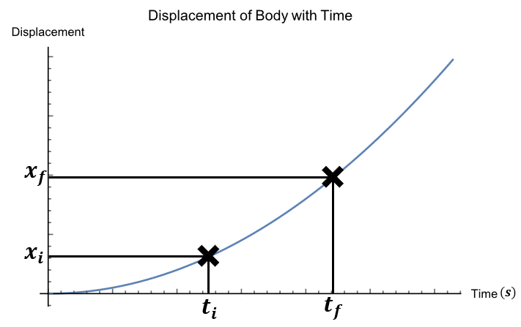On the other, talking about ***average*** velocity, we simply define range of time, thus choosing two points in time rather than one. Then we take the difference in position and divide it by the difference in time to calculate the ***average*** velocity. That is to say, for the graph below,

We can calculate the average velocity as

We can take the same approach and understanding and apply it to acceleration, but with a velocity time graph rather than a displacement time graph.

|  |
| --- |
| Sample Problem 2.1  The motion of a body is described by the equation , where is in metres per second and is in seconds. Calculate the instantaneous velocity of the body at and the average acceleration between and .  **Answer:** |
| Sample Problem 2.2  The motion of a body is shown in the graph shown in Figure 1. Calculate the displacement of the body and calculate the average velocity of the body. **Answer:**  Displacement of the body can be calculated by recognising that the area under the velocity -time graph represents the displacement of the body. So all we need is to sum up all the areas under the graph.  The average velocity can be calculated by simply dividing the displacement by the total time of motion. |

## Kinematic Equations

Now we want to look at kinematic equations, which are equations that relates variables that describes motion such as displacement, velocity and acceleration.

### Derivation by calculus

We’d like to derive the equations from our understanding of linear motion and using calculus. We begin with the definition of acceleration

Assuming constant acceleration, we can rearrange then integrate both sides to yield

Adjusting such that , and defining , .

And then rearranging this equation yields

which is the same equation as the first equation found in LO2. Simply put, the final velocity of a body is initial velocity plus the product of acceleration and time difference.

We can take the same approach to find the third equation in LO2 using the first equation. We start with the definition of velocity and then rearranging it,

Note that since velocity is not a constant, cannot be directly integrated. We therefore need an equation for velocity as a function of time (first equation).

Since and are constants, these integrals become

Solving this integral gives

For the second equation, we can start take advantage of calculus by starting with a time independent derivative,

Rearranging this gives us the needed integral to solve

Further rearrangement yields an equation

matching with the third equation found in LO2.

Equation 4 of LO2 does not require any integration, rather we can obtain it using and . This is left for the reader to do.

### Geometric Derivation

By definition,

Rearranging this gives

Consider an object that starts its motion with velocity and maintains its constant acceleration to a final velocity of . We can describe its motion diagrammatically as below

Since the area under the graph represents displacement, all we need to do is to add up the area of A and B. If

then

If, on the other hand, we consider

Then we find that

For the equation of , we can start the derivation by considering

And

We can substitute time equation into the displacement to yield

|  |
| --- |
| Sample Problem 2.3  A 2022 Honda Accord can travel down a mile track in from rest. Calculate the acceleration (in SI units), assuming that its acceleration is constant.  **Answer:**  Values given  Choice of equation |
| Sample Problem 2.4  A car initially travels at . If the car undergoes constant acceleration of , determine the time the car need to reach double of its initial velocity.  **Answer:**  Values given  Choice of equation |

## Projectile Motion (Motion in 2 Dimensions)

When dealing with motion in two dimensions, the minimum that we need is the Pythagorean theorem as well as the definition of tangent. We consider a vector defined by

where and are component vectors of , each parallel to one of the axes in a rectangular coordinate system.

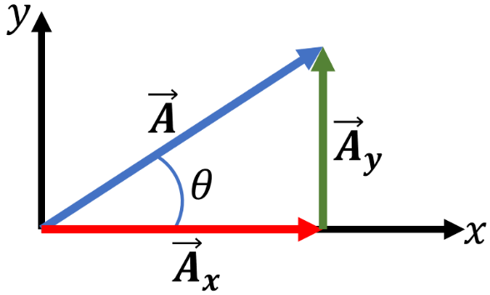

It then follows that the magnitude and direction of can be related to its components by the Pythagorean theorem and the definition of tangent,

Conversely, we can work out the components of from the magnitude of and the angle ,

One case study that we can do on two-dimensional motion is **projectile motion,** a motion that follows a parabolic path. The simplest case of projectile motion would be one where the air resistance and the rotation of the Earth is simply neglected, and that the motion is only affected by the Earth’s gravity (). One important aspect of this case is that the horizontal (x-direction) and vertical (y-direction) motions are independent of each other. This means that the kinematics equation we have studied earlier can be dealt with separately for both x and y directions.

Keeping in mind that and , we can then work out the 6 equations that describes the projectile motion:

|  |  |
| --- | --- |
| x-direction (where ) | y-direction (where ) |
|  |  |
|  |  |
|  |  |

We can also work out the velocity of the projectile by keeping in mind that it merely follows from Pythagorean theorem

If we substitute the equation for time-x-component, , in the equation for displacement in y-direction, , what we get is the parabolic equation for the projectile motion path,

There are two more items that are of our interest:

1. If we were to look for the “**peak**” of the parabolic path, we can do so by applying to the kinematics equations. This is simply because it is at this peak that such that the velocity of the projectile is momentarily zero before the projectile falls back down towards the Earth.
2. Another item that would be of our interest is the **range** of the projectile motion. By range, what we are referring to is the point at which the projectile reaches back to ground or stop accelerating in the y-direction. This would differ from case to case, of course, and we shall demonstrate in the sample problems following this.

|  |  |  |
| --- | --- | --- |
| Sample Problem 2.5  An object is launched at a velocity of in a direction making an angle of upward with the horizontal.  Calculate   1. Initial velocity in x and y direction. 2. the location of the object at . 3. the total horizontal range. 4. the velocity of the object just before it hits the ground.   **Answer:**       |  |  | | --- | --- | |  |  | |

|  |  |  |  |  |  |  |  |  |  |  |  |  |  |  |  |  |  |
| --- | --- | --- | --- | --- | --- | --- | --- | --- | --- | --- | --- | --- | --- | --- | --- | --- | --- |
| Sample Problem 2.6  Compare the horizontal range of a ball thrown at velocity 35 if the angle of release is , and .  **Answer:**   |  |  |  |  |  |  |  |  |  |  |  |  |  |  |  |  |  | | --- | --- | --- | --- | --- | --- | --- | --- | --- | --- | --- | --- | --- | --- | --- | --- | --- | | Condition for determining horizontal range .               |  |  |  | | --- | --- | --- | |  | (s) |  | |  | 6.89244 | 62.4363 | |  | 6.17959 | 108.143 | |  | 5.04562 | 124.873 | |  | 3.56779 | 108.143 |   The horizontal range peaks at . |  | |

# Chapter 3: Dynamics of Linear Motion

**Learning Outcomes**

1. Define
   1. Momentum,
   2. Impulse,
2. Solve problem related to impulse and impulse-momentum theorem,

*\*1D only*

1. Use *F*-*t* graph to determine impulse.
2. State:
   1. the principle of conservation of linear momentum.
   2. Newton’s laws of motion.
3. Apply
   1. the principle of conservation of momentum in elastic and inelastic collisions in 2D collisions.
   2. Newton’s laws of motion.

*\*include static and dynamic equilibrium for Newton’s first law motion*

1. Differentiate elastic and inelastic collisions. (remarks: similarities & differences)
2. Identify the forces acting on a body in different situations - Weight, *W;* Tension, *T;* Normal force, *N;* Friction, *f;* and External force (pull or push), *F*.
3. Sketch free body diagram.
4. Determine static and kinetic friction, ,

In the previous chapters, we have looked at describing motion without the hassle of asking, “what force is causing the body to move?”. In this chapter, we aim to expand our knowledge to a body’s motion in that very aspect.

## Types of Forces

We begin with asking the question, “what is force?”, a simple answer would be to say force is a push and pull. Here, however, let us define force a bit further. Let us define force as **an agent for motion change**. Force is a vector quantity, that means **direction matters**. Two oppositely directed force acting on the same body work against each other. A body can experience multiple forces acting on it, however it is the net force, i.e., the resultant of all the forces acting on the body, that changes the motion of the body.

4 types of forces we’d consider in this chapter – gravitational (weight), tensional, normal and frictional. Their definitions and directions are as follows:

|  |  |  |
| --- | --- | --- |
| Forces | Definitions | Directions |
| Gravitational | Force exerted upon a body interacting with a gravitational field. | Towards the gravitational source. |
| Tensional | Force transmitted axially through a massless one-dimensional continuous element. | Along the one-dimensional continuous element. |
| Normal | Support force, perpendicular to the surface, exerted upon a body in contact with a stable object. | Perpendicular to the surface the body is in contact with. |
| Frictional | Force acting upon bodies that are in contact and moving relative to each other. | Against the direction of motion. |

One particular type of force that maybe be of our interest is frictional force. This is because frictional force depends on the motion of the object. If the object is static, then it is subject to *static friction*. On the other hand, if the object is moving (relative to the surface it is in contact with) at some velocity, and therefore has some kinetic energy, then the object is subject to *kinetic friction*. Static friction is generally higher than kinetic friction because of the asperities (roughness) of the surfaces of the contacting bodies. This asperity enables the surfaces to interlock with each other, causing adhesion. This means that the force applied to the body must overcome this adhesion before the bodies can start moving relative to each other. This phenomenon can be observed by looking at the frictional force as a function of applied force graph:

As the applied force is increased, so does the frictional force. This is true until a certain threshold is reached, after which the body will start to move. This threshold is exactly the unlocking of the asperities.

|  |  |  |  |  |  |  |
| --- | --- | --- | --- | --- | --- | --- |
| Sample Problem 3.1   |  |  |  | | --- | --- | --- | | Determine the resultant force exerted on the body shown in the diagram. | |  | | Solution |  | | |

|  |  |  |  |  |  |  |  |  |  |  |  |  |  |  |  |  |  |  |  |  |  |
| --- | --- | --- | --- | --- | --- | --- | --- | --- | --- | --- | --- | --- | --- | --- | --- | --- | --- | --- | --- | --- | --- |
| Sample Problem 3.2   |  |  | | --- | --- | |  | Calculate the resultant force if , and | | Solution   |  |  |  |  |  |  |  |  |  |  |  |  |  |  |  |  |  | | --- | --- | --- | --- | --- | --- | --- | --- | --- | --- | --- | --- | --- | --- | --- | --- | --- | | |  |  |  | | --- | --- | --- | | Force | x-components | y-components | |  |  |  | |  |  | 0N | |  | 0N |  | |  | 21.16N | -12N | |  | | | |

## Newton’s Law of Motion

There are laws of motion that a moving under force would generally follow. These laws were first introduced and came into its modern form via Newton’s *Principia*. In it, 3 laws of motions were found:

1. A body, when no external force is applied, will not undergo velocity change, i.e.
2. When a force is acted upon it, a body will move in a manner such that rate of momentum change is equal to the said force, i.e.
3. Forces exerted onto two interacting bodies will be equal in magnitude but opposite in direction.

If    is force exerted onto body 1 by body 2, then

These three laws form the foundation for what is known today as the *Newtonian Laws of Motion*.

## Momentum

The first and third requires no further definitions of variable, however the second one, mentions an idea of ***momentum***. It seems useful to define this term at this point. What we mean by momentum at this point is the property of a moving body that rises from the product of the mass the body and its velocity, i.e.

If the velocity of the body changes (and therefore so does the momentum of the body in question), we quantify that change and call it ***impulse***:

This also means that the area under the F-t graph represents impulse.

It is from Kinematics that we know a change in velocity means a non-zero acceleration. Knowing this as well as Newton’s Second Law, we can say that force is present when acceleration is non-zero,

This statement, of course can be derived quite simply from Newton’s Second Law of motion:

Here we can see that a change in mass may also produce force and that if mass change is zero, then what we have is the equation seen before,

|  |  |  |  |  |
| --- | --- | --- | --- | --- |
| Sample Problem 3.3  Suppose an object of 15 kg is placed on an incline plane of from the horizontal. Calculate the magnitude of frictional force that keeps the object from sliding down the incline plane.  Solution   |  |  | | --- | --- | |  | Since the object stays static | |  |  | |
| Sample Problem 3.4   |  |  |  |  | | --- | --- | --- | --- | | Problem:  Based on the diagram, calculate the acceleration of both the objects. | Solution   |  |  | | --- | --- | |  | Equation of motion for 5kg body:  Equation of motion for 5kg body:  Rearrange for a, |   The 2kg object will move **upwards** at .  The 5kg object will move **downwards** at . | |  | |
| Sample Problem 3.5  A 50g ball at 30 is travelling towards a wall. Upon striking the wall, the ball bounces back in the opposite direction at a speed of 10. Calculate the impulse.  Solution  ; |
| Sample Problem 3.6  A footballer kicks a 300g ball from rest to a speed of in a collision lasting . Calculate the force generated by the footballer.  Solution  Since , then |

One of the ways for bodies to interact is through collisions. When this happens, assuming this happens in an isolated system. The total momentum of the system doesn’t change with the passage of time. The momenta of the participating bodies may change, but not the vector sum total momentum of the system. When we say that a quantity doesn’t change, we say that the quantity is **conserved**. So, in this case, we say that the **total momentum is conserved**. Conservation of momentum is simply

When we talk about collisions, we may consider two types of collision – elastic and inelastic collisions. Note that whilst momentum is conserved in **all** types of collisions, kinetic energy is not as it may be converted into other forms of energy (e.g., sound energy). It is this exact parameter from which we differentiate elastic from inelastic collisions. A perfectly elastic collision is defined by a collision in which both momentum and kinetic energy is conserved whilst a perfectly inelastic collision is a collision in which conservation of kinetic energy is not obeyed.

|  |
| --- |
| Sample Problem 3.7 (Conservation of momentum)  Ball A of mass 30g, travels at collides head on with Ball B of 50g at rest. Calculate the velocity of Ball B after the collision if Ball A has the final velocity of .  Solution  in the same direction as Ball A. |
| Sample Problem 3.8 (Conservation of momentum in 2 Dimensions)  Ball A of mass 3kg, travels at in the positive x direction collides with Ball B of 5kg travelling at in the positive y direction. If the balls stick together after the collision, determine their velocity.  Solution  Need to apply conservation of momentum in x and y direction separately.   |  |  |  | | --- | --- | --- | |  | X | Y | | Momentum before |  |  | | Momentum after |  |  | | Final velocity | ---(1) | ---(2) |  |  |  | | --- | --- | |  |  | |
| Sample Problem 3.9 (Perfectly Elastic Collision)  A ball, travelling at , collides head on with another ball of the same mass, travelling in the opposite direction. Determine their velocities post-collision?  Solution  Let us assume that ball 1, travelling at , initially travels in the positive direction such that  Since the balls are of the same mass,  Assuming the collision is elastic, the system would obey both the conservation of momentum and the conservation of kinetic energy.  2 possible set of answers  Option 1: , (which is just the initial case)  Option 2: (a more sensible answer) |
| Sample Problem 3.10 (Perfectly Inelastic collision)  A ball of mass 0.5kg, travelling in the +x direction at , collides with another ball of mass 0.2kg travelling in the opposite direction at . After the collision, the balls stick together and travels at the same speed. Determine the final velocity and its direction. Compare the kinetic energies before and after the collision.  Solution  Applying conservation of momentum,  in the positive x direction  To compare the kinetic energies, we can take their difference.  This means 0.875J of kinetic energy has been converted into energies of other forms |

# Chapter 4: Work, Energy and Power

**Learning Outcomes**

1. State:
   1. the physical meaning of dot (scalar) product for work:
   2. the principle of conservation of energy.
2. Define and apply
   1. work done by a constant force.
   2. Gravitational potential energy,
   3. Elastic potential energy for spring,
   4. Kinetic energy,
   5. work-energy theorem,
   6. average power, and instantaneous power,
3. Determine work done from a force-displacement graph.
4. Apply the principle of conservation of mechanical energy.

## Work

Let us begin by defining work. The work on an object, *W*, is defined to be the product of magnitude of the displacement, *s*, and the force component parallel to the displacement of the object , i.e.

Notice that it is not the product of force and displacement but the product of displacement and force component, the important characteristic of that particular force component is that it must be parallel to the displacement. The diagram below illustrates this point, we cannot simply multiply the magnitude of . We must find the component of force that **is** parallel the displacement, and then we can find their product.

This of course means that in the force-displacement graph, work done by a force is equal to the area under the graph. That is to say, the work done to displace an object from is simply

|  |  |  |
| --- | --- | --- |
| Sample Problem 4.1  A block is pulled with a force of 50N (directed from the horizontal) on a smooth horizontal surface for 5m. Calculate the work done by the pulling force.  Answer:   |  |  | | --- | --- | |  |  | |
| Sample Problem 4.2  A block is pushed with 5N in the positive x direction for on a horizontal surface. If the block travels at constant speed, calculate the work done by frictional force, work done by the applied force and the total work done.  Answer   |  |  | | --- | --- | |  | Since the block travels at constant speed,  That means the magnitude of frictional force is equal to the magnitude of applied force, but acts in the opposite direction. |   Similarly, |

## Work Energy Theorem

When an object moves, we say it contains kinetic energy. Kinetic energy quantifies the amount of energy a moving object has. It depends on the velocity of the moving object,

Now what we want to do is to show a relationship between the quantity related to moving object (kinetic energy) and another quantity related to the changes of object position (work).

We begin with the definition of work done on an object and Newton’s Second Law of motion to show that

Assuming that the force is constant and therefore the acceleration is also constant, we can then apply equation of kinematics

This show derivation brings about an important theorem, called the work-energy theorem. This theorem states that the work done onto a body is equal to the change in kinetic energy of the body.

|  |
| --- |
| Sample Problem 4.3  A 150g block begins travelling along a horizontal surface at 4.20 . If the kinetic friction coefficient between the block and surface is 0.45, calculate the distance that the block moves before coming to a stop.    Answer: |

## Energies

Two more energies that are of interest to us. The first is the gravitational potential energy, which is the energy contained in an object due to its position, measure from a gravitational source. A more detailed analysis is found in the Newtonian Gravity part of this course. At this point, it is sufficient for us to know that if an object of mass *m* is position at height *h* from the surface of the Earth, then the gravitational potential energy found in that object is

The second type of potential energy of interest is the elastic potential energy of a spring. By Hooke’s Law, the force acting on a spring is direction proportional to its extension (or compression).

We can then utilize work energy theorem to find the elastic potential energy of a spring,

Apart from the conservation of momentum, another important principle of conservation crucial to our study of moving bodies is the **principle of mechanical energy conservation.** The law simply states that the sum of all kinetic energy and all potential energy must remain constant at all times. That is to say

|  |
| --- |
| Sample Problem 4.4  An 2kg object was released from 20m height. Calculate its velocity just before striking the ground.    Answer:  Initially the object would have gravitational potential energy of  This energy is then converted fully into kinetic energy at  Therefore, the amount of kinetic energy possessed by the body will be 392.4J. |

## Power

Now that we have familiarize ourselves with work and energy, let us now talk about **power**, which is simply defined by the rate of work done. Average power refers to the work done within a time interval,

On the other hand, instantaneous power refers to the mechanical power at one instant in time

|  |
| --- |
| Sample Problem 4.5  Calculate the average power required to lift a 75kg man to a height of 10m in 2minutes.  Answer:  By work energy theorem, |
| Sample Problem 4.5  Calculate the instantaneous power required to lift a 75kg man at 0.09.  Answer: |

# Chapter 5: Circular Motion

**Learning Outcomes**

1. Define and use:
   1. angular displacement,
   2. period, *T*
   3. frequency, *f*
   4. angular velocity,
2. Describe uniform circular motion.
3. Convert units between degrees, radian, and revolution or rotation.
4. Explain centripetal acceleration and centripetal force,

and

1. Solve problems related to centripetal force for uniform circular motion cases: horizontal circular motion, vertical circular motion and conical pendulum.

*\*exclude banked curve*

## Uniform Circular Motion

Consider moving a body from coordinates (0,r) to (r,0) whilst keeping the same distance *r,* from the origin (0,0). The motion that has taken place is what is known as a **rotation** and the path the body has taken is what we consider to be **circular**. We call it **circular** simply because throughout the motion, a fixed distance *r* was kept between the origin and the object. This is shown in in the diagram 4.1. This transformation may be easy enough to see and describe as it is simply a rotation. However, dealing with rotations using Cartesian coordinates can get really complicated. So let us propose new method of describing such motion.

In linear dynamics, we started with displacement *x* and took derivatives of it twice over to obtain acceleration. In dealing with rotational motion, let us instead begin with angular displacement, . The rate of change of this angular displacement, we can then call **angular velocity** , and the rate of change of angular velocity is what is known as **angular acceleration**.

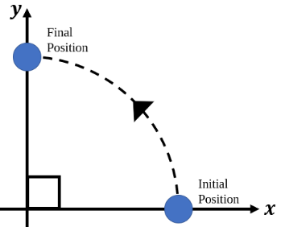

Diagram 5- 1

If we define in radian, then we can work out the arc length of the object’s path using

It is at this point, it is useful for use to know the conversion between angles in radians and angles in degrees, which is . A sample conversion practice is demonstrated in Sample Problem 5.1.

|  |
| --- |
| Sample Problem 5.1  Convert the following angles to its alternative units:   1. radians   **Answer:** |

If we differentiate the arc length with respect to time, what we get is quite simple the tangential velocity *v*, which is the speed at which the body covers said length.

We may apply the same logic to find the tangential acceleration and relate it to angular acceleration ,

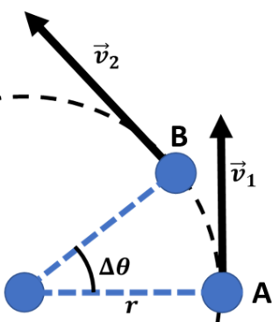Now we ask what direction are these quantities, tangential velocity and tangential acceleration? As the name suggests, they have the direction tangent to the circular path, illustrated in Diagram 5-2. Now, tangential acceleration alone will not be enough to ensure the body in motion to follow a circular path, we now need an acceleration towards the centre of the circle, called a **radial (centripetal) acceleration,** generally denoted by . Together with the tangential acceleration, they combined and ensures the body follows a circular path.

Diagram 5-3

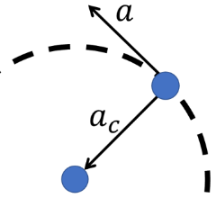

Diagram 5- 2

We can now work out the equation for this centripetal acceleration. We can begin by reminding ourselves that the effect of centripetal acceleration is the change in direction. Mind that the speed does not change, but the direction changes. Referring to Diagram 5-3, we can see that if is relatively small,

We also know that the change in arc length is related to the change in the angle,

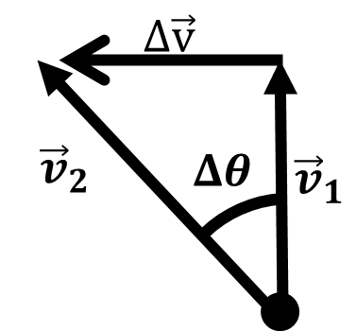

Diagram 5- 4

This means that

The force associated with this centripetal acceleration is known as the **centripetal acceleration** and follows the equation

Centripetal force is **not** a type of force per se. Rather it is a way to say a force is acting as a centripetal force. For example, the gravitational force causes the moon to curve and travel in a circular path around the earth. In this instance, the gravitational force acts as a centripetal force. The way we can think about this is when we talk about retarding force, that retarding force in linear motion could be friction force or any other applied force acting opposing to the direction of motion. In the case of centripetal force, any force could act as centripetal force if it is the force that causes the body to follow a circular path.

When we work with bodies following a circular path, we know that after , the object has returned to its initial position. We say that it has undergo one full revolution. The time the body take to travel one revolution is what we call **period** *T,* and the number of revolutions per unit time is what we call **frequency** *f***.** Frequency and period is merely the inverse of each other.

## The case for conical pendulum

The conical pendulum is a system of pendulum in which rather than having the pendulum bob swing back and forth in a single place, the path of the pendulum bob is circular about a center, whereby the string along with the pendulum bob traces a cone.

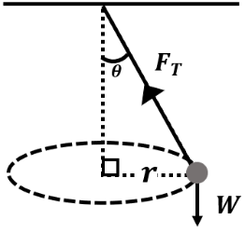 Consider a conical pendulum consisting of a bob of mass *m* revolving without friction in a circular path at constant speed *v* on a string of length *l* at an angle from the vertical, as shown in Diagram 5-5. We can see that two forces acting on the pendulum bob, tension along the string and weight of the pendulum bob. The tensional force can be resolved into its horizontal component , and its vertical component .

Diagram 5- 5

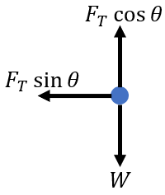Applying Newton’s second law, we find that

To find the angle from the vertical,

To find the period for the pendulum,

Noting that , the period of the oscillation is therefore

We can see that in the case for the conical pendulum, the period is independent of the mass used, rather it depends on the length of the string used.

## The case for vertical pendulum

Consider swinging a ball of mass *m* vertically via a string of negligible mass, such that it follows a circular path with radius *r*. The path could be illustrated as shown in Diagram 5-6.

When the ball is at the top of the path, we can see that the tensional force is directed in the same direction as the ball’s weight. On the other hand, when the ball is at the bottom of the path, the tensional force is directed in the opposite direction of the weight of the ball.

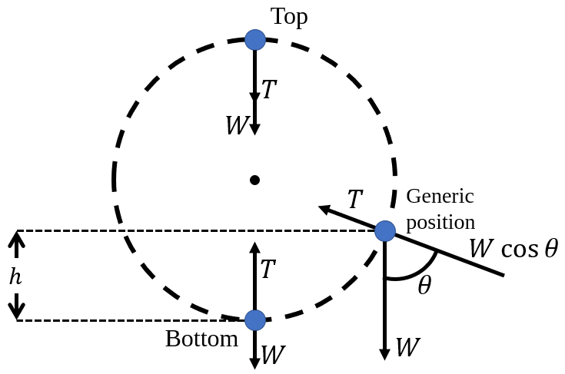

Diagram 5- 6

We can apply compare the velocities of the ball at any generic position on the path using conservation of energy.

We can see that the velocity of the ball is not constant as it follows the vertical circular. In this case, we do recognize that it is the ball undergoes circular motion but not **uniform** circular motion. This is of course if the tensional force along the string is constant. If different tension is applied along the circular path, then it is possible to ensure **uniform circular motion**.

Let us compare then the tension needed at the top and the bottom of the circular path. At the bottom, the tension is pointing upwards and the weight is pointing downwards. We then have . At the top, the tensional force and the weight is pointing in the same direction (downwards) and therefore we have .

Now if we consider the forces acting on the ball at the generic position,

From the figure, we find to be

As such, we may express the tensional force along the string to be

Expressing this in terms of the speed at the bottom gives,

What can we do with this information? Well one of the things we can do is to talk about the **minimum speed** at the bottom of the motion to ensure the ball completes one loop.

At the top of the loop, we want the tensional force to be positive, such that

At this point,

Since we know , then for , we need

So the **minimum speed** required at the bottom of the motion to ensure the ball completes one loop must follow the condition of

We shall deal with rotational kinematics in the following chapter.

|  |
| --- |
| Sample Problem 5.2 (Horizontal Circular Motion)  A 0.45 kg ball is attached to a 1.2 m string and swings in a circular path. The angle of the string is at horizontal. Find the tension in the string if the ball makes 2 revolutions per second  **Answer:** |
| Sample Problem 5.3 (Vertical Circular Motion)   |  |  | | --- | --- | | The figure shows a motorcyclist attempting to ride up a loop-the-loop in a vertical circle. The radius of the loop is 10m and the total mass of the motorcycle and the motorcyclist is 200kg. Calculate the minimum speed the motorcyclist must be at when entering the loop-the-loop such that the motorcyclist is able to complete the loop. |  |   **Answer:**  At the top of the loop, the following FBD can be drawn.    As such, applying Newton’s Law gives  This follows our treatment for ball connected to a string in vertical circular motion. As such the minimum speed so that , requires  So, the motorcyclist will need to enter the loop at the bottom with speed of at least |
| Sample Problem 5.2 (Conical Pendulum)   |  |  | | --- | --- | | The diagram shows a small ball of 200g connected to a ceiling via a massless string 15cm long. The small ball rotates about a point vertically under point P. If the string makes an angle of with the vertical, determine the tensional force along the string. |  |   **Answer:** |

# Chapter 6: Rotation of Rigid Body

**Learning Outcomes**

|  |  |
| --- | --- |
| 1. | Define and use:   1. angular displacement, *θ*; 2. average angular velocity, *ω*av; 3. instantaneous angular velocity, *ω*; 4. average angular acceleration, *αa*v; and 5. instantaneous angular acceleration, *α* 6. torque 7. moment of inertia, 8. net torque, 9. angular momentum, |
| 2. | Analyse parameters in rotational motion with their corresponding quantities in linear motion:  , , , |
| 3. | Solve problem related to rotational motion with constant angular acceleration:  , , , |
| 4. | State and apply:   * 1. the physical meaning of cross (vector) product for torque,   2. the conditions for equilibrium of rigid body, ,   3. the principle of conservation of angular momentum. |
| 5. | Solve problems related to equilibrium of a uniform rigid body.  *\*Limit to 5 forces* |
| 6. | Use the moment of inertia of a uniform rigid body.  (Sphere, cylinder, ring, disc, and rod). |

## Revisions & Definitions

In the previous chapters, we have familiarised ourselves with the idea of instantaneous quantities, average quantities, angular displacement, angular velocity as well as angular acceleration. We recap those ideas in this section.

When we say angular velocity, what we mean is the rate of change of angular displacement ,

We may find the **average** angular velocity if we are only concerned about the final state and the initial state of , i.e.

Such distinctions can also be done for angular acceleration, i.e.

If we consider the relationship between angular displacement, and the arc length of a motion, , we can quite quickly workout the relationship between the linear speed and the angular speed .

Similar operations can be done to fine the relationship between tangential acceleration, and angular acceleration, .

## Analogy to linear kinematics

We now have the ingredients we need to work out the **equations for rotational motion with constant angular acceleration**. Because and may be defined analogously to their linear counterparts, and , equations for linear kinematics may be applied when we make substitutions Below we present the results of the substitutions

|  |
| --- |
| **Sample Problem 6.1**  A rotating platform reaches an angular velocity of 6 from rest in 10s. Calculate the angular acceleration and the total angular displacement through the 10s.  **Answer:** |
| **Sample Problem 6.2**  Brakes were applied to a rotating wheel rotating at 100rpm initially. The wheel turns a further 15 revolutions before coming to a complete stop. Calculate the angular acceleration.  **Answer:** |

## Rotational Dynamics

Considering we have analogous cases between linear kinematics and rotational kinematics, i.e., , surely, we must have analogous quantities for describing a body’s motion.

If we recall Newton’s 2nd Law of Motion, whereby we say a force accelerates a body, we can now ask what quantity brings about changes to the angular acceleration? We’d be right in this line of thinking and what we will eventually find is a quantity called **torque,** . Much like rotational kinematics, we can relate torque to its linear counterpart,

Where is the distance between the force applied and the rotation axis and is the force vector applied. The direction of the torque will follow mathematical convention of cross products.

Now we ask, what is the rotational analogue to the Newton’s 2nd law of motion? Considering we know , we know we can substitute . But what do we substitute with? We substitute it with the **moment of inertia,** . In that case, we shall have

Just as in Newton’s law of motion, equilibrium dictates , equilibrium in the rotation of rigid body dictates

But what is this moment of inertia? If mass can be defined to be property of the body that resists linear acceleration, then moment of inertia can be defined to be as the property of the body (or system) to resist angular acceleration. If the system consists of discrete individual mass points, then

If the system consists of a continuous distribution of matter, then

Considering that this is an algebra-based physics course, you are not expected to be able to derive equations for moment of inertia for a system of continuous distribution of matter (though I highly recommend you trying as you should know integration from your maths course!). As such, moment of inertia equations commonly used in this course is provided in the table below:

|  |  |
| --- | --- |
| Description and Diagram | |
| Thin rod of mass M about its centre | Thin ring about its centre axis |
| Thin rod of mass M about its end | Disk/ solid cylinder about its axis |
| Solid Sphere | Hollow spherical shell |

Note: For those of you who are keen on learning more about moment of inertia and how their equations are derived, feel free explore **integrations related to rotational inertia**, **the parallel axis theorem**, and **the perpendicular axis theorem**.

|  |
| --- |
| **Sample Problem 6.3**  2 objects of equal mass of 2kg are connected by a rod of negligible mass with length 0.75m. Calculate the moment of inertia about an axis one-third of the way from one end of the rod.  **Answer:**  Because this is a case for system of discrete individual mass points,  Let us set that object A is closest to the axis of rotation. Then  Since the objects are of equal masses,  Then |
| **Sample Problem 6.4**  A wheel of 6kg has a radius of gyration of 15cm. Calculate the torque needed to give it an angular acceleration of .  **Answer:**  The torque needed to produce ,  One can assume that the wheel will have the shape of a thin ring, then its moment of inertia is  As such, |

|  |
| --- |
| **Sample Problem 6.5 (Equilibrium Problem)**  2 masses (mass of 6kg and 8kg) are placed on ends of a seesaw with a pivot at its centre. If the 6kg mass was placed at 0.8m from the pivot, calculate the distance between the pivot and the 8kg mass such that the system is at rotational equilibrium.  **Answer:**  Let us first have a sketch of what the situation should look like,    We have torque coming from 2 forces,  acts as a torque that contributes to the counter clockwise rotation whereas the contributes to clockwise rotation.  Equilibrium requires |
| **Sample Problem 6.6**  The figure below shows a load of mass 20kg suspended from a 1.2m, 5kg rod pivoted to a wall and supported by a cable of negligible mass.    If the mass is suspended at 0.9m from the hinge and the angle at A is , determine the tension in the cable AB.  **Answer:**  Let us add force vectors to the figure given.    From here we can list out the torque and forces related to it  For equilibrium, |

Since we have talked about rotational analog to kinematics as well as forces, it is natural to proceed to asking if there exist a rotational analog to linear momentum. There is! It is called **angular momentum, ,** and is defined as

Conservation law also exist for this quantity,

|  |
| --- |
| **Sample Problem 6.7**  Determine the angular momentum of the Earth if the mass of the Earth is approximately and its diameter is approximately .  **Answer:**  We know for a fact that the period of the Earth is 1 day,  We can then approximate the Earth as a sphere such that its moment of inertia is |

# Chapter 7: Oscillations & Waves

**Learning Outcomes**

|  |  |  |
| --- | --- | --- |
| SHM | 1. | Explain SHM. |
| 2. | Apply SHM displacement equation, |
| 3. | Derive, use and apply equations:   1. velocity, 2. acceleration,   (remarks: No calculus. Derive use algebra and trigonometry method, refer reference book Cutnell)   1. kinetic energy, 2. potential energy, 3. period of SHM, *T* for simple pendulum, 4. period of SHM, *T* for mass-spring system : |
| 4. | Emphasise the relationship between total SHM energy and amplitude. |
| 5. | Analyse the following graphs:   1. displacement-time; 2. velocity-time; 3. acceleration-time; and 4. energy-displacement. |
| Waves | 1. | Define/state:   * 1. wavelength   2. wavenumber   3. the principle of wave propagation for constructive and destructive interference   4. Doppler Effect for sounds waves |
| 2. | Solve problems:   * + - * 1. related to progressive wave equation,         2. related to the fundamental and overtone frequencies for stretched string () and open () and closed () ended air columns. |
| 3. | Distinguish/compare:   * + - * 1. between particle vibrational velocity and wave propagation velocity         2. progressive and standing waves |
| 4. | Use:   * + - * 1. wavenumber,         2. particle vibrational velocity,         3. propagation velocity,         4. the standing wave equation,         5. wave speed in a stretched string,         6. Doppler Effect equation, , for relative motion between source and observer. Limited to stationary observer and moving source and vice versa. |
| 5. | Analyse graphs of  displacement-time,  displacement-distance, x-t |

## Part 1: Simple Harmonic Motion

When we observe a motion in which the restoring force acting upon a system is directly proportional to the magnitude of its displacement and acts towards the initial position, then the situation at hand we say to have **simple harmonic motion (SHM).** Mathematically, systems undergoing SHM will obey

The importance of understanding SHM is that it is foundational for the understand and analysis of more complex periodic motion, which is typically analysed using Fourier Analysis. Applying Newton’s 2nd law of motion to the equation above gives us the differential equation

where k is just the constant of proportionality for the relations above.

The solution for this differential equation is then

Since we know the limits to the cosine function is , a full cycle requires to go from 0 to and that a period is defined to be the time for one full cycle, we can make the conclusion that

And of course, frequency is simply the inverse of period,

### Kinematics of SHM

Once we have defined an equation for displacement, we can quite easily proceed to equations for velocity and acceleration. This can be achieved by 2 methods – by calculus and by algebra.

Let us first work with **calculus**.

For velocity, it is simply the first derivative of displacement with respect to time and therefore has the form

and acceleration is simply the second derivative of displacement,

As for functions of displacement,

Solving this differential equation yields

This leads to

We can set such that at .

We then have

Rearranging for give

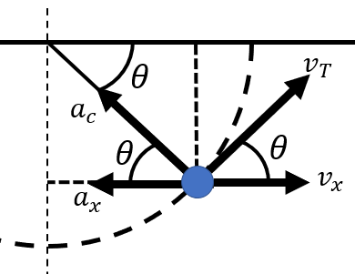Now, let us derive the equations for velocity and acceleration for an object under SHM **without calculus**, only algebraically and trigonometrically. Let us consider the motion of a simple pendulum shown in the diagram.

We can now use this vector diagram to relate several physical quantities together. Note that .

First, note that the displacement of the pendulum is expressed as

For velocity, we see that

And since ,

Lastly, we can work out the linear acceleration in the x direction as a function of time by noting that

And since ,

For the equation describing velocity as a function of displacement, we start with the

and then we would utilise a trigonometric identity

Rearrange it for ,

and substitute it back into the equation

### Energy in SHM

If we consider the equation for kinetic energy,

It is quite easy to see how one would be able to get the variation of kinetic energy as the object undergoes SHM. This can be achieved simply by substituting with .

For ,

On the other hand, if the restoring force acting upon the system is described by , then the potential energy that provides the system with such restoring force must have obey the equation

since . As such we can substitute and , which yields,

By law of energy conservation, we can find the equation for total mechanical energy

It is from this equation that whilst the kinetic energy and potential energy of the system depends on the displacement, the total energy only depends on the amplitude, angular velocity, and mass of the system.

### Case study

For this section of the topic, we are interested in 2 cases – simple pendulum and spring mass system. For both cases, we aim to derive their equations for the period of their oscillation.

Case 1: Simple Pendulum

|  |  |
| --- | --- |
| Consider the motion of a simple pendulum based on the diagram given.  In this diagram, the restoring force is a component of the weight of the pendulum bob,  If we apply **small angle approximation, i.e.**  we find that |  |
| We can now compare with the SHM equation, , and find that  And since , the expression for period of oscillation for a simple pendulum is | |

Case 2: Spring-mass system

|  |  |
| --- | --- |
| Consider the motion of a mass attached to a spring. At equilibrium,  Let us now introduce an extension *x* to the system. Newton’s 2nd law of motion, when applied will result in  Comparing this to the SHM equation, , we find that  And since , the expression for period of oscillation for the spring mass system is |  |

## Part 2: Waves

As discussed before, the solution of the SHM equation can be written as

Here, the ω represents the rate of change of the sinusoidal wave- form. It answers the question of "How big is the phase change in 1 second?". ω is related to the period , and frequency f by the following equation:

Mechanical waves work by energy transfer from one point to another point some distance away. Take water waves for example. the disturbance causes the water particles to oscillate up and down, but it doesn’t traverse or spread out. This oscillation is merely the transfer of kinetic energy from particles at one point to another in space. The velocity of the particle’s up and down motion is known as the particle vibrational velocity. A snapshot of this oscillation may produce a graph as shown below

The distance between corresponding points in successive wave- form is known as the wavelength. If the oscillation occurs at frequency f, in one second the wave has move forward by fλ. This means the velocity of the wave (also known as the wave propagation velocity) is related to the frequency and wavelength according to

Wave number is the number of wave per unit distance. This is similar to the case of angular frequency, what angular frequency is to period, is what wave number is to wavelength. Difference is in the dimension, where wave number and wavelength are in the dimensions of space and angular frequency and period are in the dimension of time.

### Progressive Wave

A progressive wave is a wave where the wave profile moves along with the speed of the wave. Its equation takes the following form

Different from the SHM where the variation of y is only dependent on x, here the equation for progressive wave is a function of both x and t. This is y varies with t. Because of this variation, at any point in x from the origin, the particle is displaced by a phase of kx.

To determine whether the wave is moving towards positive x direction or negative x direction, we may revisit the equation for velocity:

If then v > 0. This is achievable if ωt − kx = 0. This means if the wave is moving in the positive x direction then the general equation takes the form

y(x, t) = A sin (ωt − kx).

### Principle of Wave Superposition

The Principle of Wave Superposition states that the resultant displacement at any point is the sum of the individual wave dis- placements. That is to say

### Standing Wave

Whilst the progressive wave is a wave whose wave profile moves along the speed of the wave„ the standing wave is a case where the wave profile does not move in space. The peak amplitude of the wave oscillation at any point in space is independent of time.

The locations of minimum amplitudes are known as nodes and the locations of maximum amplitudes are called antinodes. A standing wave can be produce by having 2 progressive waves (of the same amplitude, frequency and wave number but travelling at opposite direction) superpose. This gives a resultant wave of the following equation:

### Travelling Wave Solution for String

Consider a single symmetrical pulse on a stretched string that moves in the ±x direction.

Take a small string element ∆l within the pulse. This string element has the mass of ∆m, where with µ = string mass density, is given by

The end points of the element forms an arc of a circle of radius r, subtending 2θ at the centre of that circle. Assuming constant velocity, the horizontal components of τ cancels and its vertical component is the restoring force,

Making small angle approximation and consider the equation of an arc length, *s* = *r*, gives

Since the element is moving in an arc of the circle, its cen tripetal acceleration is given by

Thus

### Sound Waves

One example of a longitudinal wave is sound wave. Sound wave here refers to the transmission of energy through the adiabatic compression and decompression of a medium. We can charac- terise sound in 3 aspects - loudness (amplitude), quality (over- lapping of overtones) and pitch (frequency). In this section, we shall discuss these 3 characters of sound waves to some extent.

#### Loudness

Sensed as loudness, acoustic intensity, I, is defined as the power, P , propagated by the sound wave per unit area, A, in the direction normal to that area. In equation form,

We can expand this to show the relationship between intensity of sound wave to its amplitude, , by considering the mass and velocity of an air layer as it reaches a point some distance away from the source. That layer of air vibrates at with simple harmonic motion. If the mass of the air layer is m and the velocity of the air layer is , then the intensity of the sound wave is

This tells us for any wave

Shifting our attention to area, we can assume that the sound wave is spherical, then the intensity of sound was at a distance r from the source is

because the area of a sphere of radius r is . Here, we see it follows the inverse square law that states

#### Quality

The quality of the sound, or timbre, describes the characteristic of a sound which allows us to distinguish sounds that has the same pitch and loudness. We shall study the primary contributor to the timbre of a sound, which is the its harmonic content. When a musical instrument is heard, what our ears pick up is not the wave of single frequency but the the superposition product of sound waves of multiple frequencies. This is what is known as the harmonic content. Reversing the process, the harmonic content of a sound can broken down into its individual pure tones by Fourier transform.

Our interest, however, is to consider pure tones. What we mean by pure tone here is that instead of considering a combina- tion of sound waves of various frequencies, we consider a sound which is made up of a sound of a single frequency. We shall consider the boundary conditions of 3 systems and deduce the allowable frequencies of the sound produced. These 3 systems are chosen because most a large percentage of the all the musical instruments fundamentally works based on these 3 systems.

Before specifying the systems, let us recall some general ideas of waves:

1. Frequency () ⇒ number of oscillation per second, unit: Hz
2. Wavelength ( ) distance between corresponding points in successive wave form.
3. Nodes (N) = location on a standing wave at which mini- mum amplitudes are observed.
4. Anti nodes (AN)= location on a standing wave at which maximum amplitudes are observed.

Additional terms that will be used in the analysis of the systems are

1. Fundamental frequency, = the lowest frequency
2. Harmonics = whole number multiples of the
3. Overtone = any frequency produced by the system which is greater than
4. End correction, e = a short distance added to the actual length of a pipe due to resonant vibration at any open end of a pipe.

Generally speaking, the nth overtone of any system is the (n +1)th harmonic of that system.

**System 1: Stretched String**

The first of the system we’re considering is the stretched string. Examples of musical instruments that works on this system in- cludes the piano and the guitar.

The boundary condition imposed here is that the ends must be composed of nodes, that is y(0, 0) = y(0, L) = 0.

We find that the string length must be integer of half wavelength, this means that

This allows us to write down the allowed frequencies for this system, and it is

**System 2: Open Pipe**

The second of the system we’re considering is the open-ended pipe. This system can be found applied in the construction of a flute.

The boundary condition imposed here is that the ends must be composed of anti-nodes.

We find that the pipe length must be integer of half wavelength, this means that

This allows us to write down the allowed frequencies for this system, and it is

With end correction,

**System 3: Closed Pipe**

The system found in some organs/clarinet is the closed pipe sys- tem. This is essentially a pipe with one of the pipe ends sealed off.

The boundary condition imposed here is that an antinode must be found at the open and a node must be found at the open end. This gives the following diagram

We find that the pipe length must be integer of a quarter wave- length, this means that

However, looking at the following harmonics we find the n does not take the values of all integers, only the odd integers. So we will have to make adjustments to our equation to only consider odd integers. That adjustment is

This yields only odd integer as we consider , resulting in

With this modification, we can write down the allowed frequencies for this system, and it is

With end correction,

#### Pitch

Frequency of waves are observed to correspond to pitch of sound. Sound waves with high frequency are observed as high pitched, and vice versa. One phenomenon of this character of sound wave is the **doppler effect**.

Imagine an ambulance, emitting a sound of frequency, moves towards you. As the ambulance approaches you, you hear that the pitch gets higher. Once the ambulance passes by you and moves away from you, the pitch becomes lower. This change in pitch is known as the *Doppler effect*.

The calculation for the change of pitch will be dealt soon, but for now, let us look at a graphical representation of what actually happen. The following figure shows how the frequency that you observe (= apparent frequency, ) depends on your position relative to the motion of the sound source.

As the source moves at a steady speed from position 1 to 4, four circular (coloured) waves are produced, which has point {1,2,3,4} as their centres. If you, as the observer positions yourself at point µ, and therefore the sound wave source is moving towards you, you will then observe sound wave in frame A. Conversely, positioning yourself at point γ means that the sound wave is observed according to frame B.

Comparing the wavelengths between wave fronts in frame A and B tells us that . Because the frequency is inversely proportional to the wavelength, we then know that for apparent frequencies, .

The most general case for the Doppler effect is when both the observer and the source is moving, therefore the approach taken here to quantify the apparent frequency to the observer will be to consider such as case.

The apparent frequency, , can be found using the equation

where v′ is the sound wave velocity relative to the observer and is the wavelength that reaches the observer.

Assuming source is moving at velocity ±vs and the observer moves at a velocity , then

In the numerator, is added to *v* when the observer is moving towards the source, and vice versa. In the denominator us is added to v when the source is moving away from the observer.

We might also find determining the plus-minus signs in the Doppler effect equation easier if we take into consideration of the to *f* ratio. This takes the form

which is bigger than 1 if a higher frequency is expected to observed and less than 1 if a lower frequency is expected to observed.

# Chapter 8: Physics of Matter

**Learning Outcomes**

|  |  |  |
| --- | --- | --- |
| Changes to material | No. | Learning Outcomes |
| Due to applied force | 1. | Distinguish between stress, and strain, |
| 2. | Analyse the graph of:   1. Stress-strain for metal under tension 2. Force-elongation for brittle and ductile materials |
| 3. | Explain elastic and plastic deformations |
| 4. | Define and use Young’s modulus, |
| 5. | Apply:   1. Strain energy from the force-elongation graph, 2. Strain energy per unit volume from stress-strain graph, |
| Due to Heat | 6. | Define:   1. heat conduction 2. coefficient of linear expansion, 3. coefficient of area expansion, 4. coefficient of volume expansion, |
| 7. | Solve problems:   1. related to rate of heat transfer, through a cross-sectional area (remarks: maximum two insulated objects in series) 2. related to thermal expansion of linear, area and volume   *; ; ;* |
| 8. | Analyse graphs of temperature-distance (T-L) for heat conduction through insulated and non-insulated rods.  *maximum two rods in series |

## Part 1: Material Changes due to Force

### Stress

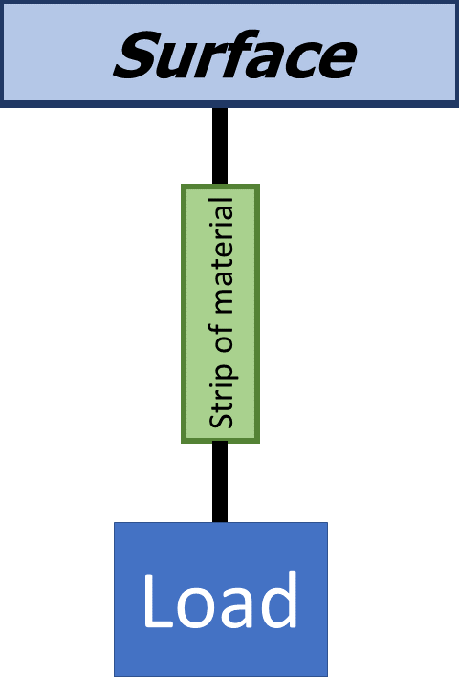To begin, we start by talking about testing things to the point of deformation — we put them under some increasing force over some area of the thing and once it starts to deform, we stop and calculate the maximum amount of force that the thing starts to deform.

The most natural way to do this is merely to subject a strip/rod of the material (of length *L* and cross-sectional area *A*) to an axial load with the other end anchored to some surface. As the mass of the load is increased, the strip/rod deforms (becomes longer) and eventually breaks off (fracturing). So naturally we’d like to know, how much load can a strip of the given material, support?

Before answering this question, we can ask ourselves if there are any geometric variables that influences the ability of the strip of material to support load. We can then repeat the same experiment using strips/blocks of the same material (with varying cross-sectional area) and we would find that the axial strength increases with the increment of the cross-sectional area. This would make sense because as the cross-sectional area is increased, so does the number of bonding between each cross-sectional layer.

We now have a value for the amount of load a material can support relative to the cross-sectional area of that material sample.

It may be expressed mathematically as

where is the load at fracture, is the Ultimate Tensile stress and is the initial cross-sectional area. This equation describes the maximum amount of stress that the strip/rod of material of cross-sectional can handle and it is at this point that the material fails and fractures.

So, when the material is said to be put under stress, and that stress is less than , what we are referring to is

This new measure has the unit of .

### Strain

In the last section, we quantified the amount of tensile stress a material may be be put under. In this section, let us quantify the "amount" of deformation that the material undergoes under some stress, that is we want to measure the stiffness.

Hooke’s law gives us a great exposure to the deformation of a material with respect to the load that the material is put under. It is commonly written as

Where *k* is the stiffness constant has units of .

We know from the previous section that this constant is not only affected by the type of material alone but also by the shape of the material. For now, we would like to normalize the measure for stiffness only by the deformation it undergoes independent of the shape. We can do this by considering the measure for the stretching of the material. This means we only consider the fractional change of the material when pun under stress, this is

where ∆L is the change in length and is the initial length before the material was put under stress. This measure is what we call ***strain***.

### Young’s Modulus

We have now discussed the measure for stress the material undergoes as well as the material’s deformation. We are now in the position to discuss how the stress that is put on the material affects the deformation observed in that material. That is to say, we want a calculable prediction on, *"If I put this amount of force, how big is the deformation I can expect? "*.

Experimental results show that for relatively small stress and strain, they are proportional to each other. This allows us to write

This tells us that there is a proportionality constant between the two, let’s call it *Y*. We can then define this proportionality constant to be

This proportionality constant is what we today call **Young’s Modulus**.

### Graph

2 graphs are studied in this section – stress-strain curve for a metal and the force-extension graph for brittle and ductile materials.

#### Stress-strain graph

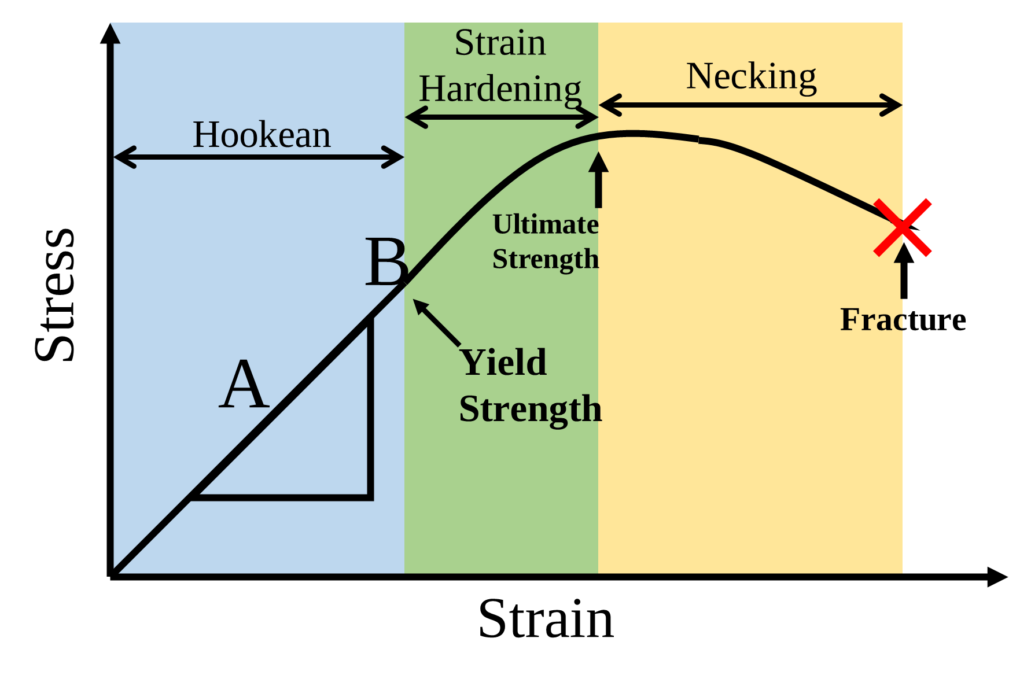Up to this point, we have considered stress and strain up within the Hookean limit. It is the best of our interest to also consider what happens further extension of the material after the Hookean limit (Yield limit) to the fracture point. The graph shows the stress-strain relation before and after the Hookean limit.

The first part (blue) shows the obeyance of the stress-strain curve to the Hookean law. Within this region, one can calculate the Young’s modulus based on the gradient of the straight line. It is also in this region that the metal undergoes what is known as **elastic deformation**. Deforming elastically refers to the ability of the stretched metal to return to its initial length when the tensile stress is removed.

Beyond the Hookean limit, Hooke’s law is no longer obeyed, and thus non-linearity is observed in the stress-strain curve. Beyond the Hookean limit, the metal undergoes **plastic deformation**, a type of deformation in which the stretched metal will not be able to return to its initial length even if the tensile stress is removed.

From the stress-strain curve, we observe that a non-linear increment of stress with the increment of strain until it reaches a peak, known as **Ultimate Tensile Strength**. The region (green) between the Hookean limit and the UTS is where strain hardening takes place. This is the phenomenon where the metal is "strengthened" by the plastic deformation. "Strengthened" here refers to the dislocation of movements in the crystal structure of the material.

Beyond the peak, the strain still increases but the tensile stress decrease until the **fracture point**. Between the UTS and fracture point (pink), what is observed of the metal is that necking takes place. This is the phenomenon in which the local cross-sectional area becomes significantly smaller than average.

For some material, the plastic deformation occurring between the Hookean limit and the fracture point is so small, that it seems to the observer as if the plastic deformation region is non-existent. For such material, we call it **brittle**.

For other materials, the plastic deformation region is great and thus we call these materials, **ductile**.

#### Force-extension graph

As mentioned in the stress-strain graph section, the plastic deformation phase for brittle materials are very short whereas the same region for the ductile materials are relatively (and observably) significant.

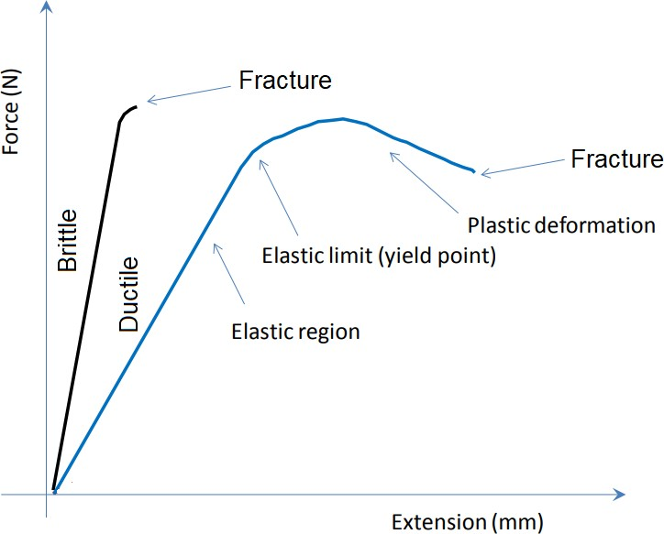

One possible inference we can make from this is that ductile materials are able to contain much more strain energy than brittle materials. It is also from the force extension graph we can deduce the strain energy by the area under the force-extension graph, that is

If were to find the strain energy per unit volume, we could easily do it by dividing both side by the volume of the material,

and reminding ourselves that the volume is merely the product of cross-sectional area and length,

We can see that the strain energy per unit volume is just the area under the stress strain curve,

|  |
| --- |
| **Sample Problem 8.1**  A 50kg box is balanced on a pole of radius 25cm. Determine the stress that the pole is under.  **Answer:**  Stress is the amount of force onto a surface area. The weight of the box is and the surface area, considering it is a circle, and thus the stress on the pole is |
| **Sample Problem 8.2**  Determine the strain on a piece of metal if is extended by 20% when some force is applied to it.  **Answer:**  Strain quantifies the fractional change to the geometry of the object. |
| **Sample Problem 8.3**  A piece of wire is hung with a mass of 2kg weight on its end. Because of the weight on its end, it stretches by 0.2cm from its original length of 5cm. If the cross-sectional area of the string is , calculate the Young’s Modulus of the wire.  **Answer:**  Young’s modulus is the ratio of stress to strain, |

## Part 2: Material Changes due to Heat

### Heat Conduction

Imagine a metal rod with one end heated. With time, the opposite end also gets hot even though it is not directly heated. The heat energy is transferred from one end to the other end. This happens through the ‘jiggling’ of the particles within the heated material. As the rod is heated, the particles begin to vibrate and collide with neighbouring particles. When they collide, they transfer some of the energy to the neighbouring particles and then the neighbouring particles starts to vibrate. This process is called **heat conduction.** It is the transfer of heat through agitations of the particles within the material without any motion of the material.

The variable that drives heat transfer is a temperature gradient across the material, that is to say there exist a difference in temperature between two parts of a conducting medium,

Referring to the rod heated on one end case, we can say that the heated end has temperature and the non-heated end to have the temperature . Fourier’s law tells us that the local heat flux in a homogeneous body, is in the direction of, and proportional to, the temperature gradient :

In one-dimensional form,

where is the thermal conductivity in the x-direction. Note that the minus sign is present due to the fact that heat flows from a higher temperature area to a lower one.

Local heat flux refers to rate of heat transfer per unit area,

The equation for the rate of heat transfer is then

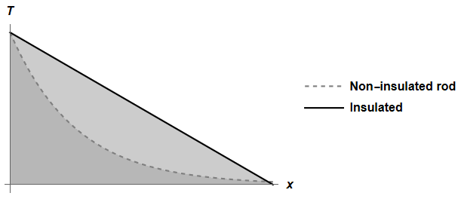 Let us now try to understand the temperature-gradient graph for a rod heated on one end. For an uninsulated rod, the heat energy will be able to escape to the environment via the sides of the rod. This leads to temperature-distance gradient to be curved with a decreasing gradient, much like graphs exhibited by functions . On the other hand, for insulated rods, the heat loss to the environment is negligible. As a result, their temperature-distance graph is a linear graph with negative gradient.

|  |
| --- |
| **Sample Problem 8.4**  One end of a metal bar is kept at , while the other end is kept at a lower temperature. The cross-sectional area of the bar is . The heat loss through the sides of the bar is negligible due to the insulation around the metal bar. Heat flows through the bar at the rate of 2.5. If the metal bar has a thermal conductivity value of 140 , calculate the temperature of the bar at a point 0.8 m from the hot end?  **Answer:** |

### Heat Expansion

Things expand when they are heated, this phenomenon is known as **thermal expansion**. A great demonstration of this phenomenon is the Ring and Ball Experiment (<https://www.youtube.com/watch?v=ne8oPFTM_AU> ). If the expansion happens in one dimension of space, we call it a **linear expansion**, where as expansion in two and three dimensions are known as **area** and **volume expansion.**

We can start by considering a small change in the object’s length. By small, we mean relative to the object’s initial dimensions. When that is the case, the change in the length is the proportional to the first power of the temperature change.

Say, that object has an initial length of along some direction at temperature . Then the change in length for a change in temperature is

where is known as **coefficient of linear expansion**.

So now how do we expand to area and volume thermal expansion? Well, note that and that . As such,

Since we are only considering only small changes, we can consider the last terms to be negligible such that

which gives us the change in area

where and is aptly named **coefficient of area expansion**. We can then imitate the same procedure to produce the equation for change in volume due to heat which will yield

where and is named **coefficient of volume expansion.**

|  |
| --- |
| **Sample Problem 8.6**  A mug of filled with 200mL of tea at . If the tea has a coefficient of linear expansion of , calculate the volume of the tea when the tea has cooled down by .  **Answer:**  Change in tea temperature,  Initial volume of water,  Coefficient of volumetric expansion, |

# Chapter 9: Kinetic Theory of Gases & Thermodynamics

**Learning Outcomes**

|  |  |  |
| --- | --- | --- |
| Molecular kinetic theory | 1. | Define/State   1. The assumptions of kinetic theory of gases. 2. The principle of equipartition of energy 3. Degrees of freedom |
| 2. | Describe/Explain:   1. Root mean square (rms) speed of gas molecules, 2. Translational kinetic energy of a molecule, 3. Internal energy of gas |
| 3. | Solve problems related to:   1. rms speed of gas molecules, 2. the equations, ; 3. Translational kinetic energy of a molecule, 4. Internal energy, |
| 4. | Identify number of degrees of freedom for monoatomic, diatomic and polyatomic gas molecules. |
| Thermodynamics | 5. | Define/State:   1. First Law of Thermodynamic, 2. Isothermal process 3. Isochoric process 4. Isobaric process 5. Adiabatic process |
| 6. | Solve problems related to:   1. First Law of Thermodynamics 2. Isothermal process, 3. Isobaric process, 4. Isochoric process, |
| 7. | Analyse graph for all the thermodynamic processes |
| 8. | Derive equation of work done in isothermal, isochoric and isobaric processes from graph. |

## Molecular Kinetic Theory

### Kinetic Theory of Gases

Because atoms are very light, it is often useful to use the **atomic mass unit** for the masses of the atomic scale. The atomic mass unit is defined as of the mass of a carbon-12 atom This atomic mass unit (a.m.u.) is related to the SI kilogram by

Apart from that, in our daily lives, quite often we deal with a large number of atoms/molecules/particles. So rather than describing is numerically by the number of particles, we often describe the number of atoms relative to the **Avogadro’s Constant,**

For example, instead of saying there are gas particles in a container, it is easier to say 0.83mol of gas particles in the container. These two new ways of quantifying the light-mass but large number particle systems leads to a very interesting result, that is **the mass per mole of any substance and the atomic (or molecular) mass unit has the same numerical value.** For example, the oxygen atom has a mass of 16u and therefore has a mass of 16.   
 Macroscopically, the simplest model for gases is the **ideal gas law,** which states

where p is the pressure of the gas (in Pa), *V* is the volume of the gas (in ), *n* is the number of mole of the gas, *T* is the temperature in Kelvin of the gas, *R* is the gas constant () and is the Boltzmann constant (defined as ).

Microscopically, though we want to start considering kinetic energies of the gas particles. Let us first lay down assumptions for our kinetic theory of gas. In one sentence, let us consider **gas to be composed of large numbers of non-null mass point-like particles that obeys Newton’s laws of motion and interact elastically with each other where the average kinetic energy of the gas particles depends solely on the absolute temperature of the gas particle system.**

Consider gas particles in a cube container of side lengths *L*. We can think of the interaction between the gas particle and the container wall to be like that of a ball hitting a wall. We can determine the force exerted by the particle onto the container wall and then divide it by the area to determine the pressure.

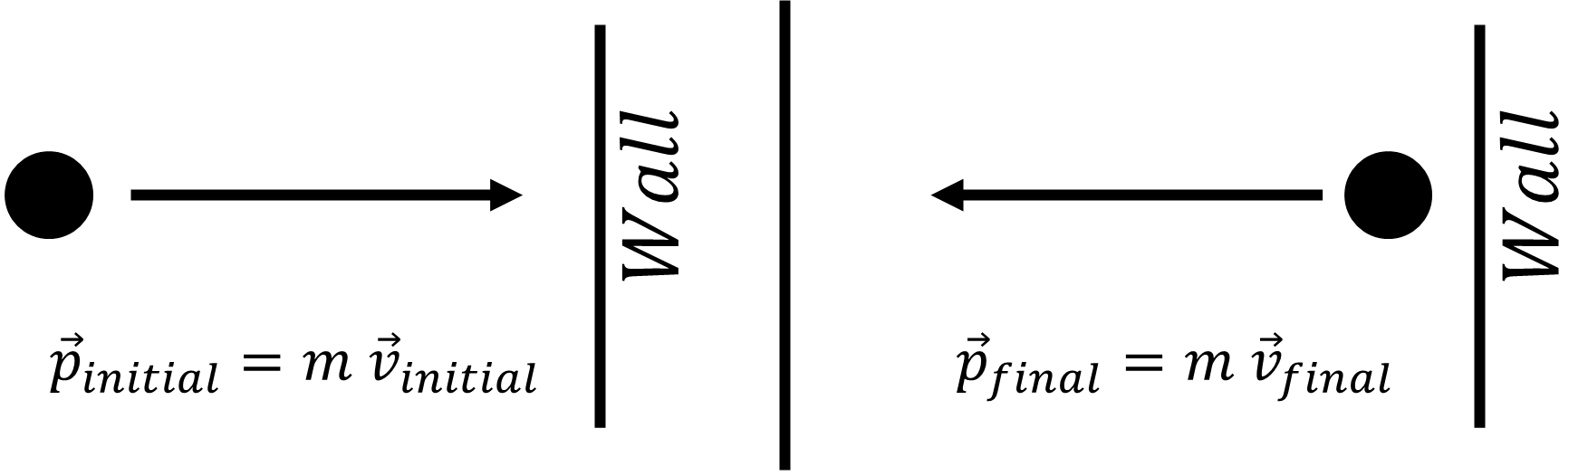

We can see that the change in momentum is

. Considering the speed of the particle is and the distance between walls of the container are *L*, the time between the collisions will simply be . The force exerted on the wall by the particle will then be

If there are N particles in the container, then the total force exerted on the container walls is

2 major changes happened - has replaced and a factor of seemed to popped up. Here are the reasons:

1. has replaced because in a system of many particles, not all the particles will have the same speed. Their speed will follow the **Maxwell-Boltzmann distribution**.

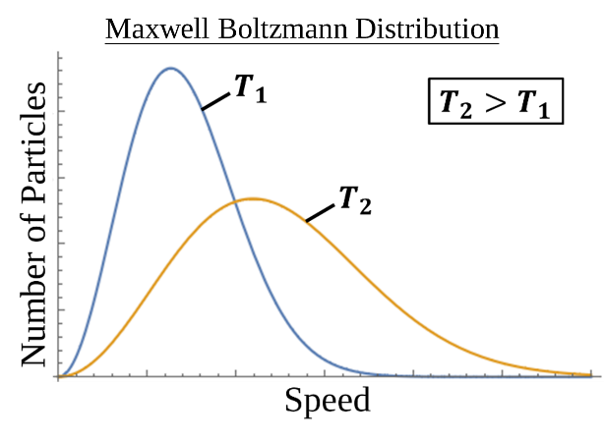

So, to take that into account, we will use the **rms speed ()** of the particle rather than the peak or average speed. This rms speed is defined by

1. On the other hand, the factor of popped us because the particles can move in 3 dimensions. This means the velocities of the particles can happen inn x, y or z axis. Considering the speeds are random, this would mean , and since , this would mean that

And thus the force can be written as

We can now divide this force by the area

Defining mass density as ,

Rearranging the pressure – rms speed equation yields

Comparing this to gives us an expression of the average kinetic energy as a function of the temperature,

This result is significant because now we really do have a **kinetic** theory of gas, where the temperature of the gas is expressed in terms of the motion of the gas particles.

### Kinetic & Internal Energy

Before talking about the classical principle equipartition of energy, we need to address what we mean when we say **degrees of freedom**. In the context of gas motion, degrees of freedom are the dynamical variables that contributes a squared term to the expression for the total particle energy. Classically, there two that we’d consider are

1. translational kinetic energy,
2. Molecular rotational energy,

Though, in the quantum regime, we need to consider vibrational energy, in which the bonds between molecules may be treated as “springs” and that would add 2 more degrees of freedom.

The following table shows the cases and the number of degrees of freedom

|  |  |
| --- | --- |
| Cases | Number of Degrees of Freedom |
| Monoatomic | 3 (Only translational) |
| Diatomic* | 5 (3 translational + 2 rotational) |

*in the classical regime. Taking into consideration quantization of energy leads to consideration for vibrational energy.

Based on the idea of degrees of freedom, we can now extend our discussion to the classical theorem of energy equipartition which states **at equilibrium, each degree of freedom contributes of energy per molecule.**

That is to say, for N number of gas molecules of *f* degrees of freedom, the total internal energy is

Here what we mean by internal energy is simply the sum of all the kinetic energy of all the molecules accounted for in the systems. If we were to talk about translational kinetic energy, we mean kinetic energy associated with translation of the particle (). If we were to talk about the total kinetic energy, we are referring to the internal energy of the system, where the degree of freedom depends on the type of particle.

## Thermodynamics

Thermodynamics is the study of heat and energy transformation. In this section, we discuss 3 things. Firstly, the 0th law of thermodynamics, which essentially provides us with the idea of **thermal equilibrium**. Secondly, we shall look at how the idea of adding (or taking our) energy to a system relates to the internal energy of the system, i.e. the 1st law of thermodynamics. Lastly, we shall consider the thermodynamical processes and lay foundations to understanding heat engines.

### Zeroth law of Thermodynamics

The 0th law of thermodynamics focuses on the idea of a thermal equilibrium. If the temperature of system A is equal to system B, and that system B has a temperature equal to system C, then system C and A is said to be at **thermal equilibrium**.

In other words, two systems are are to be in thermal equilibrium with each other if they have the same temperature. When two systems are in thermal equilibrium with each other, the net heat flow between them is essentially 0.

### First Law of Thermodynamics

At this point, what we want to do is to relate the internal energy of the system with the external factors. By External factors, we mean whether we apply heat to the system, or take heat away from it or changing the geometry of the system (whether increasing it or decreasing it). Much like the conservation of energy, the sum total of the energy of an isolated system must be conserved. Therefore, when some heat *Q* is added to the system and some work *W* is added to the system, the change in internal energy can be calculate by

Though some books may have a minus sign instead of a positive sign for the and the reason for that is that they have defined to be work done by the system.

|  |  |
| --- | --- |
| Equation | Terms definition |
|  | = work done **onto** the system |
|  | = work done **by** the system |

### Thermodynamical Processes

Looking back at the first law of thermodynamics, we want to be able to do some calculations related to it. And thus, we shall quantitatively defined *U, Q* and *W.* By internal energy, we take the definition defined previously, that is internal energy of the gas depends on the temperature of the system,

By heat added, what we refer to is the heat transfer into or out of the system. This heat is defined by

where m is the mass of the system, c is the heat capacity of the system and is the temperature of the system. By work done onto (or by) the system, we define it to be related to the change in volume of the system,

In general, we want to consider 4 case studies on thermodynamical processes:

1. Isothermal

In isothermal expansion/compression, temperature of the system is kept constant, . Since the change in internal energy depends solely on change in temperature, this means that and thus

In the isothermal case, pressure is not a constant, we can define pressure as a function of volume via the ideal gas law

And thus the work done is

1. Isochoric / Isovolumetric

In the isochoric case, the volume of the gas is kept constant, and thus

1. Isobaric

In the isobaric expansion/compression cases, the pressure of the gas is kept constant, . This means that for the calculation of work done onto (or by) the system is simply

1. Adiabatic

For the adiabatic process, what is kept constant is the heat transfer into and out of the system, . This means that . Since

The p-V graph of each thermodynamical processes is shown in the diagram below.

