|  |  |  |  |
| --- | --- | --- | --- |
|  | Experimental Physics |  |  |
|  | <<Title>> |  |  |
|  | <<Name>> |  |
|  | Module code |  |
|  | Sarawak Matriculation College |  |
|  | dd/mm/year |  |
|  | Keywords: <<keyword1>>, <<keyword2>>, <<keyword3>>,<<keyword4>>, <<keyword5>> | | |

# Abstract

Lorem ipsum dolor sit amet, consectetuer adipiscing elit. Maecenas porttitor congue massa. Fusce posuere, magna sed pulvinar ultricies, purus lectus malesuada libero, sit amet commodo magna eros quis urna. Nunc viverra imperdiet enim. Fusce est.

Contents

Abstract 1

1 Introduction 1

2 Methodology 1

3 Data Analysis 2

Theoretical Data Table 2

Experimental Data Table 2

Table of Uncertainties 3

Graphs (Computer-Generated and Hand-drawn) 4

Percentage Error 5

4 Discussion 5

5 Conclusion 5

References 5

# 1 Introduction

Lorem ipsum dolor sit amet, consectetuer adipiscing elit. Maecenas porttitor congue massa. Fusce posuere, magna sed pulvinar ultricies, purus lectus malesuada libero, sit amet commodo magna eros quis urna. Nunc viverra imperdiet enim. Fusce est. Vivamus a tellus [1]. Pellentesque habitant morbi tristique senectus et netus et malesuada fames ac turpis egestas. Proin pharetra nonummy pede. Mauris et orci. Aenean nec lorem.

In porttitor. Donec laoreet nonummy augue. Suspendisse dui purus, scelerisque at, vulputate vitae, pretium mattis, nunc. Mauris eget neque at sem venenatis eleifend. Ut nonummy. Fusce aliquet pede non pede. Suspendisse dapibus lorem pellentesque magna. Integer nulla. Donec blandit feugiat ligula. Donec hendrerit, felis et imperdiet euismod, purus ipsum pretium metus, in lacinia nulla nisl eget sapien. [2]

Donec ut est in lectus consequat consequat. Etiam eget dui. Aliquam erat volutpat. Sed at lorem in nunc porta tristique. Proin nec augue. Quisque aliquam tempor magna. Pellentesque habitant morbi tristique senectus et netus et malesuada fames ac turpis egestas. Nunc ac magna. Maecenas odio dolor, vulputate vel, auctor ac, accumsan id, felis. Pellentesque cursus sagittis felis.

# 2 Methodology

|  |
| --- |
| The experiment was set to according to the diagram below.    In this experiment, we want to look for the relationship between length of the string $l$, and the period of oscillation, $T$. Theoretically, they are related by the equation $$T=2π\sqrt{\frac{l}{g}}---\left(1\right)$$ where *l* is the length of the string and *g* is the acceleration due to gravity.  Equation (1) can be simplified into $$T^{2}=\frac{4π^{2}}{g}l---\left(2\right)$$ where a graph of $T^{2}\text{ against }l$ gives a linear graph with a gradient of $\frac{4π^{2}}{g}$.  6 different values of string length were tested and the time for 20 oscillations for each string length value was measured. These data points were then recorded, and its analysis reported in section 3. The string length was measured **using a metre ruler** with an instrument uncertainty of $0.1cm$. One oscillation is defined as the time for the pendulum bob to return to its original position. **The stopwatch** (with uncertainty of 0.01s) was started upon release of the pendulum bob and stopped once the pendulum bob has returned to its original position 20 times. Once this time is recorded, we calculated the period of oscillation by dividing this time with 20. This is to say, $$T=\frac{\text{time for 20 oscillation}}{20}$$ A few variables were kept constant. The angle of release for the pendulum was set at $5^{o}$ and this value was fixed at every data point. The mass of the pendulum was also set at 50g and remains unchanged throughout the whole experiment. The fans of the laboratory were switch off, and the windows and curtains were close to minimise effects from air resistance. |

# 

# 3 Data Analysis

## Theoretical Data Table

|  |  |
| --- | --- |
| x | y |
|  |  |
|  |  |
|  |  |
|  |  |
|  |  |

## Experimental Data Table

|  |  |  |  |  |
| --- | --- | --- | --- | --- |
|  |  |  |  |  |
|  |  |  |  |  |
|  |  |  |  |  |
|  |  |  |  |  |
|  |  |  |  |  |
|  |  |  |  |  |
|  |  |  |  |  |
|  |  |  |  |  |

## Table of Uncertainties

|  |  |  |  |  |  |  |
| --- | --- | --- | --- | --- | --- | --- |
|  |  |  |  |  |  |  |
|  |  |  |  |  |  |  |
|  |  |  |  |  |  |  |
|  |  |  |  |  |  |  |
|  |  |  |  |  |  |  |
|  |  |  |  |  |  |  |
|  |  |  |  |  |  |  |

## Calculation of gradient uncertainty

## Calculation of constant variable uncertainty

## Graphs (Computer-Generated and Hand-drawn)

## Hand-drawn graph here

<<INSER HAND-DRAWN GRAPHS HERE>>

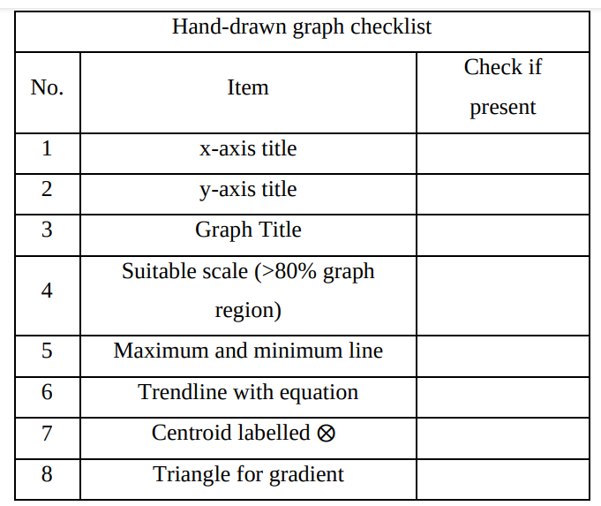

## Percentage Error

$$\frac{\left|k_{exp}-k_{theory}\right|}{k_{theory}}×100\%$$

# 4 Discussion

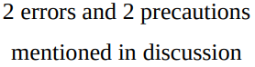

Lorem ipsum dolor sit amet, consectetuer adipiscing elit. Maecenas porttitor congue massa. Fusce posuere, magna sed pulvinar ultricies, purus lectus malesuada libero, sit amet commodo magna eros quis urna. Nunc viverra imperdiet enim. Fusce est. Vivamus a tellus. Pellentesque habitant morbi tristique senectus et netus et malesuada fames ac turpis egestas. Proin pharetra nonummy pede.

Mauris et orci. Aenean nec lorem. In porttitor. Donec laoreet nonummy augue. Suspendisse dui pretium metus, in lacinia nulla nisl eget sapien. Donec ut est in lectus consequat consequat. Etiam eget dui. Aliquam erat volutpat. Sed at lorem in nunc porta tristique.

Proin nec augue. Quisque aliquam tempor magna. Pellentesque habitant morbi tristique senectus et netus et malesuada fames ac turpis egestas. Nunc ac magna. Maecenas odio dolor, vulputate vel, auctor ac, accumsan id, felis. Pellentesque cursus sagittis felis. Pellentesque porttitor, velit lacinia egestas auctor, diam eros tempus arcu, nec vulputate augue magna vel risus. Cras non magna vel ante adipiscing rhoncus.

# 5 Conclusion

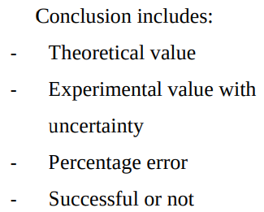

# References

|  |  |
| --- | --- |
| [1] | B. Weber, "Ohm’s law survives to the atomic scale," *Science,* vol. 335, pp. `64-67, 2012. |
| [2] | L. Onsager, "Deviations from Ohm's law in weak electrolytes," *The Journal of chemical physics,* vol. 2, no. 9, pp. 599-615, 1934. |