**Theoretical**

|  |  |
| --- | --- |
| **Equation** |  |

**Experimental Dataset**

|  |  |  |  |  |  |  |  |  |
| --- | --- | --- | --- | --- | --- | --- | --- | --- |
|  | 0.14 | 1.40 | 1.94 | 1.97 | 6.59 | 7.10 | 7.75 | 8.38 |
|  | 0.58 | 2.07 | 2.72 | 2.84 | 8.57 | 8.84 | 9.2 | 9.75 |

**Centroid:**

Centroid

**Graph:**

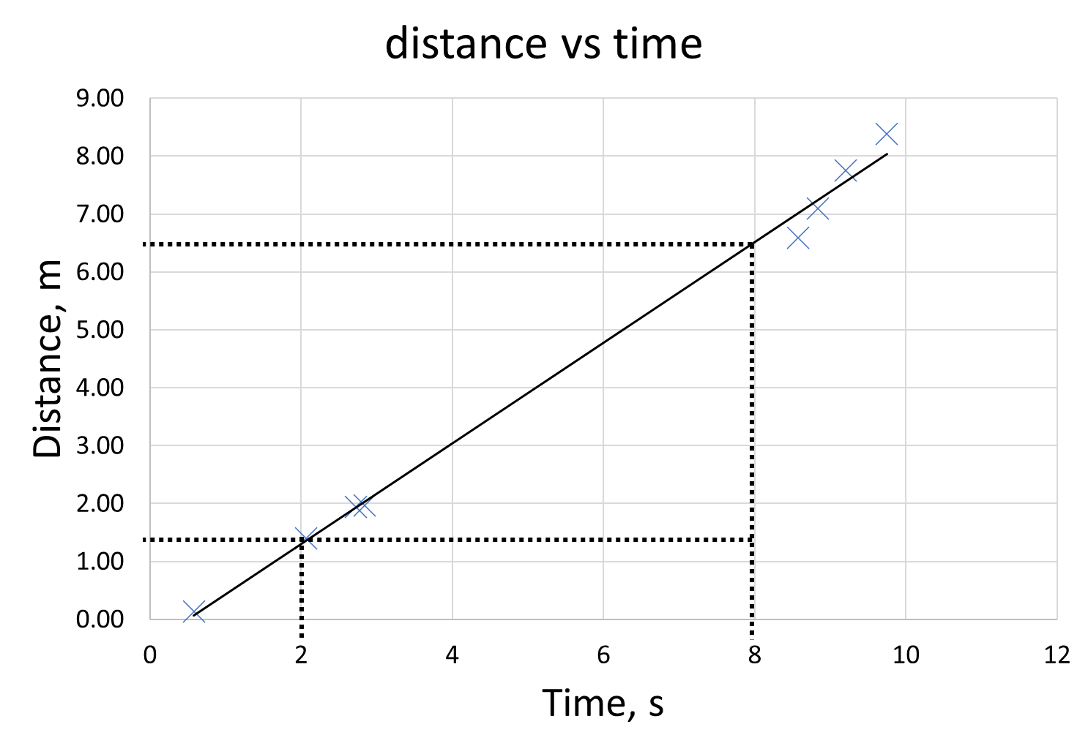

**Gradient and y-intercept Calculation:**

From graph, take 2 points

Calculate the gradient between these two points,

Calculating gradient can be done using value for gradient and one of the points above,

Equation of straight line is then

**Uncertainty Table:**

Here, values of is calculated from eq. [1].

|  |  |  |  |  |  |  |
| --- | --- | --- | --- | --- | --- | --- |
|  |  |  |  |  |  |  |
| 0.58 | -4.99 | 24.91 | 0.14 | 0.07 | 0.07 | 0.00 |
| 2.07 | -3.50 | 12.26 | 1.40 | 1.37 | 0.03 | 0.00 |
| 2.72 | -2.85 | 8.13 | 1.94 | 1.93 | 0.01 | 0.00 |
| 2.84 | -2.73 | 7.46 | 1.97 | 2.03 | -0.06 | 0.00 |
| 8.57 | 3.00 | 8.99 | 6.59 | 7.02 | -0.43 | 0.18 |
| 8.84 | 3.27 | 10.68 | 7.10 | 7.25 | -0.15 | 0.02 |
| 9.20 | 3.63 | 13.17 | 7.75 | 7.56 | 0.19 | 0.04 |
| 9.75 | 4.18 | 17.46 | 8.38 | 8.04 | 0.34 | 0.12 |
| 44.57 |  | 103.06 |  |  |  | 0.36 |

**Calculation of gradient and y-intercept uncertainty:**

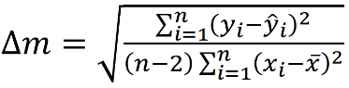

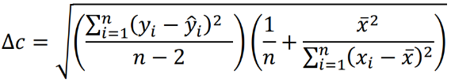

**Experimental and Theoretical equation comparison**

compared with

So, the experimental value of u (along with its uncertainty) is

**Percentage of difference**