Diagrams
Core Functionality Modules
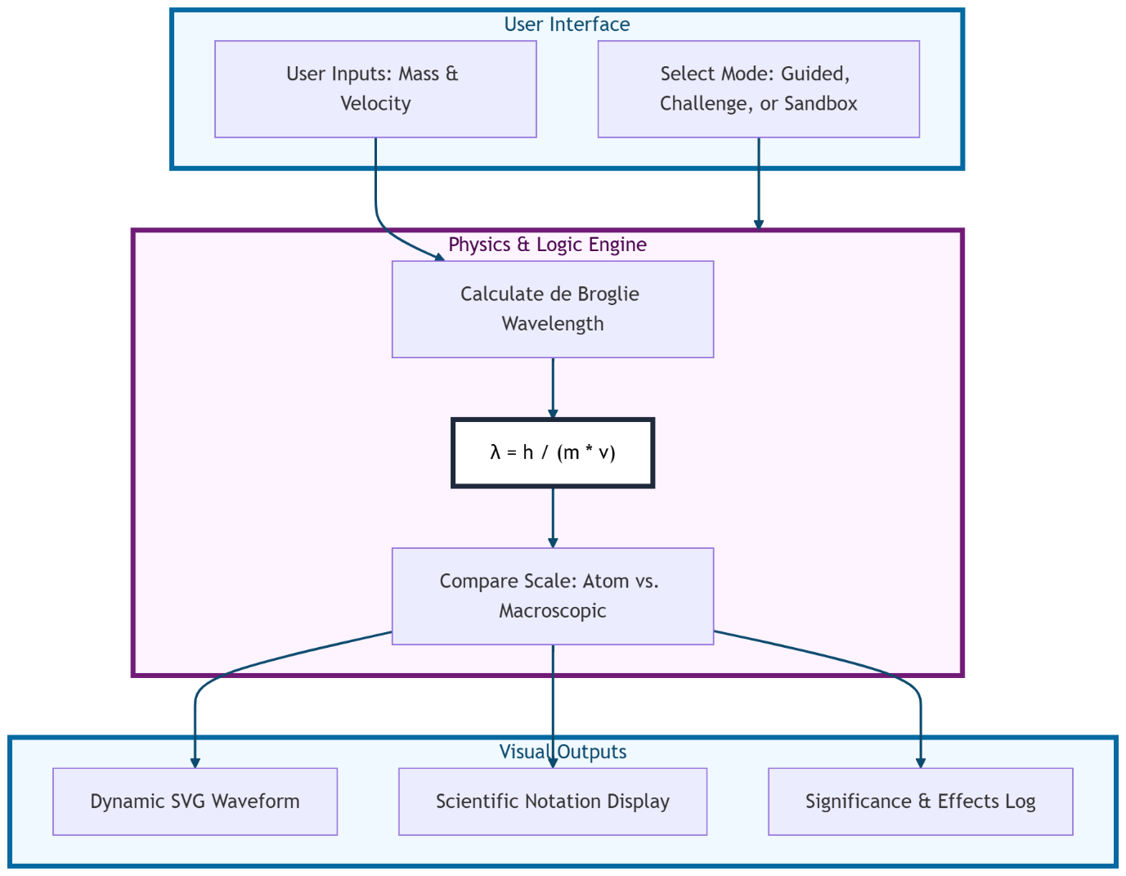

Physics Calculation Pipeline
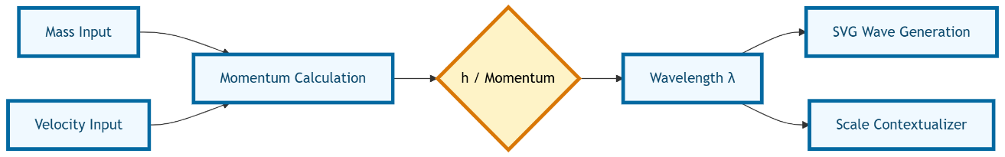

Particle vs. Wave Logic
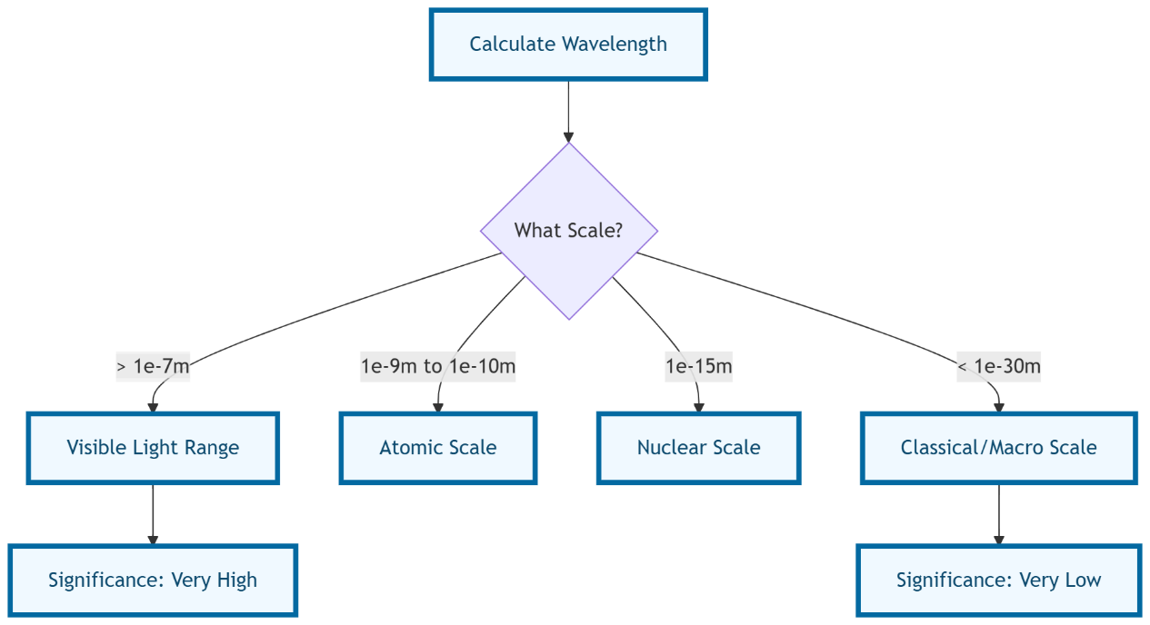
.
User Journey State Diagram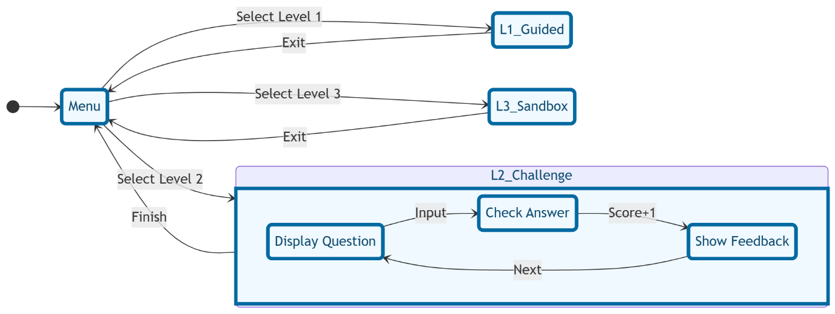

Technical Methodology: Computational Physics & UI Synchronization
The "Wave Nature Explorer" utilizes a decoupled architecture where the Physics Engine operates independently of the Rendering Engine. Upon user interaction, the application executes a three-stage pipeline:
- Normalization & Calculation: Raw inputs (mass and velocity) are validated and processed using the de Broglie relation ($\lambda = \frac{h}{mv}$). Due to the extreme range of subatomic masses ($10^{-31}$ kg) versus macroscopic objects, all calculations are performed in double-precision floating-point format to prevent underflow errors.
- Logarithmic Scaling: To bridge the gap between physical reality and screen space, the application maps the result onto a logarithmic scale. This ensures that a $10^{-34}$m wavelength remains visually distinguishable from a $10^{-10}$m wavelength within the fixed dimensions of the SVG viewport.
- Dynamic Path Interpolation: The SVG <path> element is recalculated in real-time. The generateWavePath function acts as an interpolator, mapping the calculated frequency to a set of Bézier curve coordinates, creating a smooth visual representation of the wave-particle duality.

Crucial Diagram 1: The "Visual Scaling" Algorithm (16:9)
This diagram explains how you solved the problem of displaying microscopic data on a macroscopic screen.
Crucial Diagram 2: Event-Driven Architecture
This shows the technical flow of the "Sandbox" (Level 3), which is the most complex part of your code's logic.
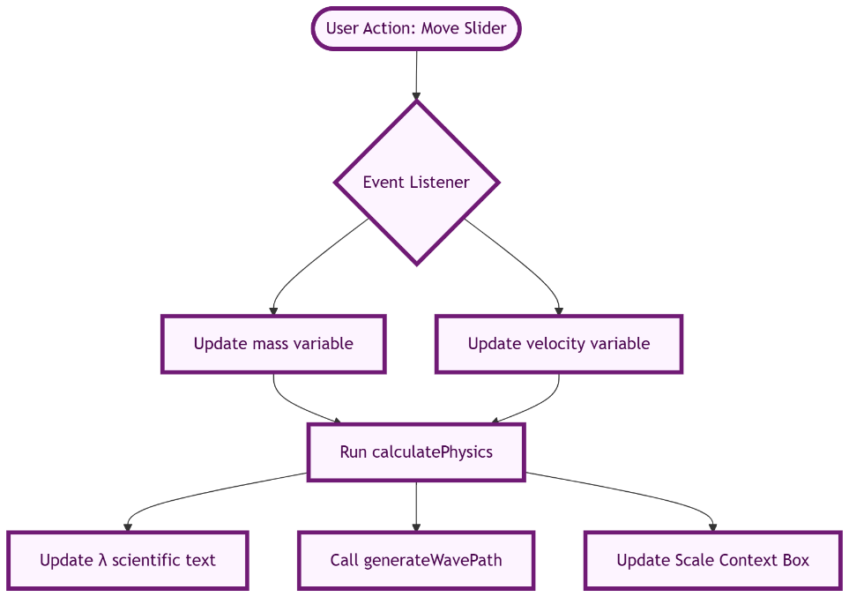
Crucial Diagram 3: Comparison Logic (Hypothesis Testing)
In Level 3, the code compares user text to scientific data. This is a "Validation Flow" diagram.
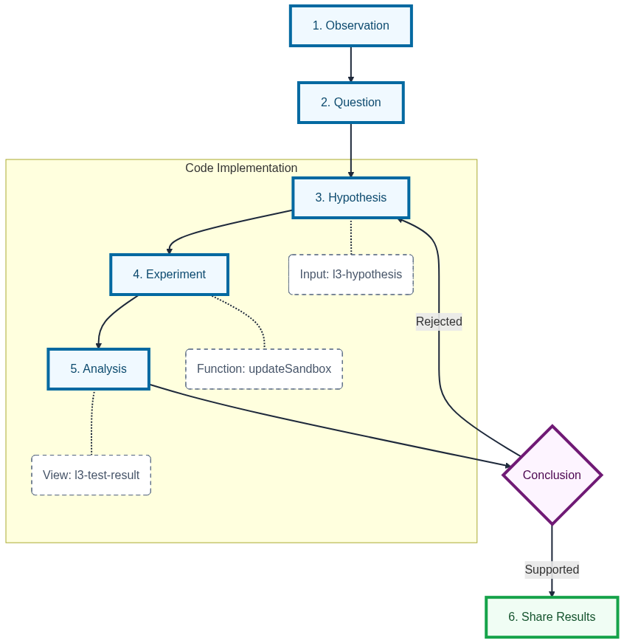
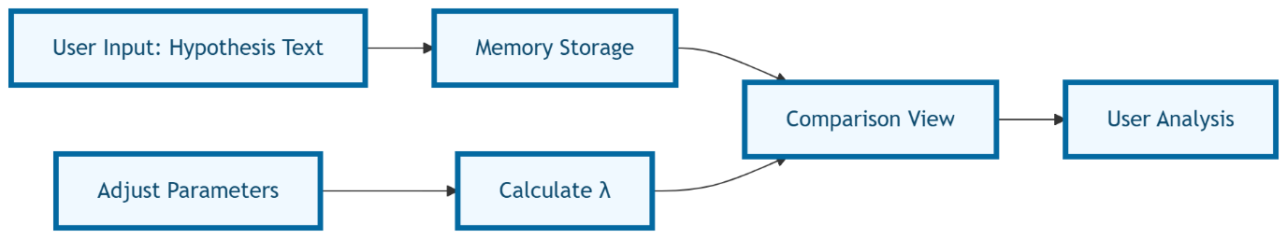
Report Recommendation
When presenting these:
- Use the Data Transformation Pipeline to explain your mathematical accuracy.
- Use the Visual Scaling Algorithm to explain your front-end UX design choices.
- Use the Event-Driven Architecture to prove the code's performance (showing that it updates instantly without lag).
Would you like me to generate a Table of Variables that maps the code’s variable names to their physical units for your report's appendix?

