Evaluating ChatGPT as an Automated Writing Evaluation Tool: A Preliminary Study of Score Concordance and Formative Feedback in Malaysian Matriculation MUET Essay Writing
Chan Kin Wei & Shafiq bin Rasulan
Kolej Matrikulasi Sarawak, Kuching, Sarawak, Malaysia

ABSTRACT
Writing is the most persistent barrier to Band improvement in the Malaysian University English Test (MUET), and grading latency in conventional classrooms delays the formative feedback students need to revise effectively. This action research, conducted at Kolej Matrikulasi Sarawak under the Kanvas Model Transformasi Sekolah (KMTS) FACES framework, examined the score concordance between ChatGPT and official MUET examiners, and explored how real-time AI feedback related to essay performance across iterative practice, for MUET Writing Paper 800/4. Baseline data showed 69% of 208 matriculation students scored Band 3 or below in writing, with a focal sample of 40 students returning a comparable 47.5% at Band 3 or below. Over three months, students handwrote timed essays, digitized them via Google Lens OCR, and submitted them to structured ChatGPT prompts (CEFR B2-anchored grading, sentence-level grammar checks) for same-day feedback, before reconstructing their actual MUET exam essays from memory and re-evaluating them with the same protocol. Percentage agreement between ChatGPT and official MUET examiners on these post-examination reconstructions reached 95% exact Band match (38 of 40 students), with 5% (n = 2) showing minor variance of ±0.5 Band; because this comparison relied on reconstructed rather than original scripts, it is best read as preliminary, criterion-related evidence of score concordance under reconstructed conditions rather than validated accuracy against live examination performance. Band 4-and-above attainment moved descriptively from 17.5% (baseline) to 22.5% (AI-assisted practice) before settling at 12.5% in the actual examination; in the absence of a control group or inferential statistical testing, these changes are reported as observed patterns rather than confirmed effects. Findings suggest that prompt-guided generative AI can achieve high score concordance with examiners under structured, single-institution conditions while compressing feedback turnaround from days to hours, offering preliminary evidence relevant to Zone of Proximal Development scaffolding, Assessment for Learning, and self-regulated iterative writing practice. Implications for lecturer workload and scaling strategies are discussed alongside notable limitations, including reconstruction bias, the absence of chance-corrected agreement statistics and inferential tests, and incomplete reporting of the ChatGPT model and prompting environment used.
Keywords: Generative AI; Automated Writing Evaluation; MUET Writing; Formative Feedback
INTRODUCTION
Writing proficiency is the single most consequential and most difficult skill for Malaysian matriculation students to master en route to university admission, because it disproportionately determines whether a candidate secures a competitive MUET overall Band. Institutional data from Kolej Matrikulasi Sarawak illustrate the scale of the problem. Across the 2024/2025 session, the overall MUET cohort of 208 matriculation students was dominated by Band 4 performance; however, when writing (Paper 800/4) was isolated as a discrete skill, 69% of the same 208 students scored Band 3 or below. A subsequent focal sample of 40 students sitting the 800/4 Session 1 2025 MUET paper echoed this pattern, with the majority clustering at Band 3.5, a meaningful number at Band 3 or 2.5, and only a handful reaching Band 4 or above, translating to 47.5% of the sample at Band 3 or below.
This writing deficit is compounded by a structural bottleneck: grading latency. Manual marking of large matriculation cohorts requires lecturers to devote extensive out-of-class hours to reading, scoring, and annotating handwritten scripts, so students typically wait several days before receiving feedback. By the time feedback arrives, the cognitive and motivational context in which the essay was produced has often faded, undermining students' ability to act on it. This gap between the pedagogical ideal of immediate, formative feedback and the practical constraints of manual grading is the central problem this study addresses.
Research Objectives
This study aims to: (i) determine the scoring concordance between ChatGPT-generated evaluations and official MUET examiner writing Band scores; (ii) examine how real-time AI formative feedback relates to changes in student essay performance across iterative practice sessions; and (iii) evaluate the viability of integrating OCR digitizing tools (Google Lens) with structured prompts for same-day writing evaluation in L2 classrooms.
Research Questions
- RQ1 (Concordance): What is the scoring concordance between ChatGPT-generated evaluations and official MUET examiner writing Band scores?
- RQ2 (Longitudinal Pattern): How does real-time AI formative feedback relate to changes in student essay performance across iterative practice sessions?
- RQ3 (Viability): How viable is the integration of OCR digitizing tools (Google Lens) and structured prompts for same-day writing evaluation in L2 classrooms?
Literature Review
Three overlapping strands of recent scholarship (2022–2026) bear on the present study: evidence on generative AI's accuracy as an essay-scoring instrument, evidence on its effectiveness as a formative feedback source, and the still-thin but rapidly growing body of Malaysian and regional research on AI-assisted ESL writing. Read together, they point less to a single verdict on “whether ChatGPT works” than to a converging, conditional picture: accuracy and instructional value both rise sharply when the tool is constrained by explicit criteria, and both remain understudied at the specific point where Malaysian matriculation students prepare for a single, high-stakes gatekeeping writing exam.
On scoring accuracy, the international evidence is consistently positive in direction but variable in magnitude, and the variability itself is informative. Mizumoto and Eguchi (2023), scoring 12,100 TOEFL11 essays with a GPT-based model, and Manning et al. (2025), comparing ChatGPT3.5/4 against trained raters, both report a meaningful but incomplete level of agreement with human scores, generally in the moderate range rather than near-exact. Where concordance climbs closer to expert-level agreement, it tends to do so under tightly specified conditions: Quah et al. (2024) obtained strong-to-moderate correlations between ChatGPT-4 and human examiners only once a detailed assessment rubric was supplied, and Poole and Coss (2024) show directly that ChatGPT's ability to apply a rubric to L2 writing depends less on the model itself than on how the prompt is engineered. Uyar and Büyükahıska (2025) reach a parallel conclusion, framing ChatGPT as viable specifically as a criterion-anchored AES tool rather than an open-ended judge of essay quality. Set against this pattern, Yamashita (2025) offers an important counterweight, documenting systematic biases in GPT-4o's ratings of English language learners' essays that persisted even under structured conditions, a reminder that rubric specificity narrows but does not eliminate scoring risk. Taken as a set, this literature suggests that near-perfect concordance is achievable but is the exception rather than the norm, and is most plausible precisely under the kind of narrow, Band-anchored, single-criterion prompting used in the present study.
On formative use, the picture is more genuinely mixed rather than simply cautious. Steiss et al. (2024), in the most methodologically rigorous comparison to date, scored 200 matched instances of human and ChatGPT feedback on secondary students' essays and found that trained human raters outperformed ChatGPT on four of five quality dimensions, with ChatGPT competitive only on criteria-based alignment; the authors nonetheless concluded that AI feedback remains useful where time-savings and feedback volume matter more than peak quality. In contrast, intervention studies that examine downstream student outcomes rather than feedback quality in isolation report more consistently positive effects: Meyer et al. (2024), in a randomized controlled trial with 459 German secondary students, found that GPT-3.5-generated feedback significantly increased text revision, motivation, and positive affect relative to no AI feedback. The apparent tension between these two strands, feedback that is measurably less polished than a trained teacher's yet still moves students to revise more and feel better about doing so, is consistent with the Assessment for Learning and Self-Regulated Learning rationale for this study: the operative advantage of AI feedback may lie less in matching human sophistication and more in its immediacy and its capacity to sustain iterative practice.
Within Malaysia specifically, AI-assisted English writing instruction has become an active research area only very recently, and almost entirely outside the matriculation/MUET context. Ooi et al. (2026) examined Form 2 secondary students' perceptions of GeniusWrite, an AI-integrated writing module developed under the Ministry of Education's Digital Educational Learning Initiative, and Sharmithashini and Hashim (2026) similarly found that AI-powered writing tools improved perceived grammar accuracy, vocabulary range, and revision autonomy among secondary ESL learners in a Kuala Lumpur international school, while flagging a moderate degree of tool dependence. At the secondary level in Johor Bahru, Ling and Salam (2025) found that Form 4 students needed a purpose-built scaffold (“Bard G”) to use generative AI productively for essay writing, citing gaps in digital literacy and guidance as key barriers, a finding that echoes this study's decision to constrain ChatGPT with three fixed prompts rather than open-ended use. Closest in learner profile to the present sample, Awaludin et al. (2025) surveyed 120 pre-university and undergraduate ESL students at a UiTM branch campus on their use of ChatGPT, Grammarly, QuillBot, and Google Translate, and reported strong perceived gains in writing performance and engagement, tempered by concerns about overdependence and limited critical evaluation of AI output. The only MUET-specific precedent, Ng et al. (2016), proposed a purpose-built Automated Essay Scoring Feedback (AESF) system for MUET writing preparation, arguing that rule-based computational support was needed given how demanding essay marking and feedback provision are in Malaysia's second-language classrooms; that proposal, however, predates the emergence of general-purpose large language models by several years.
Reading these three strands together identifies the gap this study addresses. The accuracy literature shows that near-exact AI–examiner concordance is achievable but rare and condition-dependent; the formative-feedback literature shows that AI feedback can drive engagement and revision even where its raw quality trails a trained teacher's; and the Malaysian literature shows growing but still secondary-school- and undergraduate-weighted interest in AI-assisted ESL writing, with no identified peer-reviewed study evaluating a general-purpose generative AI tool against official MUET examiner Band scores at the matriculation level, nor pairing such evaluation with a low-cost OCR digitization workflow. The present study is positioned to test, in this specific and previously unexamined setting, whether the conditions under which the international literature reports its strongest concordance results (narrow, criterion-anchored, Band-referenced prompting) can be replicated with an ordinary matriculation cohort using freely accessible tools.
Theoretical Framework
Four complementary theories frame this intervention. Vygotsky's (1978) Zone of Proximal Development (ZPD) and scaffolding theory position ChatGPT as a digital “More Knowledgeable Other” (MKO), supplying targeted micro-level corrections within the learner's zone of proximal development. Black and Wiliam's (1998) work on Assessment for Learning (AfL) underlines the value of feedback that arrives while learning is still actionable, motivating the intervention's same-session feedback design. Zimmerman's (2000) Self-Regulated Learning (SRL) model frames students' engagement across forethought, performance monitoring, and self-reflection phases. Flower and Hayes's (1981) Process Writing Approach reframes essay writing as an iterative, multi-draft cognitive task rather than a single summative product, consistent with the repeated write–digitize–evaluate cycle used in this study.
Beyond these instructional theories, the study is also framed by educational measurement's treatment of validity. Messick (1989) and, more recently, Kane (2013) conceptualize validity not as a fixed property of a test or tool but as the degree to which evidence supports a specific interpretation or use of scores, built from an argument chain of scoring, generalization, extrapolation, and decision inferences. Read against this framework, the present study speaks to only one link in that chain: the scoring inference, examined here as percentage agreement between ChatGPT-generated and official MUET Band scores. It does not constitute comprehensive validation of ChatGPT as an AWE tool, and the term is avoided in that stronger sense throughout; rather, the concordance evidence reported below is best understood as preliminary, criterion-related evidence bearing on the scoring link alone, with the generalization, extrapolation, and decision links left for future work.
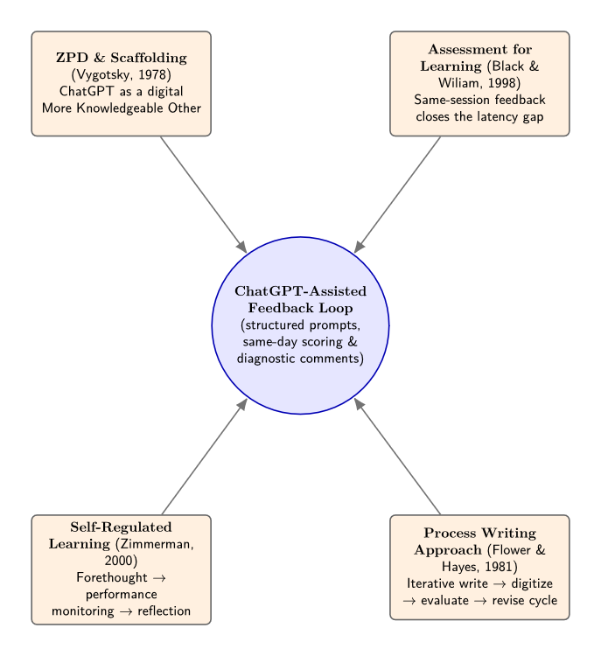
Figure 1: Conceptual diagram integrating the four guiding theories (ZPD/MKO scaffolding, AfL feedback loop, SRL cycle, and the Process Writing draft–revise loop) around the ChatGPT-assisted feedback workflow. To be inserted by the author.
METHODOLOGY
Research Design
This study adopted an action research design implemented through the Kanvas Model Transformasi Sekolah (KMTS) FACES framework (Find, Analyze, Curate, Execute, Sustain), a structured school-improvement planning tool used within the Talent in Leadership (TIL) coaching programme. The intervention was implemented by one PSELF lecturer (Chan Kin Wei) with support from one buddy/superior colleague (Shafiq bin Rasulan) at Kolej Matrikulasi Sarawak, Kuching, over an implementation period of approximately three months (April–June 2026).
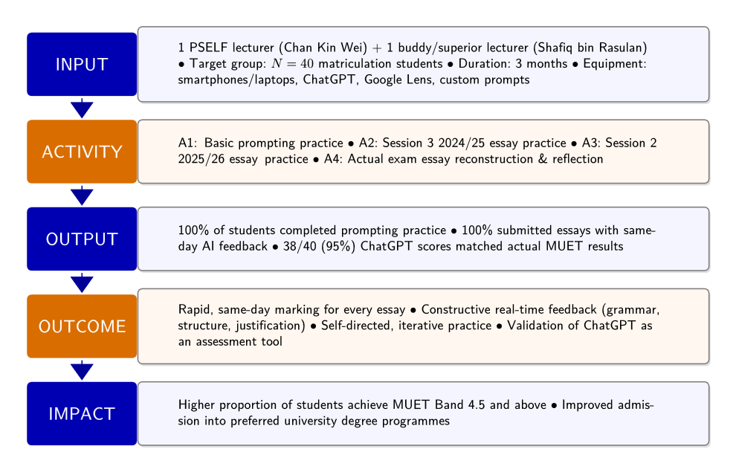Figure 2: KMTS FACES Logic Model (Input → Activity → Output → Outcome → Impact), summarizing implementation personnel, target group, duration, and equipment against the four intervention activities and their outputs, outcomes, and impact goals. Source: KMTS TIL project planning documentation. To be inserted by the author.
Sampling
A purposive sample of N = 40 matriculation students was drawn from a 167-student cohort at the college (itself part of a larger 208-student MUET cohort). The sample was selected on the basis of availability for the 800/4 Session 1 2025 MUET writing paper and continued participation across all subsequent intervention phases.
Instruments
Instruments comprised: (i) three official MUET writing examination papers (Session 3 2024/2025, Session 2 2025/2026, and the actual Session 3 2025/2026 examination); (ii) Google Lens, used for optical character recognition (OCR) digitization of handwritten scripts; and (iii) a set of three structured ChatGPT prompts, namely “Grade my essay based on MUET pitch at B2 level,” “Check my grammar sentence by sentence,” and “Improve my essay to B2 level,” used consistently across all evaluation cycles. The specific ChatGPT model version, access date, and default account settings used across sessions were not systematically logged as part of the original project documentation; this is acknowledged as a reproducibility limitation in the Discussion, and future replications should record the exact model, version, and full verbatim prompt wording for each session.
Data Collection Procedures
The intervention followed a structured, multi-phase workflow. In Phase 1 (Activity 1), students were trained to use ChatGPT to evaluate three of their own essays using the structured prompt set, establishing procedural competence before graded practice. In Phase 2 (Activities 2 and 3), students completed handwritten essays under authentic examination conditions (1 hour 15 minutes) based on two official MUET papers in sequence; each essay was digitized via Google Lens OCR immediately after writing and submitted to ChatGPT using the same prompts, generating a Band score, error annotations, and improvement suggestions before the two-hour class session ended. In Phase 3 (Activity 4), two days after sitting the actual MUET Session 3 2025/2026 examination, all 40 students rewrote their examination essays from memory, digitized them via Google Lens, and evaluated them using the identical ChatGPT protocol, producing an AI-generated Band score directly comparable to each student's official MUET examiner score.
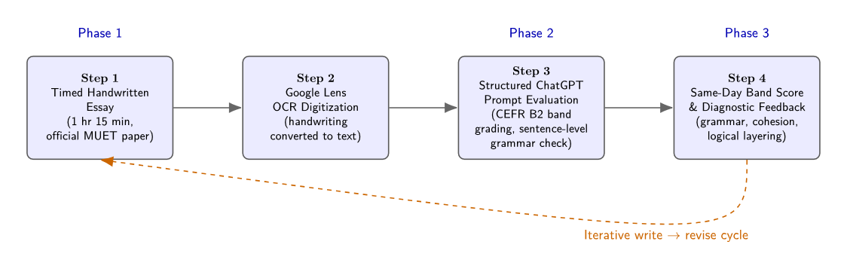Figure 3: Three-phase intervention workflow diagram (timed handwritten essay → Google Lens OCR digitization → structured ChatGPT prompt evaluation → same-day Band score and diagnostic feedback), with representative screenshots of the digitized essay and ChatGPT interface. To be inserted by the author.
Across all four activities, completion rates were consistently high: 100% of the 40 students completed the prompting practice, and 100% submitted digitized essays with same-day AI feedback for the timed practice sessions. In the post-examination reconstruction phase, 38 of 40 students (95%) returned ChatGPT Band scores that matched their actual MUET results on the reconstructed essays, forming the core concordance dataset for RQ1.
Data Analysis
Percentage agreement between ChatGPT-generated Band scores and official MUET examiner scores was calculated as the proportion of exact Band matches versus scores showing minor variance (defined as a deviation of ±0.5 Band). Score distributions and variance were analyzed using Jamovi and Microsoft Excel, the latter also used to construct a color-coded tracking dashboard that visualized individual student Band shifts across successive writing sessions. Longitudinal performance across the three practice/examination phases was tracked as the percentage of the N = 40 sample achieving Band 4 and above at each phase. Because raw, student-level Band scores from the original project records were not retained in a form suitable for re-analysis at the time of writing, two methodological choices follow directly from this constraint and are treated as limitations rather than design decisions: first, agreement is reported as simple percentage agreement rather than a chance-corrected statistic such as weighted Cohen's Kappa, which would more appropriately account for the ordinal structure of MUET Bands and for the possibility of agreement occurring by chance; second, the percentage-point changes in Band 4+ attainment across the three phases are reported descriptively, without an accompanying inferential test (e.g., McNemar's test, the Wilcoxon signed-rank test, or the Friedman test for repeated ordinal measures), and should not be interpreted as evidence of statistically significant change. Both points are revisited in the Discussion and flagged as priorities for future replications with fully retained raw data.
RESEARCH FINDINGS
RQ1: Score Concordance Between ChatGPT and Official MUET Examiners (Post-Examination Reconstructions)
Percentage agreement between ChatGPT-generated evaluations and official MUET examiner Band scores was high on this reconstructed-essay comparison. Of the 40 students who reconstructed and resubmitted their actual examination essays, 38 (95%) received a ChatGPT Band score that was an exact match to their official MUET Band. The remaining 2 students (5%) showed a minor variance of ±0.5 Band between the AI-generated score and the official result. Because students reconstructed these essays from memory rather than submitting their original exam scripts, this figure should be read as score concordance under reconstructed conditions rather than a validated accuracy rate against live examination performance; this distinction is maintained throughout the remainder of the paper and is discussed further below.
Table 1: Summary of Score Concordance Between ChatGPT and Official MUET Examiners on Reconstructed Essays (N = 40)
Outcome Category | Students (n) | Percentage
Exact Band Match | 38 | 95%
Minor Variance (±0.5 Band) | 2 | 5%
Total | 40 | 100%
Note. Data derived from Activity 4 (post-examination essay reconstruction and re-evaluation); percentage agreement only, not a chance-corrected statistic.
Figure 4: ChatGPT Score Concordance vs. Actual MUET Results on Reconstructed Essays (N = 40)
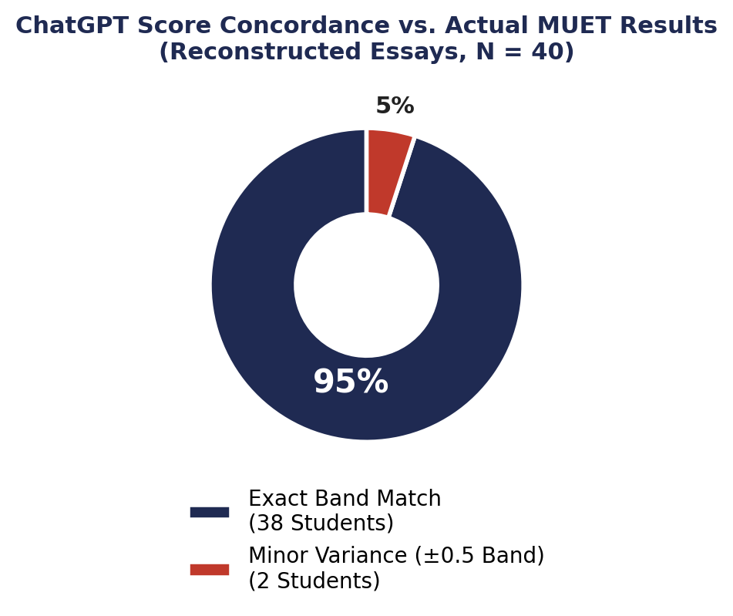
Note. Visual representation of Table 1.
RQ2: Longitudinal Pattern Across Iterative Practice Sessions
Student attainment at Band 4 and above was tracked across three successive writing phases: the Session 1 2025 baseline essay, the Session 2 2025 essay produced after AI-assisted feedback practice, and the Session 3 2025 essay corresponding to the actual MUET examination.
Table 2: Percentage of Students (N = 40) Achieving Band 4 and Above Across Project Phases
Phase | Essay Source | % Achieving Band 4+ | n / N
Session 1 (Baseline) | Session 1 2025 Actual MUET Writing Paper | 17.5% | 7/40
Session 2 (AI Feedback Practice) | Session 2 2025 Actual MUET Writing Paper | 22.5% | 9/40
Session 3 (Actual Exam Output) | Session 3 2025 Actual MUET Writing Paper | 12.5% | 5/40
Note. Session 3 corresponds to performance on the actual, high-stakes MUET examination.
Figure 5: Student Achievement (Band 4.0 & Above) Across Project Phases
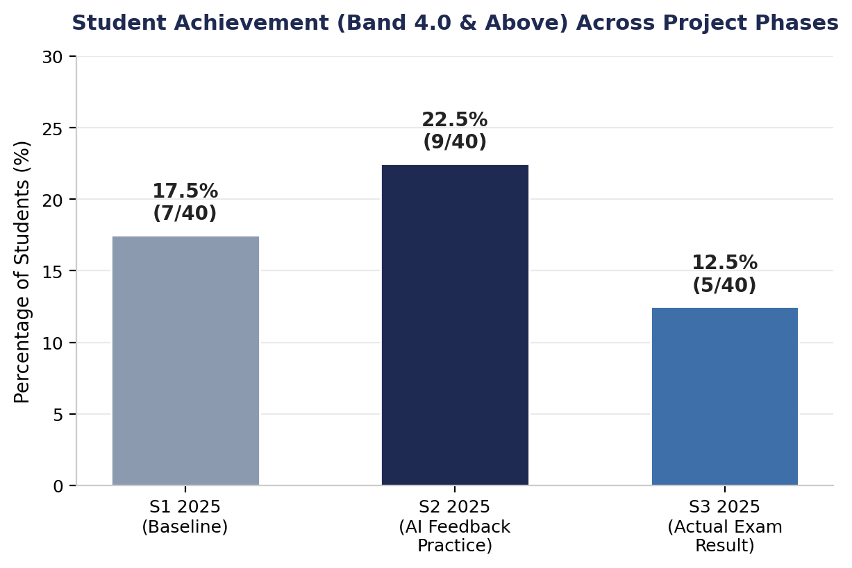
Note. Visual representation of Table 2.
Attainment rose by 5 percentage points from the baseline (17.5%) to the AI-assisted practice phase (22.5%). This change is reported descriptively: the study did not include a control group or an inferential statistical test, so it is not possible to determine from these data alone whether the increase reflects a reliable effect of the intervention or falls within the range of ordinary session-to-session variation. Performance on the actual, high-stakes examination (12.5%) subsequently fell below both prior phases, a pattern examined further in the Discussion section.
RQ3: Efficiency and Diagnostic Feedback Quality
The integration of Google Lens OCR digitization with structured ChatGPT prompts consistently enabled same-day turnaround: across all timed practice sessions, 100% of the 40 students received comprehensive AI feedback, including grammar correction, sentence-structure commentary, score justification, and actionable improvement suggestions, before the end of the same two-hour class period, eliminating the multi-day grading latency of conventional marking.
The diagnostic feedback generated by ChatGPT converged on a consistent set of barriers preventing students from advancing from high Band 4 to Band 5 performance, including: (1) generating distinct main ideas rather than repeating the same argument across different examples; (2) building paragraphs using a clear Point → Explain → Example → Explain the Example → Impact → Link sequence to strengthen logical layering; (3) selecting relevant supporting evidence that directly substantiates the main point; (4) developing more mature, analytical thinking by interrogating “why” and “so what” after each example; and (5) improving language accuracy, particularly subject–verb agreement, verb forms, prepositions, and collocations.
DISCUSSION AND CONCLUSION
Discussion
The 95% exact Band match rate (RQ1) situates this study at the favourable end of a literature whose central lesson is conditionality rather than a fixed verdict on AI scoring agreement, though the rate itself must be read with an important caveat: it reflects agreement on essays that students reconstructed from memory two days after the actual examination, not agreement against the original live exam scripts, and this distinction is discussed at length below. With that caveat in place, and consistent with Quah et al. (2024) and Poole and Coss (2024), both of whom trace ChatGPT's scoring reliability primarily to rubric specificity and prompt engineering rather than to the underlying model, and with Uyar and Büyükahıska (2025), who likewise found ChatGPT viable as an AES tool once criteria were made explicit, the present concordance rate is best read as evidence that the narrow, Band-anchored, single-criterion prompt design used here sits close to the upper bound of what the wider literature considers achievable. It also updates Ng et al. (2016), whose MUET-specific AESF proposal called for purpose-built automated scoring software, by showing that a general-purpose generative AI tool, paired with commodity OCR, can approach that same goal without dedicated development. At the same time, the concordance rate reported here is markedly higher than the moderate agreement typically reported in the broader AES literature (e.g., Mizumoto & Eguchi, 2023; Manning et al., 2025), a gap that most plausibly reflects some combination of the narrower scope of the scoring task (a single Band judgment against a familiar national rubric), the reconstruction methodology discussed below, and the modest, single-cohort sample on which the present result rests, rather than a general superiority of ChatGPT as an evaluator. It should also be read alongside Yamashita's (2025) finding that GPT-4o ratings of English language learners' essays can carry systematic biases even under structured conditions. Framed within Kane's (2013) argument-based validity model, this result speaks only to the scoring inference in an interpretation/use argument for ChatGPT as an AWE tool; it does not, by itself, establish the generalization, extrapolation, or decision inferences that a fuller validity argument would require.
The longitudinal data (RQ2) and the diagnostic feedback findings (RQ3) sit within a formative-feedback literature that is more genuinely divided than the accuracy literature. Steiss et al. (2024), in the most rigorous available comparison, found that trained human raters outperformed ChatGPT on four of five formative feedback quality dimensions, with ChatGPT competitive mainly on criteria-based alignment, a finding that argues against treating AI feedback as a like-for-like substitute for expert marking. Yet Meyer et al. (2024), examining downstream student behaviour rather than feedback quality in isolation, found in a randomized trial that GPT-3.5 feedback significantly increased text revision, motivation, and positive affect among secondary students. The present study's descriptive pattern, an observed rise in Band 4+ attainment from baseline to AI-assisted practice (17.5% to 22.5%) despite feedback that was not independently benchmarked against expert markers, is more consistent with the Meyer et al. account than with a simple quality-matching explanation; because the present design lacks a control group and inferential testing, however, this pattern can only be described as associated with the AI-assisted practice phase, not attributed to it causally. One plausible, untested mechanism is that ChatGPT feedback may operate less by matching a trained lecturer's sophistication and more by arriving immediately and sustaining the iterative write-revise cycle central to Flower and Hayes's (1981) process writing approach. This same-session immediacy is also the mechanism through which Black and Wiliam's (1998) AfL principle and Vygotsky's (1978) ZPD/MKO framing operate here, and the planned move to individual Google Sites e-portfolios extends this into the self-reflection phase of Zimmerman's (2000) SRL cycle.
Positioned against Malaysian and regional evidence, the findings both corroborate and extend a still-thin local literature. The positive perceived gains in grammar accuracy and revision autonomy reported among Malaysian secondary ESL learners by Sharmithashini and Hashim (2026) and Ooi et al. (2026) are echoed here in the consistency of the diagnostic feedback categories (logical layering, evidence selection, subject-verb agreement) that ChatGPT surfaced across the sample; unlike those two studies, however, the present design adds an objective, examiner-referenced concordance check rather than relying on self-reported perceptions alone. Ling and Salam's (2025) finding that Johor Bahru secondary students needed a structured scaffold to use generative AI productively, rather than being left to use it unguided, mirrors this study's decision to constrain ChatGPT to three fixed prompts, and may help explain why the present sample did not exhibit the overdependence and limited critical evaluation that Awaludin et al. (2025) flagged among UiTM pre-university and undergraduate ESL students using a wider, less-structured toolkit (ChatGPT, Grammarly, QuillBot, and Google Translate together). Read as a set, this comparison suggests that the risk of overreliance on AI in Malaysian ESL writing instruction identified elsewhere in the literature is not inherent to the tools themselves but is moderated by how tightly the prompting protocol is scaffolded, an implication with direct bearing on how this intervention should be scaled.
Two patterns within the present data merit closer interpretation. First, and most importantly, the reconstruction methodology underlying the RQ1 comparison is arguably the most significant threat to the internal validity of this study's concordance finding. Because Activity 4 required students to reconstruct their examination essay from memory two days after sitting the actual test, students had an open opportunity to revise, correct, or otherwise improve their wording relative to what they originally produced under timed exam conditions before that reconstructed text was ever submitted to ChatGPT for evaluation. This means the 95% concordance figure reflects agreement between ChatGPT and examiners on two different texts for the same student (a polished reconstruction versus the original timed script), not a direct comparison on identical text, and it is plausible that this reconstruction effect flatters the concordance rate rather than depresses it, since students had incentive and opportunity to correct exactly the kinds of errors examiners and ChatGPT would both penalize. The 5% (n = 2) of students whose ChatGPT-derived Band score diverged from their official result by ±0.5 Band is consistent with this account, but the more consequential implication is that the concordance rate for the other 95% cannot be fully disentangled from reconstruction and self-editing effects either. This limitation cannot be resolved with the present data and is the primary reason a direct comparison against original, unedited exam scripts is recommended as the first priority for replication (see Conclusion and Recommendations). Second, the dip in Band 4+ attainment at the actual examination phase (12.5%) relative to the AI-assisted practice phase (22.5%) should not be read as evidence that the intervention was ineffective; actual MUET examinations carry higher performance stakes, tighter time pressure, and the absence of any in-task feedback loop, all of which plausibly suppress performance relative to a practice session in which students had just received, and could still apply, real-time diagnostic comments. As noted above, however, this remains a descriptive observation rather than a statistically tested effect.
For lecturer workload, the demonstrated same-day turnaround suggests AI-assisted marking can substantially offset the manual grading burden associated with large matriculation cohorts, freeing lecturer time for higher-order feedback rather than first-pass error identification, a benefit consistent with Steiss et al.'s (2024) conclusion that AI feedback remains valuable on time-saving grounds even where its raw quality trails a trained teacher's.
Several limitations constrain the generalizability and strength of these findings, and are stated here explicitly rather than folded into the surrounding discussion. First, as noted above, the RQ1 comparison relies on post-exam essay reconstructions rather than original exam scripts, which introduces a recall-and-revision confound that likely inflates the reported concordance rate; a design comparing ChatGPT scoring directly against original, unedited scripts is needed before the concordance figure can be treated as a stable estimate. Second, agreement was quantified using simple percentage agreement rather than a chance-corrected, ordinal-appropriate statistic such as weighted Cohen's Kappa, and the percentage-point changes in Band 4+ attainment across phases were not evaluated with an inferential test (e.g., McNemar's test, the Wilcoxon signed-rank test, or the Friedman test); both findings should therefore be read as descriptive rather than as evidence of statistically reliable agreement or change. Third, the ChatGPT model version, access dates, and default settings used across sessions were not systematically logged, limiting the reproducibility of the exact scoring conditions, even though the three structured prompts themselves are reported in full. Fourth, Google Lens OCR output clarity was not formally assessed; because OCR accuracy depends on handwriting legibility, undetected transcription errors could have influenced the text ChatGPT actually evaluated, independent of any scoring behaviour on ChatGPT's part. Fifth, the sample size (N = 40) is modest and drawn from a single matriculation college, which restricts generalizability; the positive results reported here should be treated as preliminary evidence specific to this institution and cohort, not as a general claim about ChatGPT's reliability as an AWE tool, and broader claims should await replication across institutions and larger, more diverse samples. Finally, following Kane's (2013) argument-based framing introduced above, this study provides evidence for only the scoring inference in a validity argument for ChatGPT as an AWE tool; claims beyond that inference, including about generalization to other cohorts, extrapolation to real-world writing ability, or the appropriateness of using ChatGPT scores for decisions about students, are outside the scope of what these data can support.
Conclusion and Recommendations
This action research study provides preliminary, single-institution evidence that generative AI, when guided by structured, criterion-referenced prompts, can achieve high score concordance with official MUET examiners and may support more immediate formative feedback than conventional marking allows for MUET Writing Paper 800/4. ChatGPT achieved a 95% exact Band match against official MUET examiner scores across a sample of 40 matriculation students on post-examination essay reconstructions, and enabled same-day feedback turnaround that is structurally difficult to achieve under conventional manual marking at scale. Longitudinal data show a descriptive increase in Band 4+ attainment during the AI-assisted practice phase, though, in the absence of a control group and inferential statistical testing, this pattern should be read as an observed association rather than a demonstrated causal effect, and performance on the single high-stakes examination remained more constrained by testing conditions than these descriptive trends can explain. Given the reconstruction-based comparison underlying the RQ1 result, the absence of chance-corrected agreement statistics, and the modest single-institution sample, these findings should be treated as preliminary and hypothesis-generating rather than as validation of ChatGPT as a general-purpose AWE tool.
Four scaling strategies are recommended for the 2026/2027 cohort and beyond, together with directions for future research:
- Cohort Expansion via a “Replicate and Duplicate” Model (July–October 2026): Extend the same structured workflow to the incoming 2026/2027 Semester 1 matriculation cohort over their four-month MUET preparation window, treating this as a further test of the pattern reported here rather than a confirmed effect.
- Google Sites Student E-Portfolios: Require each student to maintain an individual Google Sites portfolio logging weekly essays, ChatGPT evaluation reports, and revision iterations across a 16-week cycle.
- Integrated Speaking–Writing Skill Enhancement: Expand the structured prompt framework to incorporate MUET Speaking (800/2) alongside Writing (800/4) within combined interactive language sessions.
- Methodological Strengthening and Future Research: Sustain collaborative monitoring using the color-coded Excel tracking dashboard, and pursue larger, multi-institution replications that (a) compare ChatGPT scoring directly against original examination scripts rather than post-exam reconstructions to remove the recall-bias confound identified in this study; (b) report a chance-corrected agreement statistic such as weighted Cohen's Kappa alongside percentage agreement; (c) apply an appropriate inferential test (e.g., McNemar's, Wilcoxon signed-rank, or Friedman) to longitudinal Band changes; (d) formally assess Google Lens OCR transcription accuracy; and (e) report the specific ChatGPT model, version, and access conditions used in full.
Collectively, these findings support a cautious conclusion: prompt-guided generative AI shows promising, criterion-related evidence of score concordance and may plausibly support scalable, same-day formative assessment in L2 writing instruction, provided its use remains anchored to explicit scoring criteria, is subject to periodic human validation, and is understood as a preliminary finding from a single institution rather than a general endorsement of ChatGPT as a validated AWE tool.
REFERENCES
Awaludin, F. A., Ahmad Junid, R., Zaidi, A., Che Ghani, N. F., Abd Karim, R., Ibrahim, N. A., & Norafand, N. N. (2025). Student engagement and perceptions of AI-powered tools in ESL learning: Effectiveness in higher education. International Journal of Research and Innovation in Social Science, 9(11), 3318–3330.
Black, P., & Wiliam, D. (1998). Assessment and classroom learning. Assessment in Education: Principles, Policy & Practice, 5(1), 7–74. https://doi.org/10.1080/0969595980050102
Flower, L., & Hayes, J. R. (1981). A cognitive process theory of writing. College Composition and Communication, 32(4), 365–387. https://doi.org/10.2307/356600
Kane, M. T. (2013). Validating the interpretations and uses of test scores. Journal of Educational Measurement, 50(1), 1–73. https://doi.org/10.1111/jedm.12000
Ling, S. J., & Salam, A. R. (2025). Teaching secondary school essay writing using generative AI. International Journal of Research and Innovation in Social Science, 9(3S), 6065–6070.
Manning, J., Baldwin, J., & Powell, N. (2025). Human versus machine: The effectiveness of ChatGPT in automated essay scoring. Innovations in Education and Teaching International, 62(5), 1500–1513. https://doi.org/10.1080/14703297.2025.2469089
Messick, S. (1989). Validity. In R. L. Linn (Ed.), Educational measurement (3rd ed., pp. 13–103). Macmillan/American Council on Education.
Meyer, J., Jansen, T., Schiller, R., Liebenow, L. W., Steinbach, M., Horbach, A., & Fleckenstein, J. (2024). Using LLMs to bring evidence-based feedback into the classroom: AI-generated feedback increases secondary students' text revision, motivation, and positive emotions. Computers and Education: Artificial Intelligence, 6, Article 100199. https://doi.org/10.1016/j.caeai.2023.100199
Mizumoto, A., & Eguchi, M. (2023). Exploring the potential of using an AI language model for automated essay scoring. Research Methods in Applied Linguistics, 2(2), Article 100050. https://doi.org/10.1016/j.rmal.2023.100050
Ng, S. Y., Bong, C. H., Lee, N. K., & Hong, K. S. (2016). Automated Essay Scoring Feedback (AESF): An innovative writing solution to the Malaysian University English Test (MUET). Penerbit UiTM (UiTM Press).
Ooi, Y. H., Yunus, M. M., & Said, N. E. M. (2026). Perceptions of Malaysian secondary school students on GeniusWrite, AI-integrated module for learning English writing. International Journal of Learning, Teaching and Educational Research, 25(6), 334–371.
Poole, F. J., & Coss, M. D. (2024). Can ChatGPT reliably and accurately apply a rubric to L2 writing assessments? The devil is in the prompt(s). Journal of Technology and Chinese Language Teaching, 15(1), 1–24.
Quah, B., Zheng, L., Sng, T. J. H., Yong, C. W., & Islam, I. (2024). Reliability of ChatGPT in automated essay scoring for dental undergraduate examinations. BMC Medical Education, 24(1), Article 962. https://doi.org/10.1186/s12909-024-05881-6
Sharmithashini, M., & Hashim, H. (2026). Enhancing secondary ESL students' writing proficiency with AI-powered writing tools: An empirical study. International Journal of Research and Innovation in Social Science, 13(1). https://doi.org/10.51244/IJRSI.2026.13010220
Steiss, J., Tate, T., Graham, S., Cruz, J., Hebert, M., Wang, J., Moon, Y., Tseng, W., Warschauer, M., & Olson, C. B. (2024). Comparing the quality of human and ChatGPT feedback of students' writing. Learning and Instruction, 91, Article 101894. https://doi.org/10.1016/j.learninstruc.2024.101894
Uyar, A. C., & Büyükahıska, D. (2025). Artificial intelligence as an automated essay scoring tool: A focus on ChatGPT. International Journal of Assessment Tools in Education, 12(1), 20–32.
Vygotsky, L. S. (1978). Mind in society: The development of higher psychological processes. Harvard University Press.
Yamashita, T. (2025). Exploring potential biases in GPT-4o's ratings of English language learners' essays. Language Testing, 42(3), 344–358.
Zimmerman, B. J. (2000). Attaining self-regulation: A social cognitive perspective. In M. Boekaerts, P. R. Pintrich, & M. Zeidner (Eds.), Handbook of self-regulation (pp. 13–39). Academic Press.

