**Scaffolded Independent Practice in Physics: An Action Research Study**

*Latihan Kendiri Berperancah dalam Fizik: Satu Kajian Tindakan*

**Shafiq Bin Rasulan1\***

1 Sarawak Matriculation College, Sarawak

*Corresponding author: bm-3542@moe-dl.edu.my

**Abstract**

This study investigated the impact of Scaffolded Independent Practice on conceptual understanding of Newtonian mechanics among secondary students. Using an action research design with two iterative cycles of implementation 3, the study involved 12 matriculation students selected through purposive sampling based on demonstrated conceptual difficulties (pre-test scores <40%). The Half-Length Force Concept Inventory (HFCI) was administered as pre-test, intermediate, and post-test to quantify conceptual gains, while semi-structured interviews provided qualitative insights. Quantitative analysis revealed statistically significant improvement (t=10.79, p<0.001) with mean scores increasing from 48.21% (SD=11.76) to 80.36% (SD=7.03), yielding a high normalized gain of <g>=0.62 and large effect size (Cohen’s d=2.80). Thematic analysis identified four key mechanisms: reduced cognitive load, increased problem-solving confidence, enhanced metacognitive skills, and successful transfer of strategic frameworks. Findings demonstrate that scaffolded practice effectively addresses conceptual barriers by making expert problem-solving processes accessible. Implications include the value of structured scaffolding in physics instruction and the utility of action research for teacher-led pedagogical innovation.

**Keywords:** Physics Education, Conceptual Understanding, Scaffolding, Action Research, Force Concept Inventory, Problem-Solving

**Abstrak**

Kajian ini mengkaji kesan Latihan Kendiri Berperancah terhadap kefahaman konseptual mekanik Newton dalam kalangan pelajar fizik peringkat matrikulasi. Penyelidikan ini menggunakan reka bentuk kajian tindakan dengan dua kitaran pelaksanaan yang melibatkan 12 orang pelajar yang dipilih melalui persampelan bertujuan berdasarkan pencapaian rendah (skor ujian pra <40%). Inventori Konsep Daya Setengah (HFCI) digunakan sebagai instrumen ujian pra, ujian pasca dan penilaian pertengahan, manakala temu bual separa berstruktur memberikan data kualitatif. Analisis kuantitatif menunjukkan peningkatan signifikan (t=10.79, p<0.001) dengan skor min meningkat daripada 48.21% (SP=11.76) kepada 80.36% (SP=7.03), menunjukkan peningkatan ternormalisasi tinggi <g>=0.62 dengan kesan saiz yang besar (d=2.80). Analisis tematik mendapati empat tema utama: pengurangan beban kognitif, peningkatan keyakinan menyelesaikan masalah, pengukuhan kemahiran metakognitif, dan pemindahan strategi penyelesaian masalah. Hasil kajian membuktikan keberkesanan Latihan Kendiri Berperancah dalam meningkatkan kefahaman konseptual fizik. Implikasi kajian mencadangkan integrasi elemen perancah dalam pedagogi fizik dan penggunaan kajian tindakan dalam pembangunan profesional guru.

**Kata kunci:** Pendidikan Fizik, Kefahaman Konseptual, Pembelajaran Berperancah, Kajian Tindakan, Inventori Konsep Daya, Penyelesaian Masalah

**INTRODUCTION**

Conceptual understanding in Newtonian mechanics forms the foundation of advanced physics, yet it remains a significant and persistent challenge for students worldwide. Decades of research have shown that traditional instruction often fails to dislodge deeply held misconceptions about force, motion, and energy, leading to a disconnect between algorithmic problem-solving skills and genuine physical reasoning (Hestenes et al., 1992; Mazur, 1997). The Half-Length Force Concept Inventory (HFCI) and similar instruments have consistently documented this problem, revealing that students can often apply formulas correctly without understanding the underlying principles (Hestenes, 1998).

Within the Malaysian Matriculation programme, students consistently demonstrated an inability to meaningfully engage with homework and achieved low scores on conceptual diagnostics. In our practice, traditional lecture-based instruction on Newton’s laws yielded persistently low performance and confidence, revealing the inadequacy of transmission-style teaching for fostering deep conceptual change.

This reflection on the inadequacy of past practice led to a search for pedagogies aligned with constructivist and sociocultural learning theories (Vygotsky, 1978), which posit that knowledge is actively built by the learner through guided inquiry and social interaction. Moving from a traditional, teacher-centred lecture format towards a student-centred learning approach became the primary goal. Scaffolded Independent Practice was selected as the intervention strategy, as it is engineered to provide temporary, structured support that guides students through complex problem-solving, making the implicit processes of experts explicit, before gradually fading that support to build independence (Wood et al., 1976).

While the effectiveness of scaffolded learning is supported by educational research, its implementation is highly context-dependent. The specific problem of *how* to design, implement, and refine such scaffolds to meet the precise needs of a particular student cohort—in this case, matriculation students struggling with foundational concepts—remains an open area for practitioner inquiry. This study therefore employs an action research methodology (Kemmis & McTaggart, 1988), a reflective process of progressive problem-solving, to address this gap. Action research is uniquely suited to this task, as it empowers practitioners to iteratively develop and improve their own teaching practices based on emergent, real-time data from their classrooms.

The primary objectives of this study are:

1. To design and iteratively refine Scaffolded Independent Practice (SIP) worksheets for Newtonian mechanics within the Malaysian Matriculation context.
2. To evaluate the impact of the refined SIP on the conceptual understanding of a cohort of students with significant conceptual difficulties, as measured by the HFCI.
3. To identify the mechanisms (e.g., cognitive load, metacognition, problem-solving confidence) through which the scaffolds facilitate learning, using qualitative data from student interviews.
4. To contribute a model of reflective practice for physics education that bridges the gap between educational theory and classroom application.

The remainder of this paper is structured as follows. The methodology details the action research design, participants, ethical considerations, and the specific instruments used. The results and discussion present the findings from two iterative cycles, including the quantitative gains in conceptual understanding and the qualitative themes explaining these gains. The paper concludes with implications for teaching practice and recommendations for educators seeking to implement similar student-centred interventions.

**METHODOLOGY [TIMES NEW ROMAN, CAPITAL LETTERS, FONT SIZE 12]**

**Research Design and Context**

This study employed an action research design (Kemmis & McTaggart, 1988), a methodology chosen for its suitability in iteratively improving educational practice. Grounded in constructivist and sociocultural learning theories (Vygotsky, 1978), the design acknowledges that conceptual change requires active, scaffolded knowledge construction. The two-week intervention encompassed two complete action research cycles, with each cycle systematically addressing the implementation and refinement of scaffolded independent practice in physics education. This iterative design facilitated a responsive research process where teaching practices were continuously refined based on emergent, real-time data.

**Participants**

The participants comprised twelve matriculation students (N=12), with a gender distribution of six males and six females, all aged 18-19. Selection was conducted via purposive sampling to specifically target students demonstrating significant conceptual weaknesses. The inclusion criteria were a score below 40% on a diagnostic test on Newtonian forces and corroborating teacher recommendations based on classroom performance.

**Ethical Considerations**

All participants provided written informed consent after the study's purpose, procedures, and their rights were thoroughly explained. To ensure data anonymity and confidentiality, all participant names were replaced with unique, random identifier codes (e.g., “Student 1”, “Student 2”,…,etc) immediately upon data collection. All research data, including assessment results and interview transcripts, were linked only to these codes and stored on a secure, encrypted server, with any documents containing personal information kept in a locked cabinet accessible solely to the primary researcher. Crucially, we guaranteed the right of participants to withdraw at any time without any consequence to their academic standing, a principle that was reinforced at the beginning of each major research activity to affirm the voluntary nature of their involvement.

**Instruments and Materials**

The primary quantitative instrument was the Half-Length Force Concept Inventory (HFCI). Two equivalent forms, Set A and Set B, were utilised to mitigate practice effects and track conceptual development longitudinally. Set A was administered as both a pre-test and a post-test, while Set B served as an intermediate assessment following the first action research cycle.

The intervention materials consisted of a series of specially designed Scaffolded Independent Practice worksheets. These materials were engineered to provide structured support, featuring context-rich problems tiered by difficulty, conceptual analysis prompts that required engagement before numerical computation, integrated strategic hint systems, and metacognitive reflection components to encourage self-monitoring.

Qualitative data were gathered through semi-structured interviews conducted post-intervention. The interview protocol was designed to elicit student perceptions on several dimensions: the perceived change in their conceptual understanding, the utility and accessibility of the various scaffolding elements, identification of any persistent conceptual difficulties, and constructive suggestions for improving the instructional materials.

**Procedure**

The procedure operationalized the Kemmis and McTaggart (1988) action research model through two intensive, iterative cycles conducted over consecutive weeks. Each cycle consisted of distinct planning, acting, observing, and reflecting phases, with insights from each phase directly informing the next.

**Cycle 1 (Week 1):**

The planning phase involved analyzing pre-test results (HFCI Set A) to identify student misconceptions, which were then used to create the first set of SCAFFOLDED INDEPENDENT PRACTICE materials. During the acting phase, these materials were implemented in three one-hour sessions focusing on forces, motion, and applications of Newton's laws. The observing phase consisted of administering the HFCI Set B to gather data on student progress after the initial intervention.

The immediate impact of the first intervention cycle was evaluated through the administration of HFCI Set B. Student responses were collected to serve as an intermediate assessment of conceptual development. A thorough analysis of the HFCI Set B data and facilitator observations was conducted. The purpose of this reflection was to identify the strengths and weaknesses of the initial SCAFFOLDED INDEPENDENT PRACTICE materials and to pinpoint any persistent conceptual difficulties, providing a basis for refining the intervention for Cycle 2.

**Figure 1.**

*Action Research Phases, based on action research model of Kemmis and McTaggart*

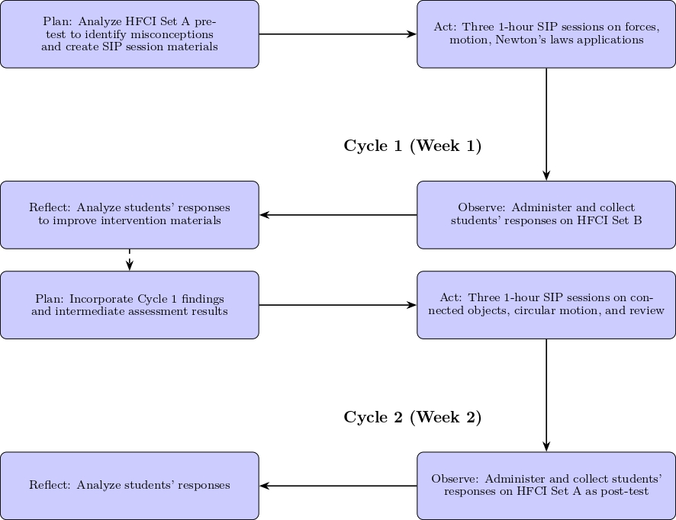

**Cycle 2 (Week 2):**

The planning phase incorporated findings from Cycle 1's reflection phase and intermediate assessment results. The acting phase therefore consisted of three 1-hour Scaffolded Independent Practice sessions that targeted the specific advanced concepts identified in the revised plan, namely connected objects and circular motion, culminating in a comprehensive review. Subsequently, the observing phase evaluated the efficacy of the complete two-cycle intervention by administering the HFCI Set A as a post-test. Finally, the reflecting phase involved a thorough analysis of this post-test data to determine the overall impact of the scaffolded instruction on conceptual understanding.

**Follow-Up Qualitative Data Collection**

In the week following the final cycle, semi-structured interviews were conducted with all twelve participants to gather rich qualitative data on their experiences with the scaffolding and their metacognitive development.

**Data Analysis**

Quantitative data from HFCI assessments were analyzed using descriptive statistics and normalized gain scores. Paired samples t-tests compared pre-test and post-test results to assess statistical significance of conceptual gains.

Qualitative data from interviews underwent thematic analysis following Braun and Clarke's (2006) framework. Analysis focused on identifying patterns in conceptual development, perceptions of scaffold utility, and emergent themes regarding learning barriers and successes.

**Research Strategy and Alignment**

To ensure a coherent approach to addressing the research objectives, a mixed-methods strategy was employed, integrating quantitative and qualitative data collection and analysis. This alignment between the objectives, data collection, and analysis methods is summarized in Table 1, providing a framework for the study's research strategy.

**Table 1**

*Alignment of Research Objectives, Data Collection, and Analysis Methods*

| **Research Objective** | **Data Collection Method** | **Analysis Method** |
| --- | --- | --- |
| 1. Design & implement SIP worksheets | Document analysis of worksheets | Descriptive summary of design features |
| 2. Evaluate conceptual change | HFCI (Pre-test/Post-test) | Descriptive stats, normalized gain, paired t-test |
| 3. Identify learning mechanisms | Semi-structured interviews | Thematic Analysis (Braun & Clarke, 2006) |
| 4. Refine instructional practices | HFCI Set B, facilitator observations | Reflective analysis (Kemmis & McTaggart model) |

**RESULTS AND DISCUSSION**

**Cycle 1 Reflective Findings and Material Refinement**

The reflective analysis of HFCI Set B data and observational notes from the first week's sessions revealed two critical weaknesses in the initial SCAFFOLDED INDEPENDENT PRACTICE materials, related to their differentiated support:

1. Ambiguity in Strategic Hint System: While the hint system was frequently used, its effectiveness was mixed. Observational data showed that students often requested verbal clarification for hints related to "identifying the system" in Newton's Second Law problems (e.g., "Should I treat the two blocks as one system or separately?"). This indicated that the written hints were too vague, leading to confusion rather than clarity.
2. Inadequate Tiering of Difficulty: The jump from Tier 2 (intermediate) to Tier 3 (advanced) problems was too steep. The top quartile of students completed the Tier 3 problems quickly and became disengaged, while the bottom quartile abandoned them entirely. This was corroborated by HFCI Set B, which showed a high error rate on questions requiring the multi-step problem-solving that Tier 3 was meant to develop.

The SCAFFOLDED INDEPENDENT PRACTICE materials were refined to directly address these weaknesses:

1. To improve hint clarity, all strategic hints were revised to be more action-oriented and specific. For example, the hint "Identify all objects involved" was replaced with a two-part prompt: "Step 1: Isolate object A. List all forces acting *only* on it. Step 2: Now isolate object B. List all forces acting *only* on it." This provided a concrete procedure instead of a vague directive.
2. To better tier difficulty, a new "Tier 2.5" problem was introduced between the intermediate and advanced levels. This problem was designed to scaffold the single most challenging step of the advanced problem (e.g., calculating the tension between two connected objects before asking for the acceleration). Furthermore, an optional "Challenge" extension was added for early finishers, requiring a conceptual explanation of how the answer would change under different conditions, thus promoting deeper learning without simply moving them to a new numerical problem.

**Quantitative Results**

The efficacy of the scaffolded independent practice intervention was evaluated through a pre-test/post-test design using the HFCI. The quantitative results, summarised in table 1, demonstrate a substantial shift in conceptual understanding of Newtonian mechanics among the participant cohort.

**Table 1.**

*Descriptive statistics for FCI scores and normalized gains.*

|  |  |  |  |
| --- | --- | --- | --- |
| Statistic | Pre-test score (%) | Post-test score (%) | Normalized gain, <g> |
| Mean | 48.21 | 80.36 | 0.62 |
| Standard deviation | 11.76 | 7.03 | 0.17 |
| Minimum | 35.71 | 71.43 | 0.20 |
| Maximum | 71.43 | 92.86 | 0.78 |

The mean pre-test score of 48.21±11.76% confirms the cohort's initial conceptual difficulties, consistent with the selection criteria. Following the intervention, the mean post-test score rose significantly to 80.36±7.03%. The magnitude of this improvement is captured by the normalized gain, which yielded a mean of <g> = 0.62. This value is categorised as a high gain according to standard physics education research metrics, indicating that the intervention enabled students to correct a majority of their prior misconceptions.

The distribution of individual gains, shown in figure 1, further elucidates the intervention's impact. All 12 students achieved a positive normalized gain, with values ranging from <g> = 0.20 to <g> = 0.78. The distribution is unimodal and positively skewed, with 83% of participants (10 of 12) achieving a gain of over 0.50. This indicates that the SCAFFOLDED INDEPENDENT PRACTICE strategy was effective across almost the entire cohort, irrespective of their initial proficiency level. Furthermore, the reduction in standard deviation from pre-test to post-test suggests a convergence towards a high level of conceptual mastery, reducing the spread of understanding within the group.

A paired-samples t-test was conducted to evaluate the statistical significance of the score improvement. The results indicate a statistically significant difference ($t=10.79, p<0.001$)between the pre-test (M=48.21, SD=11.76) and post-test (M=80.36, SD=7.03) scores. The effect size, calculated using Cohen's d, was 2.80, which denotes an exceptionally large effect, underscoring the practical significance of the intervention's impact. The assumptions of normality for parametric testing were confirmed via Shapiro-Wilk tests for pre-test scores (p = .381), post-test scores (p = .149), and normalized gain scores (p = .283).

In summary, the quantitative data provides compelling evidence that the implemented scaffolding strategy effectively facilitated a robust and statistically significant conceptual change in mechanics within this student cohort.

**Table 2.**

*Results of Pre and Post Test for each students*

|  |  |  |  |
| --- | --- | --- | --- |
| **Student** | **Pre-Test Percentage (%)** | **Post-Test Percentage (%)** | **Normalized Gain** |
| Student 1 | 50.00 | 71.43 | 0.43 |
| Student 2 | 64.29 | 85.71 | 0.60 |
| Student 3 | 35.71 | 85.71 | 0.78 |
| Student 4 | 35.71 | 78.57 | 0.67 |
| Student 5 | 42.86 | 78.57 | 0.62 |
| Student 6 | 50.00 | 85.71 | 0.71 |
| Student 7 | 64.29 | 71.43 | 0.20 |
| Student 8 | 50.00 | 71.43 | 0.43 |
| Student 9 | 71.43 | 92.86 | 0.75 |
| Student 10 | 42.86 | 85.71 | 0.75 |
| Student 11 | 42.86 | 78.57 | 0.62 |
| Student 12 | 35.71 | 78.57 | 0.67 |

**Figure 1.**

*Normalized gain distribution across the 12 students*

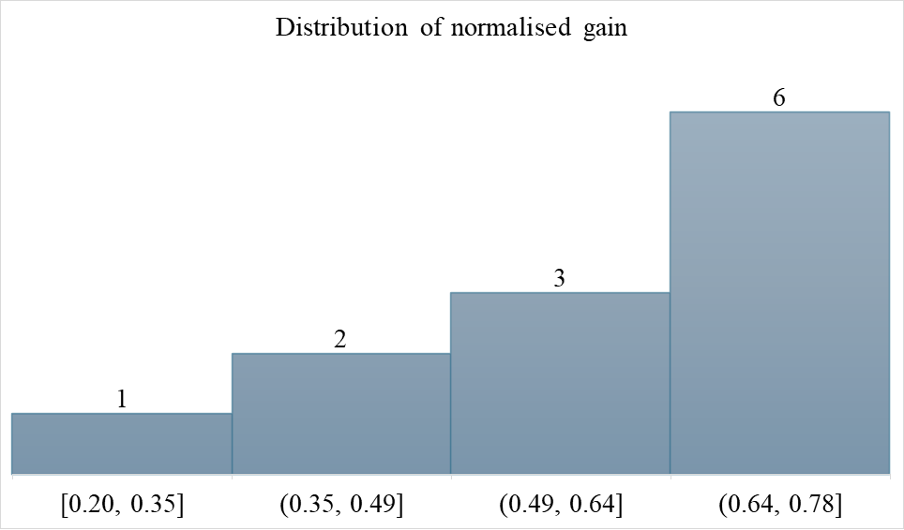

**Figure 1.**

*Comparison of students’ pre-test and post-test scores (%) in physics. The results show overall improvement in performance after the scaffolded independent practice intervention.*

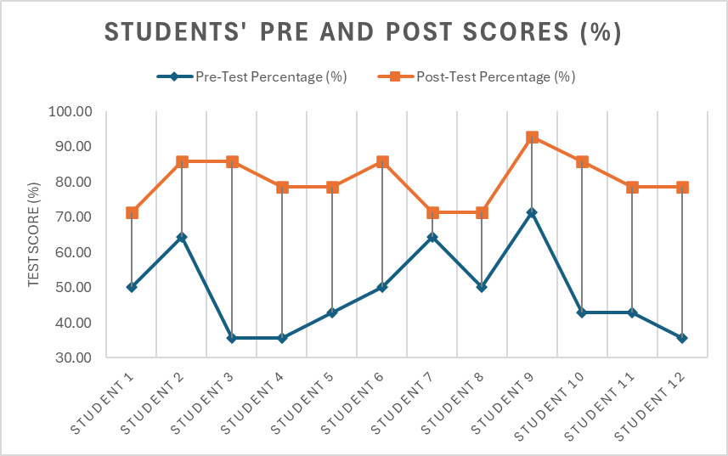

**Qualitative Results**

Thematic analysis revealed four key themes explaining the quantitative gains, indicating the intervention successfully modelled expert problem-solving approaches.

**Table 3. Prevalence of primary themes in student interview responses (N=12).**

|  |  |  |
| --- | --- | --- |
| **Theme** | **Frequency** | **Representative Codes** |
| Reduced cognitive load | 11/12 | "knew where to start", "less overwhelming", "structured approach" |
| Increased solving confidence | 12/12 | "could do it myself", "had a strategy", "more sure of answers" |
| Metacognitive skill development | 9/12 | "think about my thinking", "check my approach", "monitor understanding" |
| Strategic problem-solving transfer | 8/12 | "use steps on other problems", "same method in tests", "automatic process" |

Analysis of student interviews revealed four salient themes explaining the intervention's effectiveness. The structured scaffolding reduced cognitive load for 11 of 12 students by providing explicit problem-solving frameworks, minimizing extraneous load and freeing working memory for conceptual tasks. As one student noted, *"The sheets forced me to break problems down logically instead of panicking"* (Student 3). All participants reported enhanced self-efficacy through development of reliable problem-solving strategies, with the fading support proving crucial to building independence: *"I internalized the process and relied less on the hints each week"* (Student 2).

Additionally, 9 students demonstrated improved metacognitive awareness, consciously monitoring their problem-solving approach. This was exemplified by Student 7's statement: *"I now pause to ask 'what concept is this testing?' before calculating."* Finally, 8 students successfully transferred the strategic framework to unscaffolded contexts, with Student 9 reporting: *"I used the mental steps during the post-test automatically,"* indicating successful internalization of expert problem-solving processes.

The concurrence of these themes indicates the intervention’s efficacy stemmed from making expert processes accessible, thereby fostering durable, transferable learning strategies.

The convergence of quantitative and qualitative data provides a compelling explanation for the intervention's efficacy. The significant pre-post gains and large effect size quantitatively demonstrate a substantial conceptual change across the cohort. The qualitative themes elucidate the underlying mechanisms driving this change. The SCAFFOLDED INDEPENDENT PRACTICE worksheets did not merely present content; they structured the problem-solving process, which reduced cognitive load and built solving confidence. This allowed students to develop and internalize metacognitive skills, ultimately enabling them to transfer strategic reasoning to novel contexts, as evidenced by their success on the post-test. This suggests that the intervention's success was not just in teaching physics concepts, but in apprenticing students into the expert practice of problem-solving, making the implicit processes of physicists explicit and accessible.

**Achievement of Research Objectives**

This study successfully addressed its four primary objectives. First, a set of Scaffolded Independent Practice worksheets for Newtonian mechanics was designed and implemented (Objective 1). Second, the intervention's effectiveness was confirmed through significant quantitative gains in HFCI scores (Objective 2). Third, thematic analysis of interview data identified reduced cognitive load, increased confidence, metacognitive development, and strategic transfer as the key mechanisms behind this effectiveness (Objective 3). Finally, the action research framework enabled the continuous refinement of these materials based on emergent data, fulfilling the iterative improvement goal (Objective 4).

**CONCLUSION**

This action research study demonstrated the profound impact of Scaffolded Independent Practice (SIP) on the conceptual understanding of Newtonian mechanics among matriculation students with significant initial learning difficulties. The two-cycle intervention, grounded in constructivist and sociocultural principles, yielded statistically significant and educationally meaningful gains, as evidenced by a high normalized gain (<g> = 0.62) and an exceptionally large effect size (Cohen’s d = 2.80). Crucially, the qualitative findings revealed the underlying mechanisms of this success: the structured worksheets reduced cognitive load, built problem-solving confidence, enhanced metacognitive skills, and facilitated the transfer of expert-like strategies to novel contexts.

The iterative action research design was instrumental in this process. The reflective analysis after Cycle 1 enabled the precise refinement of instructional materials, which directly contributed to the robust outcomes observed in Cycle 2. This highlights the critical role of teacher-researcher reflection and adaptability in developing effective, student-centered pedagogy.

**Implications for Practice**

For educators, this study provides a transferable model for addressing conceptual barriers in physics. The findings strongly suggest that integrating explicitly structured scaffolds, which make expert problem-solving processes visible and accessible, can be far more effective than traditional, transmission-based instruction. Teachers are encouraged to adopt similar iterative approaches to material design, using formative assessment and student feedback to continuously tailor support to their learners' evolving needs.

**Limitations and Suggestions for Future Research**

While the findings are compelling, this study was conducted with a small, purposefully selected sample within a specific educational context, which may limit the generalizability of the results. Future research could investigate the long-term retention of conceptual gains and the transferability of the SIP approach to other physics topics or larger, more diverse student populations. Expanding the action research to involve a community of practicing teachers could also explore the model’s effectiveness across different classrooms and institutions.

In conclusion, this study affirms that with appropriately designed and iteratively refined support, students who struggle profoundly with fundamental concepts can achieve a high level of conceptual mastery. It underscores the value of action research as a powerful tool for teacher-led innovation, ultimately bridging the gap between educational theory and transformative classroom practice.

**ACKNOWLEDGEMENT [TIMES NEW ROMAN, CAPITAL LETTERS, FONT SIZE 12]**

The author would like to express their sincere gratitude to the students who participated in this study; their willingness to engage deeply with the intervention made this research possible.

We extend our thanks to the administration of the Malaysian Matriculation programme and the Physics Unit of Kolej Matrikulasi [State] (KMS) for their invaluable support and for providing the conducive environment necessary for this work.

A special note of thanks goes to my wife, [Wife's Name], for her unwavering patience, steadfast encouragement, and understanding throughout the duration of this research.

This research did not receive any specific grant from funding agencies in the public, commercial, or not-for-profit sectors.

**REFERENCES [TIMES NEW ROMAN, CAPITAL LETTERS, FONT SIZE 12]**

The manuscripts should be written according to the latest of Publication Manual of the American Psychological Association (APA). [Times New Roman, font size 10, included in body text]

[Example of references writing for book, proceding and journal]

Box, G. E. P., & Jenkins, J. M. (1976). *Time series analysis: Forecasting and control*. Holden-Day, San Francisco, CA.

Chu, W. W., Ong, E. T., Ayop, S. K., Mohd Azmi, M. S., Abdullah, A. S., Abd Karim, N. S., & Tho, S. W. (2023). The innovative use of smartphone for sound STEM practical kit: a pilot implementation for secondary classroom. *Research in Science & Technological Education, 41*(3), 1008–1030. doi: 10.1080/02635143.2021.1978963.

Supian, F. L., Tho, S. W., Wong, Y. Y., Azmi, M. M., Hosman, N. J., Ratnawulan, R., & Al Naim, A. F. (2023). The Evaluation of a Technology-Embedded Solar Energy STEM (SESTEM) Module: A Pilot Implementation of Modern Teaching Tool for Diploma Science Students. *Jurnal Pendidikan IPA Indonesia, 12*(4), 509-597. doi: 10.15294/jpii.v12i4.43994.

Tho, S. W., Yeung, Y. Y., Wei, R., Chan, K. W., & So, W. W. M. (2017). A systematic review of remote laboratory work in science education with the support of visualizing its structure through the HistCite and CiteSpace software. *International Journal of Science and Mathematics Education, 15*(7), 1217-1236.