|  |  |
| --- | --- |
| **Details** | |
| Title | The Investment Strategies of Sovereign Wealth Funds |
| Author | Shai Bernstein, Josh Lerner, Antoinette Schoar |
| DOI number | 10.1257/jep.27.2.219 |
| url | https://www.aeaweb.org/articles?id=10.1257/jep.27.2.219 |

**Summary**

**Part 1: Sovereign wealth fund overview**

1. In most cases, the funds for SWF sourced from oil revenues.

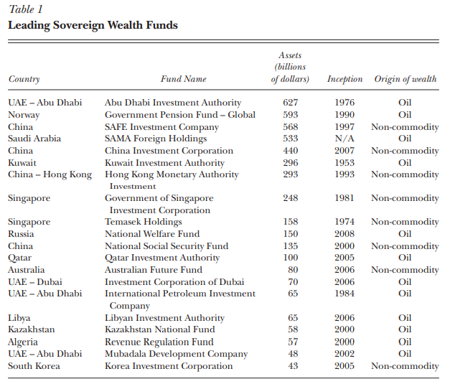

1. SWF in China and Singapore sourced from trade surpluses.
2. Rapid growth in SWF: $USD500\text{ billion }⇒USD5\text{ trillion}$ from 1990 to 2013.
3. 24% annual growth rate between 2010-2013.
4. 3 distinct roles of SWF:
   1. serve as a **source of capital** for future generations,

e.g. Kiribati Revenue Equalization Reserve Fund, extraction of guano stopped in 1979, but funds remains key economic contributor.

- The fund is 10x the Gross Domestic Product (GDP) of Kiribati.

- Interest rate of the fund contributes 30% of the Kiribati’s revenue.

* 1. a **stabilizing role** by reducing the volatility of government revenues
     + stabilizing role for countries that depend heavily on commodity revenue.
     + e.g. alleviate pressure on falling prices of oil for certain countries
  2. as **holding companies**, with which the government places its strategic investments.
     + For strategic investment purposes by public leaders in domestic/foreign firms

**Part 2: Mixed Legacy**

1. Case study on Norway in 1970s & 1980s:
   1. Oil prices surge, sudden increase of funds
   2. Most of the money was spent immediately, some of the spending were **not** beneficial long term (increase in minimum wage leading to an uncompetitive economic sectors in the global market)
   3. Some of the funds spent on dying sector (shipbuilding).
   4. Some of the funds spent on new ventures of the friends and relatives of parliamentarians or of the bureaucrats responsible for allocating the funds.
   5. Oil prices dropped in the 1980s, which led to a drop in Norway’s GDP ($USD11.2\text{billion}⇒USD2.4\text{billion}$) between 1985 to 1988.
2. SWF can address this downside of wealth accumulation in 2 ways:
   1. **Disallowing immediate spending**, preserving the gains for future generations.
   2. Reduce the risk that government officials spending these revenues in an unwise or corrupt manner (assuming, of course, the sovereign fund is run in a professional manner.)
3. Structure of SWF can face two serious agency problems:
   1. introduce short-run pressures on SWF to financially support local firms or subsidize industrial policies within the country.