

NAMA PENSYARAH

1



**BORANG SENARAI SEMAK PORTFOLIO PENGAJARAN (TEACHING PORTFOLIO)**

: SHAFIQ BIN RASULAN

UNIT : FIZIK

KOLEJ : KOLEJ MATRIKULASI SARAWAK

SESI : --

|  |  |  |  |  |  |
| --- | --- | --- | --- | --- | --- |
| **BAHAGIAN A – UMUM (GENERAL)** | | | | | |
| **TAG** | **TAJUK** | **ITEM** | **ADA** | **TIADA** | **CATATAN** |
| A1 | Profil Pensyarah (*Curriculum Vitae*) | 1. Biodata pensyarah 2. Gambar 3. Latarbelakang akademik 4. Pengalaman bekerja 5. Sumbangan 6. Anugerah/ penghargaan yang diterima |  |  |  |
| A2 | Falsafah Pengajaran (*Teaching Philosophy*) | Pensyarah |  |  |  |
| **BAHAGIAN B – KURIKULUM (CURRICULUM)** | | | | | |
| B1 | Visi dan Misi (*Vision and Mission*) | 1. Visi 2. Misi |  |  | Selaras dengan visi dan misi BMKPM |
| B2 | Objektif Pembelajaran Program (*Programme Educational Objectives*, PEO) |  |  |  | Selaras dengan Spesifikasi Kurikulum |
| B3 | Hasil Pembelajaran Program (*Programme Learning Outcomes,* PLO) |  |  |  |
| B4 | Hasil Pembelajaran Kursus (*Course Learning Outcome,* CLO) dan  Pemetaan CLO terhadap PLO |  |  |  |
| B5 | Huraian Sukatan Pelajaran (*Curriculum Specifications*) | Spesifikasi Kurikulum |  |  |  |
| **BAHAGIAN C – PENGAJARAN DAN PEMBELAJARAN (TEACHING AND LEARNING)** | | | | | |
| C1 | Kalendar Akademik (*Academic Calendar*) | Kalendar Akademik BMKPM |  |  |  |
| C2 | Jadual Waktu Pensyarah (*Lecturer’s TimeTable*) | Jadual Waktu PdP |  |  | 1. Tandatangan 2. Tarikh   kuatkuasa |
| C3 | Rancangan Pembelajaran Semester (*Scheme of Work* SOW) | RPS |  |  |  |
| C4 | Rancangan Mengajar (*Lesson Plan*) | | | | Mengikut unit |
| C4.1 | Laporan Pengajaran (*Teaching Report*) | Rancangan Instruksional Mingguan |  |  |  |
| C5 | Kertas Penerangan (*Information Sheet*) | | | | Bahan-bahan PdP |
| C5.1 | Nota kuliah (*Lecture note*) |  |  |  |  |

2



|  |  |  |  |  |  |  |
| --- | --- | --- | --- | --- | --- | --- |
| C5.2 | Kertas (T*utorials/* | Tutoran/ Latihan/ Kuiz *Exercises/ Quiz Sheets*) |  |  |  |  |
| C5.3 | Kertas | Amali / Buku Panduan Amali *Sheets*/ |  |  |  |  |
|  | (*Experiment* |
| C5.4 | Kertas Tugasan /Projek (*Assignment/ Project Sheets*) | |  |  |  |  |
| C6 | Rekod Kehadiran Pelajar (*Students Attendance Record*) | |  |  |  |  |
| **BAHAGIAN D – PENTAKSIRAN (ASSESSMENT)** | | | | | | |
| D1 | Huraian Pentaksiran (*Detailed Assessment*) | | | | |  |
| D1.1 | Format Instrumen Pentaksiran  (*Assessment Instrument Format*) | | 1. Panduan Wajaran Penilaian Berterusan BMKPM 2. JPUPS |  |  |  |
| D1.2 | Pemetaan Pentaksiran kepada CLO | | 1. Borang JST1 2. Borang JST2 3. Borang PTP |  |  |  |
| D1.3 | Instrumen Pentaksiran *(Assessment* *Instrument*) | | 1. Soalan 2. Skema jawapan/ Rubrik 3. Borang moderasi 4. Laporan moderasi 5. Borang maklumbalas tugasan pelajar 6. Sampel tugasan pelajar |  |  |  |
| **BAHAGIAN E - PENAMBAHBAIKAN KUALITI BERTERUSAN (CONTINUOUS QUALITY IMPROVEMENT, CQI)** | | | | | | |
| E1 | Analisis Pencapaian CLO (CLO *Achievement Analysis*) | | | | |  |
| E1.1 | Rekod Prestasi Akademik Pelajar (*Students Academic Achievement Record*) | |  |  |  |  |
| E1.2 | Laporan Penilaian Kursus *(Course Assessment Report*, CAR) | |  |  |  |  |
| E1.3 | Analisis *End of Course Survey* (ECS) | |  |  |  |  |
| E1.4 | Laporan CQI (CQI *Report*) | |  |  |  |  |
| **BAHAGIAN F - KEPUTUSAN PENILAIAN DAN PEMANTAUAN PdP (TnL MONITORING RESULT)** | | | | | | |
| F1 | Laporan Penilaian PdP (TnL *Evaluation Report*) | | | | |  |
| F1.1 | Penilaian oleh Pelajar (*Assessment by Students*) | | Rumusan Analisis Penilaian Pengajaran (Peringkat Unit) |  |  |  |
| F1.2 | Penilaian oleh Wakil Pengurusan (*Assessment by Management Representative*) | |  |  |  |
| F2 | Bimbingan dan Pementoran (*Coaching & Mentoring*) | | i. Rekod Bimbingan/ Pementoran/ Konsultasi |  |  |  |

Disemak oleh:



3

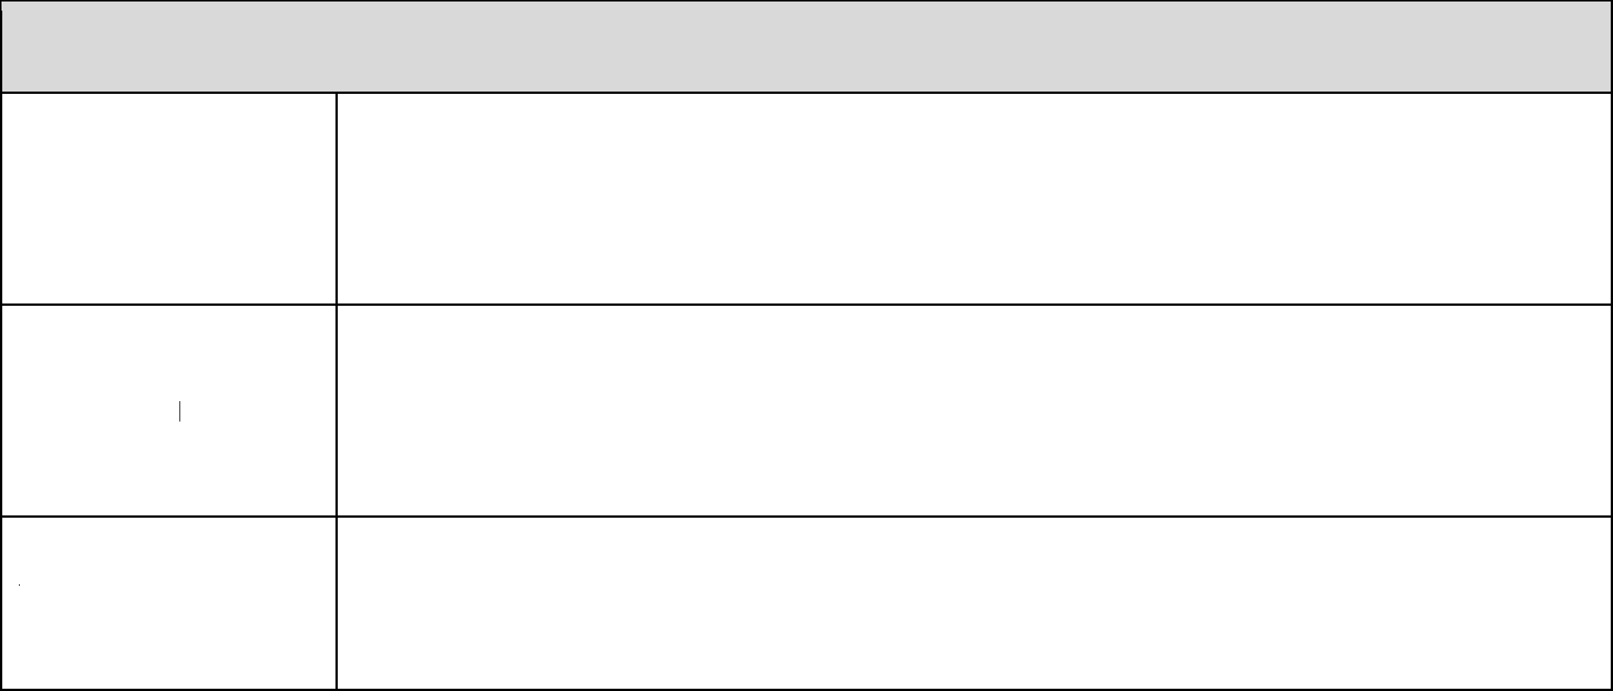

**LAIN-LAIN**

CADANGAN PENAMBAHBAIKAN

KEKUATAN

KELEMAHAN

|  |  |
| --- | --- |
| Nama | : |
| Tarikh | : |
| Cop jawatan | : |