|  |  |
| --- | --- |
|  | **Disediakan oleh,** |
|  | **(SHAFIQ BIN RASULAN)**  **Pensyarah Fizik KMSW** |
|  |  |
|  | **Disemak oleh,** |
|  | **(MARY GWADOLINE YUSUS)**  **Ketua Unit Fizik KMSw** |
|  |  |
|  | **Disahkan oleh,** |
|  | **( )** |

**Blended Intervention to Improve Student Mastery of Faraday’s and Lenz’s Law**

**By Shafiq Rasulan**

**Executive Summary**

This report documents a targeted teaching intervention conducted with five Semester 2 pre-university physics students at Sarawak Matriculation College, focusing on improving conceptual understanding of Faraday’s and Lenz’s Law. The intervention was developed in response to observed misconceptions and low quiz performance among a small group of learners.

Grounded in 21st-century teaching practices, the intervention employed a cooperative learning model integrated with interactive simulations to promote active, student-centered engagement. It was delivered over two weeks through a blended learning format, combining one in-person session and one online session per week.

Instructional activities included guided exploration using PhET simulations, structured worksheets, group discussions, and conceptual application exercises. Scaffolding strategies were incorporated to support learners with varying levels of prior knowledge.

The effectiveness of the intervention was evaluated through pre- and post-tests, with normalized gain scores ranging from 0.40 to 0.92. All students showed significant improvements, with post-test scores rising by as much as 80 percentage points in some cases. Student reflections indicated increased confidence, improved understanding, and appreciation for the visual and collaborative learning methods.

The report concludes that simulation-based cooperative learning is an effective strategy for teaching abstract physics concepts at the pre-university level. Key recommendations include expanding the model to larger cohorts, integrating formative assessments, and exploring long-term impacts on knowledge retention.

Table of Contents

1 Introduction 3

Context and Background 3

Target Group of Students 3

2 Intervention Design 4

Instructional Strategies 4

Planned Activities 4

Materials and Resources Used 5

Planned Adaptations 5

3 Implementation 6

Delivery Method 6

Session Schedule 6

People Involved 6

Fidelity Notes 7

4 Evaluation & Results 7

Assessment Methods 7

Data Collection Tools 7

Summary of Findings 7

5 Reflection & Recommendations 10

Effectiveness of the Intervention 10

Lessons Learned 10

Recommendations for Future Implementation 11

# 1 Introduction

## Context and Background

In recent lessons covering electromagnetic induction, it was observed that several students struggled with conceptual questions related to Faraday’s Law and Lenz’s Law. This challenge became evident when five students performed poorly in a class quiz focused on this topic.

Faraday's and Lenz's Law involve abstract concepts such as magnetic flux and induced currents, which require students to mentally visualise invisible interactions. Traditional chalk-and-talk methods seemed insufficient in helping students construct a clear understanding of the phenomena involved.

This teaching intervention was designed in response to this learning gap, aligning with the Malaysian Matriculation Physics curriculum. It aims to support struggling learners using a combination of simulation tools, scaffolded instruction, and cooperative learning strategies, all of which reflect principles of 21st-century teaching and learning.

## Target Group of Students

The intervention targets five Semester 2 pre-university students who demonstrated low performance in the recent class quiz on Faraday’s and Lenz’s Law. All five students showed common misconceptions and had difficulty mentally visualising the electromagnetic induction process. They also displayed signs of disengagement during prior theoretical lessons, indicating the need for a more interactive and collaborative learning experience.

**Learning Objectives**

By the end of this intervention, students will be able to:

* **Explain** Faraday’s Law and Lenz’s Law using visual and conceptual models.
* **Predict** the direction of induced current in simple setups involving moving magnets and coils.
* **Collaborate** effectively in small groups to analyse and discuss simulation-based problems.
* **Apply** the laws to explain real-world electromagnetic phenomena.

# 2 Intervention Design

## Instructional Strategies

This intervention employed cooperative learning as the core instructional strategy, encouraging students to work collaboratively in small groups to foster peer support and shared problem-solving. The approach leverages the social nature of learning to deepen conceptual understanding.

Additionally, the use of simulation-based learning allowed students to interact with visual and dynamic models of Faraday’s and Lenz’s Law, making abstract concepts more concrete. This aligns with constructivist principles by enabling students to explore, hypothesize, and receive immediate feedback from the simulation environment.

## Planned Activities

The intervention consisted of the following key activities:

* **Simulation Exploration**

Students worked in pairs to manipulate PhET simulations illustrating electromagnetic induction. They observed changes in magnetic flux and the resulting induced currents in real-time.

* **Guided Inquiry Worksheets**

Accompanying the simulation, students completed worksheets with structured questions to guide observation, hypothesis formation, and reasoning.

* **Group Discussion**

After individual exploration, students formed small groups to discuss their findings, clarify misconceptions, and explain concepts to one another.

* **Concept Application**

Groups solved application problems relating to everyday electromagnetic phenomena (e.g., electric generators, transformers), linking theory to practical examples.

* **Reflection**

Each student wrote a brief reflection on how the simulation helped them understand the laws better.

## Materials and Resources Used

* **PhET Interactive Simulations**

Specifically, the “Faraday’s Electromagnetic Lab” and “Javalab’s Faraday’s Law of Electromagnetic Induction” simulation was used to demonstrate induction phenomena dynamically.

* **Worksheets**

Custom-designed inquiry-based worksheets aligned with the simulation activities.

* **Laptops or Tablets**

To run simulations in pairs.

## Planned Adaptations

To support diverse learners, additional scaffolding was integrated through:

* Step-by-step guided questions on worksheets to prevent cognitive overload.
* Peer tutoring within cooperative groups to provide immediate support.
* Teacher facilitation during discussions to address misconceptions as they arose.
* Flexibility to allow students to replay simulation scenarios or review concepts as needed.

# 3 Implementation

## Delivery Method

The intervention was delivered through a **blended approach** consisting of both in-person and online sessions. One in-person session and one online session were conducted each week over a period of two weeks. The in-person sessions took place in the college physics laboratory equipped with computers and internet access, while the online sessions were conducted via the institution’s learning management system, allowing students to access simulation tools and instructional materials remotely.

## Session Schedule

* **Week 1:**
  + In-person session (1 hour): Introduction to the simulation tools, initial exploration of Faraday’s and Lenz’s Law simulations, and guided worksheet activities.
  + Online session (1 hour): Continued simulation practice and group discussion forum to reinforce concepts.
* **Week 2:**
  + In-person session (1 hour): Application exercises, group problem-solving, and conceptual discussions.
  + Online session (1 hour): Reflection activities and submission of individual learning reflections.

## People Involved

The intervention was facilitated by the course instructor (the author), who guided the students through both in-person and online activities. The five target students participated collectively as a single cooperative learning group throughout all sessions. The instructor provided real-time support and feedback during in-person lessons and monitored online discussions to ensure active participation.

## Fidelity Notes

The intervention was implemented as planned without significant deviations. Students engaged actively in both modalities, and no technical or logistical issues affected the delivery. The blended format successfully balanced hands-on interaction with flexible online learning opportunities.

# 4 Evaluation & Results

## Assessment Methods

Student understanding of Faraday’s and Lenz’s Law was evaluated using a pre-test and post-test design. Both tests consisted of conceptual and application questions aligned with the learning objectives of the intervention. The pre-test was administered before the intervention began to establish baseline knowledge, and the post-test was conducted immediately after the intervention to measure learning gains.

## Data Collection Tools

* Pre-Test and Post-Test

Custom-designed tests to measure student knowledge and conceptual understanding.

* Normalized Gain Calculation

The normalized gain (g) was calculated for each student using the formula

$$g=\frac{\text{post-test score}-\text{pre-test }\text{score}}{100-\text{pre-test score}}$$

providing a standardized measure of improvement relative to initial performance.

* Student Reflections and Feedback:

Optional written reflections were collected during the online session to gather qualitative feedback on the learning experience.

## Summary of Findings

The intervention yielded positive learning outcomes for all five target students. The normalized gain scores ranged from 0.40 to 0.92, indicating moderate to high improvement in conceptual understanding:

* Student 1 achieved a normalized gain of 0.40.
* Students 2 to 5 scored normalized gains above 0.70, with Student 5 achieving the highest gain of 0.92.

The pre-test and post-test marks showed consistent improvement across all students:

|  |  |  |  |
| --- | --- | --- | --- |
| **Student** | **Marks in Percentage (%)** | | **Normalized Gain** |
| **Pre-Test** | **Post-Test** |
| Student 1 | 33.33 | 60.00 | 0.40 |
| Student 2 | 6.67 | 73.33 | 0.71 |
| Student 3 | 13.33 | 80.00 | 0.77 |
| Student 4 | 40.00 | 86.67 | 0.78 |
| Student 5 | 13.33 | 93.33 | 0.92 |

This demonstrates substantial knowledge gains and supports the effectiveness of simulation-based cooperative learning for enhancing comprehension of electromagnetic induction concepts.

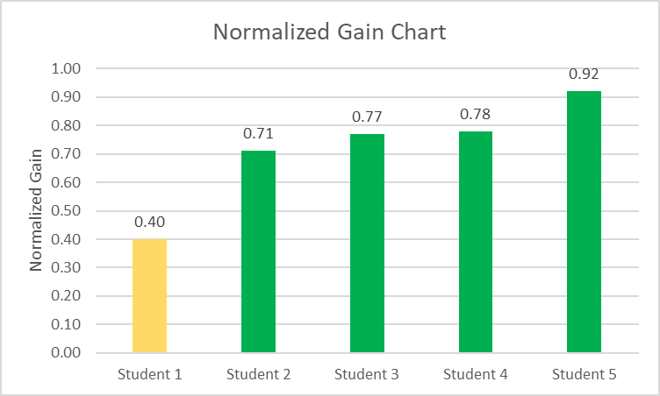

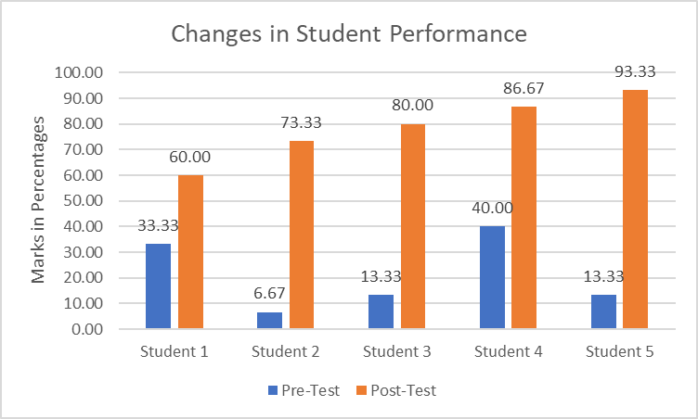

**Student Feedback (Optional)**

Students shared positive feedback regarding the intervention, particularly highlighting the simulations and group collaboration:

* *“I finally understood how the direction of the current changes when the magnet moves. The simulation made it clear instantly.”* – Student 3
* *“Working with friends helped me feel more confident. We could ask each other questions without feeling embarrassed.”* – Student 2
* *“Before this, I memorized the rules without really understanding them. Now I can explain what’s happening and why.”* – Student 5
* *“The worksheets guided me well. I didn’t feel lost during the simulation.”* – Student 1
* *“The combination of online and in-person lessons worked well. I used the online time to revise and explore more.”* – Student 4

Overall, the feedback supported the value of combining technology with peer learning and scaffolding in building conceptual understanding.

# 5 Reflection & Recommendations

## Effectiveness of the Intervention

The intervention achieved its intended objectives, as evidenced by significant improvements in both individual performance and group engagement. The combination of **interactive simulations**, **cooperative learning**, and **targeted scaffolding** created a learner-centered environment that promoted conceptual clarity and critical thinking.

Normalized gain scores and post-test results indicated substantial learning progress across all five students, especially those who had initially performed poorly. Students not only gained better factual understanding but also showed increased confidence in applying Faraday’s and Lenz’s Law to real-world contexts.

## Lessons Learned

Several key takeaways emerged from this intervention:

* Simulations are powerful visual tools for teaching abstract physics concepts, particularly when paired with guided inquiry.
* Group-based learning fosters peer-to-peer explanation, which enhances understanding and encourages active participation from lower-performing students.
* Blended learning formats (in-person and online) offer flexibility and extend learning beyond the classroom.
* Structured scaffolding through worksheets and discussions ensures that all students can engage meaningfully, regardless of their starting level.

## Recommendations for Future Implementation

1. **Expand to Larger Groups**

Consider implementing the strategy in larger class settings by dividing students into smaller cooperative subgroups, each with defined roles (e.g., leader, recorder, presenter).

1. **Integrate Formative Assessment**

Add short formative checks (e.g., mini quizzes or concept maps) during sessions to monitor progress in real-time.

1. **Use Peer Teaching**

Encourage high-performing students to explain concepts to peers in a tutor-tutee format, reinforcing their own understanding while supporting others.

1. **Include More Simulation Time**

Allocate additional online time for students to revisit and experiment with simulations independently.

1. **Collect Longer-Term Data**

Conduct delayed post-tests to evaluate retention and long-term understanding.

|  |
| --- |
| **This page has been intentionally left blank.** |