|  |  |
| --- | --- |
|  | **Disediakan oleh,** |
|  | **(SHAFIQ BIN RASULAN)**  **Pensyarah Fizik KMSW** |
|  |  |
|  | **Disemak oleh,** |
|  | **(MARY GWADOLINE YUSUS)**  **Ketua Unit Fizik KMSw** |
|  |  |
|  | **Disahkan oleh,** |
|  | **( )** |

**Inclined Plane Dynamics:**

**A Simulation and Scaffolding Intervention**

**By Shafiq Rasulan**

**Executive Summary**

This report evaluates the "Inclined Plane Dynamics: A Simulation and Scaffolding Intervention," a three-hour program designed to improve six pre-university physics students' application of net force concepts on inclined planes. The intervention employed interactive simulations, scaffolded worksheets, and collaborative group tasks to address common student difficulties. Quantitative results demonstrated substantial learning gains across all participants, with normalized gains ranging from 0.64 to 0.93 from a low initial understanding. Qualitative feedback from students overwhelmingly confirmed the intervention's success, highlighting the benefits of simulations for visualization, scaffolding for problem-solving, and group work for conceptual clarity. Students reported increased confidence and a resolution of prior misconceptions. In conclusion, the intervention proved highly effective, successfully enhancing students' understanding and application of inclined plane dynamics through its interactive and structured pedagogical approach.

**Table of Contents**

1 Introduction 5

Context and Background of the Intervention 5

Target Group of Students 5

Learning Objectives 5

2 Intervention Design 6

Instructional Strategies 6

Planned Activities 7

Materials and Resources Used 8

Planned Adaptations/Differentiation 8

3 Implementation 9

Delivery Method and Setting 9

Session Schedule and Duration 9

People Involved 9

Fidelity of Implementation and Deviations 10

4 Evaluation & Results 10

Assessment Methods 10

Data Collection Tools 10

Pre- and Post-Test Results 11

Qualitative Findings 12

Overall Finding 12

5 Reflection & Recommendations 13

Reflection on Effectiveness of the Intervention 13

Lessons Learned 14

Recommendations for Future Implementation 15

# 1 Introduction

## Context and Background of the Intervention

This intervention was designed and implemented within the context of a pre-university physics program, specifically for Semester 1 Malaysian matriculation students. A consistent challenge observed among these students is their struggle to accurately understand and apply the principles of net force in dynamic situations involving unbalanced forces, particularly when forces act at angles, such as on inclined planes or in tension systems. While students are generally able to state Newton's Second Law (F=ma), they frequently encounter difficulties in its practical application. Common errors include misinterpreting force directions, incorrectly identifying the net force, or failing to properly resolve forces into their components This persistent gap in conceptual understanding and problem-solving skills significantly impedes their ability to tackle more complex dynamics problems, highlighting a critical area for targeted pedagogical intervention.

## Target Group of Students

This intervention was specifically aimed at a small group of six (6) Semester 1 Malaysian matriculation physics students. These students were selected to participate based on their identified struggles with the foundational concepts of force and motion on inclined planes.

## Learning Objectives

Upon completion of this intervention, students were expected to achieve the following specific, measurable learning outcomes:

* Accurately draw free-body diagrams for objects situated on inclined planes, correctly identifying and representing all pertinent forces, including gravity, normal force, friction, tension, and applied forces.
* Proficiently decompose force vectors into their respective components along appropriate axes (both parallel and perpendicular to the inclined surface).
* Correctly apply Newton’s Second Law (F=ma) to calculate net force and acceleration for objects subjected to unbalanced forces on inclined planes.
* Critically analyze and effectively solve quantitative problems involving motion on inclined planes, both with and without the presence of frictional forces.

# 2 Intervention Design

## Instructional Strategies

The intervention was built upon a multi-faceted instructional approach designed to address the identified learning gaps in applying net force concepts on inclined planes.

* **Interactive Simulation-Based Learning**

Core to the intervention was the use of visual and interactive simulations. PhET's "Forces and Motion: Basics" and oPhysics' "Inclined Plane Simulation" were utilized to provide students with dynamic, hands-on opportunities to observe and manipulate variables affecting forces and motion on inclined surfaces. This strategy aimed to foster intuitive understanding and visualize abstract concepts like force vectors and their resultant effects.

* **Scaffolded Problem Solving**

A structured, scaffolded approach was integrated through a specially designed worksheet. This worksheet guided students progressively through the steps of drawing accurate force diagrams, resolving forces into components, and systematically calculating net force, ensuring foundational skills were built before tackling more complex scenarios.

* **Collaborative Learning (Think-Pair-Share)**

Small-group discussions, specifically utilizing the Think-Pair-Share technique, were facilitated. This encouraged students to verbalize their reasoning, learn from peers, and collaboratively solve applied problems (e.g., a box sliding up or down an incline with friction), promoting deeper processing and peer teaching.

* **Guided Examples and Explicit Instruction:** The instructor provided guided examples, emphasizing the critical importance of accurate force diagrams and the systematic resolution of force components. This explicit instruction aimed to model effective problem-solving strategies and directly address common misconceptions.

## Planned Activities

The intervention was structured around a series of progressive activities:

* **Simulation Exploration**

Students engaged directly with the PhET "Forces and Motion: Basics" and oPhysics "Inclined Plane Simulation." They were encouraged to experiment with varying parameters (e.g., mass, friction, angle of incline, applied force) to observe the resulting changes in force vectors and motion, thereby building an intuitive understanding of force interactions.

* **Scaffolded Force Diagram Worksheet**

Students completed a structured worksheet that incrementally guided them through the process of drawing free-body diagrams for objects on inclines, breaking down forces into their parallel and perpendicular components, and setting up the appropriate equations derived from Newton's Second Law.

* **Think-Pair-Share Applied Problem Solving**

Working in small groups, students applied their developing understanding to solve a curated set of applied problems involving realistic scenarios of objects on inclined planes with and without friction. They would first think individually, then discuss with a partner, and finally share their solutions and reasoning with the larger group.

* **Instructor-Led Examples and Discussion**

The instructor led sessions demonstrating solved examples, paying particular attention to common pitfalls in force diagram construction and component resolution. This was coupled with open discussions to address student queries and reinforce correct methodologies.

## Materials and Resources Used

The following materials and resources were essential for the delivery of the intervention:

* **Digital Resources:**
  + PhET Interactive Simulations: "Forces and Motion: Basics" (Available online)
  + oPhysics Inclined Plane Simulation (Available online)
  + Laptop/desktop computers or tablets with internet access for each student or pair.
  + Projector and smartboard/screen for whole-class demonstrations and discussions.
* **Printed Materials:**
  + Custom-designed scaffolded force diagram worksheets.
  + Sets of applied problems for group work.
  + Pre-test and post-test papers for assessment.
  + 7-item self-reflection questionnaires for qualitative feedback.
* **General Classroom Supplies:**
  + Whiteboard or chalkboard, markers/chalk.
  + Pens, paper, and scientific calculators for student use.

## Planned Adaptations/Differentiation

No specific adaptations or differentiation strategies were pre-planned for this small group of 6 students. However, the small class size allowed for real-time, informal differentiation based on immediate observation of student needs, enabling the instructor to provide targeted support or more challenging extensions as required during the sessions.

# 3 Implementation

## Delivery Method and Setting

The intervention was delivered using a face-to-face instruction method, conducted within a standard physics classroom environment. The classroom was equipped with necessary technological resources, including computers with internet access and a projector, to facilitate the use of interactive simulations and aid in instruction. The small group size of 6 students fostered a conducive environment for direct interaction and personalized attention.

## Session Schedule and Duration

The intervention comprised a total of three hours of direct instruction with students, distributed over three distinct one-hour lessons.

* **Total Duration:** 3 hours.
* **Number of Sessions:** 3 sessions.
* **Session Length:** Each session lasted approximately 1 hour.
* **Schedule Breakdown:**

|  |  |
| --- | --- |
| **Session 1 (1 hour)** | Focused on introducing students to the PhET "Forces and Motion: Basics" simulation. The session covered foundational concepts of force and motion, including the nature of friction, using the simulation as a visual aid. |
| **Session 2 (1 hour)** | Transitioned to the oPhysics "Inclined Plane Simulation" to specifically explore forces on inclined surfaces. The core activity involved working through the scaffolded force diagram worksheet, emphasizing the resolution of forces into components. |
| **Session 3 (1 hour)** | Dedicated to collaborative problem-solving using the Think-Pair-Share method for applied problems. The instructor also provided further guided examples and facilitated discussions to reinforce challenging concepts and address any remaining misconceptions. |

## People Involved

The primary individual responsible for the design and delivery of this intervention was the author, who served as the instructor. This individual led all instructional sessions, facilitated group activities, and provided direct guidance and feedback to the students throughout the intervention. No additional support staff were involved in the direct delivery.

## Fidelity of Implementation and Deviations

The intervention was implemented largely as planned, with all core instructional strategies, planned activities, and materials utilized across the three sessions. The small group size allowed for close monitoring of student engagement and understanding, ensuring adherence to the pedagogical intent.

A minor deviation occurred during the initial phase of Session 1. There was a brief period of technical setup required to ensure all student computers had stable internet access for the PhET simulation. This resulted in a slight reduction in the time allocated for unstructured exploration of the simulation in the first session. However, this was quickly resolved, and the overall flow of activities was maintained without compromising the learning objectives. The direct engagement and responsiveness of the instructor were able to mitigate any potential impact of this minor delay.

# 4 Evaluation & Results

## Assessment Methods

Student learning was assessed using a pre-test and a post-test, both designed to measure understanding of free-body diagrams and net force calculation in contexts involving multiple forces and inclined planes. Additionally, a 5-item self-reflection questionnaire was administered to gather qualitative feedback on the learning experience and the perceived effectiveness of the intervention's components.

## Data Collection Tools

1. **Pre and Post-test Paper:** A written test comprising problems that required students to draw free-body diagrams and calculate net force for objects on inclined planes.
2. **Self-reflection Questionnaire:** A Likert scale-based questionnaire to collect student perspectives.

**Summary of Findings**

The intervention yielded significant positive results across all participating students, as demonstrated by the improvements in their post-test scores and the consistently high normalized gains.

### Pre- and Post-Test Results

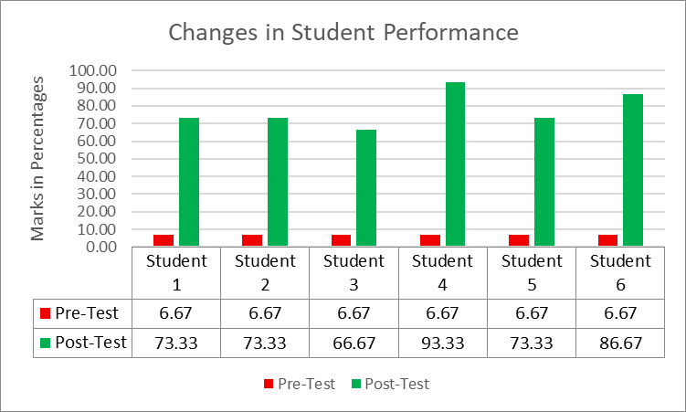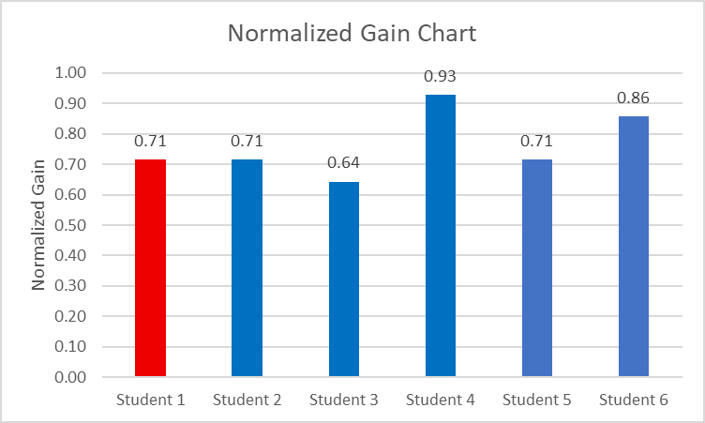The following table summarizes the test scores and normalized gain for each of the six students:

All six participating students, who began with a uniformly low pre-test score of 6.67%, demonstrated substantial learning gains. Post-test scores ranged from 66.67% to an impressive 93.33%. This translates to consistently high normalized gains, spanning from 0.64 to 0.93. Such high normalized gains, particularly for a challenging topic, signify that students achieved a significant portion of their potential learning, effectively bridging a substantial gap in their initial understanding. Student 4 notably achieved near-mastery with a 0.93 normalized gain, while all others also showed strong to excellent progress.

### Qualitative Findings



The student self-reflection questionnaire results corroborate and provide deeper insight into these quantitative improvements. Students reported highly positive experiences across all aspects of the intervention (mean scores between 4.33 and 4.83 out of 5, indicating strong agreement).

### Overall Finding

The convergence of the data strongly suggests that the multi-faceted intervention, combining interactive simulations, scaffolded problem-solving, and collaborative group tasks supported by clear instruction, was highly successful. The significant improvements in test scores are directly supported by student perceptions of enhanced understanding, increased confidence, effective learning tools, and successful clarification of prior misconceptions, validating the intervention's design and implementation.

# 5 Reflection & Recommendations

## Reflection on Effectiveness of the Intervention

The "Inclined Plane Dynamics: A Simulation and Scaffolding Intervention" proved to be highly effective in addressing the identified learning challenges related to net force and motion on inclined planes. The quantitative data, characterized by substantial normalized gains across all six students (ranging from 0.64 to 0.93), clearly demonstrates a significant improvement in their conceptual understanding and problem-solving abilities from a very low baseline. This indicates that the intervention successfully enabled students to overcome their initial difficulties in applying Newton's Second Law in complex, non-horizontal contexts.

The qualitative feedback from the self-reflection questionnaire strongly reinforces these positive outcomes. Students overwhelmingly reported that the interactive simulations were instrumental in visualizing abstract force concepts, and the scaffolded worksheets provided crucial, step-by-step guidance. The collaborative Think-Pair-Share activities were particularly effective in clarifying doubts and fostering deeper understanding through peer interaction. Furthermore, students expressed significantly increased confidence in tackling inclined plane problems and explicitly acknowledged that the intervention helped them overcome specific prior misconceptions. The high engagement levels reported by students also suggest that the chosen instructional strategies were well-received and conducive to active learning.

Overall, the intervention successfully met its learning objectives, transforming students' initial struggles into a robust grasp of inclined plane dynamics.

## Lessons Learned

Several key lessons emerged from the design and implementation of this intervention:

* **Power of Visualization**

Interactive simulations like PhET and oPhysics are invaluable tools for teaching abstract physics concepts. Their ability to dynamically represent forces, components, and motion in real-time significantly aids conceptual understanding and allows students to experiment and discover principles independently.

* **Importance of Scaffolding**

For complex problem-solving tasks such as force resolution on inclined planes, a scaffolded approach is critical. Breaking down the process into manageable steps (e.g., drawing diagrams, identifying forces, decomposing components, setting up equations) helps students build confidence and master each sub-skill before integrating them into a complete solution.

* **Value of Collaborative Learning**

Small-group discussions and peer-to-peer problem-solving, as facilitated by Think-Pair-Share, are highly effective. They provide a safe space for students to articulate their thoughts, challenge their own understanding, and learn from diverse perspectives, leading to deeper conceptual clarity.

* **Targeted Instruction for Misconceptions**

The intervention's focus on common pitfalls, particularly regarding force direction and component resolution, coupled with guided examples from the instructor, was crucial. Directly addressing these areas helped to dismantle pre-existing misconceptions.

## Recommendations for Future Implementation

Based on the successful outcomes and lessons learned, the following recommendations are proposed for future implementations of this intervention:

* **Integrate Pre-Assessment Insights**

Use the pre-test data more explicitly to tailor the initial scaffolding. For instance, if a specific type of force (e.g., friction) is consistently misunderstood, dedicate a slightly longer segment to its conceptualization within the simulations.

* **Expand Problem Variety**

While effective, consider introducing a slightly wider range of applied problems for the Think-Pair-Share sessions, including scenarios with varying levels of friction, different angles of incline, and perhaps even simple pulley systems on inclines, to further challenge and solidify understanding.

* **Formalize Differentiation**

For larger class sizes, formalize the differentiation strategies. This could involve providing tiered worksheets (e.g., basic, intermediate, advanced) or assigning specific roles within group tasks to cater to diverse learning paces and abilities.

* **Incorporate Peer Feedback Mechanisms**

Explore structured ways for students to provide feedback on each other's force diagrams or problem solutions during group work, beyond just discussion, to enhance active learning and critical evaluation skills.

* **Longitudinal Assessment**

To assess the long-term retention of concepts, consider administering a follow-up assessment (e.g., a short quiz or problem) several weeks after the intervention concludes.

|  |
| --- |
| **This page has been intentionally left blank.** |