# Sample Methodology

The experiment was set to according to the diagram below.

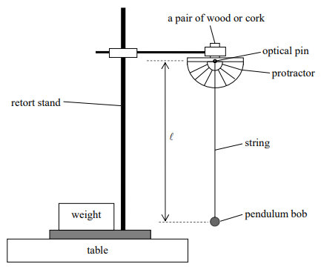

In this experiment, we want to look for the relationship between length of the string $l$, and the period of oscillation, $T$. Theoretically, they are related by the equation

$$T=2π\sqrt{\frac{l}{g}}---\left(1\right)$$

where *l* is the length of the string and *g* is the acceleration due to gravity.

Equation (1) can be simplified into

$$T^{2}=\frac{4π^{2}}{g}l---\left(2\right)$$

where a graph of $T^{2}\text{ against }l$ gives a linear graph with a gradient of $\frac{4π^{2}}{g}$.

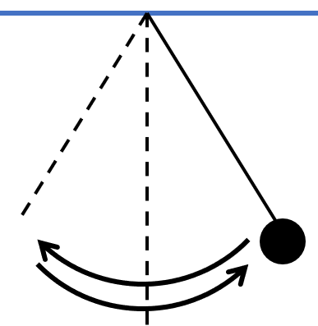6 different values of string length were tested and the time for 20 oscillations for each string length value was measured. These data points were then recorded, and its analysis reported in section 3. The string length was measured **using a metre ruler** with an instrument uncertainty of $0.1cm$. One oscillation is defined as the time for the pendulum bob to return to its original position. **The stopwatch** (with uncertainty of 0.01s) was started upon release of the pendulum bob and stopped once the pendulum bob has returned to its original position 20 times. Once this time is recorded, we calculated the period of oscillation by dividing this time with 20. This is to say,

$$T=\frac{\text{time for 20 oscillation}}{20}$$

A few variables were kept constant. The angle of release for the pendulum was set at $5^{o}$ and this value was fixed at every data point. The mass of the pendulum was also set at 50g and remains unchanged throughout the whole experiment. The fans of the laboratory were switch off, and the windows and curtains were close to minimise effects from air resistance.