**PART A: (30 MARKS)**

**INSTRUCTION:** *Answer* ***ALL*** *questions.*

1. The architecture is a representation that enables a software engineer to:
2. Analyze the effectiveness of the design in meeting its stated requirements
3. Consider architectural alternatives at a stage when making design changes is still relatively easy
4. Reduce the risks associated with the construction of the software
5. Compose individual components into larger architectural blocks.
6. I, II and III
7. I, II, and IV
8. I, III and IV
9. II, III and IV
10. In Software Engineering, the *Architectural Description Language* (ADL) provide the designer with the ability to:
    1. decompose architectural components
    2. compose individual components into larger architectural blocks
    3. represent interfaces (connection mechanisms) between components.
    4. represent the component design and implement.
11. I, II and III
12. I, II, and IV
13. I, III and IV
14. II, III and IV
15. List below are the elements in Design Model **EXCEPT**:
16. Data elements
17. Architectural elements
18. Interface elements
19. Component elements
20. The architectural model in software design can divide several model except:
    1. Structuring Model
    2. Control Modelling
    3. Centralize Modelling
    4. Modular decomposition
21. I, II and III
22. I, II, and IV
23. I, III and IV
24. II, III and IV

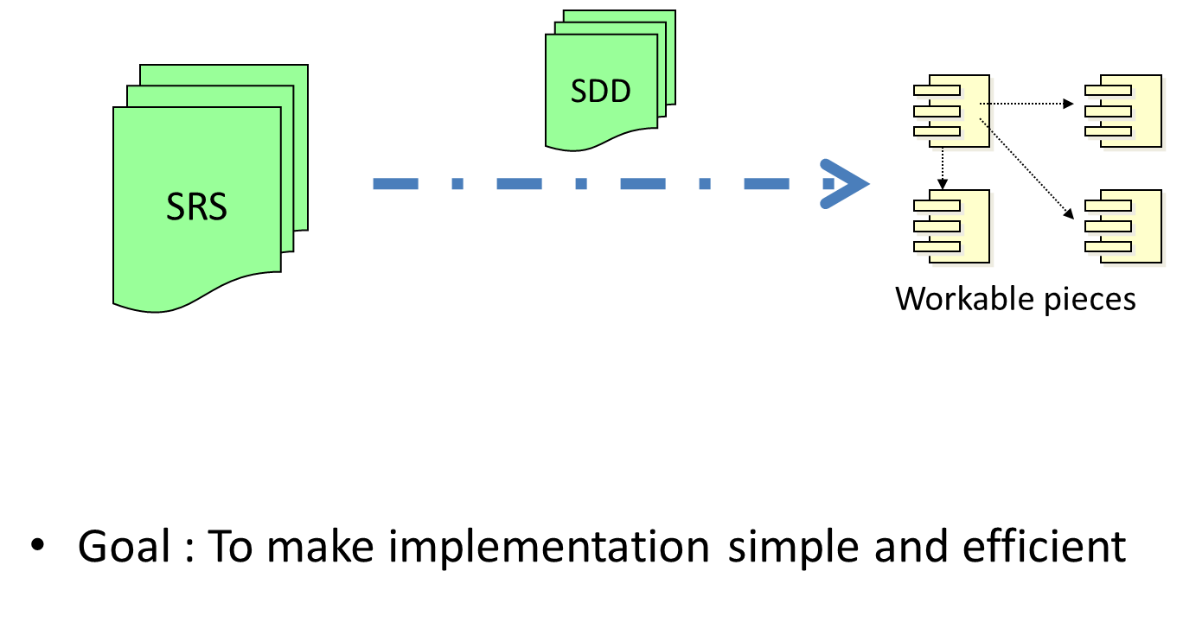

**Figure 1**

1. **Figure 1** shows on how the works from requirement to design phases and the goal on the illustration is :
2. To make implementation simple and faster
3. To make implementation simple and efficient
4. To make implementation simple and quality
5. To make implementation simple and easy
6. List are the **TRUTH** about the Architectural Design in Software Design Process **EXCEPT:**
7. An early stage of the system design process.
8. Represents the link between specification and design processes.
9. Often carried out in parallel with some specification activities.
10. It involves in identifying the minor system components and their communications.
11. The important elements in Interface design are:
    1. User interface (UI).
    2. External interfaces to other systems.
    3. Internal interfaces between various design components.
    4. Connected interface with few types of communication.
12. I, II and III
13. I, II, and IV
14. I, III and IV
15. II, III and IV
16. In software engineering, a **good design** can be defined as:
17. “A design which balances trade-offs to minimise the total cost of the system over its entire lifetime.”
18. “Software design should Exhibit with Firmness, Commodity and Delight.”
19. “Software design should Inhibit with Firmness, Commodity and Delight.”
20. “A design which balances to maximise the entire of lifetime system with the total cost of the system”

**Identify True (A) or False (B) for Questions 9 and 10.**

1. Inheritance—all responsibilities of a superclass is immediately inherited by all subclasses
2. True
3. False
4. Polymorphism—a characteristic that greatly reduces the effort required to extend the design
5. True
6. False
7. Identify the correct sequence of stages in the system evolution process
8. Impact analysis, release planning, change implementation, system release
9. Release planning, impact analysis, change implementation, system release
10. System release, release planning, impact analysis, change implementation
11. None of the above.
12. There are **THREE (3)** different types of software maintenance, fault repair, software adaptation and **x**. Identify **X**.
13. software maintenance
14. functionality addition or modification
15. functionality review
16. software addition or modification
17. Evolution processes depend on this factors except:
18. The type of software being maintained.
19. The development processes used.
20. The skills and experience of the people involved.
21. The milestones allocated for the project.
22. All of these are factors that need to do software maintenance, **EXCEPT**
23. To repair errors.
24. New requirements are added to the system.
25. Performance or reliability that requires improvement.
26. Staff changes.

For Question 5, 6 and 7 please refer to **Figure 2**

y 17%

z 18%

x 65%

**Figure 2. Distribution of maintenance effort**

1. **Figure 2** shows the different types of software maintenance and how is effort distributed. Identify **X**?
2. Maintenance to repair software faults.
3. Maintenance to adapt software to a different operating environment.
4. Maintenance to add or modify the system’s functionality.
5. Maintenance to improve the organizational building.
6. Why **X** is needed for software maintenance?

1. An early stage of the system design process.
2. Represents the link between specification and design processes.
3. To satisfy new requirements.
4. To identify the minor system components and their communications.
5. Which type of software maintenace suits this definition?

*“Changing a system to correct deficiencies in the way meets its*

*requirements.”*

1. Maintenance to repair software faults.
2. Maintenance to adapt software to a different operating environment.
3. Maintenance to add or modify the system’s functionality.
4. Maintenance to improve the organizational building.

For question 18 please refer to **Figure 3**

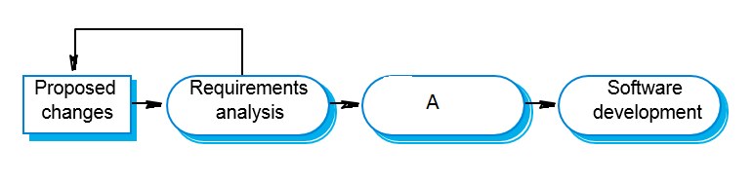

**Figure 3. Change implementation**

1. **Figure** **3** shows the sequence of change implementation. Identify **A**?
2. Requirements updating
3. Impact analysis
4. Release planning
5. System release
6. When urgent change request can be implemented?
7. If a serious fault has to be repaired
8. If changes to the system’s environment have unexpected effects
9. If there are business changes that require a very rapid response.
10. All of the above.
11. *“Re-structuring or re-writing part or all of a legacy system without changing its functionality”* is the definition for
12. System re-engineering
13. Legacy system
14. System quality
15. Process quality
16. Select the correct quality management activity and its definition.
17. Quality assurance – establishing standards
18. Quality planning – checking conformance to standards
19. Quality control – selecting appropriate standards
20. All of the above.
21. What are Product standards?
22. Product standards apply to the software product being developed in document standards, documentation standards and coding standards.
23. Product standards define the processes that should be followed during software development from definition of specification, design and validation processes and a description of the documents that should be written.
24. Product standards apply to the procedure that merged in document standards, documentation standards and coding standards.
25. Product standards define the business processes that should be followed during software development from definition of specification, design and validation processes and a description of the documents that should be written.
26. Listed below are the benefits to the organization that get the ISO 9000 verification **EXCEPT**?
27. Provides know-how for establishing a quality management system.
28. It is a status symbol for the organizations.
29. Improves products and services.
30. Increase the salary.
31. In smaller systems, the scope of quality management needs ____________________.
32. Less documentation only.
33. Focus on establishing a quality culture only.
34. Less documentation and should focus on establishing a quality culture.
35. None of the above.
36. Listed below are the Quality Management activities, **EXCEPT**?
37. Quality assurance.
38. Quality planning.
39. Quality control.
40. Quality product.
41. What are the stages in the software inspection process?
42. Planning, Overview, Individual Preparation, Inspection Meeting, Rework, Follow -up
43. Overview, Planning, Individual Preparation, Inspection Meeting, Rework, Follow -up
44. Overview, Planning, Individual Preparation, Inspection Meeting, Follow –up, Rework
45. None of the above.
46. Which classes of faults that should be considered in an inspection list?
47. Data faults.
48. Control faults.
49. Input/Output faults.
50. All of the above.

**Identify True (A) or False (B) for Questions 28, 29 and 30.**

1. Software quality management is concerned with ensuring that the required level of quality is achieved in a software product.
2. True.
3. False.
4. The quality plan should define the quality assessment process.
5. True.
6. False.
7. There are different types of quality review with different objectives.
8. True.
9. False.

**PART B: (70 MARKS)**

**INSTRUCTION:** *Answer* ***ALL*** *questions.*

**QUESTION 1 (15 MARKS)**

# Based on the business rules / rules in the following case study provided for an imaginary application on AIRPORT BOARDING; students need to develop the USE CASE diagrams.

**CASE STUDY: Passenger Check-In and Boarding**

We differentiate between **THREE (3)** options for check-in:

* **Normal check-in** with luggage at a normal check-in counter
* **Express check-in** without luggage at a special check-in counter
* **Automated check-in** without luggage at a machine
* In addition to the passenger, who represents travellers, there is the check-in representative. The check-in representative is a person who is not the actual passenger, but an agent of the passenger. The check-in representative has the task of performing the check-in with the ticket of the passenger.
* The check-in procedure includes submitting the ticket, baggage check-in, seat reservation, and issuing and handing over the boarding pass.
* Passengers who only have hand luggage can use express check-in. No baggage check-in is performed.
* During boarding, the boarding pass of the passenger is verified at the gate.
* Automated check-in is conducted without the help of a check-in clerk, directly at a machine (screen). Baggage cannot be checked in.
* The passenger can choose between a normal check-in, automated check-in, and express check-in. The passenger walks to the gate and presents his or her boarding pass. The check-in representative can perform a regular check-in, but is not able to perform express check-in and automated check-in.
* If we take a closer look, we notice that a passenger often travels with luggage, which he or she checks in. Baggage transportation is responsible for loading luggage into the airplane. Baggage transportation is carried out by an independent organization, known as a handling agent. Consequently, it is considered an actor, more specifically, an outside service provider. It does not matter for our diagram that individual employees of the partner enterprise perform these tasks.
* Ten minutes before a flight leaves, baggage transportation requests a passenger list from passenger services, which includes every passenger who checked in, but did not board the airplane. On the basis of this list all affected luggage will be unloaded again from the airplane. If the flight is an international flight, the customs authorities of the country in which the destination airport is located also request a passenger list.

**(10 marks)**

1. In software engineering, a **Good Design** can be defined as:

(**2 marks**)

1. One of the design phases is the algorithm design, give **ANY THREE (3)** approaches that can be used in algorithm design:

**(3 marks)**

**QUESTION 2 (20 MARKS)**

1. Write how the verification and validation can be described in a V-model. Support with suitable diagram.

**(10 marks)**

1. There are **TWO (2)** common procedures in unit testing. Explain both of them with suitable diagram.

**(6 marks)**

1. **Figure 4** shows a sample of flow chart. Determine the appropriate number and details path for all possible testing.

4

3

2

1

**a**

**b**

**c**

**Figure 4**

**(4 marks)**