Hospitality Business Strategy: Strategic Directions Using Porter’s and Bowman’s Frameworks

# Strategic Direction: The Foundation of Competitive Advantage

Strategic direction refers to the actionable plans an organization adopts to achieve its long-term goals and vision. It aligns resources, operations, and people toward common objectives, ensuring the organization thrives in a competitive environment. After analyzing internal strengths, external opportunities, and industry competition, leaders must choose a strategic direction that builds a **sustainable competitive advantage**—a unique position that competitors cannot easily replicate.

**Strategic direction is crucial for aligning an organization's resources and operations towards long-term goals, ensuring a sustainable competitive advantage in a competitive environment.**

# Porter’s Generic Strategies

Michael Porter’s framework identifies three primary strategies for gaining competitive advantage:

1. **Cost Leadership**: Becoming the lowest-cost provider in the industry while maintaining acceptable quality.
2. **Differentiation**: Offering unique products/services that justify premium pricing.
3. **Focus Strategy**: Targets a niche market segment through either cost focus or differentiation focus.

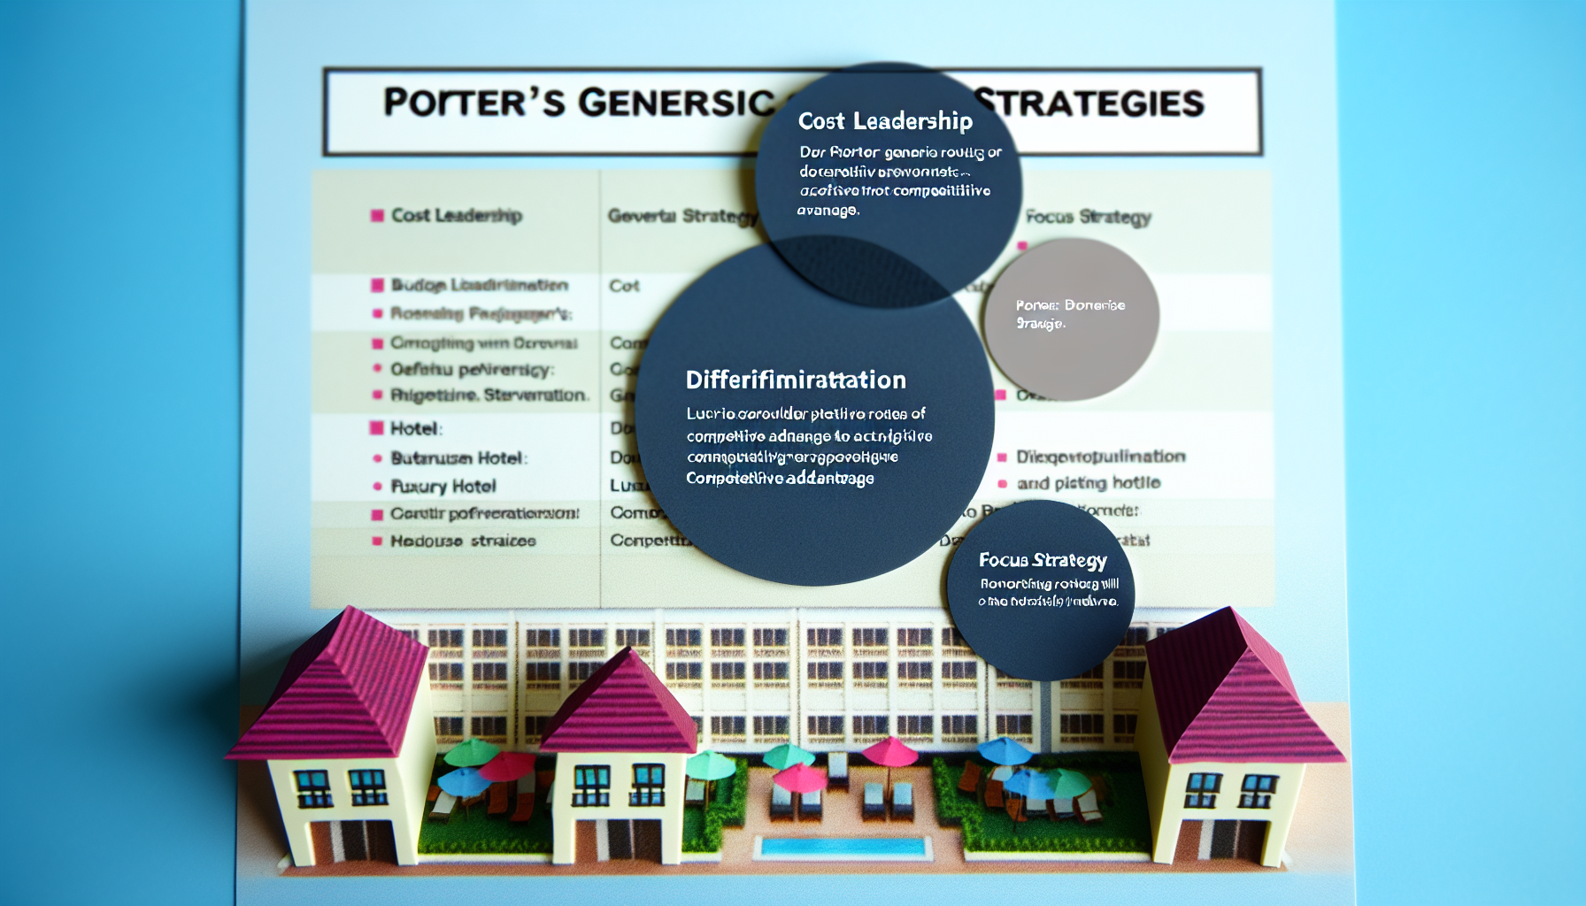

A visual representation of Porter’s Generic Strategies showing Cost Leadership, Differentiation, and Focus Strategy as distinct paths to competitive advantage in the hospitality industry.

**Porter’s Generic Strategies provide three paths to competitive advantage: Cost Leadership, Differentiation, and Focus Strategy, each with distinct applications and implications in the hospitality industry.**

# Bowman’s Strategy Clock: A Complementary Framework

Bowman’s model expands on Porter by analyzing competitive strategies based on **price** and **perceived value**. The eight positions help organizations avoid risky strategies and align with market needs.

* **Low Price/Low Value**: Risky; may lead to price wars.
* **Low Price**: Similar to cost leadership.
* **Hybrid**: Balances moderate price and value.
* **Differentiation**: Higher value without excessive pricing.
* **Focused Differentiation**: Premium pricing for exceptional value.
* **Increased Price/Standard Value**: Risky; customers reject overpriced average offerings.
* **Increased Price/Low Value**: Guaranteed failure.
* **Standard/Commodity**: No competitive edge.

**Bowman’s Strategy Clock offers a nuanced view of competitive strategies by linking price to perceived value, helping organizations identify viable and risky positions in the market.**

# Key Takeaways

* **Porter** simplifies strategy into three paths, while **Bowman** provides granularity by linking price to value.
* A hotel chain might use cost leadership for budget brands and differentiation for luxury lines.
* Strategic pitfalls include over-reliance on cost-cutting eroding quality and excessive differentiation alienating price-sensitive customers.

**Evaluating Porter’s and Bowman’s models enables hospitality organizations to choose a strategic direction that leverages their strengths and meets market demands for lasting advantage.**

* How does cost leadership differ from differentiation in Porter’s Generic Strategies?
* What are the risks associated with the Increased Price/Standard Value position in Bowman’s Strategy Clock?
* Can you provide an example of a hospitality business successfully implementing a Focus Strategy?