UNIT 7
Nadran (Sea Thanksgiving Ritual)

Tema / Theme
Bahasa Inggris | Bahasa Indonesia
Nadran is a traditional ritual expressing gratitude for marine resources. The practice reflects the cultural relationship between coastal communities and the sea. It may strengthen community awareness about responsible fishing, waste management, and marine ecosystem conservation. | Nadran adalah ritual tradisional yang mengekspresikan rasa syukur atas sumber daya laut. Praktik ini mencerminkan hubungan budaya antara masyarakat pesisir dan laut. Tradisi ini dapat memperkuat kesadaran masyarakat tentang penangkapan ikan yang bertanggung jawab, pengelolaan limbah, dan konservasi ekosistem laut.

Stimulus
Bahasa Inggris | Bahasa Indonesia
Nadran ritual, community cooperation, and the coastal ecosystem in Cirebon  Nadran is a traditional ritual practiced by coastal communities in Cirebon as an expression of gratitude for marine resources and a prayer for safety at sea. It involves collective participation and reflects the close cultural relationship between fishermen and the sea.  Studies about Nadran in Cirebon and nearby coastal regions show that the tradition contains values of gratitude, cooperation, cultural identity, and ecological awareness. These values can encourage more responsible fishing behavior and support marine ecosystem conservation.  In this unit, students investigate how fishing intensity, community awareness, waste management, and conservation efforts influence fish population, water quality, biodiversity, and marine sustainability through a simulation. | Ritual Nadran, kerja sama masyarakat, dan ekosistem pesisir di Cirebon  Nadran adalah ritual tradisional yang dipraktikkan oleh masyarakat pesisir di Cirebon sebagai ungkapan rasa syukur atas sumber daya laut dan doa untuk keselamatan di laut. Ritual ini melibatkan partisipasi bersama dan mencerminkan hubungan budaya yang erat antara nelayan dan laut.  Studi tentang Nadran di Cirebon dan wilayah pesisir sekitarnya menunjukkan bahwa tradisi ini mengandung nilai rasa syukur, kerja sama, identitas budaya, dan kesadaran ekologis. Nilai-nilai tersebut dapat mendorong perilaku penangkapan ikan yang lebih bertanggung jawab dan mendukung konservasi ekosistem laut.  Dalam unit ini, siswa menyelidiki bagaimana intensitas penangkapan ikan, kesadaran masyarakat, pengelolaan limbah, dan upaya konservasi memengaruhi populasi ikan, kualitas air, keanekaragaman hayati, dan keberlanjutan laut melalui simulasi.

Referensi / References
- Berkes, F. (2012). Sacred ecology (3rd ed.). Routledge.
- Kementerian Kelautan dan Perikanan Republik Indonesia. (2020). Pengelolaan sumber daya kelautan berbasis masyarakat. https://kkp.go.id
- Koentjaraningrat. (2009). Pengantar ilmu antropologi. Rineka Cipta.
- Nurhikmat, A. (2020). Integrasi kearifan lokal dalam pengelolaan lingkungan pesisir. IOP Conference Series: Earth and Environmental Science, 462, 012026. https://doi.org/10.1088/1755-1315/462/1/012026
- Satria, A. (2015). Pengantar sosiologi masyarakat pesisir. Yayasan Pustaka Obor Indonesia.
- UNESCO. (2017). Local and indigenous knowledge systems (LINKS) programme. https://en.unesco.org
- Widodo, J., & Suadi. (2006). Pengelolaan sumber daya perikanan laut. Gadjah Mada University Press.

Media
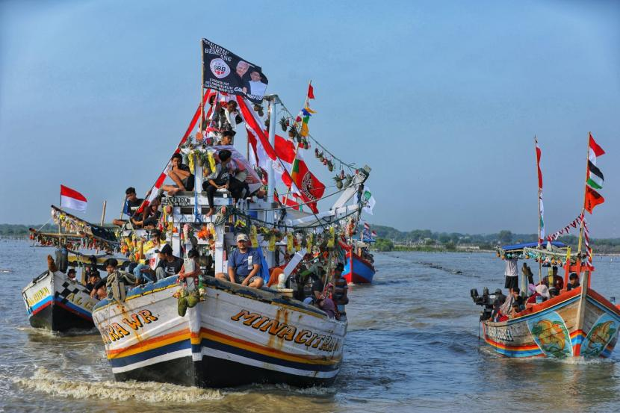
Reference: Antara. (2023, December 25). Partisipasi Ganjaran Buruh Berjuang di Nadran Cirebon jadi upaya lestarikan budaya lokal. Republika.
Video: https://youtu.be/vV-18QHE6Yg?si=1LoPx5kl6-FQCffK

Simulation
Marine Ecosystem & Nadran Sustainability Simulator / Simulasi Ekosistem Laut Cirebon
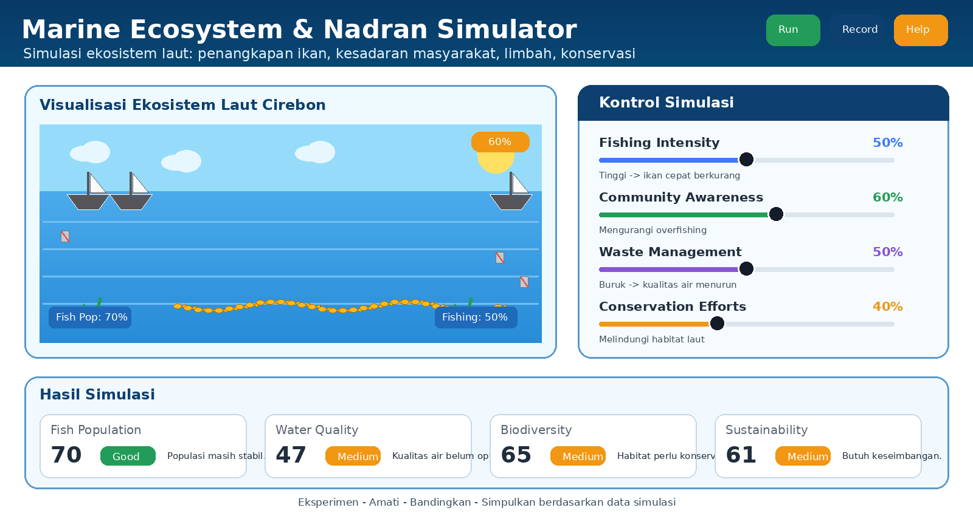

A. Purpose of the Simulation / Tujuan Simulasi
Bahasa Inggris | Bahasa Indonesia
This simulation helps students understand how human activities and environmental management affect marine sustainability. Students compare different conditions and observe changes in fish population, water quality, biodiversity, and sustainability. The simulation connects the Nadran tradition with scientific decision-making about marine conservation. | Simulasi ini membantu siswa memahami bagaimana aktivitas manusia dan pengelolaan lingkungan memengaruhi keberlanjutan laut. Siswa membandingkan beberapa kondisi dan mengamati perubahan pada populasi ikan, kualitas air, keanekaragaman hayati, dan keberlanjutan. Simulasi ini menghubungkan tradisi Nadran dengan pengambilan keputusan ilmiah tentang konservasi laut.

B. Main Variables in the Simulation / Variabel Utama
Variable | Meaning | Main Effect | Catatan Siswa SMP
Fishing Intensity / Intensitas Penangkapan | How many fish are harvested. | High fishing intensity directly decreases fish population. | Jika terlalu banyak ikan ditangkap, jumlah ikan berkurang lebih cepat.
Community Awareness / Kesadaran Masyarakat | How well the community understands sustainable behavior. | Higher awareness can reduce overfishing and support responsible actions. | Masyarakat yang sadar lingkungan lebih berhati-hati dalam menangkap ikan dan membuang sampah.
Waste Management / Pengelolaan Limbah | How well waste is managed before entering the sea. | Good waste management improves water quality and supports marine life. | Limbah yang buruk menurunkan kualitas air terlebih dahulu, lalu dapat mengganggu ikan.
Conservation Efforts / Upaya Konservasi | Actions to protect habitats and marine resources. | Stronger conservation protects biodiversity and long-term sustainability. | Konservasi membantu menjaga tempat hidup ikan dan biota laut.

C. Result Indicators / Indikator Hasil
Indicator | Meaning | Low / Medium / High Guide
Fish Population | Number of fish remaining in the ecosystem. | Low: few fish; Medium: fish population is not stable; High: fish population is healthy.
Water Quality | Condition of seawater affected by waste and pollution. | Low: polluted; Medium: needs improvement; High: clean and supportive for marine life.
Biodiversity | Variety of marine life and habitat condition. | Low: few species; Medium: moderate; High: many species and healthy habitats.
Sustainability | Balance between using resources and protecting the ecosystem. | Low: unsustainable; Medium: needs action; High: balanced and long-term.

D. How the Variables Affect the System / Cara Kerja Simulasi
If students change... | What students should observe | Scientific explanation
Fishing intensity increases | Fish population decreases more directly. | More fish are removed from the ecosystem, so the population can decline faster than reproduction.
Community awareness increases | Fish population and sustainability improve over time. | Awareness changes human behavior, such as reducing overfishing and supporting conservation.
Waste management decreases | Water quality decreases first; fish and biodiversity may decline later. | Waste and pollution make the water less suitable for marine life.
Conservation efforts increase | Biodiversity and sustainability improve. | Protected habitats help fish and other marine organisms survive and reproduce.

E. Example Simulation Scenarios / Contoh Skenario Simulasi
Scenario | Fishing Intensity | Community Awareness | Waste Management | Expected Result
Overfishing risk | High | Low | Poor | Fish population decreases strongly.
Community awareness improves | Medium | High | Fair/Good | Fish population becomes more stable over time.
Pollution problem | Medium | Medium | Poor | Water quality decreases and biodiversity may decrease.

F. Suggested Video / Animation Storyboard
Scene | Visual | Narration / Message
1 | Coastal community celebrates Nadran near the sea. | Nadran reminds people to be grateful for marine resources.
2 | Students adjust the fishing intensity slider. | When fishing intensity is too high, fish population decreases.
3 | Students increase community awareness and conservation efforts. | Responsible behavior helps reduce overfishing and protects habitats.
4 | Students improve waste management. | Cleaner water supports fish, biodiversity, and sustainability.

Question 2 (U7PG2)
Bahasa Inggris | Bahasa Indonesia
Run or observe the simulation using these settings:  - Fishing intensity: High  - Community awareness: Low  - Waste management: Poor  - Conservation efforts: Low  The result shows that fish population decreases strongly. Which factor most directly caused the decrease in fish population?  A. Water entering from the sea  B. Poor waste management  C. High fishing intensity  D. Cultural traditions | Jalankan atau amati simulasi dengan pengaturan berikut:  - Intensitas penangkapan ikan: Tinggi  - Kesadaran masyarakat: Rendah  - Pengelolaan limbah: Buruk  - Upaya konservasi: Rendah  Hasil menunjukkan bahwa populasi ikan menurun secara signifikan. Faktor manakah yang paling langsung menyebabkan penurunan populasi ikan?  A. Air yang masuk dari laut  B. Pengelolaan limbah yang buruk  C. Intensitas penangkapan ikan yang tinggi  D. Tradisi budaya

Framework categorization
Component | Category
Knowledge type | Procedural
Competency | Interpret data and evidence scientifically
Context | Local to global
Cognitive demand | Medium
Question format | Simple multiple choice
This question guides students to identify the most direct cause of overexploitation by interpreting simulation settings and results. Students need to distinguish between a direct factor (high fishing intensity) and indirect factors such as waste management.

Scoring Rubric
Criteria | Maximum Score | Description
Correct answer | 1 | Selects the correct option (C).
Incorrect answer | 0 | Selects any other option or does not answer.

Answer Explanation
Correct answer: C. High fishing intensity. High fishing intensity directly removes fish from the ecosystem. If fish are caught faster than they can reproduce, the population decreases strongly. Poor waste management can also harm the ecosystem, but its effect is usually more indirect through water quality.

Question 3 (U7PG3)
Bahasa Inggris | Bahasa Indonesia
Compare the simulation results when community awareness is low and when community awareness is high. Increasing community awareness leads to improved fish population over time. Why does this happen?  A. It raises salinity so fish can live longer.  B. It directly increases fish reproduction without changing human behavior.  C. It reduces overfishing behavior and supports more responsible use of marine resources.  D. It removes all predators from the ecosystem. | Bandingkan hasil simulasi ketika kesadaran masyarakat rendah dan ketika kesadaran masyarakat tinggi. Peningkatan kesadaran masyarakat menyebabkan populasi ikan membaik seiring waktu. Mengapa hal ini terjadi?  A. Hal ini meningkatkan salinitas sehingga ikan dapat hidup lebih lama.  B. Hal ini secara langsung meningkatkan reproduksi ikan tanpa mengubah perilaku manusia.  C. Hal ini mengurangi perilaku penangkapan berlebih dan mendukung pemanfaatan sumber daya laut yang lebih bertanggung jawab.  D. Hal ini menghilangkan semua predator dari ekosistem.

Framework categorization
Component | Category
Knowledge type | Content
Competency | Explain phenomena scientifically
Context | Local to global
Cognitive demand | Medium
Question format | Simple multiple choice
This question quantifies the role of community awareness in ecosystem stability. Students explain that awareness affects fish populations indirectly by changing human behavior, especially by reducing overfishing and supporting conservation.

Scoring Rubric
Criteria | Maximum Score | Description
Correct answer | 1 | Selects the correct option (C).
Incorrect answer | 0 | Selects any other option or does not answer.

Answer Explanation
Correct answer: C. Higher community awareness can encourage people to avoid overfishing, follow fishing rules, reduce waste, and support conservation. These behavioral changes give fish populations more time to recover and help the ecosystem become more stable.

Question 4 (U7PG4)
Bahasa Inggris | Bahasa Indonesia
Use the comparison below based on the simulation data.  Community A:  - Fishing intensity: High  - Community awareness: Low  - Result: Fish population declines  Community B:  - Fishing intensity: Medium  - Community awareness: High  - Result: Fish population is stable  Which conclusion best explains the difference?  A. Community awareness can influence fishing behavior and marine sustainability.  B. Fishing intensity has no effect on fish population.  C. Marine ecosystems are controlled only by natural factors.  D. Community traditions cannot affect the environment. | Gunakan perbandingan berikut berdasarkan data simulasi.  Komunitas A:  - Intensitas penangkapan ikan: Tinggi  - Kesadaran masyarakat: Rendah  - Hasil: Populasi ikan menurun  Komunitas B:  - Intensitas penangkapan ikan: Sedang  - Kesadaran masyarakat: Tinggi  - Hasil: Populasi ikan stabil  Kesimpulan manakah yang paling tepat menjelaskan perbedaan tersebut?  A. Kesadaran masyarakat dapat memengaruhi perilaku penangkapan ikan dan keberlanjutan laut.  B. Intensitas penangkapan ikan tidak berpengaruh terhadap populasi ikan.  C. Ekosistem laut hanya dikendalikan oleh faktor alam.  D. Tradisi masyarakat tidak dapat memengaruhi lingkungan.

Framework categorization
Component | Category
Knowledge type | Procedural
Competency | Interpret data and evidence scientifically
Context | Local to global
Cognitive demand | Medium
Question format | Simple multiple choice
This item consistently uses the term Community Awareness / Kesadaran Masyarakat. The comparison connects socio-cultural values from Nadran with scientific literacy about sustainable fishing and ecosystem balance.

Scoring Rubric
Criteria | Maximum Score | Description
Correct answer | 1 | Selects the correct option (A).
Incorrect answer | 0 | Selects any other option or does not answer.

Answer Explanation
Correct answer: A. Community B has a more stable fish population because community awareness is higher and fishing intensity is not excessive. This shows that community awareness can influence human behavior and support marine sustainability.

Question 5 (U7E5)
Bahasa Inggris | Bahasa Indonesia
The local government in Cirebon wants to improve marine sustainability. Write a short policy recommendation based on evidence from the simulation.  Your recommendation should consider:  - fishing intensity  - community awareness  - waste management  - conservation efforts  Writing guide: A strong answer proposes at least one specific policy action and explains how it can improve fish population, water quality, biodiversity, and sustainability. | Pemerintah daerah di Cirebon ingin meningkatkan keberlanjutan laut. Tulislah rekomendasi kebijakan singkat berdasarkan bukti dari simulasi.  Rekomendasi kamu harus mempertimbangkan:  - intensitas penangkapan ikan  - kesadaran masyarakat  - pengelolaan limbah  - upaya konservasi  Panduan penulisan: Jawaban yang kuat mengusulkan minimal satu tindakan kebijakan yang spesifik dan menjelaskan bagaimana tindakan tersebut dapat meningkatkan populasi ikan, kualitas air, keanekaragaman hayati, dan keberlanjutan.

Framework categorization
Component | Category
Knowledge type | Epistemic
Competency | Evaluate and use scientific information for decision-making
Context | Local to global
Cognitive demand | High
Question format | Constructed response (policy recommendation)
This final item asks students to synthesize evidence from the simulation and the Nadran context. It uses a constructed-response format so students can justify a policy recommendation using scientific reasoning and local cultural values.

Scoring Rubric (0-5)
Score | Criteria
5 | Excellent: proposes a clear and specific policy; uses simulation evidence; discusses fishing intensity, community awareness, waste management, and conservation efforts; explains effects on fish population, water quality, biodiversity, and sustainability.
4 | Good: proposes a clear policy and uses evidence, but one indicator or one variable is less fully explained.
3 | Adequate: gives a relevant recommendation and mentions some simulation variables, but explanation is general or incomplete.
2 | Limited: gives a simple recommendation with little connection to simulation evidence.
1 | Very limited: response is relevant only in a minimal way and lacks scientific explanation.
0 | Incorrect/no answer: does not provide a relevant recommendation or does not answer.

Sample Answer / Contoh Jawaban
Bahasa Inggris | Bahasa Indonesia
The local government should promote Nadran together with environmental education, fishing rules, waste management, and conservation programs. Education can increase community awareness and reduce overfishing. Better waste management improves water quality, while conservation protects habitats and biodiversity. Based on the simulation, these combined actions can help fish populations recover and support long-term marine sustainability. | Pemerintah daerah sebaiknya mempromosikan Nadran bersama pendidikan lingkungan, aturan penangkapan ikan, pengelolaan limbah, dan program konservasi. Pendidikan dapat meningkatkan kesadaran masyarakat dan mengurangi penangkapan berlebih. Pengelolaan limbah yang baik meningkatkan kualitas air, sedangkan konservasi melindungi habitat dan keanekaragaman hayati. Berdasarkan simulasi, tindakan gabungan ini dapat membantu pemulihan populasi ikan dan mendukung keberlanjutan laut jangka panjang.

Revision Notes
Revised Part | Final Adjustment
Simulation | Made clearer, more visual, and more student-friendly for junior high school students; added variables, indicators, examples, and video storyboard.
U7PG2 | Question now explicitly asks students to run/observe the simulation; answer choices are randomized; correct answer changed to C.
U7PG3 | Clarified that community awareness improves fish population through behavior change; answer choices are randomized; correct answer is C.
U7PG4 | Standardized terminology to Community Awareness / Kesadaran Masyarakat; correct answer is A.
U7E5 | Changed into a clear constructed-response policy recommendation; corrected English typos; rubric changed to 0-5.

Berikut tabel bagian yang direvisi pada Unit 7 berdasarkan file awal Unit 7 dan catatan revisi yang kamu kirim. File awal Unit 7 berisi tema Nadran, stimulus, simulasi ekosistem laut Cirebon, serta soal U7PG2, U7PG3, U7PG4, dan U7E5.
No. | Bagian | Sebelum Revisi | Sesudah Revisi | Tujuan Revisi
1 | Bagian Simulasi | Simulasi sudah ada, tetapi masih terlihat umum dan belum terlalu ramah untuk siswa SMP. | Simulasi dibuat lebih jelas dengan konsep Cirebon Marine Ecosystem Simulation / Simulasi Ekosistem Laut Cirebon. | Agar siswa lebih mudah memahami hubungan antara aktivitas manusia dan keberlanjutan laut.
2 | Visual Simulasi | Tampilan hanya menunjukkan laut, ikan, dan slider sederhana. | Ditambahkan konsep sketsa yang lebih menarik: laut Cirebon, ikan, kapal nelayan, sampah, area konservasi, dan indikator hasil. | Agar simulasi lebih kontekstual dengan Nadran dan ekosistem pesisir.
3 | Variabel Simulasi | Variabel: fishing intensity, community awareness, waste management, conservation efforts. | Variabel tetap dipakai, tetapi penjelasannya dibuat lebih sederhana: intensitas penangkapan, kesadaran masyarakat, pengelolaan limbah, dan upaya konservasi. | Supaya mudah dipahami siswa SMP.
4 | Istilah Community Awareness | Ada potensi inkonsistensi antara istilah Community Awareness dan Cultural Awareness pada soal. | Istilah dibuat konsisten menjadi Community Awareness / Kesadaran Masyarakat. | Menghindari kebingungan istilah antara soal, simulasi, dan jawaban.
5 | Indikator Hasil Simulasi | Indikator hasil sudah ada: Fish Population, Water Quality, Biodiversity, Sustainability. | Diperjelas arti setiap indikator dalam bahasa sederhana. | Agar siswa tahu data mana yang harus diamati saat menjawab soal.
6 | Panduan Penggunaan Simulasi | Panduan masih cukup umum. | Ditambahkan langkah penggunaan: ubah satu variabel, amati hasil, bandingkan skenario, lalu gunakan data sebagai bukti. | Membantu siswa menggunakan simulasi untuk menjawab soal berbasis data.
7 | U7PG2 | Soal menanyakan faktor penyebab penurunan populasi ikan, dengan kondisi fishing intensity tinggi, awareness rendah, dan waste management buruk. | Soal tetap, tetapi diarahkan agar siswa membaca hasil simulasi dan memilih penyebab paling langsung, yaitu High fishing intensity. | Menjawab catatan: apakah siswa perlu menjalankan simulasi. Soal dibuat tetap bisa dijawab dari data simulasi.
8 | Opsi Jawaban U7PG2 | Urutan opsi masih terlalu mudah ditebak. | Opsi jawaban diacak agar tidak berurutan/pola mudah ditebak. | Meningkatkan kualitas soal pilihan ganda.
9 | Penjelasan U7PG2 | Penjelasan sudah ada, tetapi masih perlu diperjelas perbedaan dampak langsung dan tidak langsung. | Diperjelas bahwa intensitas penangkapan tinggi paling langsung menurunkan populasi ikan, sedangkan limbah berdampak lebih tidak langsung melalui kualitas air. | Membuat alasan ilmiah lebih kuat.
10 | Typo U7PG2 | Terdapat typo: evdence. | Diperbaiki menjadi evidence. | Memperbaiki kesalahan penulisan Bahasa Inggris.
11 | U7PG3 | Soal mirip dengan U7PG2 karena sama-sama membahas pengaruh variabel terhadap populasi ikan. | Soal dibuat lebih fokus pada mengapa peningkatan kesadaran masyarakat dapat memperbaiki populasi ikan. | Mengurangi kemiripan dengan U7PG2.
12 | Konteks U7PG3 | Ada catatan bahwa jika waste management buruk, hasil seolah langsung berubah. | Penjelasan dibuat bertahap: awareness mengubah perilaku manusia, mengurangi overfishing, lalu populasi ikan membaik seiring waktu. | Membuat hubungan sebab-akibat lebih logis dan tidak instan.
13 | Jawaban U7PG3 | Jawaban benar tetap: meningkatkan awareness mengurangi overfishing dan mendukung pemanfaatan laut secara bertanggung jawab. | Jawaban tetap, tetapi alasan diperjelas dengan konsep perilaku manusia dan pengelolaan sumber daya laut. | Menyesuaikan dengan scientific literacy dan konteks Nadran.
14 | U7PG4 | Terdapat inkonsistensi penggunaan istilah Community Awareness dan Cultural Awareness. | Diseragamkan menjadi Community Awareness / Kesadaran Masyarakat. | Agar bahasa pada simulasi, tabel perbandingan, opsi, dan kunci jawaban konsisten.
15 | Tabel Perbandingan U7PG4 | Membandingkan dua komunitas: A dengan penangkapan tinggi dan awareness rendah, B dengan penangkapan sedang dan awareness tinggi. | Tabel tetap digunakan, tetapi bahasa diperjelas agar siswa membaca hubungan antara awareness, fishing intensity, dan hasil populasi ikan. | Membantu siswa menarik kesimpulan dari data.
16 | Jawaban U7PG4 | Jawaban benar awal: Cultural awareness can influence fishing behavior and marine sustainability. | Disesuaikan menjadi konsep community awareness can influence fishing behavior and marine sustainability. | Menghilangkan ketidakkonsistenan istilah.
17 | U7E5 | Awalnya memuat pilihan strategi dan juga perintah essay/rekomendasi kebijakan. | Diperjelas sebagai soal rekomendasi kebijakan berbasis bukti simulasi. | Agar siswa tidak bingung antara pilihan ganda dan essay.
18 | Instruksi U7E5 | Terdapat beberapa typo: reccomendation, Writting, rccomends. | Diperbaiki menjadi recommendation, Writing, recommends. | Memperbaiki kualitas bahasa Inggris.
19 | Rubrik U7E5 | Rubrik awal menggunakan skor 0–4. | Diubah menjadi rubrik 0–5. | Menyesuaikan permintaan agar essay menggunakan rubrik skala 0–5.
20 | Rubrik Essay U7E5 | Kriteria masih umum: complete, good, partial, limited, incorrect. | Dibuat lebih rinci: skor 5 sangat lengkap, 4 baik, 3 cukup, 2 terbatas, 1 sangat minim, 0 tidak relevan/tidak menjawab. | Penilaian essay menjadi lebih adil dan terukur.
21 | Bahasa untuk Siswa SMP | Beberapa kalimat masih cukup akademik. | Bahasa dibuat lebih sederhana, misalnya “penangkapan berlebihan”, “air laut lebih bersih”, “ikan punya kesempatan berkembang biak”, dan “laut lebih berkelanjutan”. | Agar soal lebih ramah untuk siswa SMP.
22 | Koneksi Nadran dengan Sains | Nadran sudah dijelaskan sebagai tradisi syukur dan hubungan masyarakat dengan laut. | Hubungan Nadran diperkuat dengan pendidikan lingkungan, kesadaran masyarakat, dan konservasi laut. | Agar konteks budaya tidak terpisah dari literasi sains.
23 | Kelengkapan Final | Soal, simulasi, framework, rubrik, dan penjelasan masih perlu diselaraskan. | Semua bagian disesuaikan: stimulus, simulasi, soal, opsi, kunci, penjelasan jawaban, framework, dan rubrik. | Membuat Unit 7 menjadi versi final yang konsisten.

