UNIT 8
Rattan Craft Industry (Rotan Plered)
Final Revised Version

Tema / Theme
Bahasa Inggris | Bahasa Indonesia
Rattan is a non-timber forest product harvested from forest ecosystems. Sustainable rattan harvesting supports local livelihoods while maintaining forest biodiversity and ecological balance when managed responsibly. | Rotan merupakan hasil hutan non-kayu yang dipanen dari ekosistem hutan. Pemanenan rotan yang berkelanjutan mendukung mata pencaharian masyarakat lokal sekaligus menjaga keanekaragaman hayati hutan dan keseimbangan ekologi jika dikelola secara bertanggung jawab.

Stimulus
Bahasa Inggris | Bahasa Indonesia
RATTAN CRAFT INDUSTRY  In Cirebon, rattan is used to make furniture and handicrafts. Rattan is a non-timber forest product, which means it is taken from forest ecosystems without cutting down trees. Researchers are interested in how rattan can be harvested and used in a sustainable way. Sustainable rattan harvesting can support local livelihoods while helping to maintain forest biodiversity and ecological balance.  However, sustainability depends on several conditions in both the forest and the industry. In this investigation, students examine three important factors over a period of time:  • Harvest rate: how much rattan is taken from the forest  • Replanting effort: how much new rattan is planted after harvesting  • Waste utilization: how much production waste is reused instead of discarded | INDUSTRI KERAJINAN ROTAN  Di Cirebon, rotan digunakan untuk membuat furnitur dan kerajinan tangan. Rotan merupakan hasil hutan non-kayu, yang berarti diambil dari ekosistem hutan tanpa menebang pohon. Para peneliti tertarik untuk mengetahui bagaimana rotan dapat dipanen dan dimanfaatkan secara berkelanjutan. Pemanenan rotan yang berkelanjutan dapat mendukung mata pencaharian masyarakat lokal sekaligus membantu menjaga keanekaragaman hayati hutan dan keseimbangan ekologi.  Namun, keberlanjutan bergantung pada beberapa kondisi baik di hutan maupun di industri. Dalam investigasi ini, siswa mempelajari tiga faktor penting dalam suatu periode waktu:  • Tingkat panen: seberapa banyak rotan yang diambil dari hutan  • Upaya penanaman kembali: seberapa banyak rotan baru yang ditanam setelah panen  • Pemanfaatan limbah: seberapa banyak limbah produksi yang digunakan kembali dibandingkan dibuang

Referensi / References
Food and Agriculture Organization. (2018). Non-wood forest products in international statistical systems. FAO. https://www.fao.org
International Tropical Timber Organization. (2019). Sustainable management of tropical forests. ITTO.
Kementerian Lingkungan Hidup dan Kehutanan Republik Indonesia. (2020). Hasil hutan bukan kayu dan peranannya dalam ekonomi masyarakat. https://www.menlhk.go.id
Liese, W. (2002). The anatomy of bamboo and rattan. INBAR.
Sunderland, T., Achdiawan, R., Angelsen, A., et al. (2014). Challenging perceptions about men, women, and forest product use: A global comparative study. World Development, 64, S56-S66.
Widjaja, E. A. (2001). Rotan: Sumber daya alam dan pemanfaatannya di Indonesia. LIPI Press.

Media
Bahan baku rotan | Hasil anyaman rotan
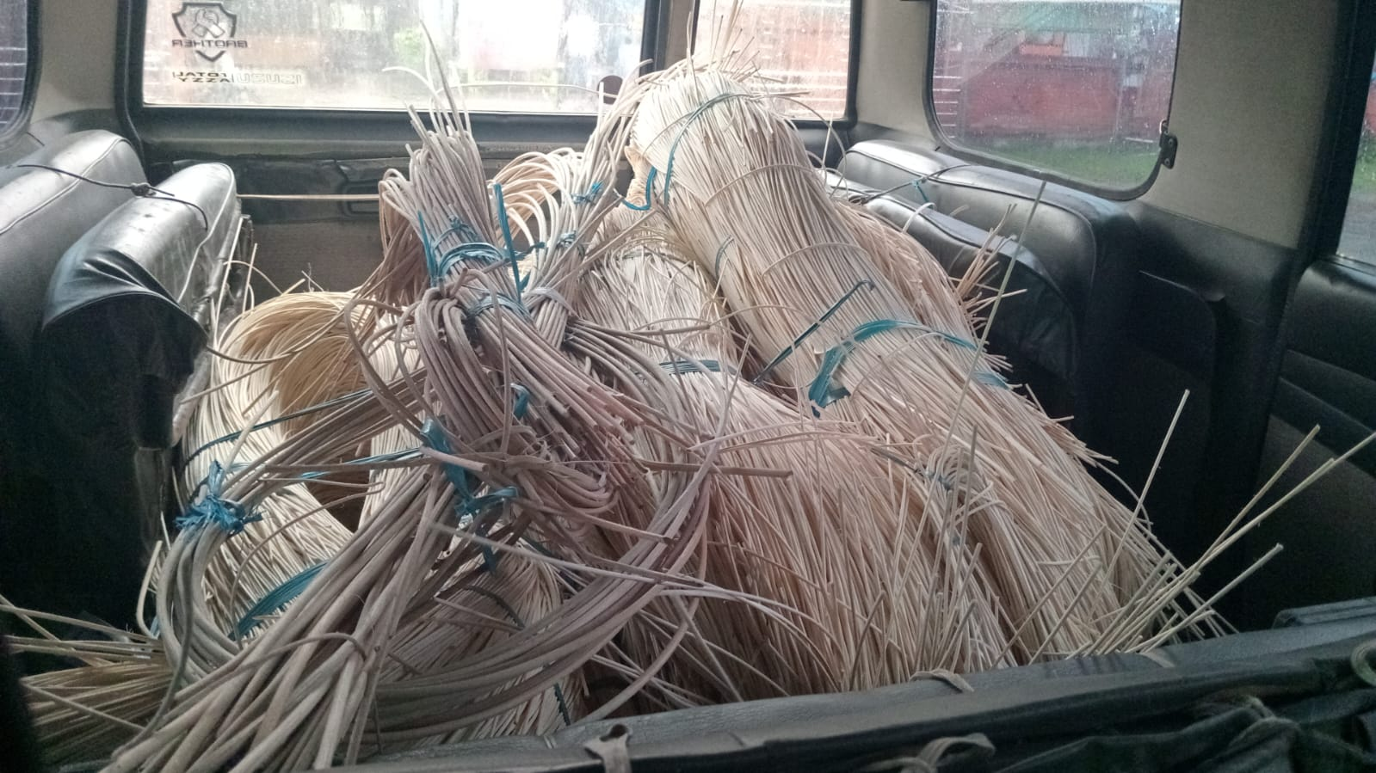 | 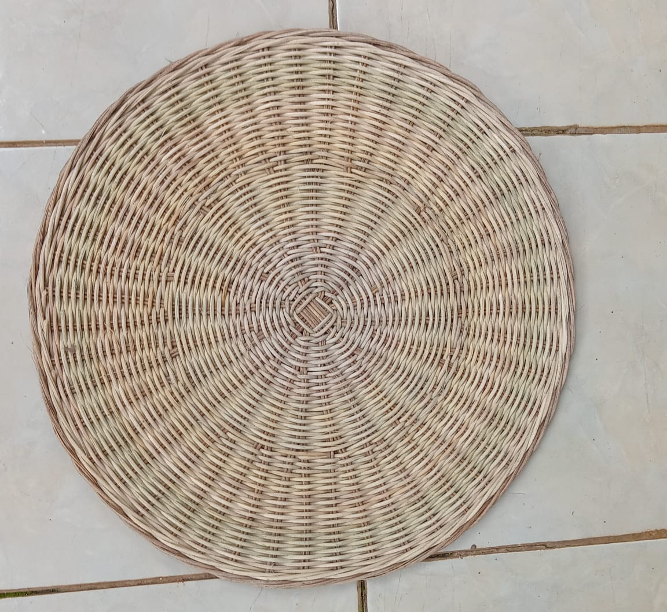
Reference: Adiansyah, L. G. (2026). Bahan baku dan hasil anyaman rotan Cirebon [Fotografi]. Koleksi pribadi.
Video: https://youtu.be/jYLDuzr-ecc?si=CjQkwZdU7fxRaPLQ

Simulation / Simulasi
Rattan Craft Industry Simulation / Simulasi Industri Kerajinan Rotan
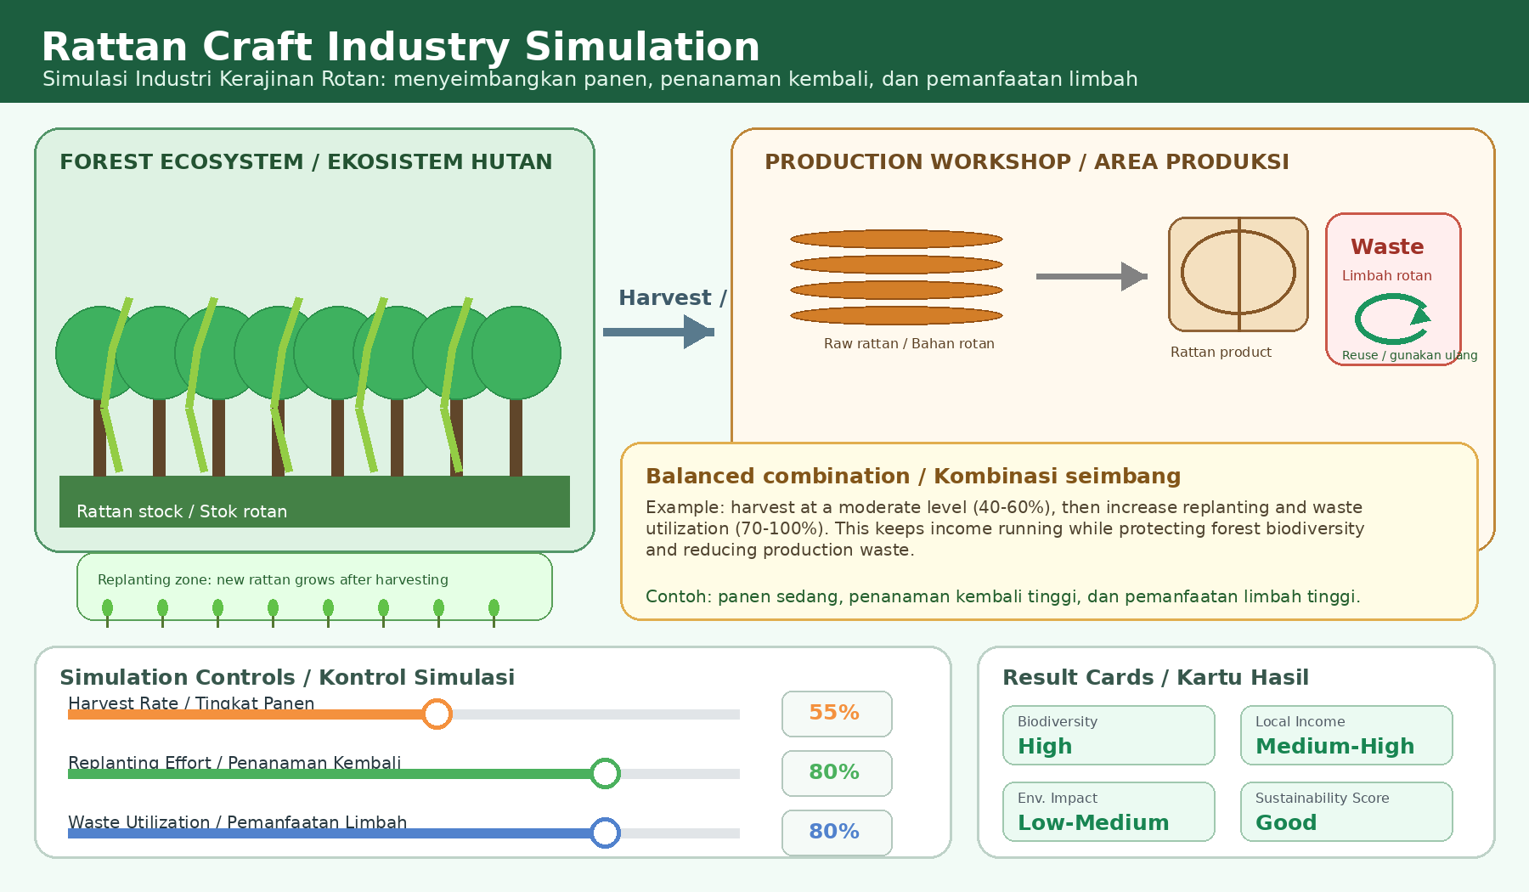

A. Purpose of the Simulation / Tujuan Simulasi
Bahasa Inggris | Bahasa Indonesia
This simulation helps students understand how rattan harvesting and craft production affect sustainability. Students compare how harvest rate, replanting effort, and waste utilization influence rattan stock, biodiversity, local income, environmental impact, and the sustainability score. | Simulasi ini membantu siswa memahami bagaimana pemanenan rotan dan produksi kerajinan memengaruhi keberlanjutan. Siswa membandingkan bagaimana tingkat panen, upaya penanaman kembali, dan pemanfaatan limbah memengaruhi stok rotan, keanekaragaman hayati, pendapatan lokal, dampak lingkungan, dan skor keberlanjutan.

B. Production Flow / Alur Produksi
Forest / Hutan | Harvest / Panen | Workshop / Produksi | Product / Produk | Waste Reuse / Limbah Digunakan Ulang
Rattan grows in the forest ecosystem.  Rotan tumbuh di ekosistem hutan. | Rattan is taken for craft materials.  Rotan diambil sebagai bahan kerajinan. | Craftspeople process rattan into products.  Pengrajin mengolah rotan menjadi produk. | Products support local income.  Produk mendukung pendapatan lokal. | Waste can be reused to reduce pollution.  Limbah dapat digunakan ulang untuk mengurangi pencemaran.

C. Main Variables in the Simulation / Variabel Utama
Variable / Variabel | Meaning / Arti | Expected Effect / Pengaruh
Harvest Rate / Tingkat Panen | How much rattan is taken from the forest. / Seberapa banyak rotan diambil dari hutan. | Higher harvest can increase income, but too high a harvest can reduce rattan stock and biodiversity. / Panen lebih tinggi dapat menaikkan pendapatan, tetapi panen terlalu tinggi dapat menurunkan stok rotan dan keanekaragaman hayati.
Replanting Effort / Upaya Penanaman Kembali | How many new rattan plants are planted after harvesting. / Seberapa banyak rotan baru ditanam setelah panen. | Higher replanting helps rattan resources recover and protects biodiversity. / Penanaman kembali yang tinggi membantu sumber daya rotan pulih dan melindungi keanekaragaman hayati.
Waste Utilization / Pemanfaatan Limbah | How much production waste is reused instead of discarded. / Seberapa banyak limbah produksi digunakan ulang, bukan dibuang. | Higher waste utilization reduces environmental impact and can create useful products. / Pemanfaatan limbah yang tinggi mengurangi dampak lingkungan dan dapat menghasilkan produk berguna.

D. Output Indicators / Indikator Hasil
Indicator / Indikator | Meaning / Makna | Simple Student Interpretation / Interpretasi Sederhana
Rattan Stock / Stok Rotan | Remaining availability of rattan resources. / Ketersediaan rotan yang tersisa. | If stock decreases too much, the forest resource is being overused. / Jika stok turun terlalu banyak, sumber daya hutan digunakan berlebihan.
Biodiversity / Keanekaragaman Hayati | Condition of living things in the forest. / Kondisi makhluk hidup di hutan. | High biodiversity means the forest ecosystem is healthier. / Keanekaragaman tinggi berarti ekosistem hutan lebih sehat.
Local Income / Pendapatan Lokal | Economic benefit for craftspeople and the local community. / Manfaat ekonomi bagi pengrajin dan masyarakat lokal. | Income should increase without damaging the forest. / Pendapatan perlu meningkat tanpa merusak hutan.
Environmental Impact / Dampak Lingkungan | Pressure from harvesting and waste. / Tekanan dari panen dan limbah. | Lower impact means production is cleaner and more responsible. / Dampak lebih rendah berarti produksi lebih bersih dan bertanggung jawab.
Sustainability Score / Skor Keberlanjutan | Overall balance of economy and ecology. / Keseimbangan umum antara ekonomi dan ekologi. | A good score means income and forest protection are balanced. / Skor baik berarti pendapatan dan perlindungan hutan seimbang.

E. How to Run the Simulation / Cara Menggunakan Simulasi
1. Start with a middle condition: harvest 50%, replanting 50%, and waste utilization 50%. / Mulai dari kondisi sedang: panen 50%, penanaman kembali 50%, dan pemanfaatan limbah 50%.
2. Change only one variable at a time, then click Run Simulation or Record Data. / Ubah satu variabel saja setiap kali, lalu klik Jalankan Simulasi atau Simpan Data.
3. Observe the result cards: biodiversity, local income, environmental impact, and sustainability score. / Amati kartu hasil: keanekaragaman hayati, pendapatan lokal, dampak lingkungan, dan skor keberlanjutan.
4. Use the Dataset Log to compare repeated results. The log should store the values of the variables and the output indicators so students can use their simulation history as evidence. / Gunakan Catatan Data untuk membandingkan hasil. Catatan ini sebaiknya menyimpan nilai variabel dan indikator hasil agar siswa dapat memakai riwayat simulasi sebagai bukti.
5. Try a balanced combination, not only “all high” or “all medium”. A good balance usually uses moderate harvest with high replanting and high waste utilization. / Cobalah kombinasi seimbang, bukan hanya “semua tinggi” atau “semua sedang”. Keseimbangan yang baik biasanya memakai panen sedang, penanaman kembali tinggi, dan pemanfaatan limbah tinggi.

F. Example Simulation Scenarios / Contoh Skenario Simulasi
Scenario | Harvest | Replanting | Waste Use | Expected Result | Simple Explanation
A: Overharvest | High (80-100%) | Low (0-40%) | Low (0-40%) | Income may rise briefly, but biodiversity and stock decline. | Too much rattan is taken and not enough is replaced.
B: Balanced | Moderate (40-60%) | High (70-100%) | High (70-100%) | Income remains useful, biodiversity is protected, and waste decreases. | Harvesting is controlled while regeneration and waste reuse are strengthened.
C: Low production | Low (0-30%) | High (70-100%) | High (70-100%) | Biodiversity is protected, but income may be low. | The forest is protected, but the workshop may not get enough raw material.

Question 1 (U8E1)
Bahasa Inggris | Bahasa Indonesia
DATA COLLECTION  Students use three indicators to study sustainability in the forest and the industry. They collect data from both the forest area and the craft-production area.  • Harvest monitor: records how much rattan is harvested from the forest in one period  • Replanting monitor: records how many new rattan plants are added after harvesting  • Waste-use monitor: records how much rattan waste is reused instead of being discarded  Students collect two measurements for each condition and then compare the pattern.  In investigating sustainable rattan production, why do students measure two of each indicator instead of using only one measurement for each indicator? | PENGUMPULAN DATA  Siswa menggunakan tiga indikator untuk mempelajari keberlanjutan di hutan dan industri. Mereka mengumpulkan data dari area hutan dan area produksi kerajinan.  • Pemantau panen: mencatat berapa banyak rotan yang dipanen dari hutan dalam satu periode  • Pemantau penanaman kembali: mencatat berapa banyak tanaman rotan baru yang ditanam setelah panen  • Pemantau penggunaan limbah: mencatat berapa banyak limbah rotan yang digunakan kembali dibandingkan dibuang  Siswa mengumpulkan dua pengukuran untuk setiap kondisi dan kemudian membandingkan polanya.  Dalam menyelidiki produksi rotan yang berkelanjutan, mengapa siswa mengukur dua kali untuk setiap indikator dibandingkan hanya menggunakan satu pengukuran untuk setiap indikator?

Framework categorization
Component | Category
Knowledge type | Epistemic
Competency | Evaluate and use scientific inquiry
Context | Local
Cognitive demand | Medium
Question format | Constructed response
This question asks students to explain why repeated measurements are used in scientific investigations. Students should connect repetition with accuracy, reliability, consistency, and reducing random error or bias.

Scoring Rubric
Score | Criteria | Description
5 | Very complete | Explains that repeated measurements improve accuracy and reliability, allow comparison of patterns, and reduce random error or bias.
4 | Good | Mentions accuracy and reliability with a clear reason, but the explanation is not fully detailed.
3 | Adequate | Mentions repeated measurements make results more accurate or reliable, but gives limited explanation.
2 | Limited | Gives a simple idea such as “to check again” without explaining reliability or error.
1 | Very limited | Mentions repetition but does not connect it to data quality.
0 | Incorrect / no answer | No relevant answer or answer is scientifically incorrect.
Answer (Sample Ideal Response)
Students take two measurements for each indicator to make the data more reliable and accurate. One measurement may contain error or be affected by unusual conditions. By repeating the measurement, students can compare the results, check whether the pattern is consistent, and make a stronger conclusion about sustainable rattan production.

Question 4 (U8E4)
Bahasa Inggris | Bahasa Indonesia
Use the simulation and type your answer.  A workshop in Cirebon wants to increase income quickly by harvesting more rattan, but it does not want biodiversity to decline too much. Use the simulation and identify one combination of variables that gives a reasonable balance between local income and biodiversity.  Current Simulation Results  Harvest: 50 | Replanting: 50 | Waste Use: 50 | Biodiversity: High | Local Income: Medium | Environmental Impact: Medium  What is a balanced combination?  A balanced combination means the variables are not simply all high or all medium. A reasonable balance usually uses moderate harvest, higher replanting, and higher waste utilization. Example: Harvest 40-60%, Replanting 70-100%, Waste Use 70-100%. | Gunakan simulasi dan tuliskan jawabanmu.  Sebuah workshop di Cirebon ingin meningkatkan pendapatan dengan cepat dengan memanen lebih banyak rotan, tetapi tidak ingin keanekaragaman hayati menurun terlalu banyak. Gunakan simulasi dan tentukan satu kombinasi variabel yang memberikan keseimbangan yang wajar antara pendapatan lokal dan keanekaragaman hayati.  Hasil Simulasi Saat Ini  Panen: 50 | Penanaman Kembali: 50 | Penggunaan Limbah: 50 | Keanekaragaman Hayati: Tinggi | Pendapatan Lokal: Sedang | Dampak Lingkungan: Sedang  Apa itu kombinasi seimbang?  Kombinasi seimbang berarti variabel tidak harus semuanya tinggi atau semuanya sedang. Keseimbangan yang wajar biasanya menggunakan panen sedang, penanaman kembali lebih tinggi, dan pemanfaatan limbah lebih tinggi. Contoh: Panen 40-60%, Penanaman Kembali 70-100%, Penggunaan Limbah 70-100%.

Framework categorization
Component | Category
Knowledge type | Epistemic
Competency | Evaluate and use scientific information for decision-making
Context | Local
Cognitive demand | High
Question format | Constructed response
This question evaluates whether students can identify a balanced variable combination using simulation evidence. It focuses on the equilibrium between economic efficiency and ecological carrying capacity.

Scoring Rubric
Score | Criteria | Description
5 | Very complete | Proposes a balanced combination such as moderate harvest + high replanting + high waste use, and clearly explains how it supports income while protecting biodiversity and reducing environmental impact.
4 | Good | Proposes a mostly balanced combination and explains income and biodiversity, but one part is less detailed.
3 | Adequate | Mentions a reasonable combination but provides limited explanation or misses one important indicator.
2 | Limited | Mentions only one or two variables without a clear balance between income and biodiversity.
1 | Very limited | Gives a vague answer such as “make it balanced” without specific variables.
0 | Incorrect / no answer | No relevant answer or proposes an unsustainable combination without explanation.
Answer (Sample Ideal Response)
A good combination is harvest 50-60%, replanting 80%, and waste utilization 80%. Moderate harvest still allows the workshop to earn income, while high replanting helps replace harvested rattan and protect biodiversity. High waste utilization reduces production waste and environmental impact, so the industry can support local income without damaging the forest too much.

Question 5 (U8E5)
Bahasa Inggris | Bahasa Indonesia
Type your policy recommendation.  If you were advising the local government in Cirebon, what policy would you recommend to support a sustainable rattan craft industry? Your answer should mention forests, livelihoods, and production waste.  DECISION MAKING  Sustainable management of non-timber forest products depends on balancing ecological health with economic needs.  Policy focus | Possible effect  • Controlled harvesting: prevents rapid decline of forest resources  • Replanting programs: supports future rattan supply  • Waste reuse innovation: reduces pollution and creates new products  • Support for local craftspeople: maintains livelihoods in Cirebon  Writing Guide  A strong response recommends regulating harvest levels, increasing replanting, and promoting circular use of rattan waste so that industry income can continue without harming forest biodiversity. | Tuliskan rekomendasi kebijakanmu.  Jika kamu menjadi penasihat pemerintah daerah di Cirebon, kebijakan apa yang akan kamu rekomendasikan untuk mendukung industri kerajinan rotan yang berkelanjutan? Jawabanmu harus menyebutkan hutan, mata pencaharian, dan limbah produksi.  PENGAMBILAN KEPUTUSAN  Pengelolaan berkelanjutan hasil hutan non-kayu bergantung pada keseimbangan antara kesehatan ekologi dan kebutuhan ekonomi.  Fokus kebijakan | Dampak yang mungkin terjadi  • Pengendalian panen: mencegah penurunan cepat sumber daya hutan  • Program penanaman kembali: mendukung pasokan rotan di masa depan  • Inovasi penggunaan ulang limbah: mengurangi polusi dan menciptakan produk baru  • Dukungan bagi pengrajin lokal: menjaga mata pencaharian di Cirebon  Panduan Menulis  Jawaban yang kuat merekomendasikan pengaturan tingkat panen, peningkatan penanaman kembali, dan pemanfaatan limbah rotan secara sirkular agar pendapatan industri tetap berjalan tanpa merusak keanekaragaman hayati hutan.

Framework categorization
Component | Category
Knowledge type | Epistemic
Competency | Evaluate and use scientific information for decision-making
Context | Local
Cognitive demand | High
Question format | Constructed response
This question asks students to create a policy recommendation that balances forest conservation, local livelihoods, and production waste management. Students must justify their recommendation using scientific reasoning and evidence from the simulation.

Scoring Rubric
Score | Criteria | Description
5 | Very complete | Includes all three aspects (forests, livelihoods, production waste), proposes clear policy actions (controlled harvest, replanting, waste reuse, support for craftspeople), and gives strong scientific reasoning.
4 | Good | Includes all three aspects and clear policy actions, but explanation is slightly less detailed.
3 | Adequate | Includes at least two aspects and some policy actions with limited reasoning.
2 | Limited | Mentions one or two aspects but does not clearly explain how the policy supports sustainability.
1 | Very limited | Gives a very general recommendation without clear connection to forest, livelihood, or waste.
0 | Incorrect / no answer | No relevant answer or recommendation does not support sustainability.
Answer (Sample Ideal Response)
The local government should regulate rattan harvest levels, support replanting programs, and promote waste reuse innovation. Controlled harvesting protects forest biodiversity and prevents rattan stock from declining too quickly. Replanting keeps rattan available for the future, so craftspeople can continue earning income. Reusing rattan waste reduces pollution and can create new products. These policies help the rattan craft industry grow while keeping the forest ecosystem healthy.

Revision Summary / Ringkasan Revisi
No. | Section | Revision | Purpose
1 | Simulation | Simulation guide rewritten with clearer flow, variables, indicators, and examples. | Make the simulation easier for junior high school students.
2 | Simulation sketch | New visual sketch added. | Make the simulation more attractive and contextual.
3 | Dataset Log | Record Data/Dataset Log instruction clarified. | Ensure students can use recorded simulation history as evidence.
4 | U8E1 | Rubric changed to 0-5 and explanation strengthened. | Align essay scoring and emphasize measurement replication.
5 | U8E4 | Balanced combination clarified with ranges and example. | Reduce ambiguity about what counts as a reasonable balance.
6 | U8E5 | Policy recommendation rubric changed to 0-5 and wording simplified. | Support clearer assessment and student-friendly language.

Berikut tabel bagian yang direvisi pada Unit 8. File awal Unit 8 berisi tema Rattan Craft Industry / Rotan Plered, stimulus tentang pemanenan rotan berkelanjutan, simulasi industri rotan, serta soal U8E1, U8E4, dan U8E5.
No. | Bagian | Sebelum Revisi | Sesudah Revisi | Tujuan Revisi
1 | Tema Unit 8 | Tema sudah sesuai tentang rotan sebagai hasil hutan non-kayu dan keberlanjutan. | Tema tetap dipertahankan, hanya diselaraskan dengan simulasi dan soal. | Agar konteks rotan, hutan, industri, dan keberlanjutan tetap konsisten.
2 | Stimulus | Stimulus menjelaskan rotan di Cirebon, tingkat panen, penanaman kembali, dan pemanfaatan limbah. | Stimulus dipertahankan, tetapi penjelasan diarahkan agar lebih mudah dipahami siswa SMP. | Supaya siswa memahami hubungan antara panen rotan, penanaman kembali, limbah, dan keberlanjutan.
3 | Bagian Simulasi | Simulasi sudah ada, tetapi masih tampak umum dan perlu diperjelas. | Simulasi dibuat lebih jelas sebagai Rattan Craft Industry Simulation / Simulasi Industri Kerajinan Rotan. | Agar siswa lebih mudah membaca hubungan sebab-akibat dalam sistem industri rotan.
4 | Visual Simulasi | Tampilan menunjukkan ekosistem rotan dan balai produksi, tetapi belum terlalu kuat menjelaskan alurnya. | Ditambahkan sketsa/konsep visual yang lebih menarik: hutan rotan → panen → workshop → produk → limbah. | Membuat simulasi lebih kontekstual dan mudah dipahami.
5 | Alur Produksi | Alur dijelaskan singkat dalam panduan simulasi. | Diperjelas menjadi alur bertahap: Forest → Harvest → Workshop → Product → Waste. | Supaya siswa memahami bahwa keberlanjutan rotan tidak hanya terjadi di hutan, tetapi juga di proses produksi.
6 | Variabel Simulasi | Variabel utama sudah ada: Harvest Level, Replanting Effort, Waste Utilization. | Variabel tetap dipakai, tetapi penjelasannya dibuat lebih sederhana: tingkat panen, upaya penanaman kembali, dan pemanfaatan limbah. | Agar lebih ramah untuk siswa SMP.
7 | Indikator Hasil Simulasi | Indikator sudah mencakup stok rotan, limbah, biodiversitas, pendapatan lokal, dampak lingkungan, dan skor keberlanjutan. | Setiap indikator diberi penjelasan lebih jelas dan sederhana. | Supaya siswa tahu data mana yang harus diamati saat menjawab soal.
8 | Panduan Penggunaan Simulasi | Panduan sudah ada, tetapi masih berupa instruksi umum. | Diperjelas: ubah satu variabel, jalankan simulasi, amati indikator, bandingkan hasil, lalu gunakan data sebagai bukti. | Agar siswa tidak hanya melihat simulasi, tetapi benar-benar menggunakannya untuk menjawab soal.
9 | U8E1 | Soal menanyakan mengapa siswa melakukan dua pengukuran untuk setiap indikator. | Soal tetap, tetapi jawaban dan rubrik diperjelas pada konsep akurasi, reliabilitas, pengulangan data, dan pengurangan kesalahan. | Menguatkan unsur literasi sains pada pengumpulan data.
10 | Rubrik U8E1 | Rubrik awal menggunakan skala 0–3. | Diubah menjadi rubrik essay 0–5. | Menyesuaikan permintaan agar essay menggunakan skala 0–5.
11 | U8E4 | Soal meminta siswa menentukan kombinasi variabel yang seimbang antara pendapatan lokal dan biodiversitas. | Diperjelas dengan contoh kombinasi seimbang: panen sedang, penanaman kembali tinggi, pemanfaatan limbah tinggi. | Menjawab catatan bahwa perlu dijelaskan kombinasi seimbang itu seperti apa.
12 | Panduan U8E4 | Panduan sudah menyebut moderate harvest, higher replanting, dan higher waste utilization. | Panduan dibuat lebih eksplisit dan ramah siswa: panen tidak terlalu tinggi, rotan ditanam kembali, limbah dimanfaatkan. | Agar siswa tidak bingung memilih kombinasi variabel.
13 | Rubrik U8E4 | Rubrik awal menggunakan skala 0–4. | Diubah menjadi rubrik essay 0–5. | Agar penilaian lebih rinci dan konsisten dengan essay lain.
14 | U8E5 | Soal meminta rekomendasi kebijakan untuk industri kerajinan rotan berkelanjutan, dengan aspek hutan, mata pencaharian, dan limbah produksi. | Soal diperjelas sebagai policy recommendation berbasis bukti simulasi. | Agar siswa memahami bahwa jawaban harus berupa rekomendasi kebijakan, bukan sekadar pendapat umum.
15 | Tabel Decision Making U8E5 | Tabel sudah memuat controlled harvesting, replanting programs, waste reuse innovation, dan support for local craftspeople. | Tabel dipertahankan dan penjelasan hubungannya dengan simulasi diperjelas. | Agar siswa dapat memakai tabel sebagai bukti dalam menulis jawaban.
16 | Rubrik U8E5 | Rubrik awal menggunakan skala 0–4. | Diubah menjadi rubrik essay 0–5. | Membuat penilaian lebih detail: sangat lengkap, baik, cukup, terbatas, sangat minim, dan tidak relevan.
17 | Bahasa untuk Siswa SMP | Beberapa bagian masih cukup akademik. | Bahasa disederhanakan, misalnya “panen tidak berlebihan”, “menanam kembali rotan”, “limbah digunakan ulang”, dan “pendapatan tetap berjalan tanpa merusak hutan”. | Supaya instruksi dan penjelasan lebih mudah dipahami siswa SMP.
18 | Konsistensi Soal-Simulasi-Rubrik | Simulasi, soal, dan rubrik masih perlu diselaraskan. | Semua disesuaikan: simulasi mendukung soal, soal memakai data simulasi, rubrik menilai sesuai indikator. | Agar Unit 8 menjadi versi final yang konsisten.
Intinya, revisi Unit 8 berfokus pada memperjelas simulasi industri rotan, membuat bahasa lebih ramah untuk siswa SMP, memperjelas contoh kombinasi seimbang pada U8E4, dan mengubah semua rubrik essay menjadi skala 0–5.

