**Exercise #10 : Create a java service with add three numbers:**

In this exercise, you will create a java service to add three numbers.

1) Goto "YourName_Training" package, in the YourName_Training.services folder create a java service called "addThreeNos"

2) Specify following inputs and output in the input/Output tab

Specify inputs as below.

input1

input2

input3

Specify output as below.

output

3) go to Input Tab, select all the input and output parameters (click ctrl to select more than one fields) and Click generate code option -> and click for implementing service option

Select check box Input and Outbound and select All fields option and Click Finish button

4) Once you get the message “The generated code has been copied to the clipboard”, click OK button,

5) Open the java service editor window for service "addThreeNos" and paste the generated content.

6) Write Logic to add three inputs. (Write logic to add three numbers). [Refer hint] and modify the code accordingly.

6) Save and run your service with different inputs

7) The output should appear in the Results window

**Exercise # 10: (Hint)**

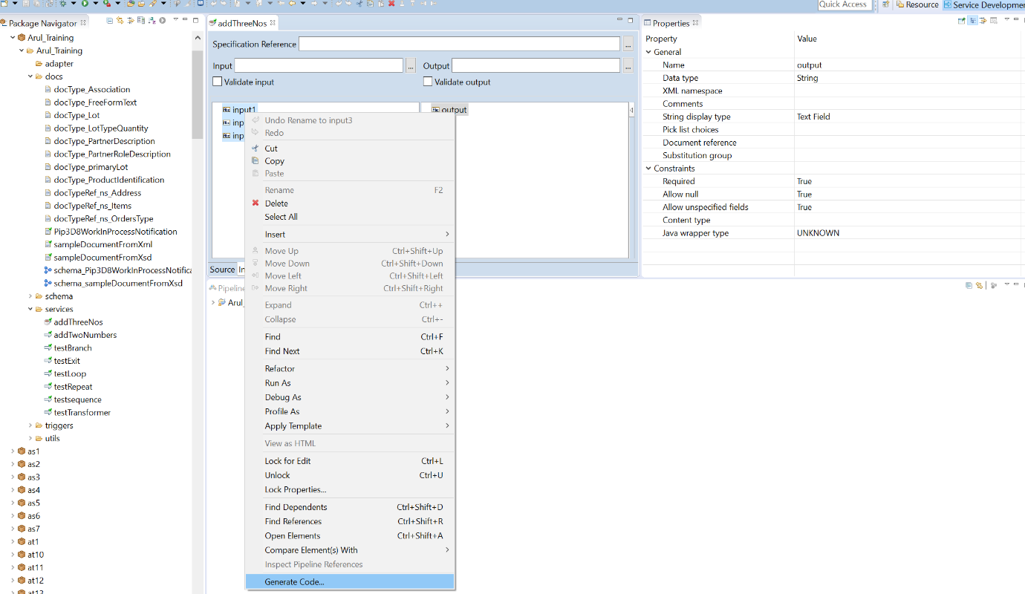

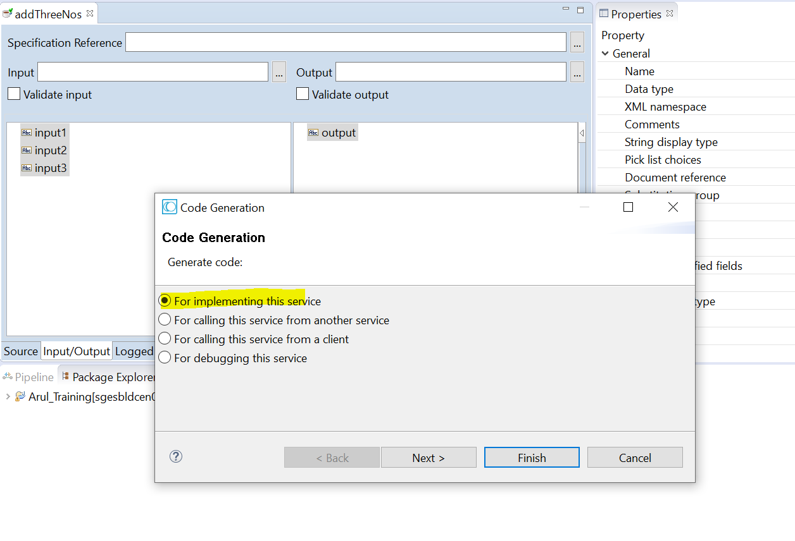

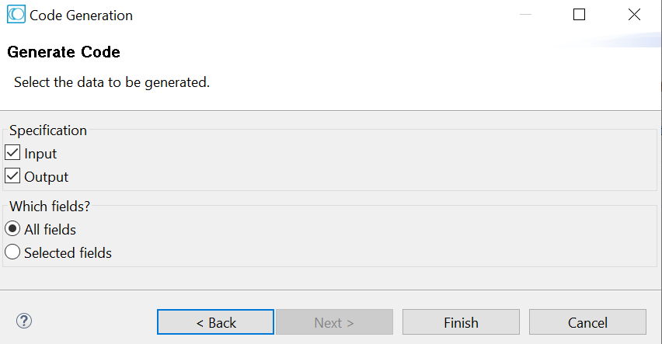

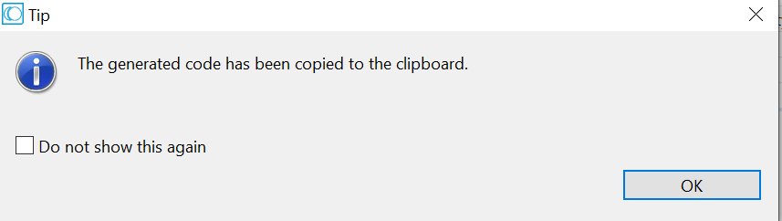

Copy the code

