**Sample File:**

ORDER,1001,Laptop,5,Raj Computers Pvt Ltd,9923222132

ORDER,1002,Desktop,100,Royal Computers,9934323432

ORDER,1003,Mouse,25,JJ Hardware Solutions,9934312345

ORDER,1004,Desktop,15,MM Labs Pvt Ltd,9972512222

**Exercise #11 : Create a flatfile schema.**

1) Goto "YourName_Training" package, in the YourName_Training.schema folder

2) Right Click from schema folder, select New🡪 All Choices 🡪 select Flatfile Schema 🡪 and click Next button

3) Enter a name “orderschema” and select folder “schema” and click Finish button

Specify the following in the schema in the tab “Flat File Definition” [Refer Hint]

Description: Address Record

Record Parser : Delimiter

Record character: newline

Field character: ,

Specify the following in the schema in the tab “Flat File Structure”

4) Create a record definition with name called "ORDER" (all capital letters) [Refer Hint]

5) In the ORDER record definitions, using Extractor type “Nth Field” option, create 5 field definitions called OrderNo, ItemName, Qty, ShipperName, Contact with and click Finish button.

Specify Field position as 1 for *OrderNo*

Specify Field position as 2 for *ItemName*

Specify Field position as 3 for *Qty*

Specify Field position as 4 for *ShipperName*

Specify Field position as 5 for *Contact*

6) Set the ORDER record definitions to have an unlimited value for Max Repeat property. [Refer Hint]

7) Save the flat file schema

8) Run the schema by selecting “Flatfile_ORDER” file which is provided.

9) The output should appear in the Results window.

**Exercise # 11: (Hint 1)**

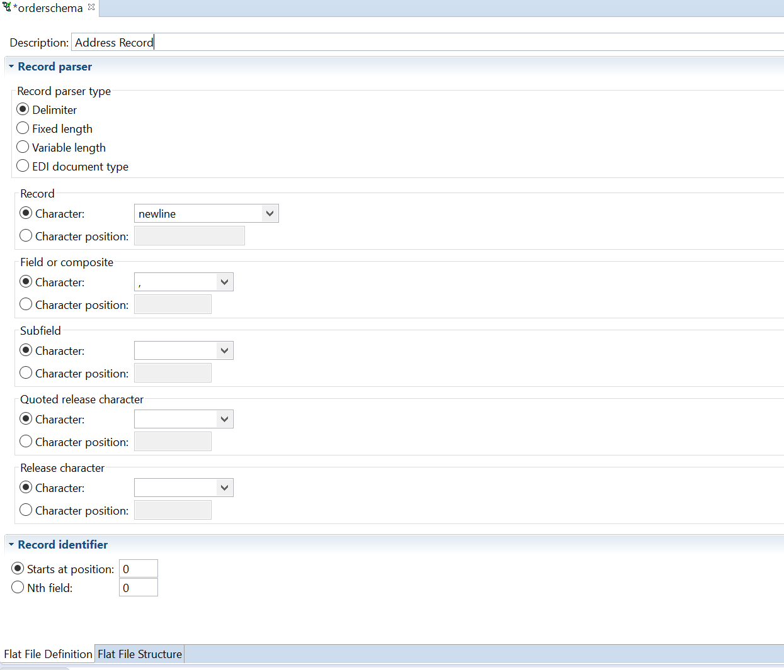

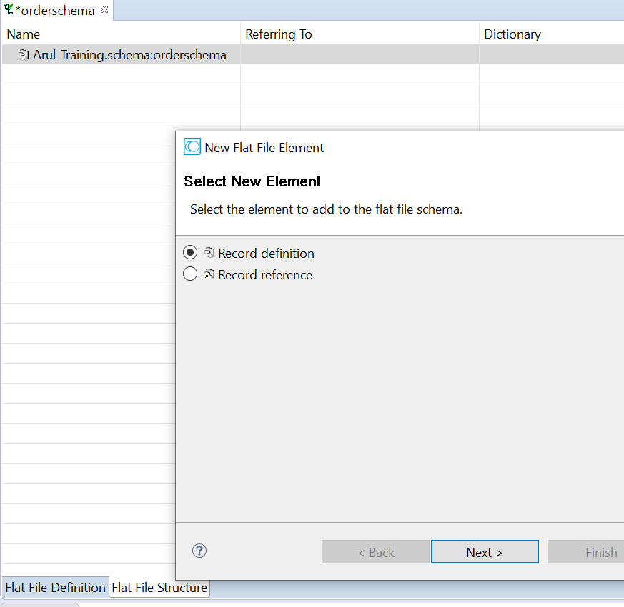

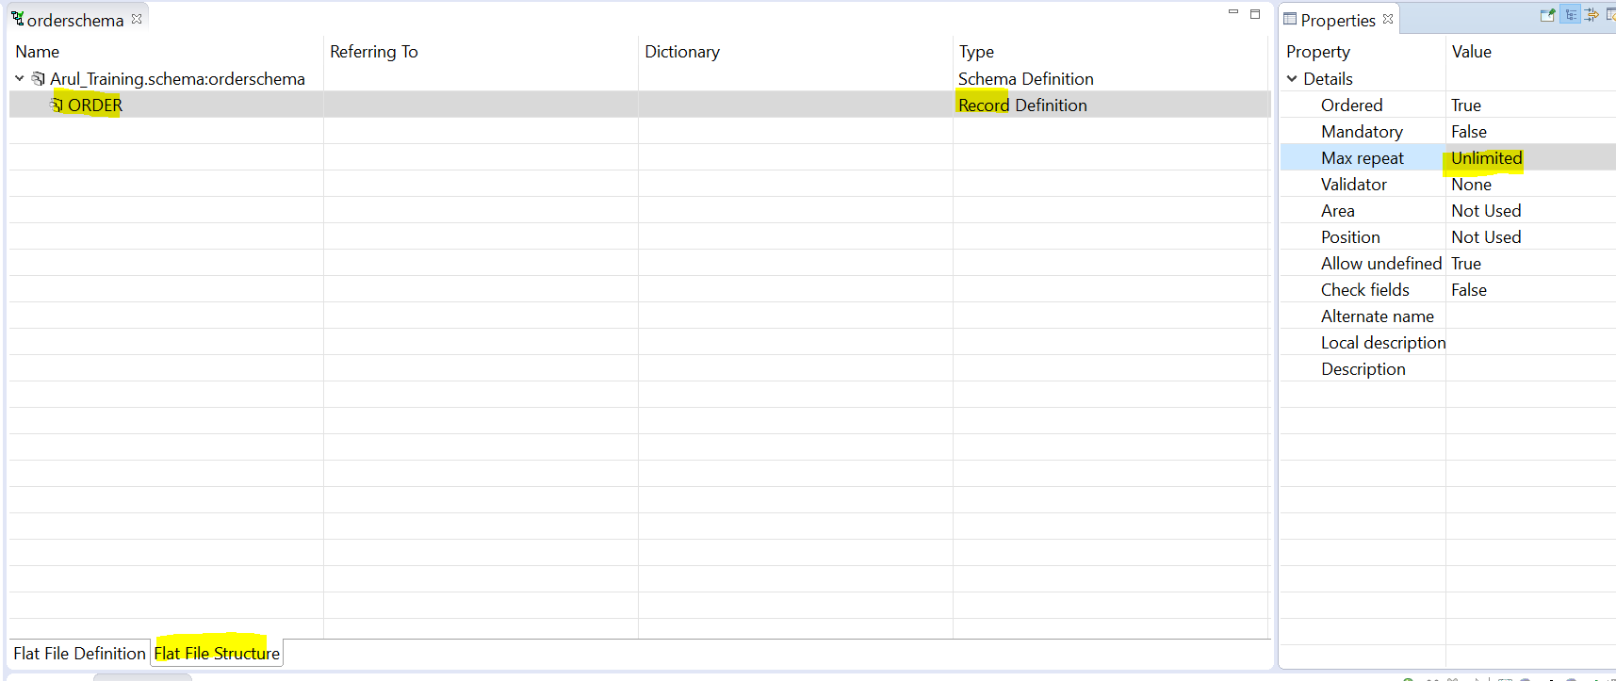

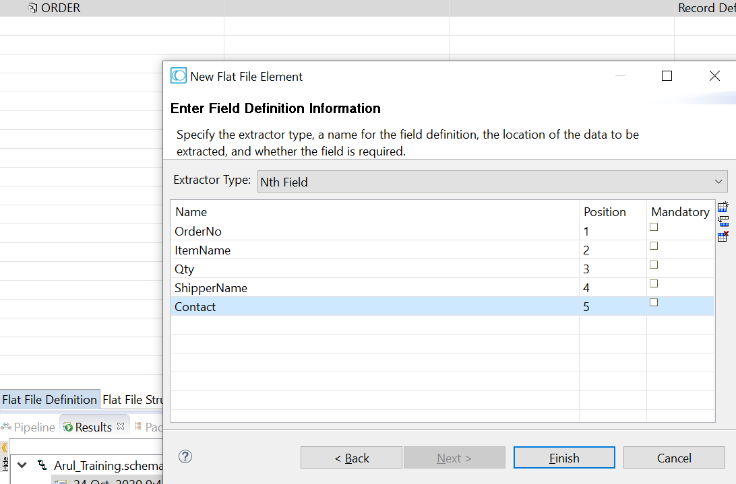

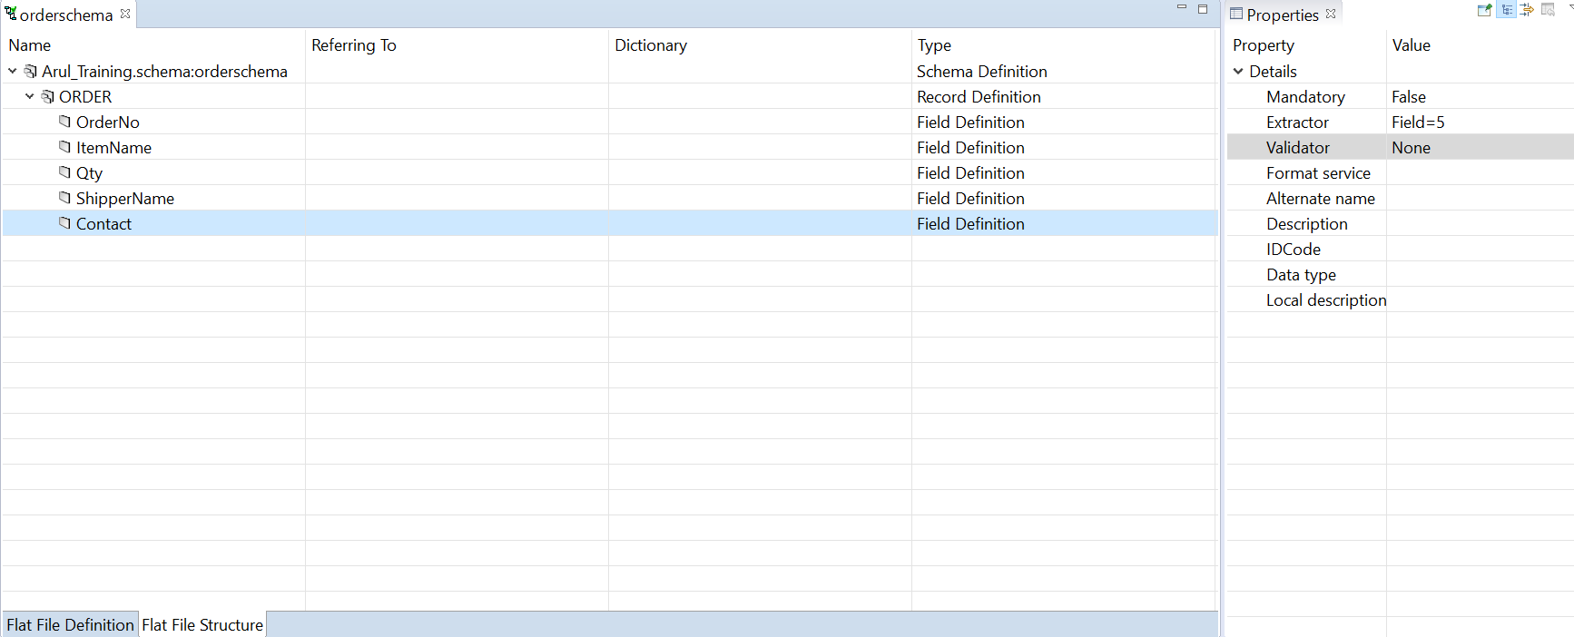

Run:

