**Exercise #12: Create a scheduler to invoke flow service for every 2 minutes:**

1. create a flow service with name “testSchedular” under the folder YourName_Training.services
2. add a pub.flow.debugLog service to specify message “Your name: scheduler invoked flow service”
3. Open IS Administrator page <Server IP:Port> in the browser and Click the Server🡪Scheduler Link from Left side navigation of Integration server
4. and click the link “Create a scheduled task”
5. Create a scheduler with name “testSchedular_Yourname” and specify the service which you want to invoke and user which you want to execute.
6. Specify complex interval time option to execute scheduler for every 2 minutes. use ctrl+Click to select minutes (2, 4, 6 etc.,)

**Exercise #12: Hint 1:**

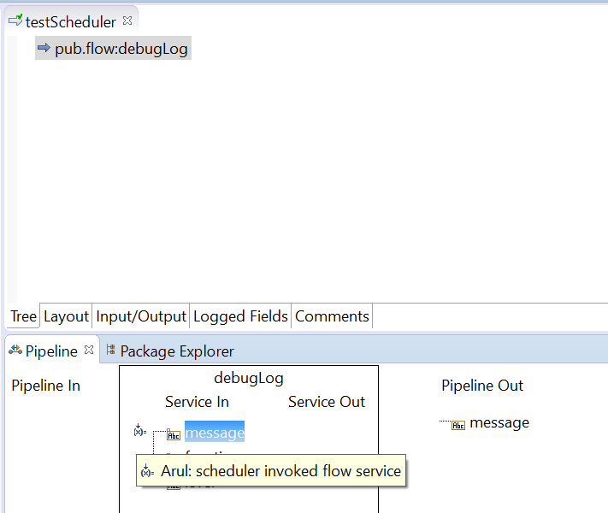

**Exercise #12: Hint 2:**

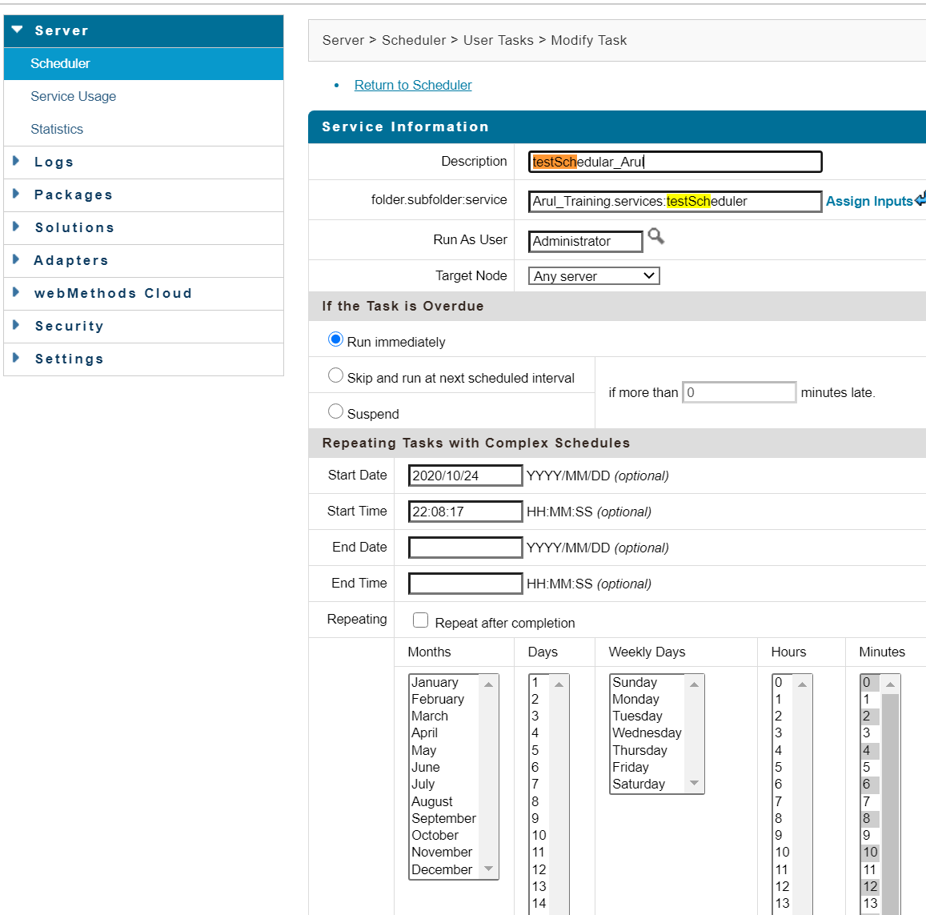

**Exercise #12: Hint 3:**

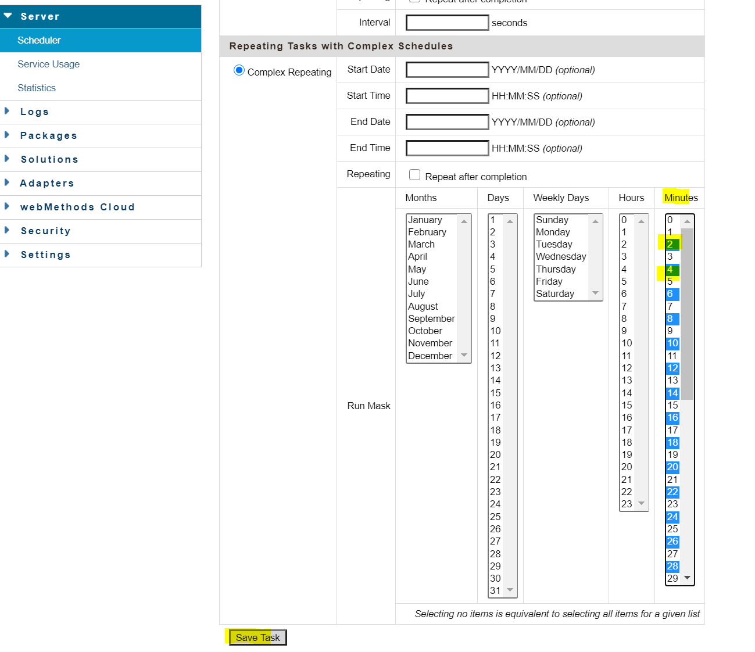

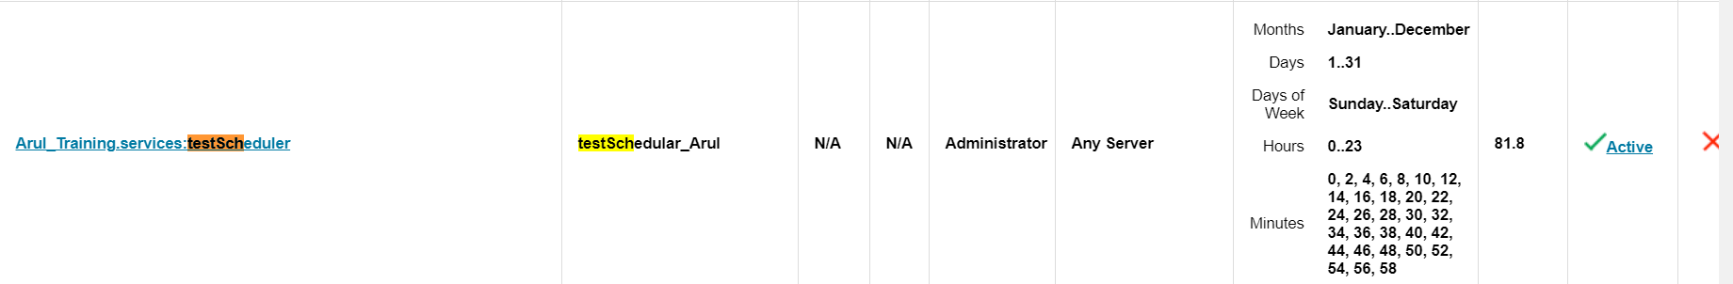

Logs showing scheduler is getting invoked every 2 min.

