**Exercise #13: Create Specification:**

1. Go to "YourName_Training" package, in the YourName_Training.services folder, Right click 🡪 New 🡪 and select All Choices --> select Specification and click Next --> specify Specification name as “numbers” and select the folder “document” and click “Finish” button
2. Open the specification “numbers” and specify inputs as “number1” and “number2”
3. Specify output as “result”
4. And save the specification using Ctrl+S. [You can also use Ctrl+S option instead of clicking Save button from menu bar ]
5. Create a flow service with name “useSpecification” in YourName_Training.services folder
6. And go to input /output tab, and select the specification reference and browse the specification which you created “YourName_Training.docs:numbers”
7. Now, whatever input and output you created in the specification is available for use in your flow services.

**Exercise #13: Hint 1:**

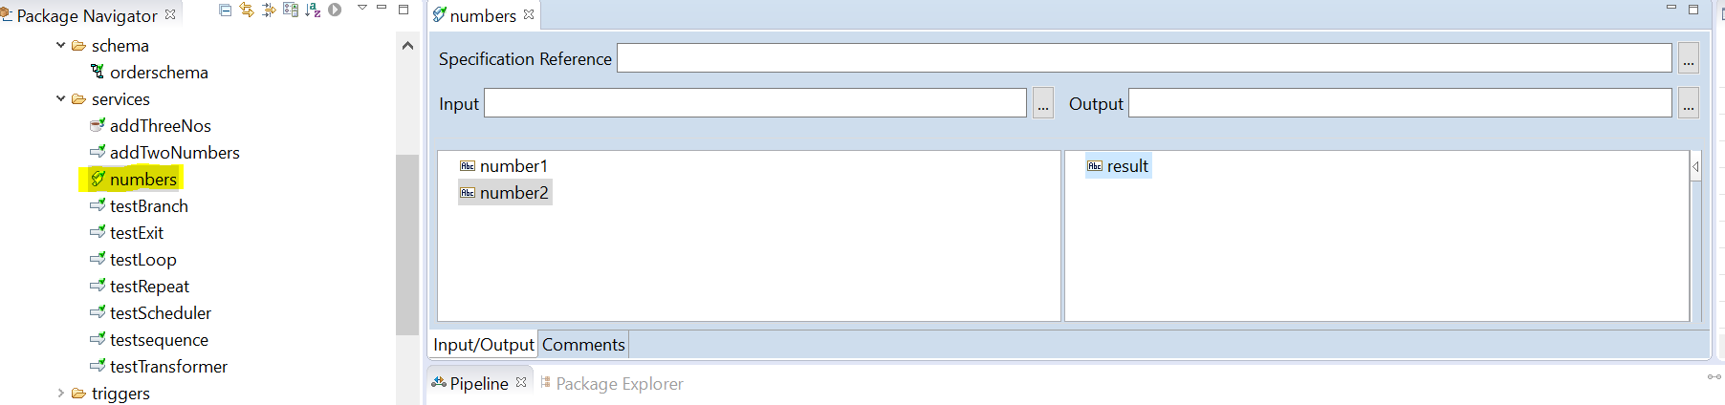

**Exercise #13: Hint 2:**

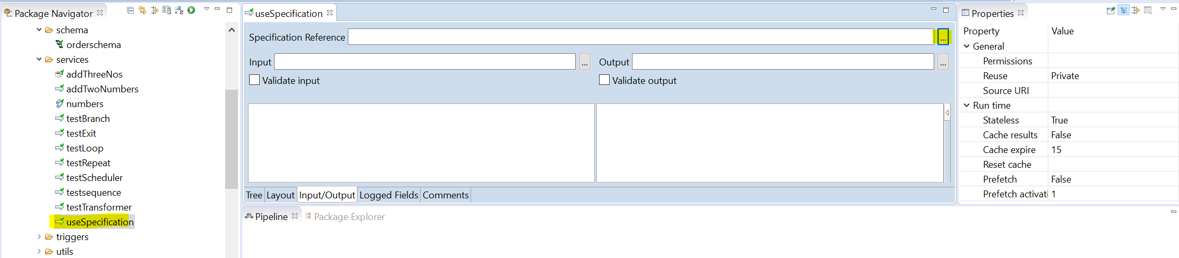

**Exercise #13: Hint 3:**

