**Exercise #14 : Create a service to publish the document and subscribe the document.**

**Publish Document to Broker/Universal Messaging:**

1) Goto "YourName_Training" package, in the YourName_Training.docs folder

2) Open the document "sampleDocumentFromXml"

3) Make the document to publishable document by using below option.

select the document "sampleDocumentFromXml" and goto properties --> Make publishable property to true and save the Document.

4) Create a service with name "testPublish" under the folder YourName_Training.services.

5) add a step inside the service *pub.pub.publish [select this built in service from WmPublic package)*

6) And specify the input using Document reference “YourName_Training.document:sampleDocumentFromXml” and rename to YourName_Training.document:sampleDocumentFromXml

7) Go to Pipeline tab and Link “YourName_Training.docs:sampleDocumentFromXml” document to document.

8) Specify the documentTypeName value is “YourName_Training.docs:sampleDocumentFromXml”

9) Run your service with more than one some employee records. (Refer Hint)

10) This will publish the document to broker with the value which you provided at the run time.

**Subscribe the document from Broker/Universal Messaging:**

1) Create a Trigger with name "subscribeEmployee" and use following option to create trigger.

Right click from folder YourName_Training.triggers--> New> webMethods messaging triggers --> provide Trigger name "subscribeEmployee"

2) select Document type "YourName_Training.document.sampleDocumentFromXml and invoke the service - YourName_Training.services.testLoop in the trigger [Refer Hint]

3) Run the testPublish service.

4) and see the output in Server Log.

Once the document published to broker/universal messaging from testPublish service, trigger will automatically subscribe the document from the Broker/universal messaging and invoked the service *“testLoop”* and printed the message in Server Log.

**Exercise #14: (Hint 1)**

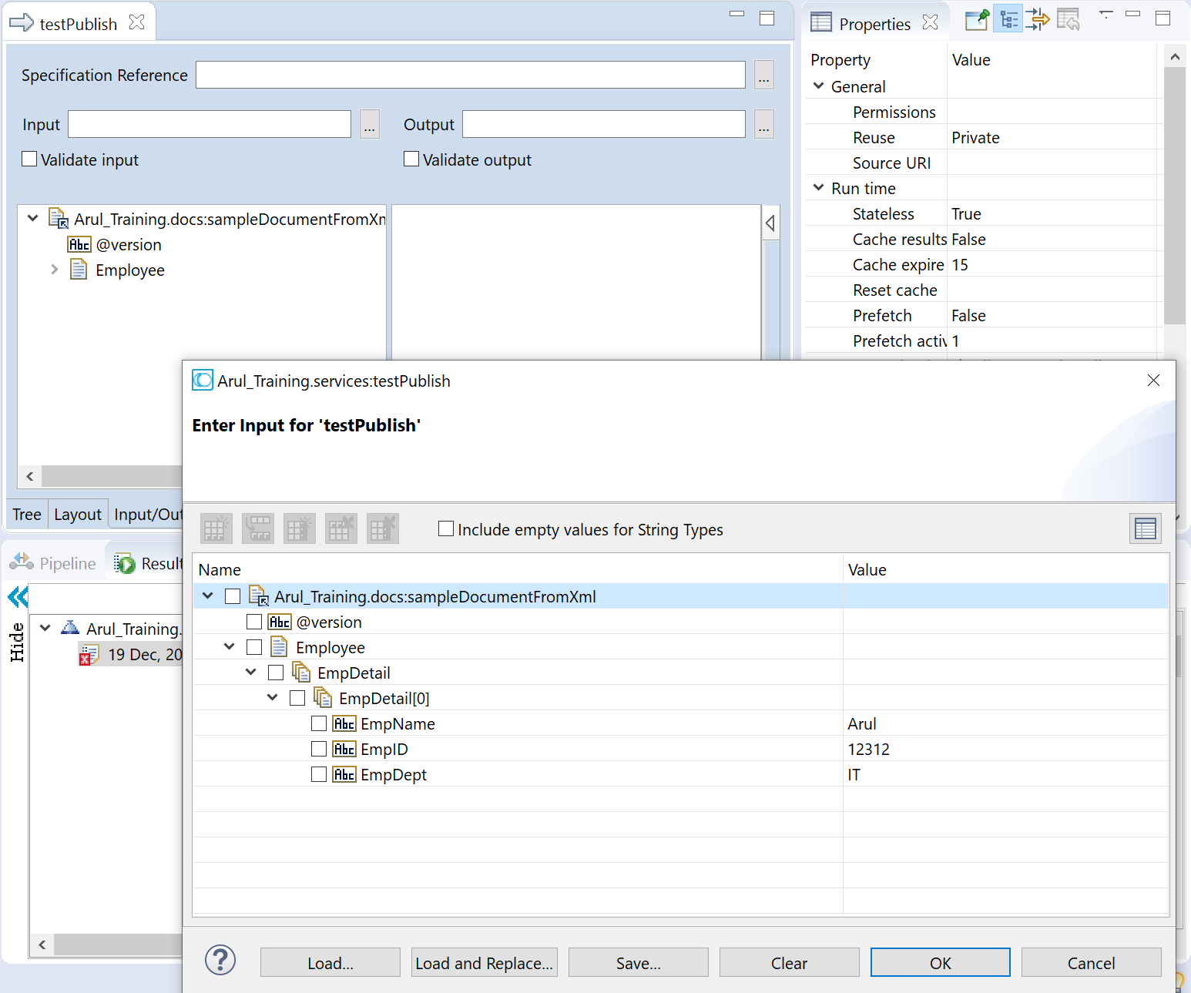

**Exercise #14: (Hint 2)**

