**Exercise #3 : Create a Document type using XML/XSD/DTD**

Create a Document type using XML.

1) Goto "YourName_Training" package, in the YourName_Training.docs folder, Right click 🡪 New 🡪 and select All Choices --> select Document type and click Next -->

Enter name 🡪 *sampleDocumentFromXml* and select folder “docs” 🡪 Click next -🡪 select a source as “XML” and click Next button 🡪 Browse Employee.xml which provided. And click Finish button.

**Exercise #3.1 (Hint)**

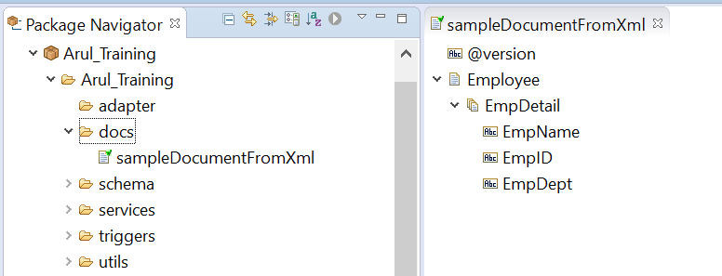

Create a document type using XSD

2) Goto "YourName_Training" package, in the YourName_Training.docs folder, Right click 🡪 New 🡪 and select All Choices --> select Document type and click Next -->

Enter name 🡪 *sampleDocumentFromXsd* and select folder “docs” 🡪 Click next -🡪 select a source as “XML Schema” and click Next button 🡪 Browse Orders.xsd which provided. And click next 🡪 select root tag as “Orders” And click Finish button.

**Exercise: 3.2 (Hint)**

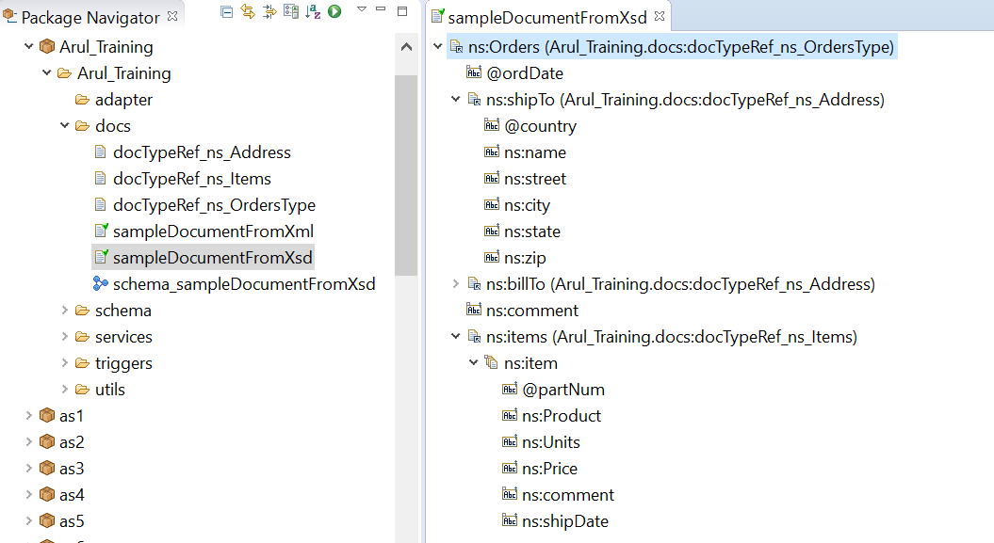

**Create a document type using DTD**

3) Goto "YourName_Training" package, in the YourName_Training.docs folder, Right click 🡪 New 🡪 and select All Choices --> select Document type and click Next -->

Enter name 🡪 *sampleDocumentFromDtd* and select folder “docs” 🡪 Click next -🡪 select a source as “DTD” and click Next button 🡪 Browse WorkInProcessNotification.dtd which provided. And click Next 🡪 select root tag as “Pip3D8WorkInProcessNotification” And click Finish button.

**Exercise #3.3 (Hint)**

