**Exercise #7 : Create a flow service with Loop:**

In this exercise, you will create a flow service with Loop step.

1) Goto "YourName_Training" package, in the YourName_Training.services folder create a flow service called "testLoop"

[Refer Hint for step 2:]

2) Go to input tab and set the input from Document reference [Browse the document from location] “YourName_Training.docs.sampleDocumentFromXml” and rename untitled1 document from input tab to “YourName_Training.docs:sampleDocumentFromXml”

3) In the Input/Output tab of your service, expand the document “YourName_Training.docs:sampleDocumentFromXml”, Find Employee/EmpDetail and right click 🡪 Copy

4) In your service add a Loop, and in the input array property, paste the content which you copied.

5) Add a Map statement under the Loop step and create a pipeline out variable “count” and Link $iteration to count.

6) Add a *pub.flow.debugLog* below the map step (make sure **it is not intended** under the loop)

7) Specify message as ***Your name -*** ***Number of Employee:: %count%***

8) Save and run your service.

9) To add the input, use the AddRow button to add some employee details. [Refer Hint]. Type some sample values for each employee and click ok button.

10.) Now you can see the results in Server Log and results panel.

**Exercise # 7 (Hint 1)**

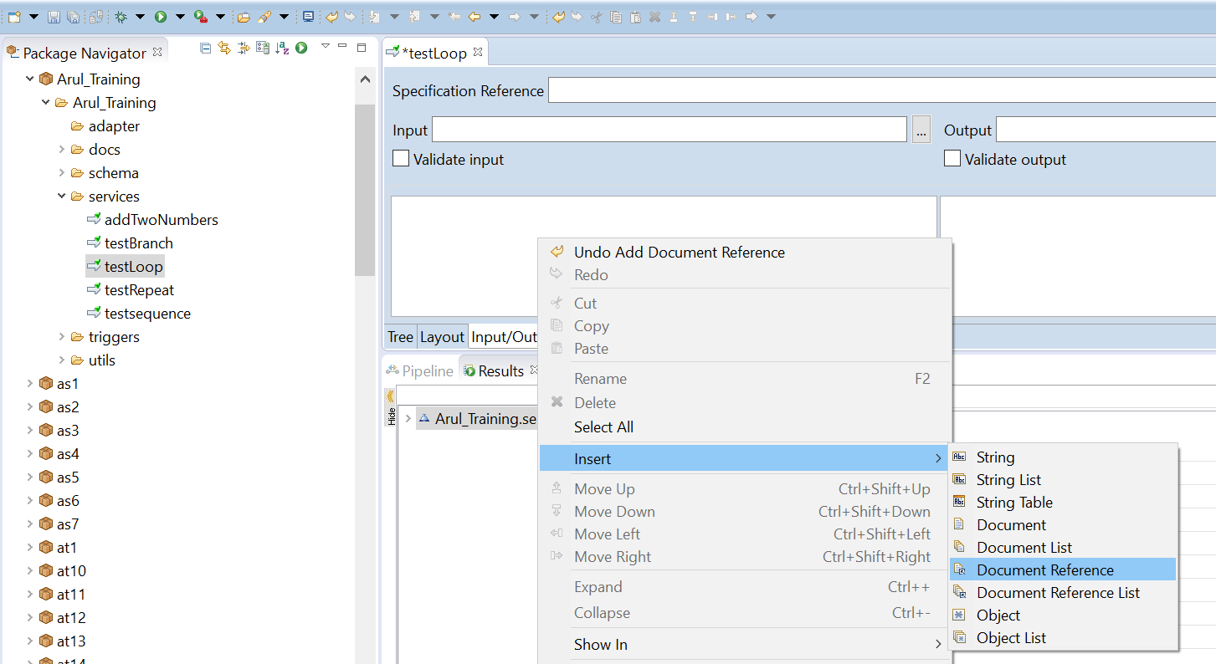

**Exercise # 7 (Hint 2)**

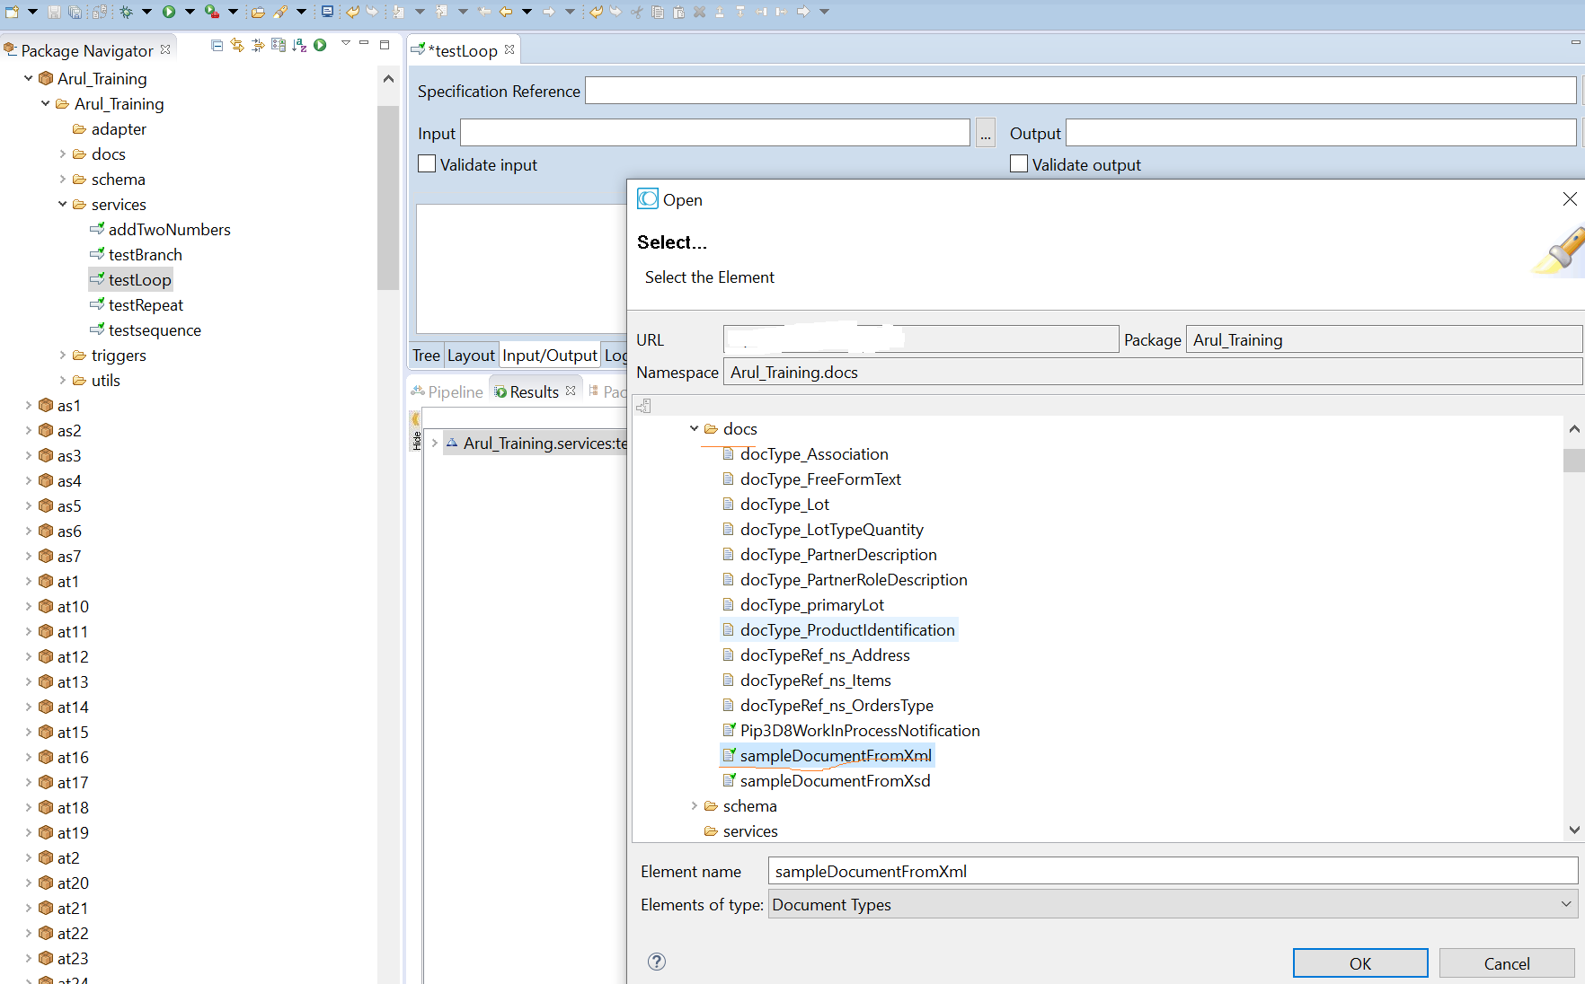

**Exercise # 7 (Hint 3)**

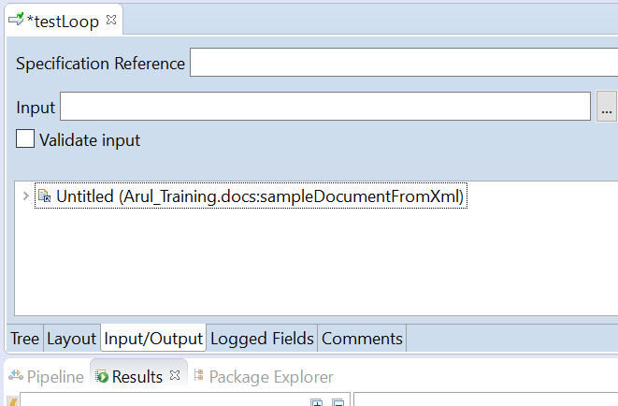

**Exercise # 7 (Hint 4)**

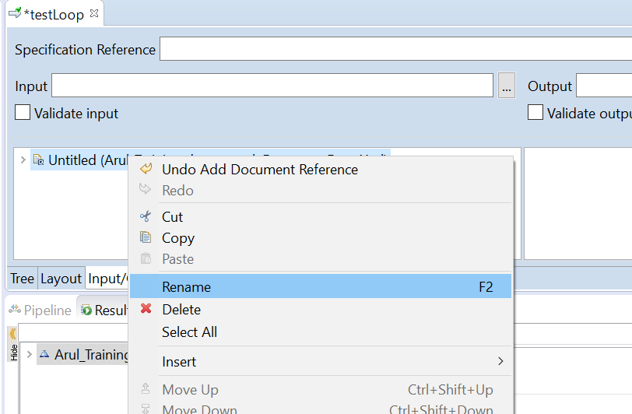

**Exercise # 7 (Hint 5)**

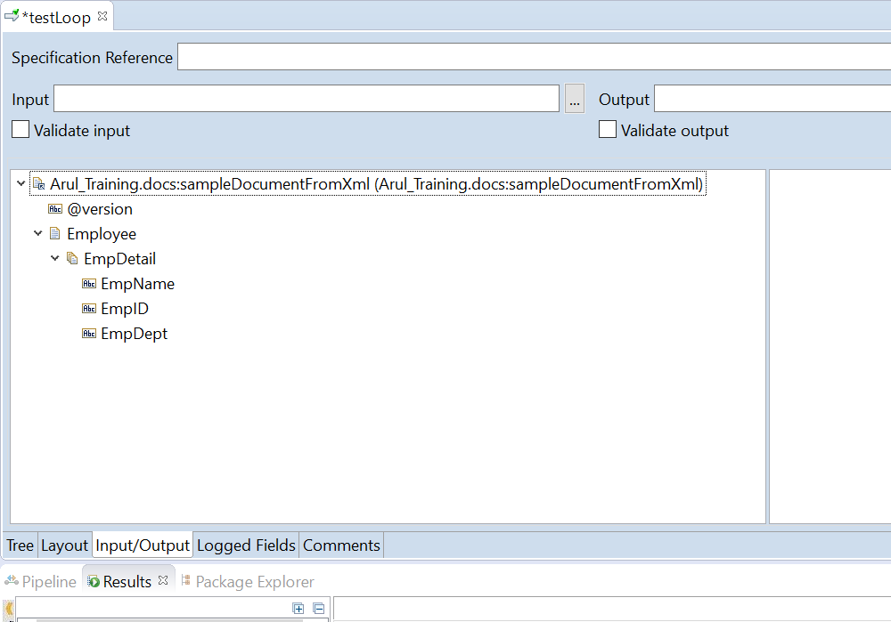

**Exercise # 7 (Hint 6)**

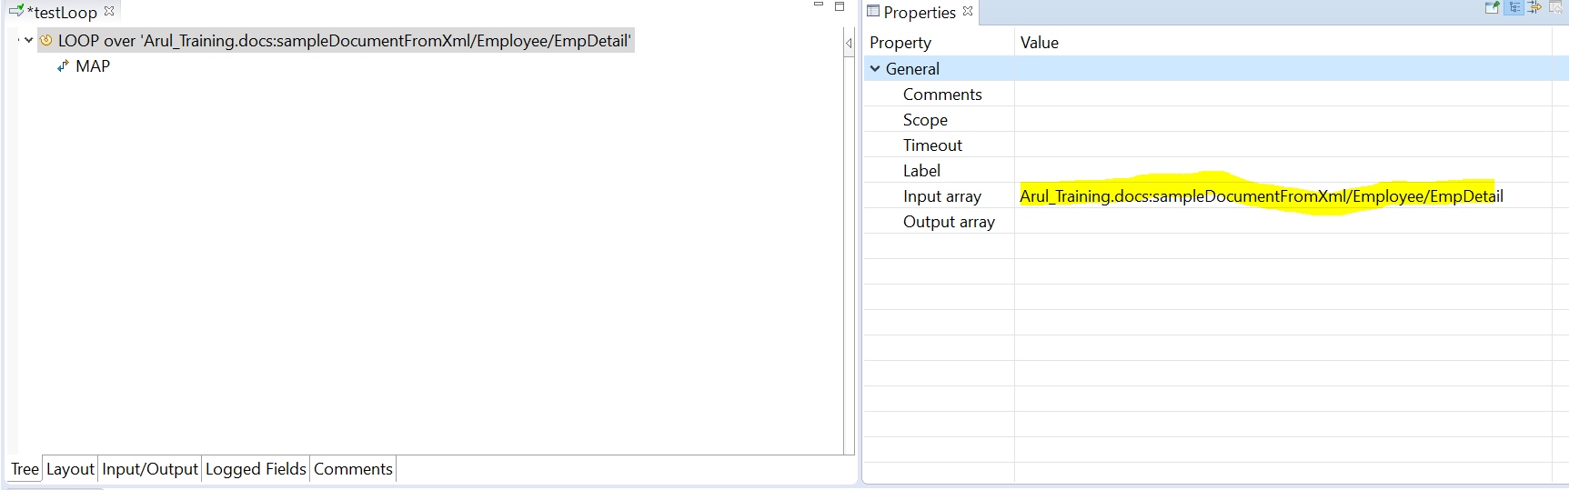

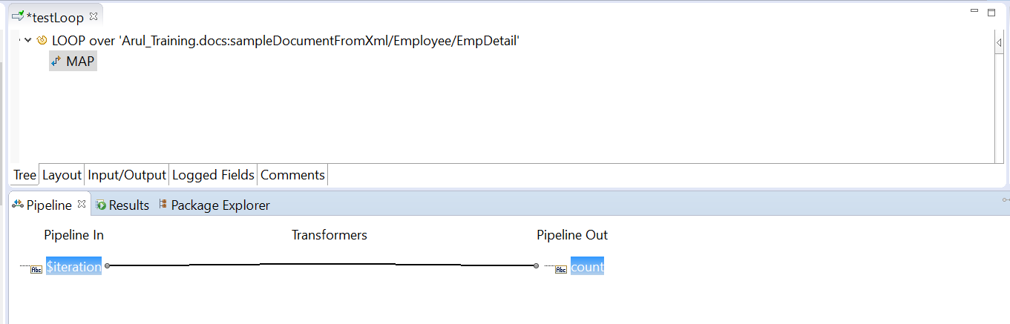

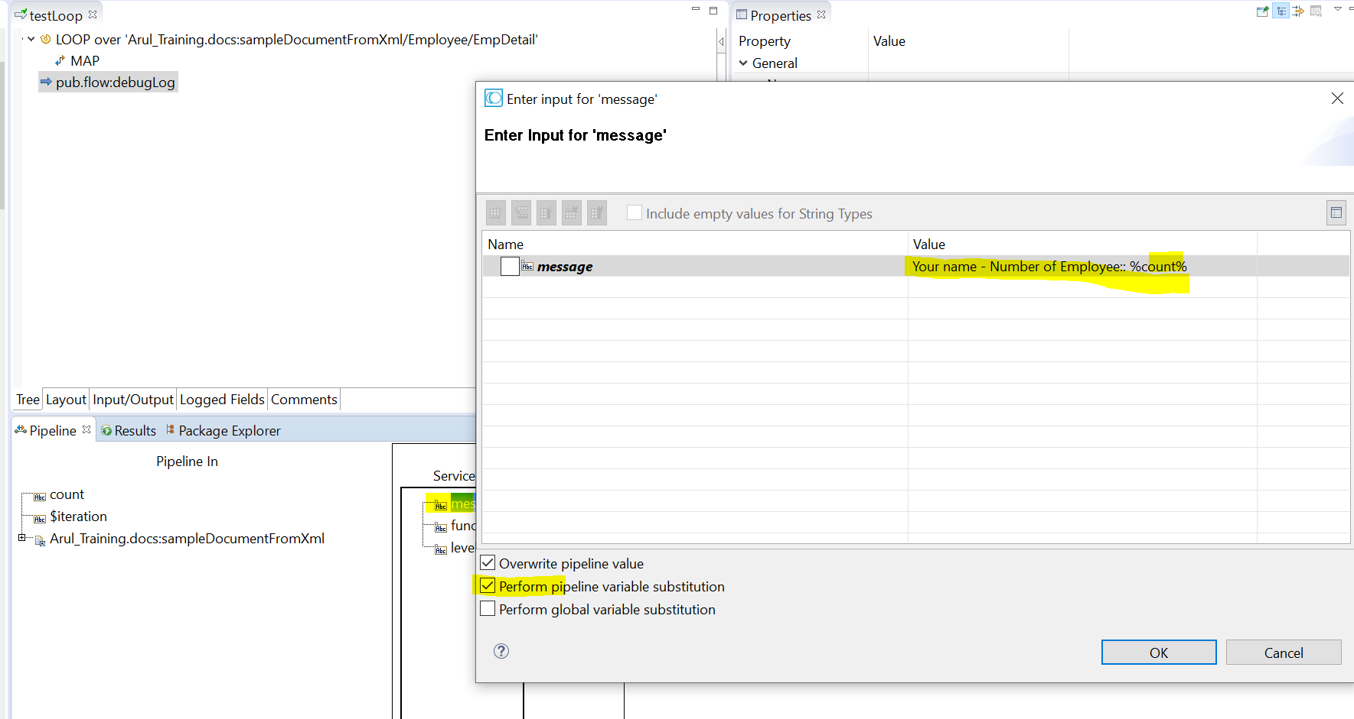

**Exercise # 7 (Hint 7)**

**Click Run, And Click Add row**

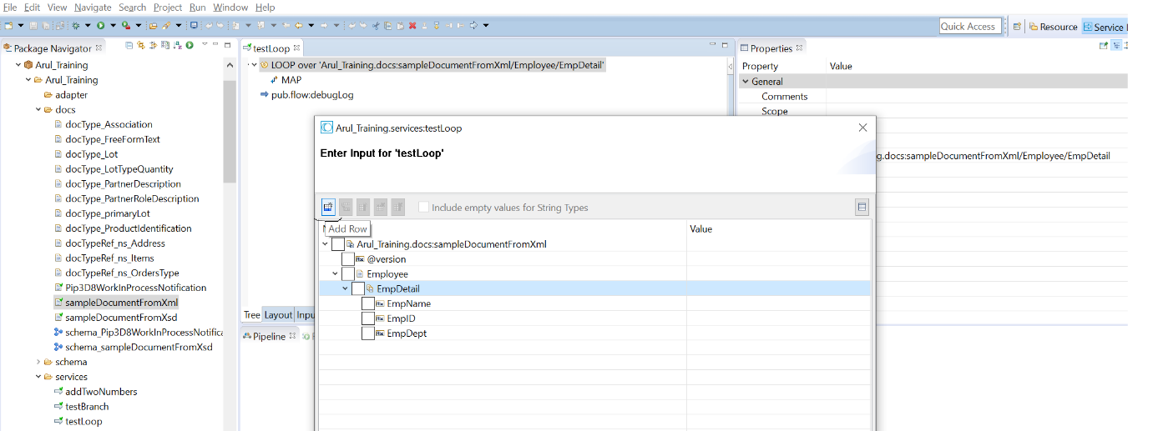

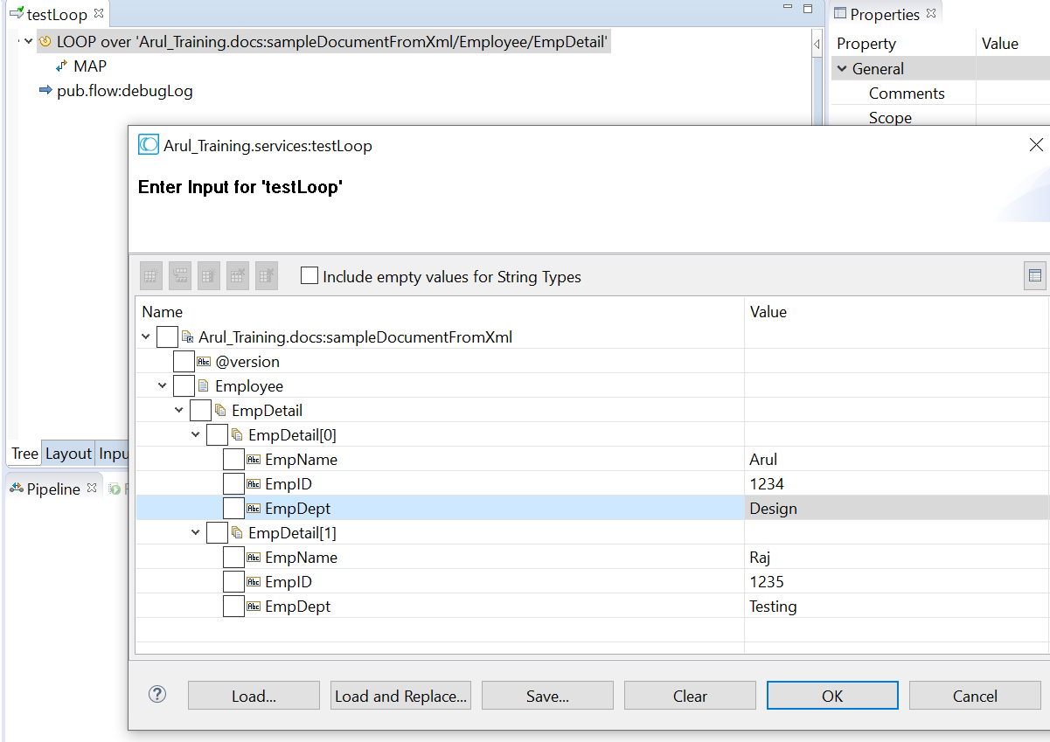

Result

