**Exercise #9 : Create a flow service with Transformers:**

In this exercise, you will create a flow service with transformers.

1) Goto "YourName_Training" package, in the YourName_Training.services folder create a flow service called "testTransformer"

2) Specify two inputs "firstNo" and "secondNo" and specify two outputs “Results1” and “Results2”

3) Add a Map step and go to pipeline tab of map step and add the following transformers.

4) Add a transformer *pub.string.concat* and map firstNo to inString1 and map secondNo to inString2 and map the value to Results1 variable. [Refer Hint]

5) Add a transformer *pub.math.addInts* in the same Map step and Link firstNo to num1 and Link secondNo to num2 and Link the value to Results2 variable.

6) Run the service with following inputs:

firstNo : 12

secondNo : 13

7) The output should appear in the Results window

**Exercise #9 (Hint)**

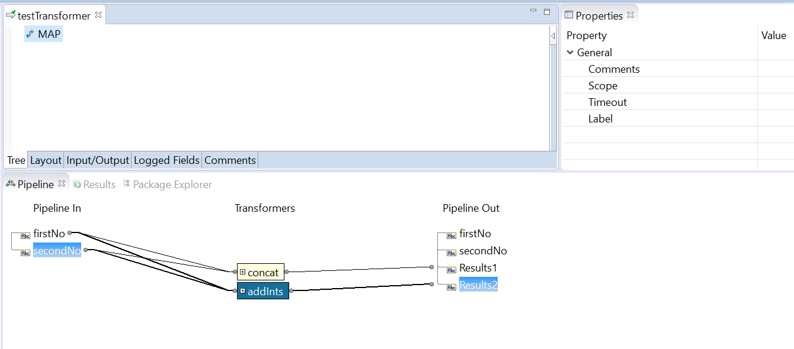

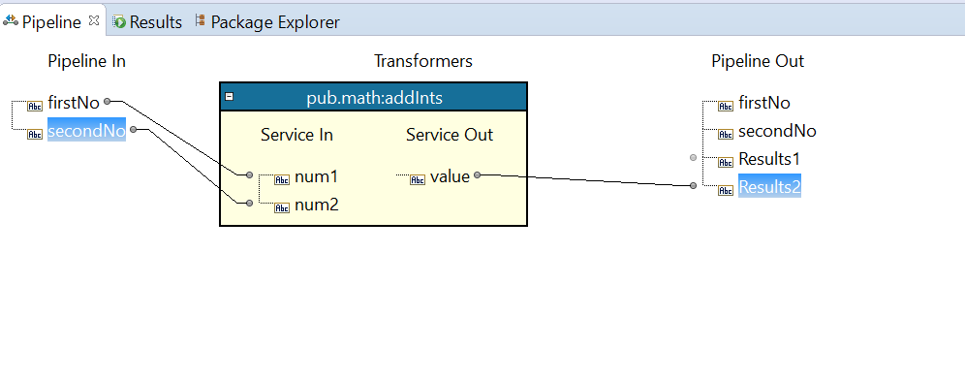

Run:

