1. Purpose: Build a state of art dashboard the enable leaders to take decision quickly. This dashboard reads the data from various data sources such as CSV, XL, XML and any RDBMS/Document oriented DBS, and produce various charts that helps to view the project/portfolio view at a glance.
2. Inception: Discussion between Siva and Shafi

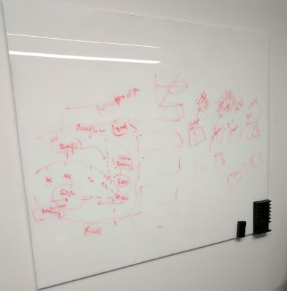

1. High level design
   1. First design discussion between Murali and Shafi. We will update the design as we evolve.

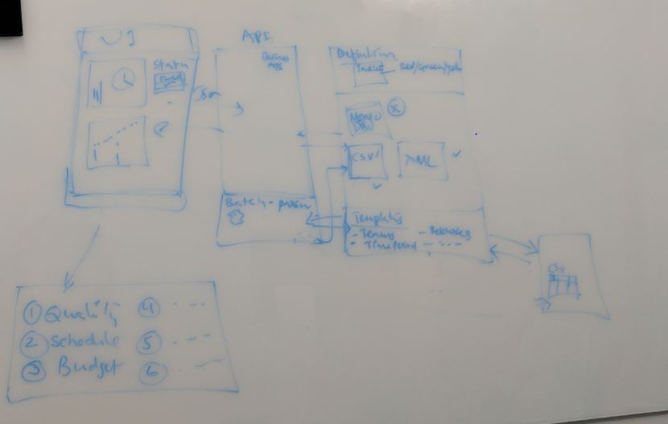

1. Next Steps:

|  |  |  |  |  |
| --- | --- | --- | --- | --- |
| Srl | Description | Status | ETA | Remarks |
| 1 | Identifying the team |  |  |  |
| 2 | Identify the Infrastructure |  |  |  |
| 3 | Identify the tool and technology |  |  |  |
| 4 | Identify the security/compliance roadblocks |  |  | Milestone |
| 5 | Start Initial setup |  | 12-Apr | Milestone |
| 5.1 | GitHub for code share |  | 17-Apr |  |
| 5.2 | Add users to GitHub to access the code |  | 17-Apr |  |
| 5.3 | Ensure all users are able to setup the project and ready to work |  | 21-Apr |  |
|  |  |  |  |  |
|  |  |  |  |  |
|  |  |  |  |  |