
shafqaat ahmad 230450 bscs_6th
DIP

April 3, 2026
sir ghulam ali

Lab 06
Create Folder: DIP-Image-Enhancement-System:
STEP 1: Project Folder EXACT Structure
DIP-Image-Enhancement-System/
│
├── code/
│ ├── main.py
│ ├── functions/
│ ├── sampling.py
│ ├── transformations.py
│ ├── intensity.py
│ ├── histogram.py
│
├── images/
│ ├── input/
│ ├── output/
│
├── results/
├── README.md
STEP 2:
Image Download low contrast.
Path: images/input/test.jpg

STEP 3: VS Code Setup
pip install opencv-python matplotlib numpy

Original image:
- normal.png → transformations show clear
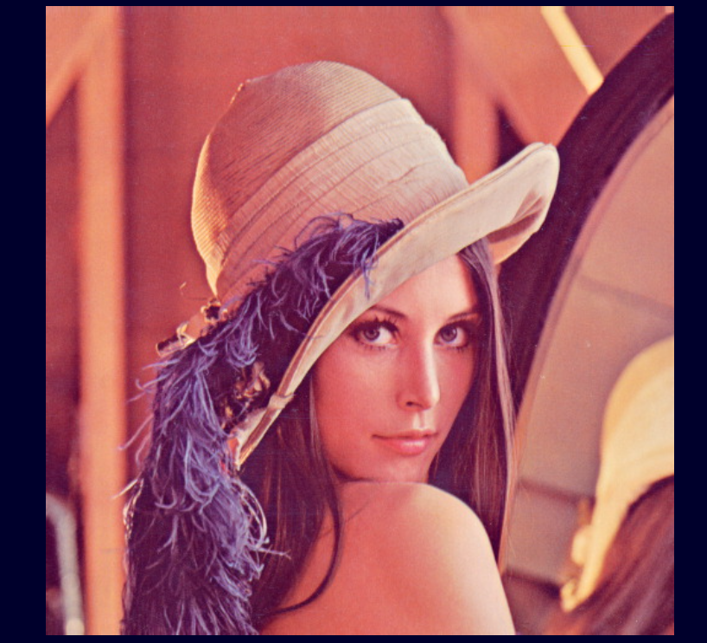
- noisy.png → quantization effect visible
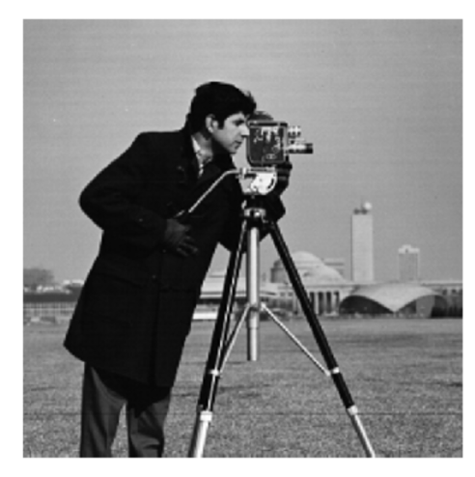
- low_contrast.png → histogram + intensity best
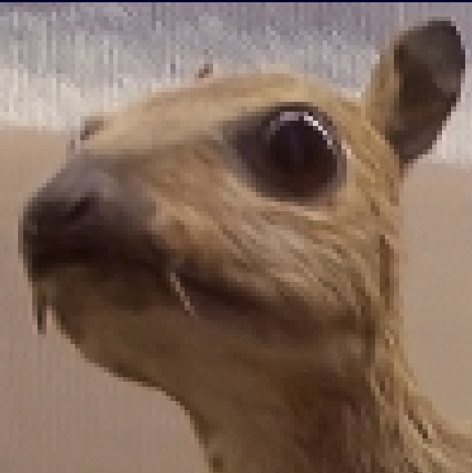
- document.png → final enhancement best
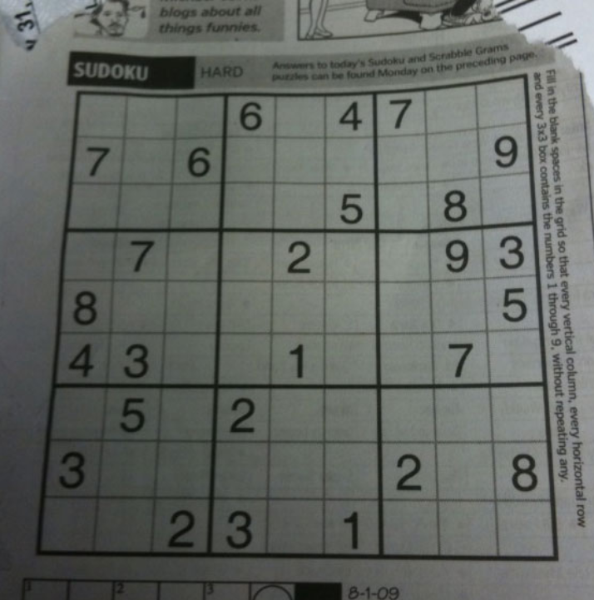
- Bright.png
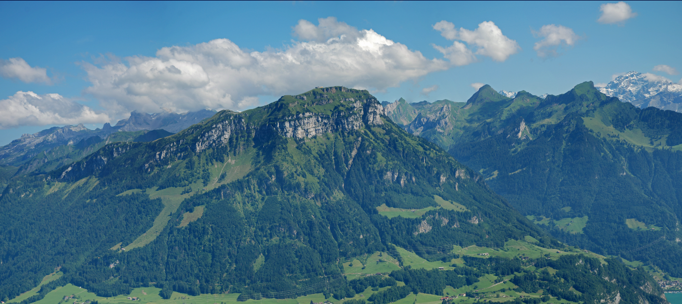

Outputs:
Histogram:
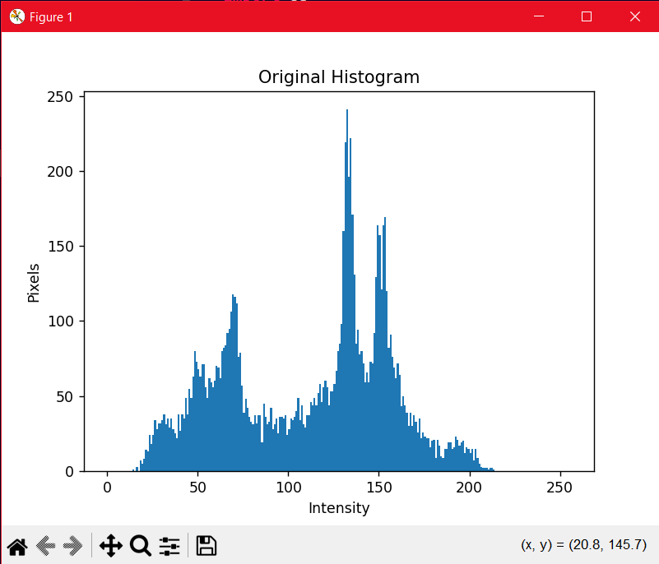
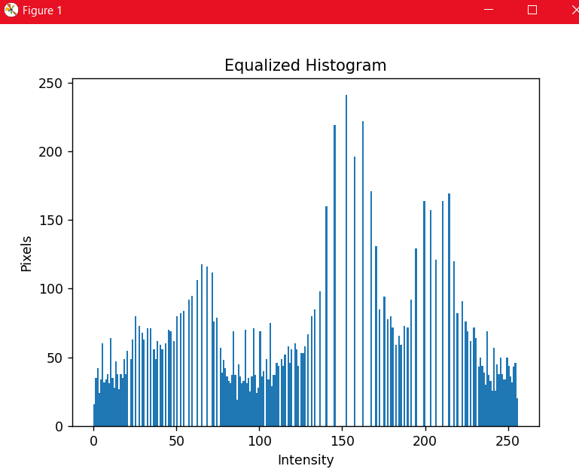

Image Sampling (Resolution Analysis)
- Figure 1: Downsampled Image (0.5x)
➡ sampling_0.5.png
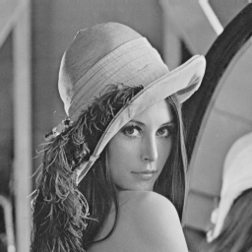
- Figure 2: Downsampled Image (0.25x)
➡ sampling_0.25.png
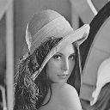
- Figure 3: Upsampled Image (1.5x)
➡ sampling_1.5.png
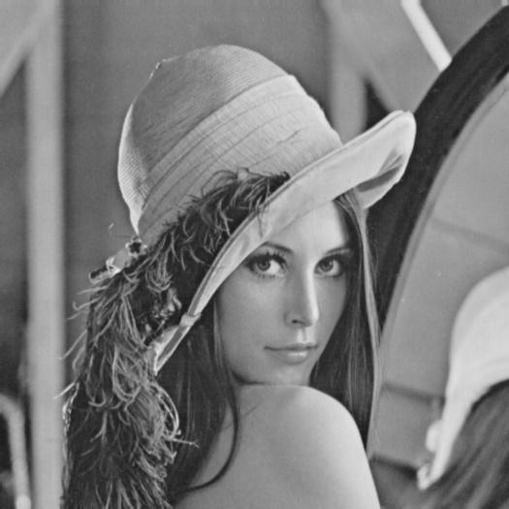
- Figure 4: Upsampled Image (2x)
➡ sampling_2.png
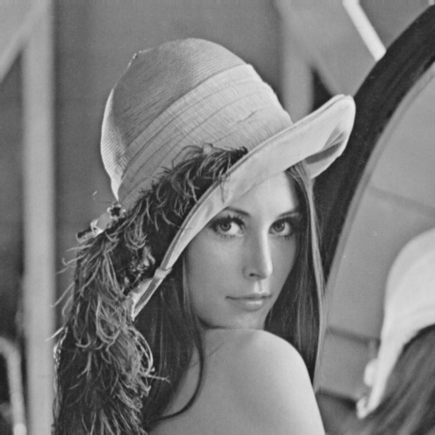
TRANSFORMATION RESULTS
Geometric Transformations
- Figure 5: Rotated Image (60°)
➡ rotate_60.png
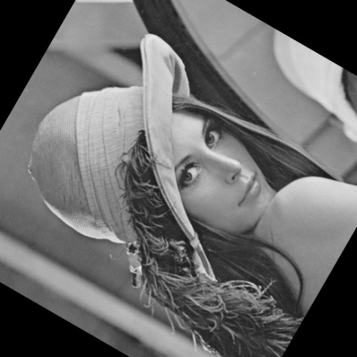
- Figure 6: Rotated Image (90°)
➡ rotate_90.png
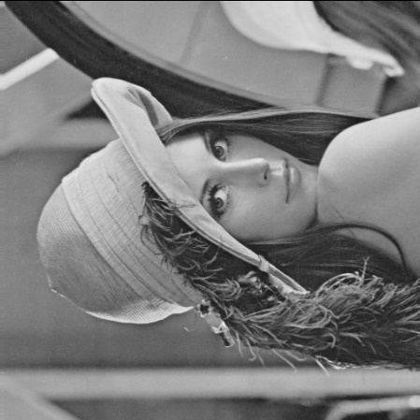
- Figure 7: Rotated Image (120°)
➡ rotate_120.png
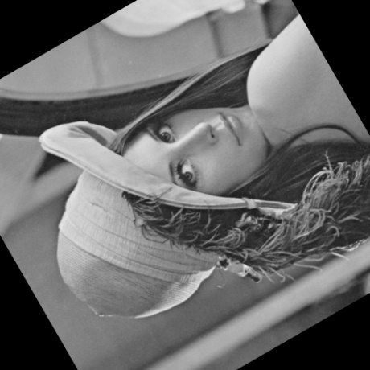
Translation Transformation
- Figure 8: Translated Image
➡ translated.png
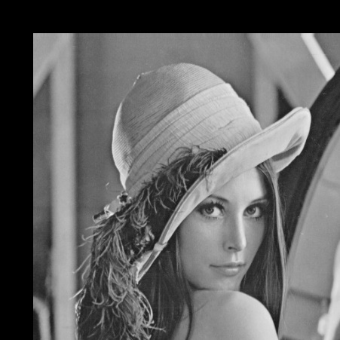
Shearing Transformation
- Figure 9: Sheared Image
➡ sheared.png
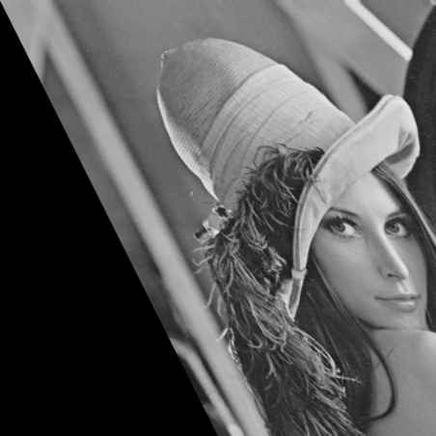

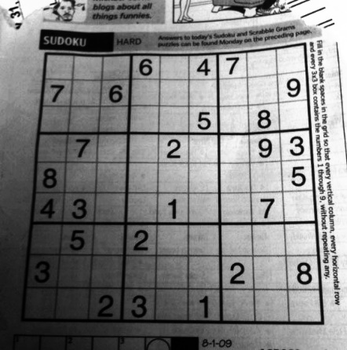
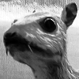
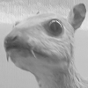
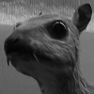
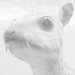
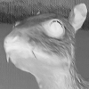
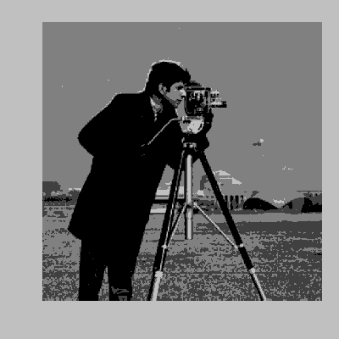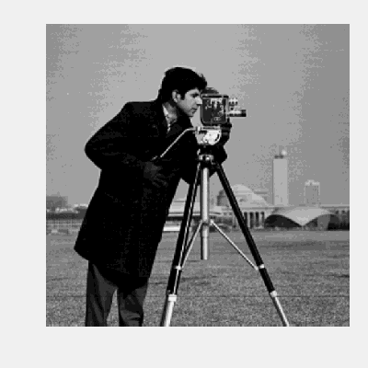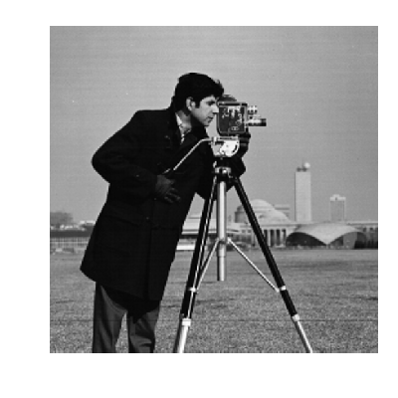

Linkedin:
https://www.linkedin.com/posts/shafqaat-ahmad-829182308_github-shafqaat618dip-image-enhancement-system-activity-7445794275839262720-Sdlr?utm_source=share&utm_medium=member_desktop&rcm=ACoAAE5V5iEB0lkLnsKtSMhYVPx_5i19eapbWOE

Github:
https://github.com/shafqaat618/DIP-Image-Enhancement-System

