
shafqaat ahmad 230450 bscs_6th
DIP

April 3, 2026
sir ghulam ali

Lab 06

1. OBJECTIVE
The objective of this project is to design and develop a complete image enhancement system using various digital image processing techniques. The system improves low-quality images by applying sampling, quantization, transformations, intensity corrections, and histogram processing. It also provides analytical insights into the effects of each method.

2. INTRODUCTION
Digital images often suffer from problems such as low contrast, poor brightness, noise, and loss of detail. This project focuses on improving such images using systematic image processing techniques. A complete pipeline is developed that takes a low-quality image as input and produces an enhanced output image along with analysis.

3. METHODOLOGY
The system follows a structured pipeline:
Input Image → Analysis → Transformation → Enhancement → Output

🔹 3.1 Image Acquisition & Understanding (Lab 01)
- Image loaded using OpenCV
- Converted from RGB to Grayscale
- Image properties analyzed
Outputs:
- Image resolution (height × width)
- Data type (uint8)
- Partial pixel matrix
Observation:
Grayscale conversion simplifies processing and reduces computational complexity.

🔹 3.2 Sampling & Quantization (Lab 02)

Sampling:
- Downsampling: 0.5, 0.25 scale
- Upsampling: 1.5, 2 scale

Quantization:
- 8-bit (original quality)
- 4-bit (reduced detail)
- 2-bit (high distortion)
Observation:
- Downsampling reduces resolution and removes details
- Upsampling increases size but introduces blur
- Lower bit depth causes banding and information loss

🔹 3.3 Geometric Transformations (Lab 03)
- Rotation: 30°, 60°, 90°, 120°
- Translation (shift in position)
- Shearing (distortion effect)
Observation:
- Rotation changes orientation
- Translation shifts image without altering content
- Shearing distorts the shape and structure

🔹 3.4 Intensity Transformations (Lab 04)
- Negative transformation
- Log transformation
- Gamma correction (γ = 0.5, 1.5)
Observation:
- Negative highlights inverted details
- Log enhances darker regions
- Gamma (0.5) produces best brightness improvement

🔹 3.5 Histogram Processing (Lab 05)
- Histogram plotted for original image
- Histogram equalization applied
Observation:
- Pixel values become more uniformly distributed
- Contrast significantly improves
- Hidden details become visible

🔹 3.6 Final Integrated System
Final pipeline:
- Convert image to grayscale
- Apply gamma correction (γ = 0.5)
- Apply histogram equalization
Result:
Enhanced image with improved brightness and contrast.

4. RESULTS
Insert your output images here with captions:

Sampling Results
- sampling_0.5.png
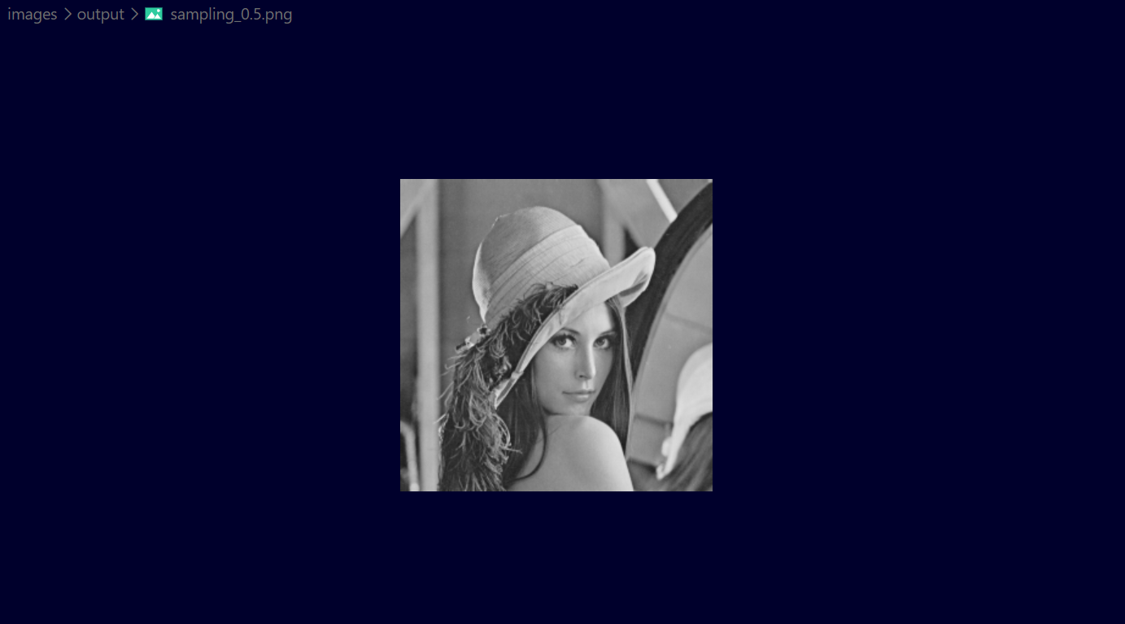
- sampling_0.25.png
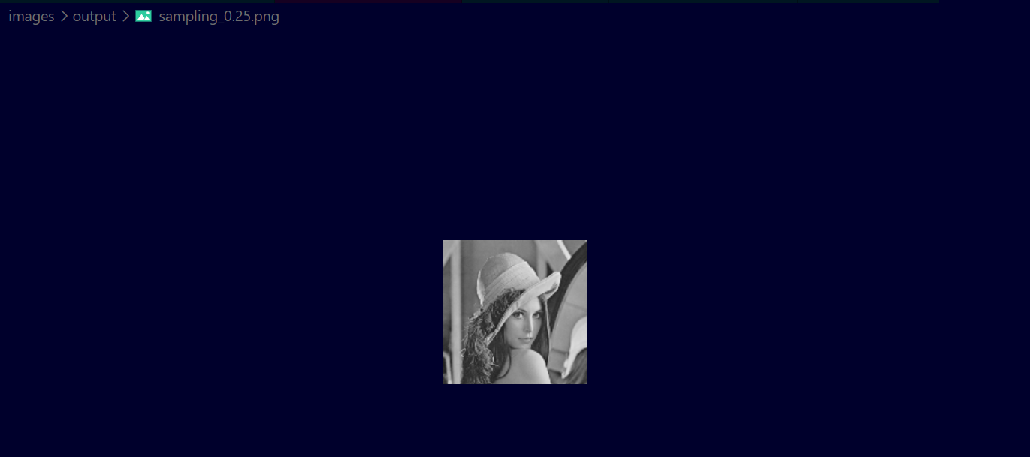
- sampling_1.5.png
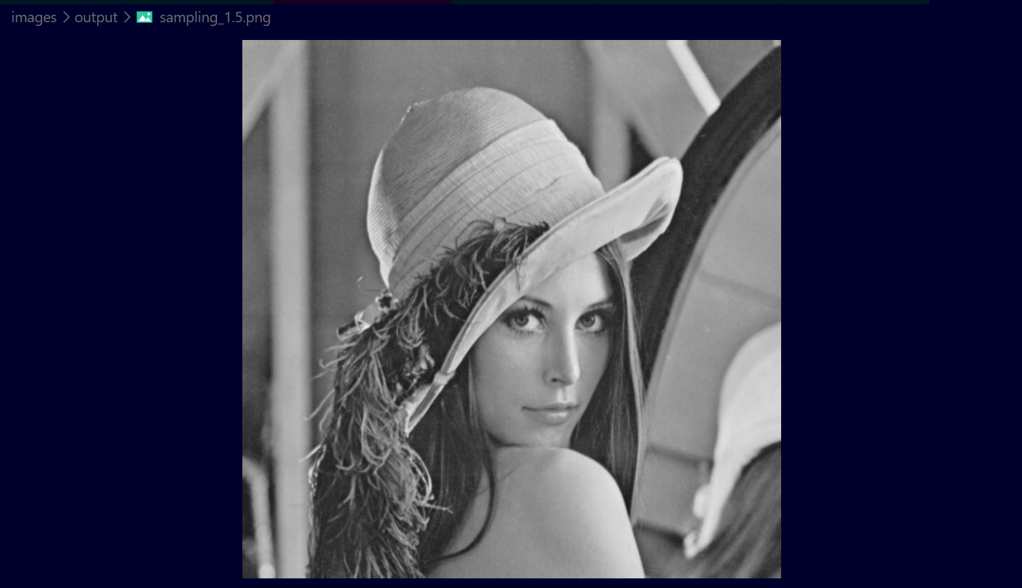
- sampling_2.png
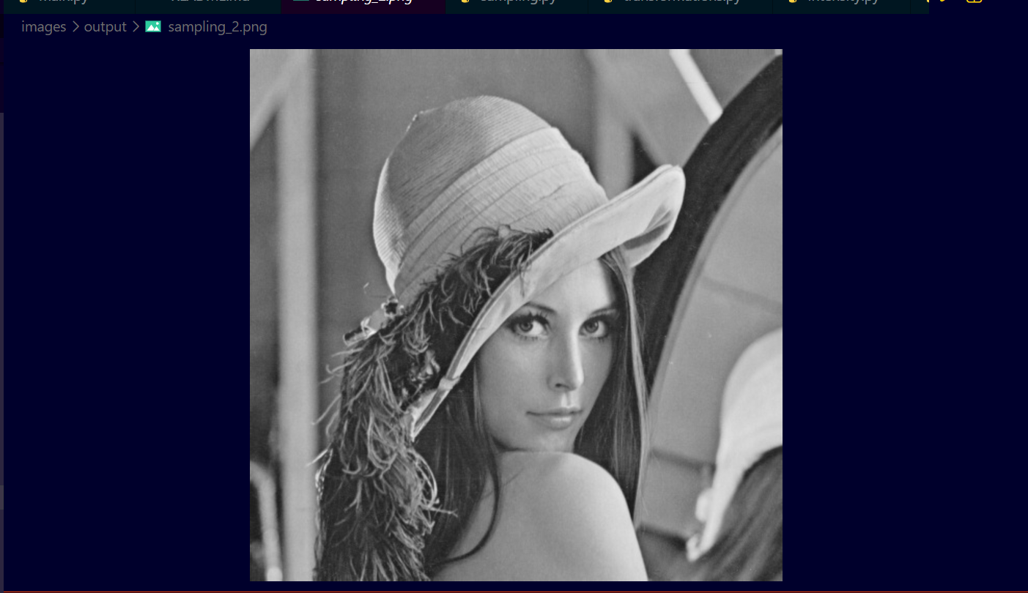

Quantization Results
- quant_8bit.png
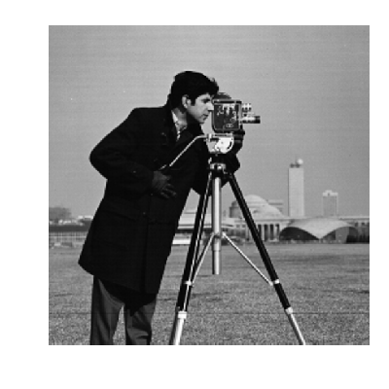
- quant_4bit.png
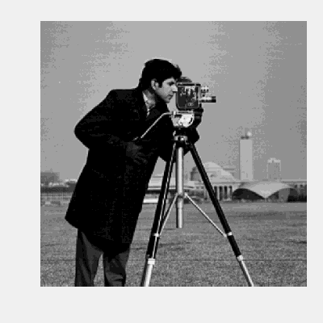
- quant_2bit.png


Transformation Results
- rotate_30.png
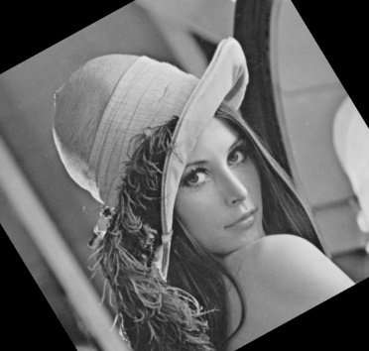
- rotate_60.png
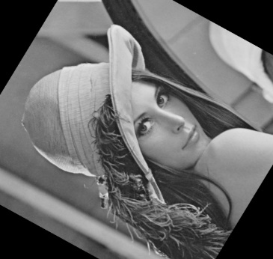
- rotate_90.png
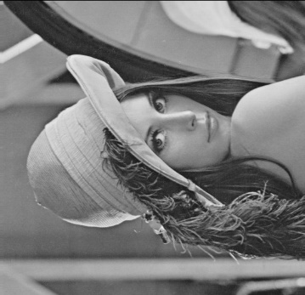
- rotate_120.png
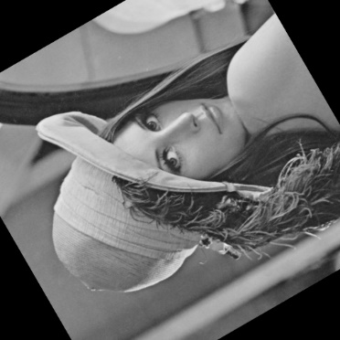
- translated.png
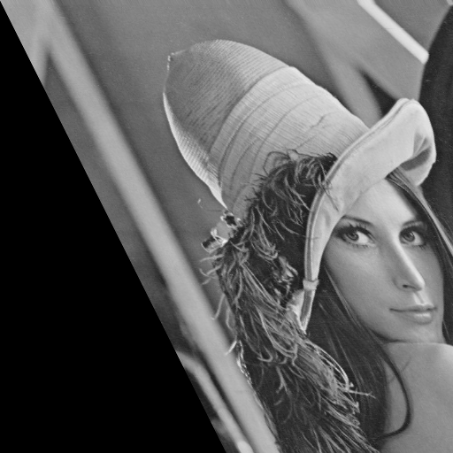
- sheared.png
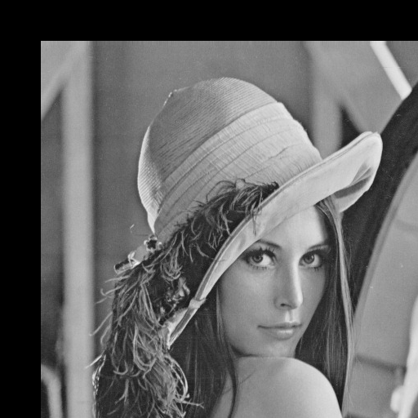

Intensity Results
- negative.png
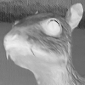
- log.png

- gamma_0.5.png

- gamma_1.5.png


Histogram Results
- equalized.png


Intensity:
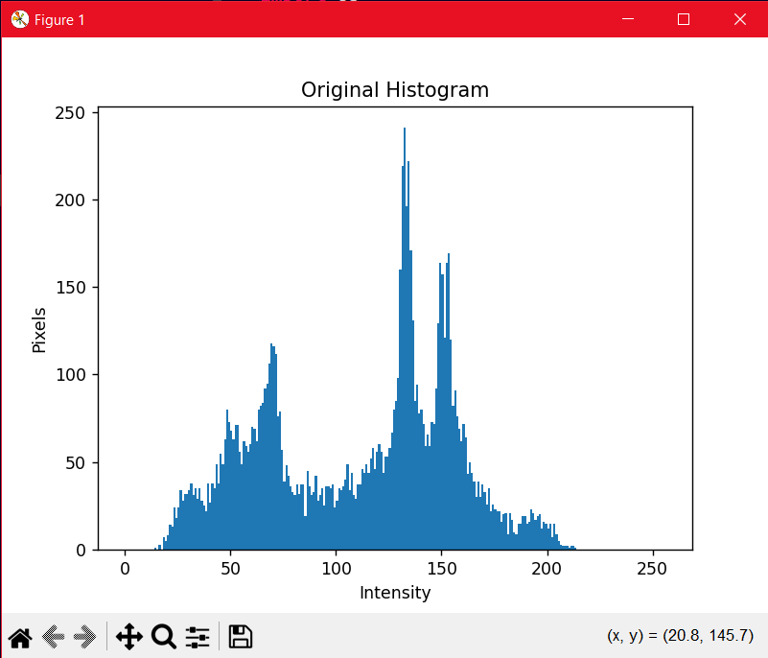
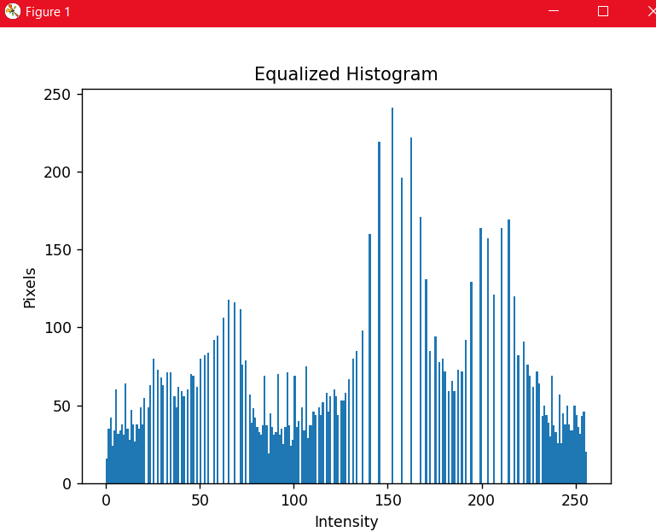

Final Output
- final.png
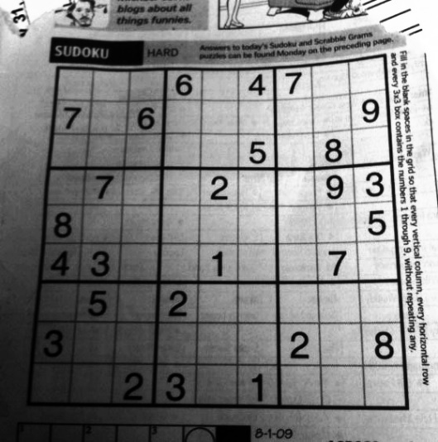

5. OBSERVATIONS & ANALYSIS
- Sampling directly affects resolution and clarity
- Quantization reduces image quality with lower bits
- Transformations affect spatial structure
- Gamma correction improves brightness effectively
- Histogram equalization enhances contrast significantly

6. CONCLUSION
The Smart Image Enhancement System successfully improves low-quality images using various image processing techniques. The final enhanced image shows significant improvement in contrast, brightness, and detail visibility. The project demonstrates how theoretical concepts can be applied to real-world problems effectively.

7. QUESTION & ANSWERS

1. Why does histogram equalization improve contrast?
Histogram equalization redistributes pixel intensity values across the full range, making dark areas brighter and bright areas more detailed.

2. How does gamma affect brightness?
Gamma controls brightness:
- γ < 1 → increases brightness
- γ > 1 → decreases brightness

3. What is the effect of quantization?
Reducing bit depth decreases the number of intensity levels, causing loss of detail and visible distortion.

4. Which transformation is reversible and why?
Rotation (e.g., 90°) is reversible because applying the inverse rotation restores the original image.

5. How do transformations affect spatial structure?
Transformations change the position, orientation, and shape of the image, altering its spatial structure.

LinkedIn:
https://www.linkedin.com/posts/shafqaat-ahmad-829182308_github-shafqaat618dip-image-enhancement-system-activity-7445794275839262720-Sdlr?utm_source=share&utm_medium=member_desktop&rcm=ACoAAE5V5iEB0lkLnsKtSMhYVPx_5i19eapbWOE

GitHub:
https://github.com/shafqaat618/DIP-Image-Enhancement-System

