**DAILY ONLINE ACTIVITIES SUMMARY**

|  |  |  |  |  |  |  |  |
| --- | --- | --- | --- | --- | --- | --- | --- |
| **Date:** | **23 MAY 2020** | | | | **Name:** | **KHATHEEJA SAFREENA** | |
| **Sem & Sec** | **4th sem 'A' section** | | | | **USN:** | **4AL18CS037** | |
| **Online Test Summary** | | | | | | | |
| **Subject** | | **DATA COMMUNICATION.** | | | | | |
| **Max. Marks** | | **30** | | **Score** | | **24** | |
| **Certification Course Summary** | | | | | | | |
| **Course** | **1.INTRODUCTION TO DIGITAL MARKETING.** | | | | | | |
| **Certificate Provider** | | | **Great learning** | **Duration** | | | **2.5 hr.** |
| **Coding Challenges** | | | | | | | |
| **Problem Statement: I have mentioned the1 problem statements below.** | | | | | | | |
| **Status: completed** | | | | | | | |
| **Uploaded the report in Github** | | | | **Yes** | | | |
| **If yes Repository name** | | | | **[http://shafreenasharief / lockdown-coding](http://shafreenasharief / lockdown-coding" \o "http://shafreenasharief / lockdown-coding)** | | | |
| **Uploaded the report in slack** | | | | **Yes** | | | |

Online Test Details: (Attach the snapshot and briefly write the report for the same)

Certification Course Details: (Attach the snapshot and briefly write the report for the same)

Coding Challenges Details: (Attach the snapshot and briefly write the report for the same)

**ONLINE TEST DETAILS:**

Today DATA COMMUNICATION was conducted of first & second module. Total marks for the test was 30.The online test conducted includes MCQ. I scored 24 on 30.

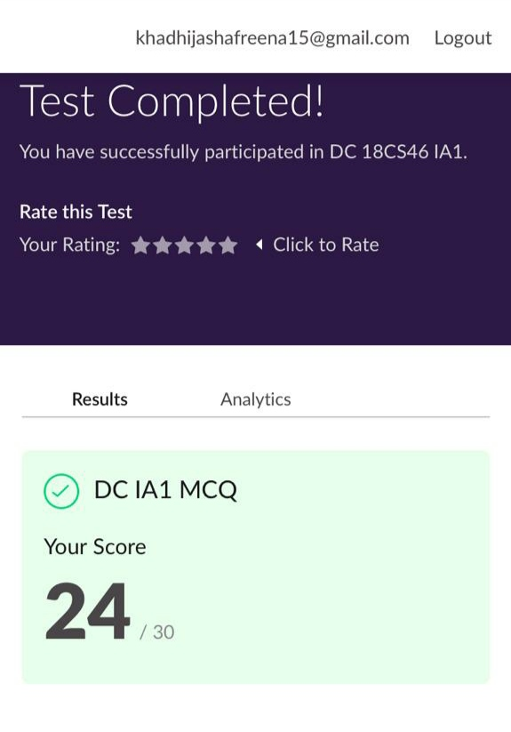

**CERTIFICATION COURSE DETAILS:**

* I'm doing certification course on INTRODUCTION TO DIGITAL MARKETING on great learning.The course is secluded for 2.5 hour.Today I completed 2 module which is Explanation of new media-cont & Understanding the brand purpose.I attempted quiz which gave me a clear veiw about the topics that were thought and discussed.
* It consists of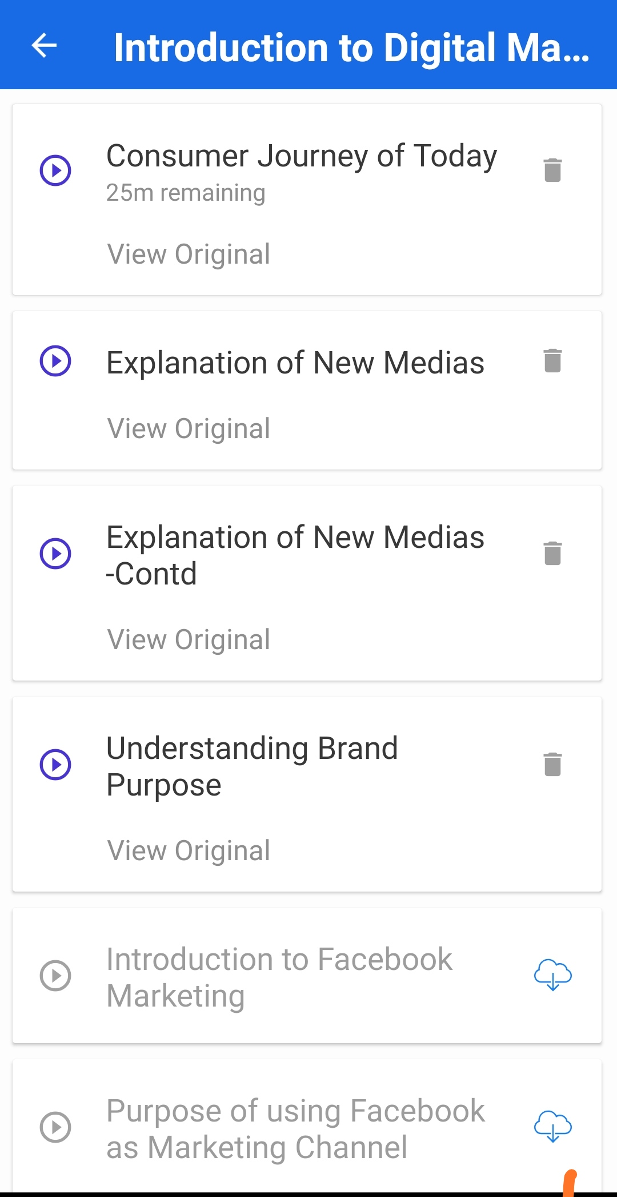 10 modules including assessments.
* Im completing modules on this course.
* **CODING CHALLENGE:**

Today I solved1 coding challenge,

1. **Write a C Program to generate first N Triangular Numbers (Where N is Read from the Key board).**

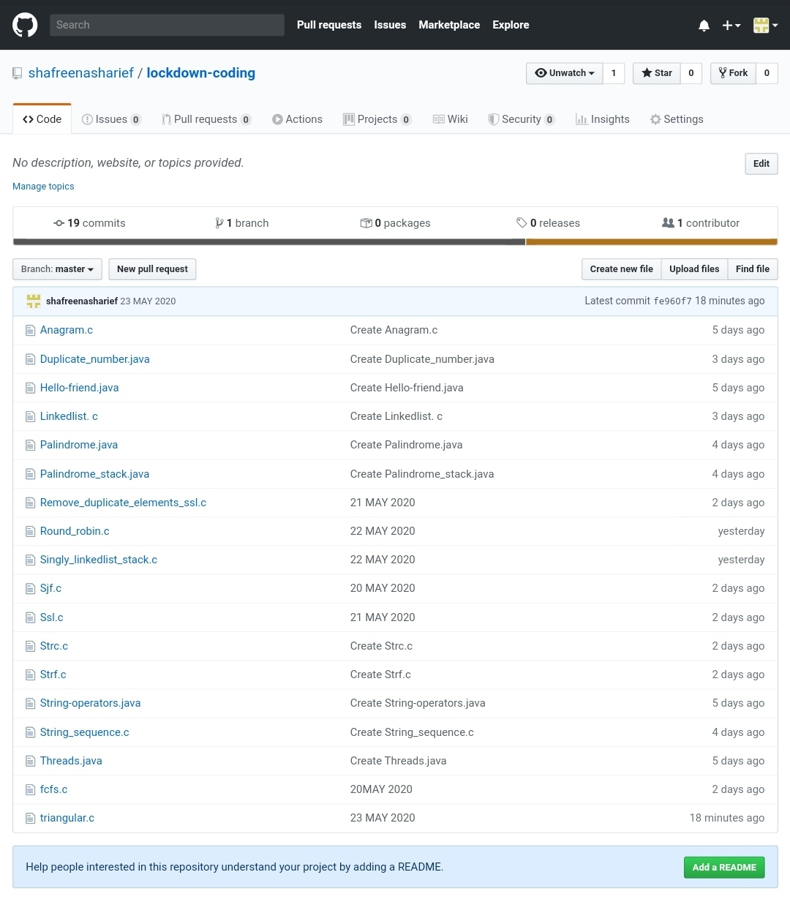

SOLUTION : I have uploaded the solution of the above 4 coding problems in my GitHub repository.

[http://shafreenasharief / lockdown-coding](http://shafreenasharief / lockdown-coding" \o "http://shafreenasharief / lockdown-coding)