**DAILY ONLINE ACTIVITIES SUMMARY**

|  |  |  |  |  |  |
| --- | --- | --- | --- | --- | --- |
| **Date:** | **21 may 2020** | **Name:** | | **KHATHEEJA SAFREENA** | |
| **Sem & Sec** | **4th sem, 2nd year** | **USN:** | | **4AL18CS037** | |
| **Online Test Summary** | | | | | |
| **Subject** | **OPERATING SYSTEM (18CS45)** | | | | |
| **Max. Marks** | **30** | | **Score** | **20** | |
| **Certification Course Summary** | | | | | |
| **Course** | **1.Java Programing.**  **2.Workshop on Python for Beginners.**  **3.Indroduction to Digital Marketing.** | | | | |
| **Certificate Provider** | **1.great learning.**  **2.Brainovision.**  **3.great learning.** | | **Duration of the course:** | | **1. 3.5 hour.**  **2. 1.5 hour.**  **3.2.5 hour.** |
| **Coding Challenges** | | | | | |
| **Problem Statement:3 program** | | | | | |
| **Status: Executed** | | | | | |
| **Uploaded the report in Github** | | | **Yes** | | |
| **If yes Repository name** | | | **[http://https://github.com/shafreenasharief/lockdown-coding](http://https://github.com/shafreenasharief/lockdown-coding" \o "http://https://github.com/shafreenasharief/lockdown-coding)** | | |
| **Uploaded the report in slack** | | | **Yes** | | |

**Online Test Details: (Attach the snapshot and briefly write the report for the same)**

**Certification Course Details: (Attach the snapshot and briefly write the report for the same)**

**Coding Challenges Details: (Attach the snapshot and briefly write the report for the same)**

* **ONLINE TEST SUMMARY:**
* **OPERATING SYSTEM (18CS43)**

Today was conducted of first module. The test was conduct on 30 marks.

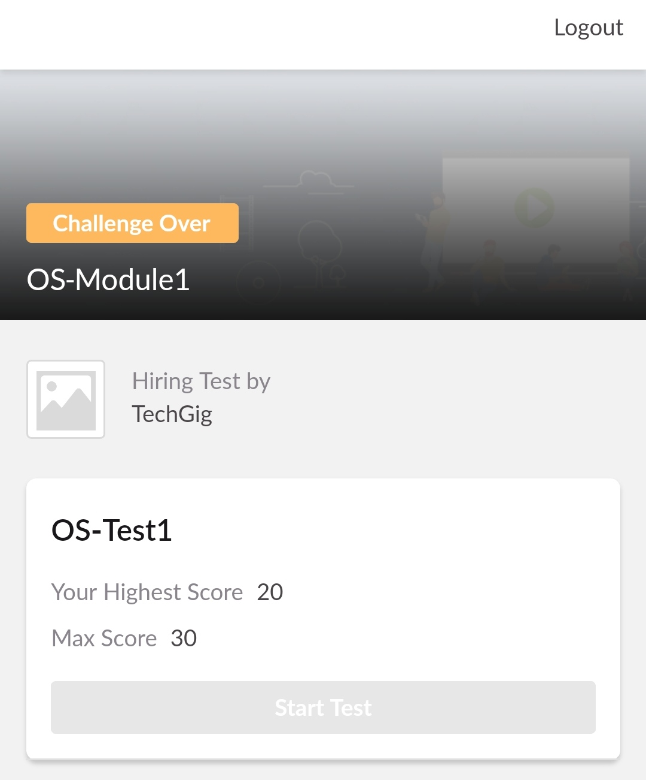

* **CERTIFICATION COURSE SUMMARY:**

**1.JAVA PROGRAMMING:**

Today I started new certificate course through Great learning. I choose the concept of Java programming.

* **The concepts covered in Java programming are:**
* What is java.
* Install Java & Java IDE.
* Variables & Data Types.
* Operators in java.
* Flow Control Statement
* Array & functions in java.
* Object Oriented programming in java.
* Inheritance on java.
* Collection in java.
* I completed the course and toke up java quiz scoring 9 out of 10.

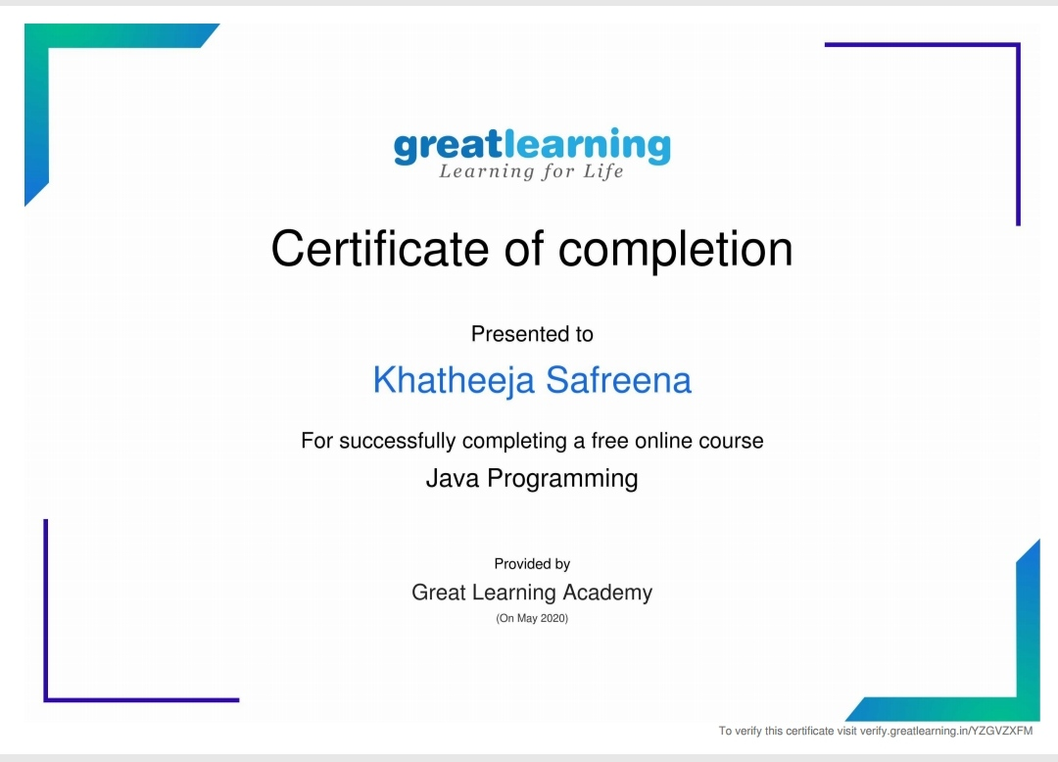

**2.WORKSHOP ON PYTHON FOR BEGINNERS:**

* On 19 MAY 2020 I took up a live sessions in YouTube on workshop on python for beginners by Brainovision. It was 1.5 hr sessions. Also completed the assignment given.
* **The concepts covered in Workshop 0n Python for Beginners are:**
* Python Programming.
* Intro to Python.
* Variables & types.
* Numbers &Maths.
* Input from users.
* Passing Arguments.
* Indentation & block of codes.

I secured certificate on completion of the course on workshop on Python for beginners

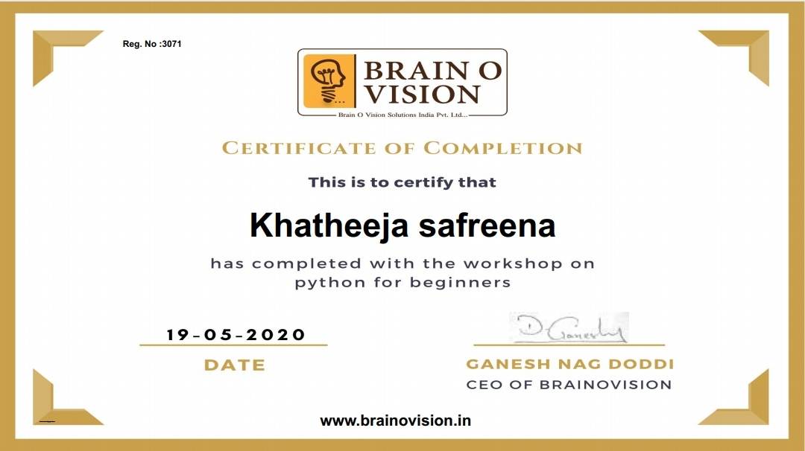

**3.DIGITAL MARKETING**

* Today I started new certificate course through Great learning. I choose the concept of INTRODUCTION DIGITAL MARKETING. It is 2.5 hr course.
* I completed 2 modulesof the course. Those are consumer journey of today and Explanation of new media

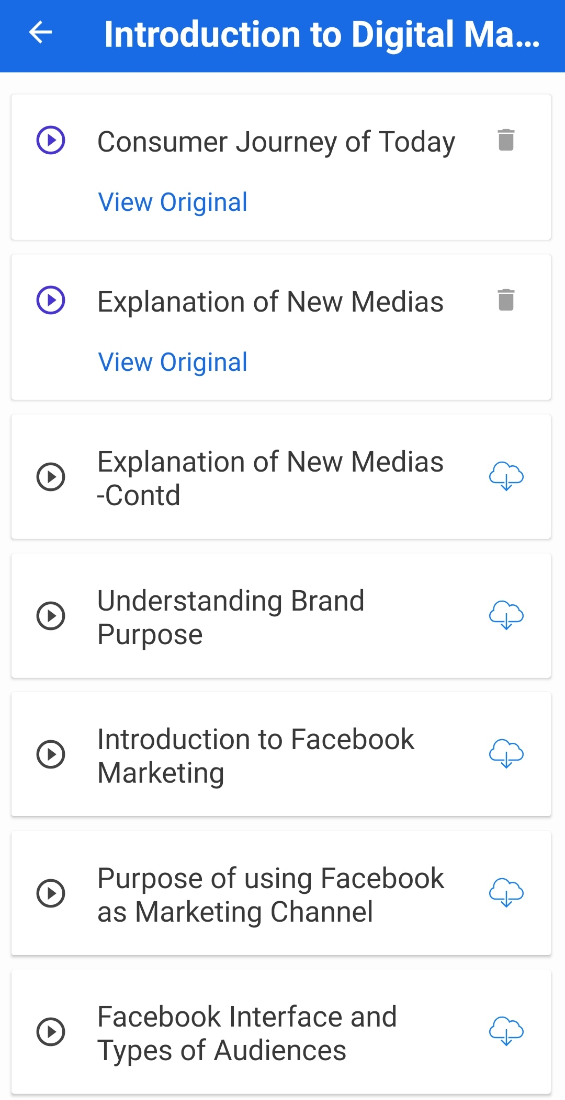

* **CODING CHALLENGES:**

Today I solved 2 coding challenge,

1. **First Create a Singly Linked List Stack with the node corresponding to First Element is the base of the stack; and its link field must be always Null.  
When you push First Element, it is the First and it is Base of the stack. Its Link must be Null. top pointer pointing to First. (top = First)  
When you push any element, (No need of checking Stack full case because SLL is dynamic) Create a new node called temp using malloc function and insert a number into Data field, and Link field must be pointing to top; and move the pointer top to point to temp.  
When you pop, First check for stack Empty. if First == NULL, then Stack Empty. If it is not empty, the pointer temp must be pointing to top. Move the pointer top to top->link. delete temp.  
When you display the stack element, First Check for Stack Empty as in pop operation. If it is not empty, display all the elements of current stack starting from top to First.**

**Write a C or Java program to implement round robin type of process scheduling.  
Input: Process with burst time, arrival time and specify the time quantum  
Output: Processes scheduled based on the round robin type of scheduling, with its average waiting time.**

SOLUTION : I have uploaded the solution of the above 2 coding problems in my GitHub repository.

**[http://https://github.com/shafreenasharief/lockdown-coding](http://https://github.com/shafreenasharief/lockdown-coding" \o "http://https://github.com/shafreenasharief/lockdown-coding)**

