**DAILY ONLINE ACTIVITIES SUMMARY**

|  |  |  |  |  |  |  |
| --- | --- | --- | --- | --- | --- | --- |
| **Date:** | | **21 may 2020** | | **Name:** | **KHATHEEJA SAFREENA** | |
| **Sem & Sec** | | **4th sem, 2nd year** | | **USN:** | **4AL18CS037** | |
| **Online Test Summary** | | | | | | |
| **Subject** | **MICROCONTROLLER AND EMBEDDED SYSTEMS (18CS44)** | | | | | |
| **Max. Marks** | **30** | | **Score** | | **15** | |
| **Certification Course Summary** | | | | | | |
| **Course** | | **1.Java Programing.**  **2.Workshop on Python for Beginners.** | | | | |
| **Certificate Provider** | | **1.great learning.**  **2.Brainovision.** | **Duration of the course:** | | | **1. 3.5 hour.**  **2. 1.5 hour** |
| **Coding Challenges** | | | | | | |
| **Problem Statement:3 program** | | | | | | |
| **Status: Executed** | | | | | | |
| **Uploaded the report in Github** | | | **Yes** | | | |
| **If yes Repository name** | | | **[http://https://github.com/shafreenasharief/lockdown-coding](http://https://github.com/shafreenasharief/lockdown-coding" \o "http://https://github.com/shafreenasharief/lockdown-coding)** | | | |
| **Uploaded the report in slack** | | | **Yes** | | | |

* **ONLINE TEST SUMMARY:**

Today **MICROCONTROLLER AND EMBEDDED SYSTEMS (18CS44)**

was conducted of first module. The test was conduct on 30 marks.

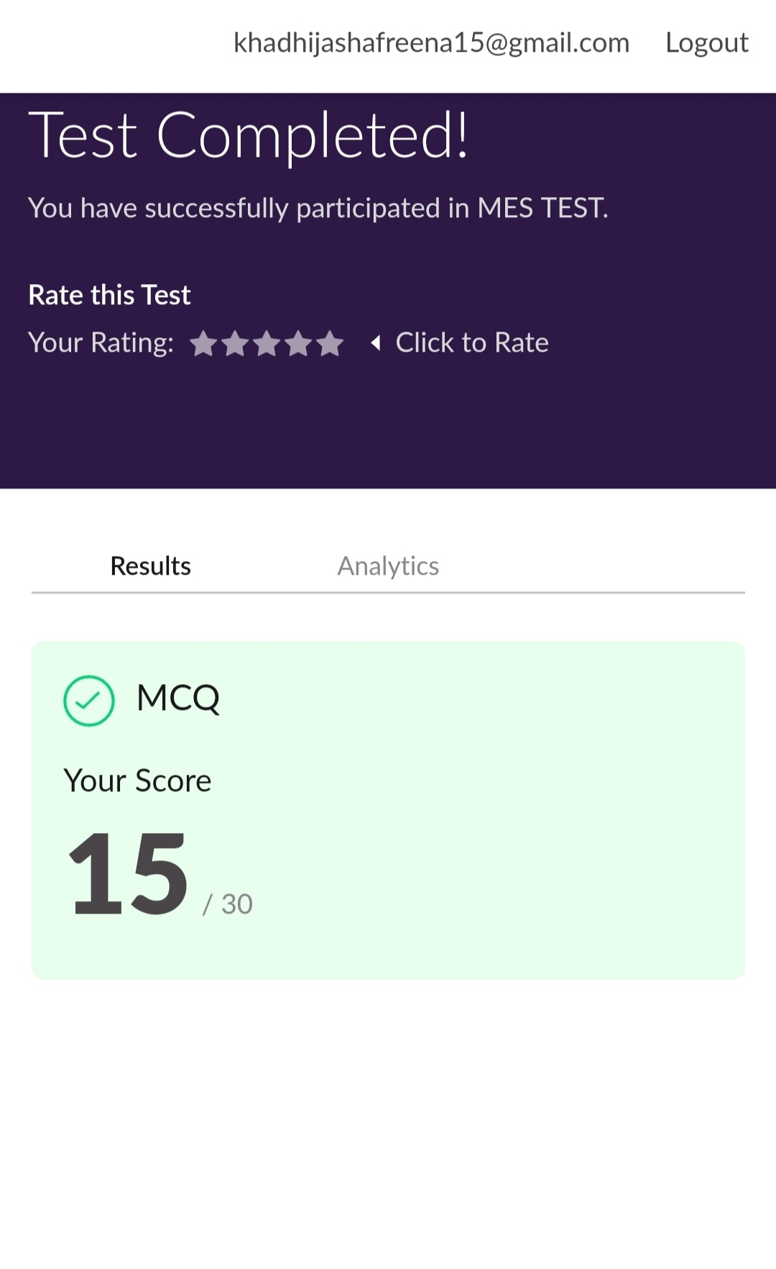

* **CERTIFICATION COURSE SUMMARY:**

**1.JAVA PROGRAMMING:**

Today I started new certificate course through Great learning. I choose the concept of Java programming.

* **The concepts covered in Java programming are:**
* What is java.
* Install Java & Java IDE.
* Variables & Data Types.
* Operators in java.
* Flow Control Statement
* Array & functions in java.
* Object Oriented programming in java.
* Inheritance on java.
* Collections in java.
* I completed the course and toke up java quiz scoring 9 out of 10.

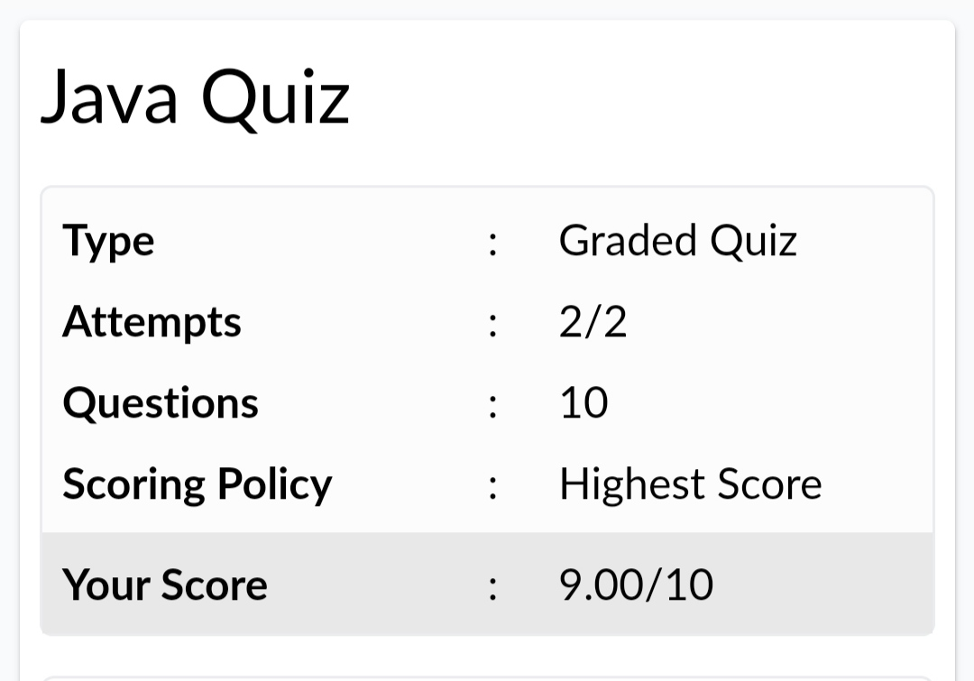

**2.WORKSHOP ON PYTHON FOR BEGINNERS:**

* On 19 MAY 2020 I took up a live sessions in YouTube on workshop on python for beginners by Brainovision. It was 1.5 hr sessions. Also completed the assignment given.
* **The concepts covered in Workshop 0n Python for Beginners are:**
* Python Programming.
* Intro to Python.
* Variables & types.
* Numbers &Maths.
* Input from users.
* Passing Arguments.
* Indentation & block of codes.

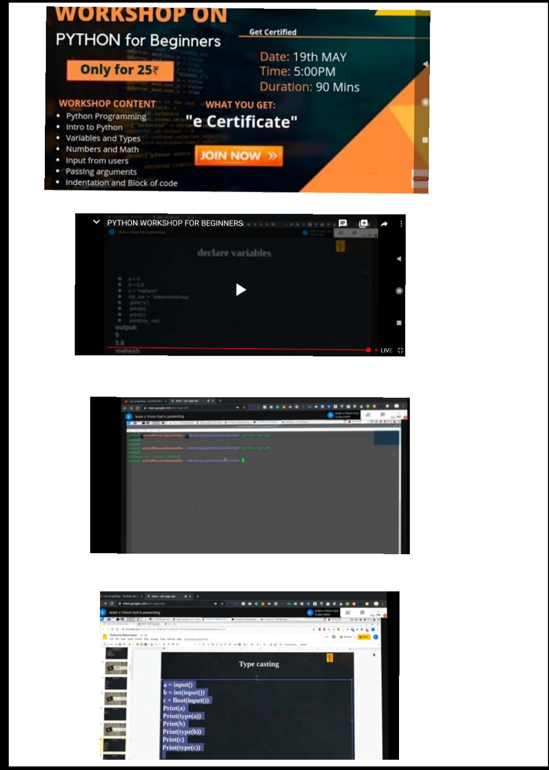

* **CODING CHALLENGES:**

Today I solved 3 coding challenge,

1. **Create the SLL, and then Reverse the Link in SLL until Head becomes NULL. Each Time Reversing the Link, Head must be moved to next immediate node.**

2. **Write a C program to implement SRTF process scheduling.  
Input: A set of processes with their burst time and arrival time  
Output: The processes scheduled based on the arrival time and a smaller burst time.**

3. **Write a C program to construct a singly linked list by removing duplicate elements in the sorted linked list  
Description:  
Take a sorted list and traverse the list. Compare the current node element with next adjacent node. If it is same then delete second element, if not retain. Finally print the resulting list.  
Sample output:  
Given list {1,2,2,3,3,3,4}  
Resulting list {1,2,3,4}**

SOLUTION : I have uploaded the solution of the above 3 coding problems in my GitHub repository.

**[http://https://github.com/shafreenasharief/lockdown-coding](http://https://github.com/shafreenasharief/lockdown-coding" \o "http://https://github.com/shafreenasharief/lockdown-coding)**

