**WEEK 6(React-JS)**

**REACT :**

**Hands-on 1:**

* ***App.css:***

.App {

text-align: center;

}

.App-logo {

height: 40vmin;

pointer-events: none;

}

@media (prefers-reduced-motion: no-preference) {

.App-logo {

animation: App-logo-spin infinite 20s linear;

}

}

.App-header {

background-color: #282c34;

min-height: 100vh;

display: flex;

flex-direction: column;

align-items: center;

justify-content: center;

font-size: calc(10px + 2vmin);

color: white;

}

.App-link {

color: #61dafb;

}

@keyframes App-logo-spin {

from {

transform: rotate(0deg);

}

to {

transform: rotate(360deg);

}

}

* ***App.js:***

function App() {

return (

<div>

<h1>Welcome to the first session of React</h1>

</div>

);

}

export default App;

* ***App_test.js:***

import { render, screen } from '@testing-library/react';

import App from './App';

test('renders learn react link', () => {

render(<App />);

const linkElement = screen.getByText(/learn react/i);

expect(linkElement).toBeInTheDocument();

});

* ***index.css:***

body {

margin: 0;

font-family: -apple-system, BlinkMacSystemFont, 'Segoe UI', 'Roboto', 'Oxygen',

'Ubuntu', 'Cantarell', 'Fira Sans', 'Droid Sans', 'Helvetica Neue',

sans-serif;

-webkit-font-smoothing: antialiased;

-moz-osx-font-smoothing: grayscale;

}

code {

font-family: source-code-pro, Menlo, Monaco, Consolas, 'Courier New',

monospace;

}

* ***index.js:***

import React from 'react';

import ReactDOM from 'react-dom/client';

import './index.css';

import App from './App';

import reportWebVitals from './reportWebVitals';

const root = ReactDOM.createRoot(document.getElementById('root'));

root.render(

<React.StrictMode>

<App />

</React.StrictMode>

);

// If you want to start measuring performance in your app, pass a function

// to log results (for example: reportWebVitals(console.log))

// or send to an analytics endpoint. Learn more: https://bit.ly/CRA-vitals

reportWebVitals();

Output:

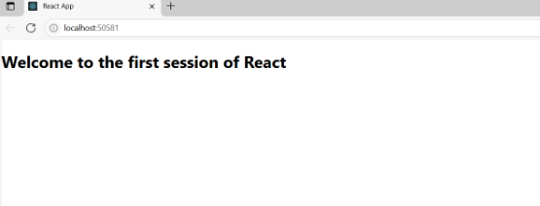

**Hands-on 2:**

* ***App.js:***

import React from 'react';

import Home from './Components/Home';

import About from './Components/About';

import Contact from './Components/Contact';

function App() {

return (

<div>

<Home />

<About />

<Contact />

</div>

);

}

export default App;

EXTRA COMPONENTS FOR ABOUT, CONTACT, HOME APART FROM FIRST PROGRAM:

* ***About.js:***

import React from 'react';

function About() {

return (

<div>

<h2>Welcome to the About page of the Student Management Portal</h2>

</div>

);

}

* ***Contact.js:***

import React from 'react';

function Contact() {

return (

<div>

<h2>Welcome to the Contact page of the Student Management Portal</h2>

</div>

);

}

export default Contact;

* ***Home.js:***

import React from 'react';

function Home() {

return (

<div>

<h2>Welcome to the Home page of Student Management Portal</h2>

</div>

);

}

export default Home;

Output:

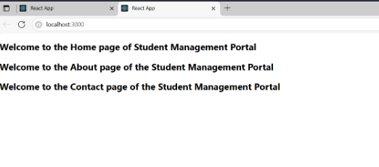

**Hands-on 3:**

* ***App.js:***

import React from 'react';

import CalculateScore from './Components/CalculateScore';

function App() {

return (

<div className="App">

<CalculateScore name="Shafreen" school="Sri Chaitanya Techno School" total={450} goal={5} />

</div>

);

}

export default App;

EXTRA COMPONENTS:

* ***CalulateScore,js:***

import React from 'react';

import '../Stylesheets/mystyle.css';

function CalculateScore(props) {

const { name, school, total, goal } = props;

const average = total / goal;

return (

<div className="score-card">

<h2>Student Score Report</h2>

<p><strong>Name:</strong> {name}</p>

<p><strong>School:</strong> {school}</p>

<p><strong>Total Marks:</strong> {total}</p>

<p><strong>Goals:</strong> {goal}</p>

<p><strong>Average Score:</strong> {average.toFixed(2)}</p>

</div>

);

}

export default CalculateScore;

Extra Styles used:

.score-card {

background-color: #f2f2f2;

padding: 20px;

margin: 30px auto;

width: 400px;

border-radius: 10px;

box-shadow: 0 0 10px rgba(0,0,0,0.1);

font-family: Arial, sans-serif;

}

.score-card h2 {

text-align: center;

color: #333;

}

.score-card p {

font-size: 16px;

line-height: 1.5;

}

Output: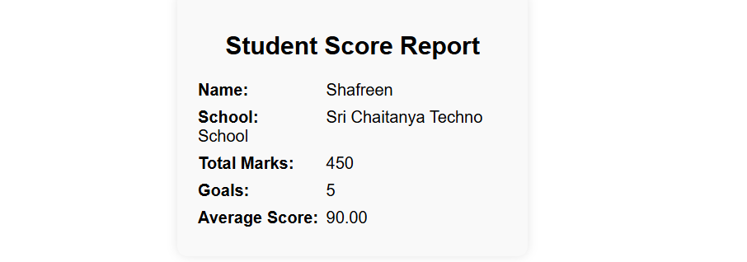

**Hands-on 4:**

EXTRA COMPONENTS:

* ***Post.js:***

class Post {

constructor(id, title, body) {

this.id = id;

this.title = title;

this.body = body;

}

}

export default Post;

* ***Posts.js:***

import React, { Component } from 'react';

class Posts extends Component {

constructor(props) {

super(props);

this.state = {

posts: [],

hasError: false

};

}

loadPosts() {

const samplePosts = [

{

id: 1,

title: "How to Get Started with React",

body: "React is a powerful JavaScript library for building user interfaces..."

},

{

id: 2,

title: "Understanding Component Lifecycle",

body: "React components go through various lifecycle phases such as mounting..."

},

{

id: 3,

title: "Using Fetch API in React",

body: "The Fetch API lets you load data asynchronously in React components..."

}

];

this.setState({ posts: samplePosts });

}

componentDidMount() {

this.loadPosts();

}

componentDidCatch(error, info) {

console.error("Caught error:", error, info);

alert("Something went wrong while loading the posts.");

this.setState({ hasError: true });

}

render() {

if (this.state.hasError) {

return <h2>Unable to load posts. Please try again later.</h2>;

}

return (

<div>

<h1>Blog Posts</h1>

{this.state.posts.map(post => (

<div key={post.id}>

<h3>{post.title}</h3>

<p>{post.body}</p>

<hr />

</div>

))}

</div>

);

}

}

export default Posts;

Output:

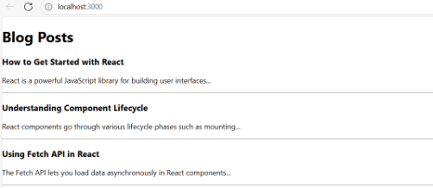

**Hands-on 5:**

EXTRA COMPONENTS:

* ***CohortDetails.css:***

.box {

width: 300px;

display: inline-block;

margin: 10px;

padding: 10px 20px;

border: 1px solid black;

border-radius: 10px;

}

dt {

font-weight: 500;

}

* ***CohortDetails.js:***

import React from 'react';

import styles from './CohortDetails.module.css';

function CohortDetails({ name, startDate, endDate, status }) {

const headingStyle = {

color: status === 'ongoing' ? 'green' : 'blue'

};

return (

<div className={styles.box}>

<h3 style={headingStyle}>{name}</h3>

<dl>

<dt>Start Date:</dt>

<dd>{startDate}</dd>

<dt>End Date:</dt>

<dd>{endDate}</dd>

<dt>Status:</dt>

<dd>{status}</dd>

</dl>

</div>

);

}

export default CohortDetails;

Output:

