*ECE 1000 Final Report: Automated Plant Watering system*

Jacob Jordan, Matthew Rosa  
*College of Engineering*  
*Tennessee Tech University*Cookeville, Putnam County

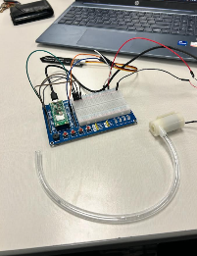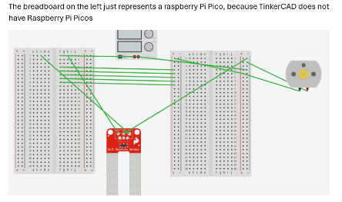Jljordan44@tntech.edu, mrosa42@tntech.edu

*Abstract*— “Automated Plant Watering System” is a project that uses a soil sensor and a Raspberry Pi Pico to power a water pump when the read soil moisture is below the desired point. The pump gets powered on while sitting in a cup of water and pumping water into the soil whenever it gets dry. The intended purpose of the pump is to allow the user to not have to continuously water the plant. Instead, they can just fill up whatever cup or bowl the pump is sat in and the pump will just kick on as needed.

Keywords—Capacitive soil sensor, Automated plant watering system, Raspberry Pi Pico, Micro Python

# Introduction

The automated plant watering system was chosen to be built by Matthew Rosa, computer engineering manager, and Jacob Jordan, electrical engineering major, to practice coding and electrical circuitry and to design a working product that could make a task more efficient and convenient.

# Background

The only source the project team used to design the system was the code for the capacitive soil sensor from JC Williams’s GitHub. The rest of the code was a collaborative effort of Matthew Rosa and Jacob Jordan.

# Project Description and formulation

The circuit is built on a Raspberry Pi Pico that connects to both a capacitive soil moisture sensor and a water pump. The moisture probe is connected to GP 26, ADC_V, and ground pins. The original design for the pump required a relay, but without access to one, the project team just connected GP0, GP1, GP 2, GP 3, and GP 0 on the breadboard to power the pump on and off. One pin from the Pi Pico board does not generate a high enough voltage to power the pump, but connecting four in series and coding them to power on and off when the moisture level dipped below a certain point generates a high enough voltage to power the pump

# IV. Discussion and results

The project worked as expected. The main improvements that could be made are more permanent connections than the jumper wires and the breadboard, because the circuit could lose connection when moved around very much. Mattew Rosa lead the coding while Jacob Jordan was typing and troubleshooting the code whenever it was not working. Jacob Jordan designed how the circuit was wired while Matthew Rosa assisted and fixed any issues as they arrived. Both Partners did about equal shares within each faucet of the project, but Matthew knew a bit more about coding and software, while Jacob jordan had more experience wiring and designing circuitry and hardware. Jacob Jordan wrote the report and Matthew Rosa set out the design for the Githubs.

# V. Conclusion

The Automated Plant Watering System’s Primary goal was to apply what the project members knew and had learned in ECE 1000 to practice coding and circuitry. The primary purpose of the actual system was to be able to automatically water plants without needing to do anything but put the pump in water and supply power to the Pi Pico, and it succeeded in that. This project took some knowledge of Micro Python, general electronics knowledge, circuit design knowledge, and an understanding of circuits in series.

##### References

1. https://github.com/JCWilliams1003/ECE-1000-Spring-2024-Final-Project-Insert-Project-Name/blob/main/Example%20Micropython%20Codes/ECE_1000_Soil_Moisture_Sensor_Example.py