1. First of all open the project and run “npm install” to install all the required packages.
2. Now run “ng serve” to see the project. Note: it will take time.

**Connecting Backend to generate report?**

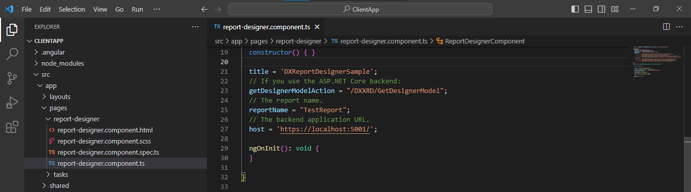

Enter report name, backend API link in host variable.

**To Change Columns of table?**

src >pages>tasks - Update both the files accordingly.

**Sample Url to Change the table data?**

<https://js.devexpress.com/Demos/DevAV/odata/Customers>