**FFMPEG**

ffmpeg -i earth_story.mkv -c:v libx264 -vf scale=3840:2160 -rc constqp -qp 24 earth_story_2160.mp4

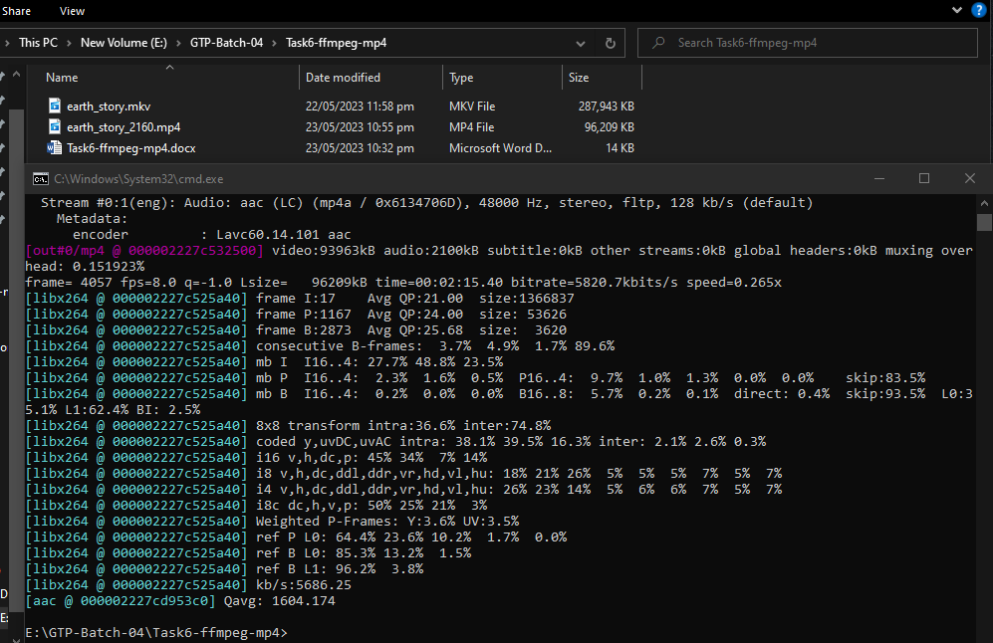

ffmpeg -i earth_story.mkv -c:v libx264 -vf scale=2560:1440 -rc constqp -qp 24 earth_story_1440.mp4

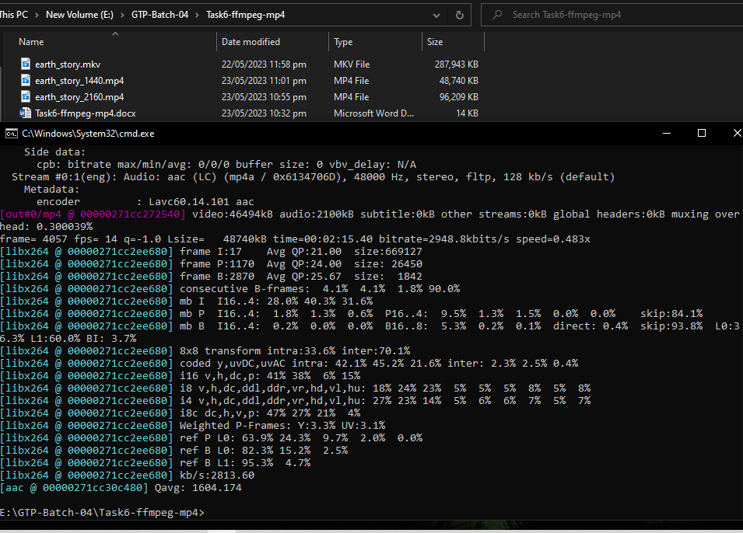

ffmpeg -i earth_story.mkv -c:v libx264 -vf scale=1920:1080 -rc constqp -qp 24 earth_story_1080.mp4

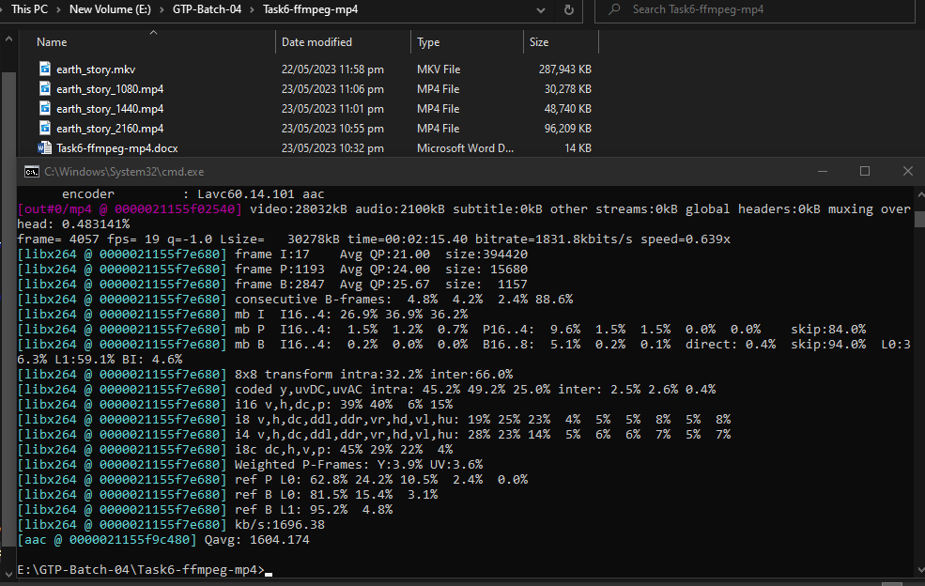

ffmpeg -i earth_story.mkv -c:v libx264 -vf scale=1280:720 -rc constqp -qp 24 earth_story_720.mp4

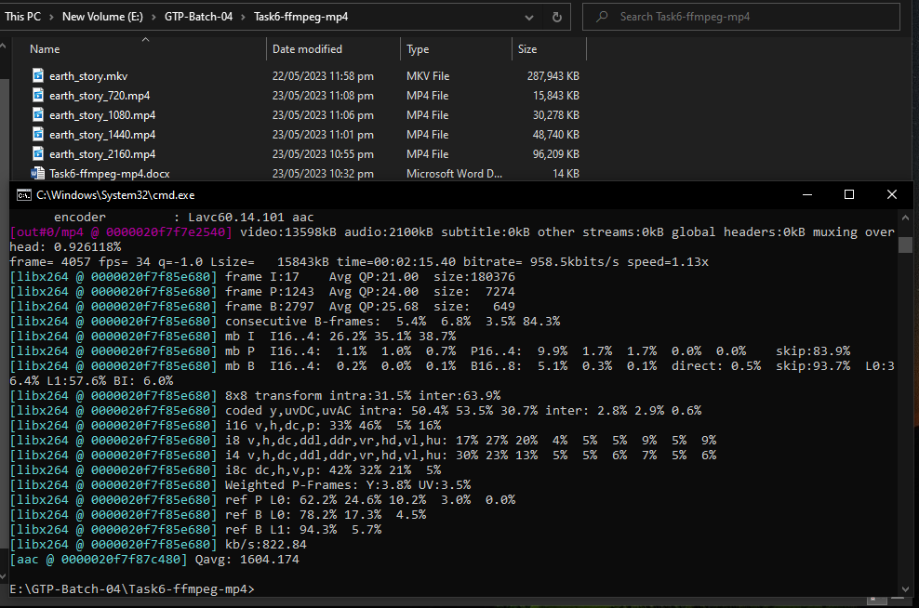

ffmpeg -i earth_story.mkv -c:v libx264 -vf scale=854:480 -rc constqp -qp 24 earth_story_480.mp4

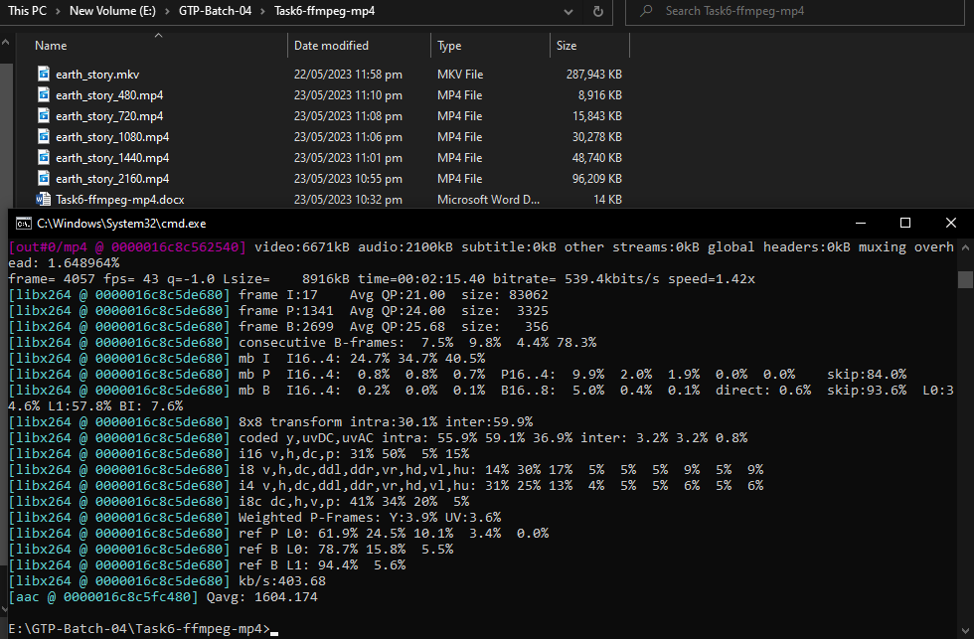

**Command Expalanation:**

ffmpeg -i input -c:v libx264 -vf scale=854:480 -rc constqp -qp 24 output

**-i Input:** Specifies input file.

**-c:v libx264:** Select the mostly used video codec libx264.

**-vf scale:** Scaling or resizing the video

**-rc constqp -qp:** The rate control method and quantization parameters for video encoding.

**output:** Specifies the output filename