**Working:**

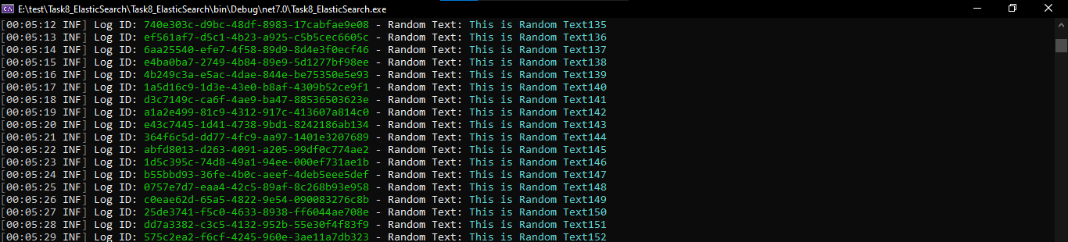

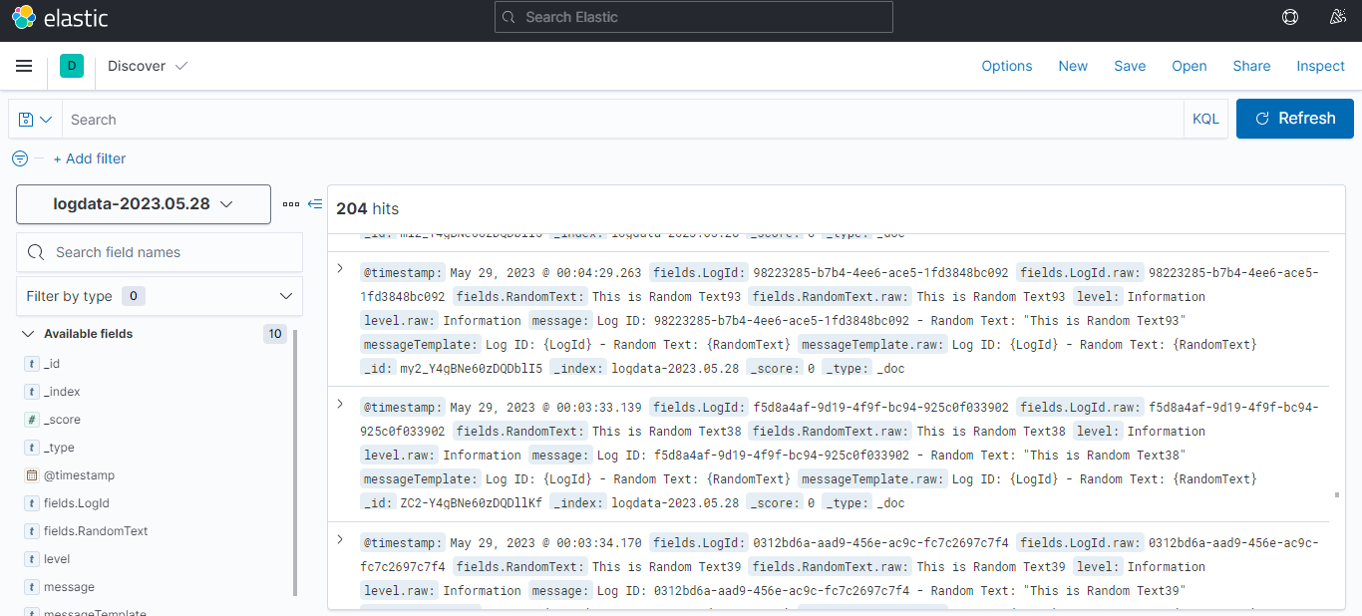

**KIBANA** : [http://localhost:5601](http://localhost:5601/)