Shagil Chaudhary

KPC International

Requirements Specification

Timetracking

# Document History

|  |  |  |  |
| --- | --- | --- | --- |
| Revision History | | | |
| Version | Author | Version Description | Date |
| V1.0 | Shagil Chaudhary | Second draft | July 31st 2023 |
|  |  |  |  |

|  |  |  |  |
| --- | --- | --- | --- |
| Review History | | | |
| Reviewer | Version reviewed | Signature | Date |
| Mick O’Gorman | V1.0 |  |  |
|  |  |  |  |

|  |  |  |  |
| --- | --- | --- | --- |
| Approval History | | | |
| Approver | Version approved | Signature | Date |
|  |  |  |  |
|  |  |  |  |

Table of Content

Document History 1

Introduction 4

Product scope 4

Product value 4

Intended Audience 4

Intended use 5

Business requirements 6

Functional Requirements 8

Application Uses 8

Application User Types 9

Administration Requirements 10

Project Manager Requirements 12

Regular User Requirements 14

Supervisor User Requirements 16

Use Cases 18

Use Case Diagrams with Description 19

Use Case: Admin Revoking Access 19

Use Case: Admin Adding/Enabling New User 19

Use Case: Admin closes the Timesheet 20

Use Case: Admin Changes Timesheet After Approval 20

Use Case: Admin Reviews Delete Request 21

Use Case: Project Manager Extracts Timesheet Information of the Selected User 21

Use Case: Project Manager Edits the Timesheet Record of the Selected User 22

Use Case: Project Manager Approves the Timesheet of the Selected User 23

Use Case: Project Manager Deletes the Timesheet for the Selected User 24

Use Case: Project Manager Changes the Status of the Timesheet for Selected User 25

Use case: Regular User wants to Edit Timesheet 26

Use Case: Regular User wants to input the timesheet data 26

Use Case: Supervisor gets a list of all projects and selects one 27

Use Case: Supervisor gets a list of all projects and users linked to select one and get details 27

Use Case: Supervisor gets Timesheet information of Selected User 28

Use Case: Supervisor views the dashboard of all the different types of users 29

Rules and examples (list required) 30

Block diagram architecture 31

External Interface Requirements 33

Data Collection for Non-NuaVal Project 34

User Interface Concepts 35

Login Page 35

Admin Portal 37

Admin Tools Portal 39

Admin Timesheet Portal 41

Project Manager User Portal 43

Project Manager Tools Portal 45

Regular User Portal 47

Regular User Tools Portal 49

Regular User Timesheet 51

Regular User Timesheet (Non-NuaVal Project) 53

Supervisor User Portal 54

Supervisor Tools Portal 56

Software interface requirements 58

Non-functional requirements 59

Security 59

Data Integrity 59

Capacity 59

Scalability 60

Maintainability 60

Usability 60

Development Process 61

Appendix 1 – Commissioning process 62

# Introduction

Welcome to our ambitious project: the design and development of a cutting-edge, cloud-based time-tracking and time-management system. Our primary goal is to create an application that not only collects and stores data, but also becomes the backbone for various applications and departments within your organization. From payroll and invoicing to benchmarking and proposal estimation, our all-encompassing platform will revolutionize your workflow.

This initial version of the application will focus on project compliance, particularly catering to the stringent auditing requirements of the pharmaceutical industry. Our solution aims to provide comprehensive insights into your business processes and, more importantly, offer a detailed breakdown of how time is allocated within each project. By doing so, we empower your team with invaluable information to drive productivity and efficiency to unprecedented levels.

But our ambitions don't stop there. Our ultimate objective is to deliver an unparalleled user experience, offering informative analyses of your overall business model. By leveraging advanced data analytics and visualization, we strive to be more than just a time-tracking tool; we aspire to be a strategic partner in your business growth.

In this document, we present the comprehensive requirements for the time tracking application, encompassing both functional and non-functional aspects. Moreover, we offer a tantalizing glimpse of the app's conceptual design, setting the stage for the remarkable user interface that will be fine-tuned during the development phase using an agile approach.

With unwavering dedication, cutting-edge technology, and a passion for excellence, we are committed to bringing your vision to life. Together, let's embark on a journey that will transform the way you manage time and elevate your organization to new heights of success.

## Product scope

In response to the evolving landscape of the pharmaceutical industry, digitization and paperless validation have emerged as essential pillars for progressive companies. Our cloud-based application comes as a strategic requirement for pharmaceutical companies, driven by the industry's growing reliance on technology and its pursuit of greater efficiency.

The pharmaceutical sector is known for its intricate and challenging projects, often leading to delays in project delivery. This is where our application becomes the ultimate solution. By providing unprecedented insights into time allocation and expenditure, the application empowers stakeholders with a level of accuracy and analysis previously unattainable.

Every aspect of the project, from commissioning to qualification and validation, will be meticulously recorded and described in great detail. This comprehensive approach will effectively highlight the contributing factors behind project delays. As a result, our application functions as a proactive agent, detecting the root causes of delays, enabling managers to swiftly rectify issues and realign projects with timelines.

Our application's impact will go beyond just identifying delays. By capturing and analysing data with unmatched precision, it will facilitate better decision-making at every level of the organization. Armed with this valuable knowledge, pharmaceutical companies will be empowered to optimize their operations, enhance productivity, and propel their growth in this ever-competitive industry.

In conclusion, our cloud-based time-tracking and management system will be the catalyst for the pharmaceutical industry's journey towards a more efficient, agile, and data-driven future. By embracing this transformative solution, companies can embrace a new era of streamlined processes, reduced project delays, and heightened success. Together, let us usher in a new age of innovation and progress in pharmaceutical project management.

## Product value

The application in its core will be objectively measuring the time taken to write, execute, and review each of the test documents and the tests within. Thus, providing data that can be analysed to create a benchmark and provide an evaluation of where the time is being spent and where it is being wasted away and pinpoint the contributing factors.

## Intended Audience

As part of the market research clients from companies like J&J, Sanofi, Lonza have been consulted to evaluate the idea behind the application and the response was positive and was stated that the application will act as a tool to help project managers deliver the projects in time successfully. During the research phase there were few challenges that came to light that should be taken care of. One of the challenges was to identify a suitable software platform for the application that will provide all the resources and technical tools that will be necessary to develop the application with success and easy to provide support to. Furthermore, the application should also be able to integrate with the different applications that are already in use.

## Intended use

The idea of the end product of the application is something that is reliable and is cloud based so that it can be connected to several other systems and also it should be able to work on large amounts of data without any problem. The application should be able to provide an analysis of all project and should be able to predict a timeline for a new project that should be realistic. Furthermore, the application would be providing different versions of itself according to the purpose of the user.

The application development phase can be broken down into the following phases:

1. Basic Time Management and Time Tracking
2. Data Collection
3. Visualisation Dashboard
4. Analysis and Prediction

The intention at the end would be to have an application that will be automatically tracking and logging the time during the project. Moreover, end product application will also be providing a detailed analysis of the project and highlight how the time is being spent and what way it is being spent specifically in all the different CQV phases. This is a requirement of the industry as no system currently exists that will provide the above stated functionalities. Furthermore, the application will also be provided to users (companies) outside of KPC as well in a later time. For the same the technical details and licenses will be decided on in a later time.

# Business requirements

The table below has an initial list of business requirements that the application needs to implement.

|  |  |  |
| --- | --- | --- |
| No. | Requirement | Priority |
| 1 | Include all items that consume time on a project – e.g. meetings |  |
|  |  |  |
| 2 | Evaluate time travelling from desk to factory as part of requirement. (Consider tracking separately). |  |
|  |  |  |
| 3 | Starting with a manual system (drop down menus) and moving to fully automated ( e.g. integrated with NuaVal, GPS) |  |
|  |  |  |
| 4 | Standalone app for use on client projects - licence based (SaaS) |  |
|  |  |  |
| 5 | The application will be able to support all types of KPC projects not depending upon whether the project is a NuaVal or a Non-NuaVal project. |  |
|  |  |  |
| 6 | Integrated with NuaVal |  |
|  |  |  |
| 7 | Accessed via mobile phones, laptops, tablet. |  |
|  |  |  |
| 8 | Integrated with KPC Business process e.g. payroll / finance etc. |  |
|  |  |  |
| 9 | Security with access e.g. dual factor authentication. |  |
|  |  |  |
| 10 | Support various levels of access – project manager, Admin, User, Supervisor User. |  |
|  |  |  |
| 11 | Exception Reporting – e.g. if someone hasn’t worked a full day |  |
|  |  |  |
| 12 | Well-designed User Interface. |  |
|  |  |  |
| 13 | Data should feed back into proposal (bids) process to help with better project estimation |  |
|  |  |  |
| 14 | There will be different levels of details in the different types of the projects and the details will be based on the needs of the user. |  |
|  |  |  |
| 15 | The application will have the ability for multiple number of different clients to access the time tracking system separately. |  |
|  |  |  |
| 16 | There will be a secure login system that will provide the required security and protect the data. |  |
|  |  |  |
| 17 | The data that the time tracking system will generate will be compatible with the other internal applications working in KPC |  |
|  |  |  |
| 18 | The application in the later version will be able to track the time automatically and will not require any form of manual input. |  |
|  |  |  |
| 19 | The application will have a dashboard section where all the analysis of the project will be present and the reports of a specific project could be downloaded or imported and shared with the user that do not have access to the system. |  |
|  |  |  |
| 20 | The later version of the application will have the option to audit all the transactions record that is being recorded. |  |
|  |  |  |
| 21 | The application will also be able to predict the timeline of a new project based on the older data. |  |
|  |  |  |
| 22 | The application will have different interface and different type of access for different types of user and each user will have specific type of jobs that they can perform. |  |
|  |  |  |
| 23 | The application will have an API that can be used to connect to external applications as well by the external users. |  |
|  |  |  |
| 24 | The initial version of the application will have a data collector that will be able to process both the NuaVal as well as the Non-NuaVal projects providing the flexibility to cover all the active as well as inactive projects in the company. |  |
|  |  |  |
| 25 | The application will have an API so as to provide the ability to connect to different systems seamlessly. |  |
|  |  |  |
| 26 | A later version of the application that will be able to provide a predictive analysis of the project based on the previous projects that have been completed successfully. |  |

# Functional Requirements

## Application Uses

The application will have potentially have 3 types of uses. These different types of uses will be implemented in the application in the form of different versions that will happen in a progressive timeline. In the initial version of the application there will be KPC NuaVal and internal (Non-NuaVal) type uses.

The following will be the uses for the application:

1. KPC NuaVal
2. KPC Internal (Non-NuaVal Project)
3. External Projects (Companies outside KPC)

#### KPC NuaVal User:

The NuaVal user will be able to login into the NuaVal system and from there the user will be able to straightaway move to the timesheet system and would not have to login again. For this specific user all the data will be coming from the NuaVal system after which that data will proceed to the timesheet system where the analysis of the selected or provided data will be showcased on the dashboard. This user will have different types of users with different levels of access. NuaVal will communicate with the time tracking system via the API

#### KPC Internal (Non-NuaVal Project) User :

The KPC internal user will be disconnected from the NuaVal system and will have a separate Data Collector Interface that will be responsible for the collection and processing of all the data that the timesheet system will be using. For the initial version of the application this data collector will be collecting data manually from all the users. This will be done but the manual submissions and data entry by the user for which a user interface will be created to ease things a little. In the further version the application will have an automated data collector that will be collecting timesheet data automatically without any intervention required for manual assistance. This application for non-NuaVal projects will use the time tracking API.

## Application User Types

The application will have four main user types namely: Administrator, Project Manager, Regular User, Supervisor User. These different user types will have different types of access levels according to their responsibilities and functions. The top tier with all the most access would be the admin then the next would be the project manager followed by the regular user and at the lowest access level with only read rights would be the supervisor.

1. Administrator user type:
   1. The admin would be able to login into the system and will have the top tier access to all the information and would also have the read and write access to the information as well.
   2. The admin will be able to get a list of the projects and the user list as well and will be able to view the timesheet of any user linked to a project.
   3. He will be able to change the status of the approved timesheets and also edit or delete the timesheets on behalf of the user and also close the timesheet for further processes to take place.
   4. The admin will have access to a dashboard where he will be able to view all the analytics.
2. Project Manager user type:
   1. The project manager will be able to get a list of all the projects the project manager is linked with and will also be able to get the detailed list of all the members linked to the project.
   2. The project manager will able have the responsibility of approving the timesheets that are submitted by the regular user. Furthermore, he can omit a timesheet on behalf of the user.
   3. The user will also have the option to add a new regular user to the database and link the user to a project.
   4. He will also have a dashboard where he will be able to view all the analytics.
3. Regular user type:
   1. The regular user will have low level access to the database and will only be able to view his details and edit them.
   2. The user will be able to create and submit his timesheets and also edit the submitted unapproved timesheets.
   3. The user can also get a list of all the timesheets that he has submitted.
   4. The regular user will have a dashboard with all the analytics data will be showcased.
4. Supervisor User Type:
   1. The Supervisor User will have read only access to all the information available but he won’t be able to edit any of the data.
   2. The user can create and submit his own timesheets from the user portal and can view and edit only his timesheets.
   3. The user will be able to get a list of all the projects and all the users linked to the project and can view all the timesheets submitted by the user.
   4. The user will have a dashboard where he will be able to view all the analytics as a summary.

## Administration Requirements

The table below outlines a list of requirements for the Administration user.

|  |  |  |
| --- | --- | --- |
| **No.** | **Requirement** | **Description** |
| 1 | Login | The admin will login through the Data Collector to gain access to the timesheet system. On successful login the user will be brought to the landing page. On error the user will be informed. |
| 2 | Get the list of projects | The admin must be able to access the directory of all the active and inactive projects that KPC currently has. From that list of projects the admin must be able to select the project for which the details are required. |
| 3 | Get the list of users | The admin must be able to access the directory or a list of the users that are linked with the projects that is selected in the previous stage. |
| 4 | Create / Enable users | The admin must have the ability to create a new user and add it to the directory of all the active or inactive users.  This functionality will depend on the technology used. |
| 5 | Create projects | The admin must have the ability to create a new project and add it to the directory of all the active or inactive projects. |
| 6 | Revoke access | The admin must have the ability to revoke the access of any of the user types if and when required.  This functionality will depend on the technology used. |
| 7 | Review deletion | The admin will review any request of deletion of records by the user after the approval of timesheet. |
| 8 | Assign users to projects | The admin will be the user type with the responsibility to assign users to different projects and provide support in the same. |
| 9 | Project manager | The admin makes sure that the assignment of a project manager for a project is done and that every project has a project manager with no exceptions of multiple project managers assigned to the same project. |
| 10 | Closing of timesheet | The admin is the user type who is able to close the timesheet after the approval to prevent from any form of changes after the approval and to ensure that the timesheet is processed and sent to the next phase so that further action can be taken by the different departments. |
| 11 | Admin reports | The admin will have his own dashboard that will contain all the data and access to all the information. Providing analysis on every aspect so that the admin has all the information required in the event when support is required. |

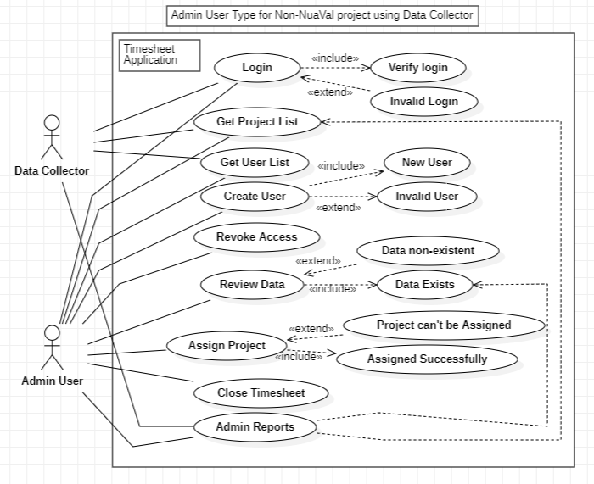

Figure Admin user

## Project Manager Requirements

The table below outlines a list of requirements for the Project Manager User.

|  |  |  |
| --- | --- | --- |
| **No.** | **Requirement** | **Description** |
| 1 | Login | The project manager will login through the Data Collector to gain access to the timesheet system. On successful login the user will be brought to the landing page. On error the user will be informed. |
| 2 | Get the list of projects | The project manager must be able to get a list of all the projects that they are linked with so as to select one project from the list to get detailed analysis. |
| 3 | Get a list of members | The project manager must be able to get a list of all the members that are linked to the project selected and the user must be able to select a member of the project from the list. |
| 4 | Approval of timesheet | The project manager must have the right to have access to all the submitted timesheets of which the user must be able to approve the ones that do not have any issues. |
| 5 | Edit or create record in timesheet | The project manager must have the right to change records in the timesheet submitted on behalf of the request made by the member of the project. Furthermore, the user must also be able to create new records in the timesheet as well on the behalf of the member of the project. |
| 6 | Delete a record | The project manager will have the access to delete any record from the timesheet submitted by the user for a selected user.  Should this be added to a audit log. |
| 7 | Add regular user | The project manager should be able to add new regular users in the project they can be pre-existing users from other projects or new users entirely. |
| 8 | Project manager level report | The project manager must have access to a dashboard that should allow the user to get detailed idea of what is going on in the selected project up to the granularity of the detailed work of any member of the project. |

Figure Project Manager

## Regular User Requirements

The table below outlines a list of requirements for the Regular User.

|  |  |  |
| --- | --- | --- |
| **No.** | **Requirement** | **Description** |
| 1 | Login | The regular user will login through the Data Collector to gain access to the timesheet system. On successful login the user will be brought to the landing page. On error the user will be informed. |
| 2 | Get a list of project | The regular user must be able to get a list of all the active projects that he is linked with and must be able to select from the given list. |
| 3 | Create a timesheet record | The regular user must be able to create a timesheet record manually by manually entering all the details and all the values for the same |
| 4 | Get a list of all the timesheet records | The regular user must be able to get a list of all the submitted timesheet records. These records will be read on access if they are approved and read and write access if they haven’t been approved. |
| 5 | Edit timesheet records | The regular user must be able to edit timesheet records after submission. This access to editing the records remains till the time the timesheet record is approved. After the approval of the timesheet record the regular type user will not be able to perform any changes for the same he has to send a request either to the project manager or the admin to get the records changed. |
| 6 | Get a list of approved timesheets | The regular user must be able to get a list of all the timesheets that have been submitted and has been approved by the project manager and these records must only be read only records and the user must not have access to change the records at all. |
| 7 | Delete a timesheet record | The regular user must be able to delete a submitted timesheet record. This action can only be accessed till the time the timesheet submitted by the user isn’t approved. Also, after the approval of a timesheet that record can’t be deleted by the user as the access level converts to read only. |
| 8 | User level report | The regular user must have access to a dashboard where all the analytics and important data must be displayed on the basis of the project selected. |

Figure Regular User

## Supervisor User Requirements

The table below outlines a list of requirements for the Supervisor User.

|  |  |  |
| --- | --- | --- |
| **No.** | **Requirement** | **Description** |
| 1 | Login | The Supervisor User must be able to login in the system and the system must be able to authenticate the credentials and show error if wrong credentials plugged. |
| 2 | Get a list of project | The Supervisor User must be able to get a list of active and inactive projects and the user must be able to select one of the project to get detailed information. |
| 3 | Get a list of users | The Supervisor User must be able to get a list of all the users linked with the project selected and should be able to view all the details. |
| 4 | Get a list of all the timesheet records | The Supervisor User must be able to get the record of all the timesheets submitted either approved or non-approved. |
| 5 | View Regular User Report | The Supervisor User must be able to view the dashboard of the Regular User type and view all the analytics data. |
| 6 | View Project Manager Report | The Supervisor User must be able to view the dashboard of the Project Manager User type and view all the analytics data. |
| 7 | View Admin Report | The Supervisor User must be able to view the dashboard of the Admin User type and view all the analytics data. |

Figure 4 Supervisor User

## Use Cases

There are many use cases that can be designed for the application to showcase the different scenarios but the following mentioned are the ones that are the most relevant ones. The below mentioned use cases will be able to describe the main features and also the design of the application and also how it’s working.

|  |  |  |
| --- | --- | --- |
| **Index** | **User** | **User cases** |
| 1 | Admin | Revoking Access |
| 2 | Admin | Adding/Enabling New User |
| 3 | Admin | Closes the Timesheet |
| 4 | Admin | Changes Timesheet After Approval |
| 5 | Admin | Reviews Delete Request |
| 6 | Project Manager | Project Manager Extracts Timesheet Information of the Selected User |
| 7 | Project Manager | Project Manager Edits the Timesheet Record of the Selected User |
| 8 | Project Manager | Project Manager Approves the Timesheet of the Selected User |
| 9 | Project Manager | Project Manager Deletes the Timesheet for the Selected User |
| 10 | Project Manager | Project Manager Changes the Status of the Timesheet for Selected User |
| 11 | Regular User | User wants to Edit Timesheet |
| 12 | Regular User | User wants to input data |
| 13 | Supervisor User | Supervisor gets a list of all projects and selects one |
| 14 | Supervisor User | Supervisor gets a list of all projects and users linked to select one and get details |
| 15 | Supervisor User | Supervisor gets Timesheet information of Selected User |
| 16 | Supervisor User | Supervisor views the dashboard of all the different types of users |

## Use Case Diagrams with Description

### Use Case: Admin Revoking Access

1. The admin will login using the valid credentials and the system will check the validity of the credentials.
2. The admin when received a request to revoke access of the user will first validate that the user is a valid user this will be done by the system.
3. After selecting the user the admin can change the status of the access level and saves all the data to the main database.

### Use Case: Admin Adding/Enabling New User

1. The admin will login using the valid credentials and the system will check the validity of the credentials.
2. The admin will first select a project from the project list and then the system will determine if the selected project is valid or not.
3. The admin will then selects the user and add the information to the project linking the user with the project.
4. The final step will be updating the main database which will be done by the system.

### Use Case: Admin closes the Timesheet

1. The admin user will login using the valid credentials which will be checked by the system.
2. The admin will select a project from the dropdown list and its validity will be checked by the system then a user will be selected linked with the project and the validity of the selected user will also be verified.
3. Then the admin will get a list of all the timesheets of which he can select the approved timesheets and then he will be presented with the close timesheet button.
4. After closing the timesheet the data will be available to other departments for further processing.
5. The final step is updating the main database with the updated data.

### Use Case: Admin Changes Timesheet After Approval

1. The admin user will login using the valid credentials which will be checked by the system.
2. The admin will select a project from the dropdown list and its validity will be checked by the system then a user will be selected linked with the project and the validity of the selected user will also be verified.
3. Then the admin will get a list of all the timesheets of which he can select the approved timesheet and then he will be presented with an edit button through which he can edit the timesheet according to the requirements.
4. The final step after the editing of the timesheet is completed is to update the main database.

### Use Case: Admin Reviews Delete Request

1. The admin user will login using the valid credentials which will be checked by the system.
2. The admin will select a project from the dropdown list and its validity will be checked by the system then a user will be selected linked with the project and the validity of the selected user will also be verified.
3. Then the admin will get a list of all the timesheets of which he can select the approved timesheet and then he will be presented with a delete button and he can delete the selected timesheet record.
4. The final step is updating the main database with the updated information about the deleted record.

### Use Case: Project Manager Extracts Timesheet Information of the Selected User

1. The project manager logs into the system with the provided credentials which will be verified by the system for the validity. If valid the user will be presented with the project manager portal.
2. From the project manager user portal the project list can be selected from the dropdown menu (only one project can be selected at once).
3. When project is selected from the list the system will check for the validity of the project selected whether there is any data present for the selected project or not. If present the user can proceed to the next step otherwise an error will ne shown.
4. The user will be presented with a list of all the users that are linked to the selected project from which the user can select one user at a time. Here, the system will select if the data for the selected user for the selected project exits or not. If the data does exist then the user can proceed to the next step.
5. After selecting the user the project manager will be presented with all the submitted timesheets for the selected user and he will be able to select one timesheet to perform different actions or even just view the timesheet.

### Use Case: Project Manager Edits the Timesheet Record of the Selected User

1. The project manager logs into the system with the provided credentials which will be verified by the system for the validity. If valid the user will be presented with the project manager portal.
2. From the project manager user portal the project list can be selected from the dropdown menu (only one project can be selected at once).
3. When project is selected from the list the system will check for the validity of the project selected whether there is any data present for the selected project or not. If present the user can proceed to the next step otherwise an error will be shown.
4. The user will be presented with a list of all the users that are linked to the selected project from which the user can select one user at a time. Here, the system will select if the data for the selected user for the selected project exits or not. If the data does exist then the user can proceed to the next step.
5. After selecting the user the project manager will be presented with all the submitted timesheets for the selected user and he can then edit the timesheet accordingly.
6. When done editing the user can save the timesheet and an updated version of the timesheet will be saved in the database.

### Use Case: Project Manager Approves the Timesheet of the Selected User

1. The project manager logs into the system with the provided credentials which will be verified by the system for the validity. If valid the user will be presented with the project manager portal.
2. From the project manager user portal the project list can be selected from the dropdown menu (only one project can be selected at once).
3. When project is selected from the list the system will check for the validity of the project selected whether there is any data present for the selected project or not. If present the user can proceed to the next step otherwise an error will be shown.
4. The user will be presented with a list of all the users that are linked to the selected project from which the user can select one user at a time. Here, the system will select if the data for the selected user for the selected project exits or not. If the data does exist then the user can proceed to the next step.
5. After selecting the user the project manager will be presented with all the submitted timesheets for the selected user and the user can select a timesheet. If the timesheet is already approved he will be displayed a message if the selected timesheet is not approved he can move to the next step and can approve the selected timesheet.
6. When the user is finished with the actions that he needed to perform he can save the timesheet and an updated version of the timesheet will be saved in the database.

### Use Case: Project Manager Deletes the Timesheet for the Selected User

1. The project manager logs into the system with the provided credentials which will be verified by the system for the validity. If valid the user will be presented with the project manager portal.
2. From the project manager user portal the project list can be selected from the dropdown menu (only one project can be selected at once).
3. When project is selected from the list the system will check for the validity of the project selected whether there is any data present for the selected project or not. If present the user can proceed to the next step otherwise an error will be shown.
4. The user will be presented with a list of all the users that are linked to the selected project from which the user can select one user at a time. Here, the system will select if the data for the selected user for the selected project exits or not. If the data does exist then the user can proceed to the next step.
5. After selecting the user the project manager will be presented with all the submitted timesheets for the selected user and he can then delete any of the timesheet.
6. When the user is finished performing the relevant action he can save the timesheet and an updated version of the timesheet will be saved in the database.

### Use Case: Project Manager Changes the Status of the Timesheet for Selected User

1. The project manager logs into the system with the provided credentials which will be verified by the system for the validity. If valid the user will be presented with the project manager portal.
2. From the project manager user portal the project list can be selected from the dropdown menu (only one project can be selected at once).
3. When project is selected from the list the system will check for the validity of the project selected whether there is any data present for the selected project or not. If present the user can proceed to the next step otherwise an error will be shown.
4. The user will be presented with a list of all the users that are linked to the selected project from which the user can select one user at a time. Here, the system will select if the data for the selected user for the selected project exits or not. If the data does exist then the user can proceed to the next step.
5. After selecting the user the project manager will be presented with all the submitted timesheets for the selected user and the user can select a timesheet. If the timesheet is already approved he will be displayed a message and he can proceed to change the status of the timesheet to not approved.
6. When the user is finished with the actions that he needed to perform he can save the timesheet and an updated version of the timesheet will be saved in the database.

### Use case: Regular User wants to Edit Timesheet

1. The regular user will login using the valid credentials which will be checked by the system.
2. The user will then get a list of the submitted timesheets and from the list the user can select one.
3. The system will check if the timesheet is approved or not. If it is approved the user can’t change the timesheet but if it isn’t approved then the user will be presented with the edit timesheet option and can edit the timesheet.
4. If the timesheet is approved the admin will be able to either edit or delete the timesheet record.
5. After the required changes are done to the timesheet the system will then update the database with updated data.

### Use Case: Regular User wants to input the timesheet data

1. The regular user logs into the system and these credentials will be validated by the system.
2. The user then will be presented with the list of all the linked projects and can select one of the projects.
3. After selecting the project the system will check if the access has been revoked or not.
4. When user is done adding the data for the timesheet then he can submit the timesheet for approval.
5. This timesheet is then updated in the main database.

### Use Case: Supervisor gets a list of all projects and selects one

1. The Supervisor User logs in with the valid credentials which will be checked by the system.
2. The supervisor will then get a dropdown list of all the projects and can select from it.
3. The list will contain data of both active as well as inactive projects and the supervisor has to select one to get the detailed information.
4. Then after selecting the project the supervisor will be able to view the details of the project.

### Use Case: Supervisor gets a list of all projects and users linked to select one and get details

1. The supervisor user logs in with the valid credentials which will be checked by the system.
2. The user will then get a dropdown list of all the projects and can select a project from it.
3. The user can then view all the users linked with the selected project and can select a user to view all detailed information.
4. After the user selection the user will have all the detailed information about the user with view only access.

### Use Case: Supervisor gets Timesheet information of Selected User

1. The supervisor user logs in with the valid credentials which will be checked by the system.
2. The user will then get a dropdown list of all the projects and can select a project from it.
3. The user can then view all the users linked with the selected project and can select a user to view all detailed information.
4. After the user selection the user will have all the detailed information about the user with view only access.
5. Here the user can select a timesheet to view all the information.

### Use Case: Supervisor views the dashboard of all the different types of users

1. The supervisor user logs in with the valid credentials which will be checked by the system.
2. The user will then get a dropdown list of all the projects and can select a project from it.
3. The user can then view all the users linked with the selected project and can select a user to view all detailed information.
4. After the user selection the user will have all the detailed information about the user with view only access.
5. Now the user can view the dashboard of the user in details with view access only.

## Rules and examples

The application will support rules that will be enforced by the system. In the initial release these rules will be applied to all users – in future releases certain rules can be applied to categories of users.

Below is a list of initial rules that will be operated in the system.

|  |  |  |
| --- | --- | --- |
| No. | Rule / Exceptions | Priority |
| 1 | Each user has to have a minimum of 40 hours submitted per week. This can be a combination of project work, sick leave and annual leave |  |
|  |  |  |
| 2 | The total of sick leave and annual leave cannot exceed 40 hours per week. |  |
|  |  |  |
| 3 | If annual leave in total for the year exceeds X days project manager and admin notified |  |
|  |  |  |

## Block diagram architecture

A requirement of the application is that it can be used by both internal and external processes.

* Internal processes is applications and business processes within KPC International that need to record time for activities.
* External processes are customers that may use the application for their own time tracking purposes. This would be deployed either within the KPC Internal environment or external to it.

This diagram above shows the outline of a scalable decoupled architecture that would provide for both an internal and external facing application.

|  |  |
| --- | --- |
| Architecture Layer | Description |
| Data Tier | Main data persistence that stores the transaction data need to run the application |
|  |  |
| Replication Process | A process (maybe ETL - Extract, transform and Load) that pulls data from the transactional runtime database into a date warehouse storage for off line processing. |
|  |  |
| Data Analytics Tier | Data persistence that will store current and historical data for other processes to interrogate and process. |
|  |  |
| Auth Process | Process to allow authentication of users. |
|  |  |
| Data Science Processes | Runtime environment (e.g. Python and associative libraries/ and/or Azure ML platform) to allow insights/predictions to be generated. |
|  |  |
| Data Extraction Processes | Process(s) that outputs data in compatible format for other applications such as payroll, invoicing etc. |
|  |  |
| Report Generation Processes | Business report generation |
|  |  |
| Business Tier | Main business logic tier with API access |
|  |  |
| Web Tier | User interface |
|  |  |
| NuaVal | External application that accesses time tracking features through a API |
|  |  |
| Other Applications | Any other application that may need to consume or provide data to time tracking application |

# External Interface Requirements

A detailed list of all the wireframes is provided below. Detailed summary of the wireframe with the motive and the working is provided alongside the wireframe.

List of all the wireframes categorised on the basis of user type:

1. Admin Type User:
   1. Login Page
   2. Admin Portal
   3. Admin Tools Portal
   4. Admin Timesheet Portal
   5. Admin User Timesheet
2. Regular Type User:
   1. Login Page
   2. Regular User Portal
   3. Regular User Tools Portal
   4. Regular User Timesheet
3. Project Manager Type User:
   1. Login Page
   2. Project Manager User Portal
   3. Project Manager Tools Portal
   4. Project Manager Timesheet
4. Supervisor Type User:
   1. Supervisor User Portal
   2. Supervisor Tools Portal
   3. Supervisor User Timesheet

It is important to note that the login page for all the user types will be the same and it may later be decided to be removed and the active directory might be used in the place of the same.

## Data Collection for Non-NuaVal Project

The below workflow shows the data collection being done for the Non-NuaVal type project. In the initial version of the application the data will be collected manually using a form based UI which will then generate an excel type data which could be exported into different types of data forms which then can be used by the application. This version of timesheet will contain detailed information of the timesheet that will have the first level of information starting from Project ID. This will be filled in manually by the user in the initial application which will be done by presenting the user with a user interface of a form type where the user will input all the data in details as required. The different levels of detailed information that will be manually entered by the user is as follows:

1. Project ID
2. Area ID
3. Activity
4. Document Status
5. Standard Hours Worked (for the day which will be filled in automatically, if less hours worked then the user can edit the number of hours worked)
6. Overtime – {during development workshops - details of whether this will be entered or calculated will be decided}
7. Annual Leave
8. Sick Leave

All of the above data will be collected and can be exported in several data formats and then it will either be collected in a separate database or it will go directly to the time-tracking application.

## User Interface Concepts

This section outlines potential concept user interface models – the finalised user interface will be designed and developed during the development phase.

### Login Page

The login page will be the first page any user type will be greeted with when accessing the application. This page will be common with all the user types. Here the user will have to provide a mandatory input of “username” and “password”. After providing the credentials the system will verify the credentials and check of the provided details are valid or not and whether the user have any kind of access. Furthermore, the system will also determine what kind of user it is based on the credentials logged in. This is necessary as that will determine the level of access the user have of the application.

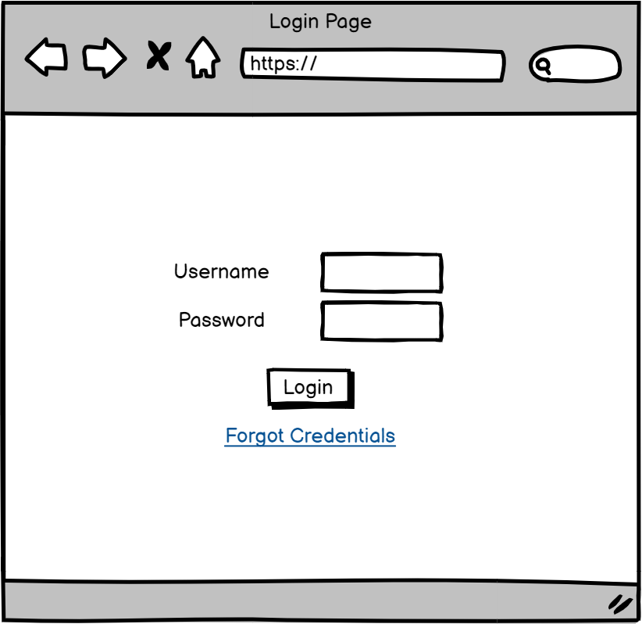

|  |  |  |
| --- | --- | --- |
| **No.** | **Requirement** | **Description** |
| 1 | Login Page | The Login system will take allow all types of users to login and also distinguish between them. |
| 2 | Username | The user has to provide a valid username in the field. This is a mandatory field for the login system to work. |
| 3 | Password | The user has to provide a valid password linked with the username entered above. This is a mandatory field for the login system to work. |
| 4 | Login Button | When clicked the system will check the credentials and let the user in to the appropriate destination based on the user type else gives error. |
| 5 | Forgot Credentials | When clicked If the user don’t remember either of the above mentioned mandatory fields then the link will take to a portal to further authenticate and reset the credentials. |

### Admin Portal

The admin portal page will provide the user logged in with all the tools necessary to perform administrative duties. The user will have read and write access to all of the data and information in the database and will be able to view all the different versions of dashboards based on the different types of users. When logged in the page will allow the administrator to have a quick insight into the number of currently active vs the currently inactive projects. Furthermore, the admin will be able to select a project from the dropdown list. This list will contain all the projects that are present in the directory of projects and will allow to select one project. After the selection of the project the user will then be allowed to select a user from the drop down list. This list will contain all the different users that are linked with the project selected. When clicked on the user data button the user will be directed towards the admin tools portal where he can perform more actions. Moreover, the admin also have the option to create a new user as well as create new project by clicking on the create new user or create new project button respectively. Finally, there is an option of contact on the page which will provide information regarding who to contact if any assistance is required or to raise a request to perform an action. To raise a request email client will be used and not the timesheet management system.

|  |  |  |
| --- | --- | --- |
| **No.** | **Requirement** | **Description** |
| 1 | Admin Portal Page | The interface system with administrator level access. |
| 2 | Home | The link will take the user to the main user portal where he can get the basic insights. |
| 3 | Dashboard | The link will take the user to the dashboard section where he can see the timesheets and other analytics. |
| 4 | Contact | The link will take the user to the contact section where the contact details for support will be present. |
| 5 | Select Project | This is a dropdown list providing a list of all the projects from the active directory from which the user can select one at a time. |
| 6 | Select User | This is a dropdown list providing a list of all the users that are linked to the project selected. |
| 7 | User Data | When clicked on this button it will redirect to the dashboard page with the above details as input for the detailed information about the timesheets. |
| 8 | Create New User | When clicked on this button it will redirect to the forms page where the user will be able to put in the details of the new user as per the requirements stated. |
| 9 | Create New Project | When clicked on this button it will redirect to the forms page where the user will be able to put in the details of the new project as per the requirements stated. |
| 10 | Projects | The link take the user to a page with view access only showcasing all the active as well as inactive projects currently in the active directory. |

### Admin Tools Portal

When the admin selects the project and the user from the dropdown list and click on user data he will be taken to the admin tools portal. This page contains all the tools necessary to perform any form of administrative tasks. On this portal the project details of the user is provided which lists all the different projects that the user is linked with the project number in order to create the link between the timesheet data and the projects linked with the user. Furthermore, there is a section that gives detailed information about the selected user and also provides the admin an option to revoke the access of the user and also edit this information if requested by the user. Additionally, the admin is also able to assign a project to the selected user as well from the portal. Below all this information the admin will have access to the timesheets that were submitted by the selected user with the action buttons next to every timesheet entry. These buttons are; view as the eye icon which will pop out a window showing the timesheet in details with read only access, the delete button to delete the timesheet record if it was requested by the user, then the arrow with disk will perform close timesheet action which is executed if the admin decides that the timesheet submitted is as per the requirements. This action lets the admin forward the timesheet to be processed by the other departments. If the admin decides to perform more actions on the timesheet he can select the timesheet and then click on select timesheet button which will direct the user to a different page with more tools and actions available.

|  |  |  |
| --- | --- | --- |
| **No.** | **Requirement** | **Description** |
| 1 | Admin Tools Portal Page | The interactive page with the administrator level access and all the admin tools available. |
| 2 | Home | The link will take the user to the main user portal where he can get the basic insights. |
| 3 | Dashboard | The link will take the user to the dashboard section where he can see the timesheets and other analytics. |
| 4 | Contact | The link will take the user to the contact section where the contact details for support will be present. |
| 5 | Select Timesheet | The user will be able to select a timesheet from the list above. By clicking it will take the user to a page with more detailed information about the selected timesheet. |
| 6 | Edit User | By clicking this the user will be able to change the details of the selected user. |
| 7 | Revoke | By clicking this the user will be able to revoke edit access for the selected user and the selected user will not be able to submit any timesheet record or edit them. |
| 8 | Assign Project | By clicking this the user will be able to assign a project to the selected user and also will be able to see all the projects that are linked to the selected user. |

### Admin Timesheet Portal

The admin timesheet portal will contain more actions and tools designed to manage the selected timesheet and perform Omition if required. On this page the admin will be able to view the selected timesheet in details containing the different projects on which the user has worked on and how many hours he has worked on. Furthermore, the timesheet will also contain the total number of hours put in everyday and the weekly total hours. There will also be a section that will contain the details about the standard hours, overtime, time off in lieu, and sick leave. This data will be available on a weekly basis. Additionally, there will a section containing the details of projects linked with the user and the user details. The admin will have the option to edit the timesheet as per the requirements also depending upon any requests sent by the selected user. He will also have the option to delete the timesheet if there is any form of discrepancy found in the timesheet. Also, the admin can change the status of the timesheet from approved to not approved and if everything is up to the requirements the admin will then close the timesheet and allow the other departments to access the timesheet and perform further actions.

|  |  |  |
| --- | --- | --- |
| **No.** | **Requirement** | **Description** |
| 1 | Admin Tools Portal Page | The interactive page with the administrator level access and all the admin tools available. |
| 2 | Home | The link will take the user to the main user portal where he can get the basic insights. |
| 3 | Dashboard | The link will take the user to the dashboard section where he can see the timesheets and other analytics. |
| 4 | Contact | The link will take the user to the contact section where the contact details for support will be present. |
| 5 | Select Timesheet | The user will be able to select a timesheet from the list above. By clicking it will take the user to a page with more detailed information about the selected timesheet. |
| 6 | Edit User | By clicking this the user will be able to change the details of the selected user. |
| 7 | Revoke | By clicking this the user will be able to revoke edit access for the selected user and the selected user will not be able to submit any timesheet record or edit them. |
| 8 | Assign Project | By clicking this the user will be able to assign a project to the selected user and also will be able to see all the projects that are linked to the selected user. |
| 9 | Edit Timesheet | By clicking this the user will be able to edit the timesheet selected above on behalf of the selected user. |
| 10 | Delete Timesheet | By clicking this the user will be able to delete the timesheet selected above on behalf of the selected user. |
| 11 | Change Status | By clicking this the user will be able to change the status of the timesheet from approved to not approved so the selected user can change the details. |
| 12 | Close Timesheet | By clicking this the user will be able to close the selected timesheet for further processing for the selected user. |

### Project Manager User Portal

The project manager user portal will contain the basic overview of the timesheets that he has submitted. With every entry of the timesheet there will be two actions that the user can perform. He can view the timesheet in a form of a popup window. Also, if the user wants to edit the timesheet he can by clicking on the pen action button alongside the timesheet entry. The user can also submit a timesheet entry by clicking on the submit timesheet button and entering all the details necessary to fill in the timesheet entry. The project manager will have an option to select a project from the dropdown list of all the projects that he is linked to and can select one from the list. After the project selection process the project manager can select a user from the user drop down list. Finally, the project manager can click on the user data button and will be able to get the detailed information of the user selected and can perform further actions related to the project manager.

|  |  |  |
| --- | --- | --- |
| **No.** | **Requirement** | **Description** |
| 1 | Project Manager Portal Page | The interactive page with the project manager level access and all the project manager tools available. |
| 2 | Home | The link will take the user to the main user portal where he can get the basic insights. |
| 3 | Dashboard | The link will take the user to the dashboard section where he can see the timesheets and other analytics. |
| 4 | Contact | The link will take the user to the contact section where the contact details for support will be present. |
| 5 | Select Timesheet | The user will be able to select a timesheet from the list above. By clicking it will take the user to a page with more detailed information about the selected timesheet. |
| 6 | Submit Timesheet | By clicking this the user will be able to submit a timesheet record for the approval. |
| 7 | Select Project | This will provide the user with a dropdown list of the projects that the user linked with and will allow to select one project at a time. |
| 8 | Select User | This will provide the user with a dropdown list of the user that are linked with the project selected |
| 9 | User Data | By clicking this the user will be redirected to a page with the details of all the records for the selected user. |
| 10 | My Timesheets | In this interactive box the user will be able to see an overview of all the timesheets that he has uploaded and their status as well. |

### Project Manager Tools Portal

After clicking the user data button the project manager will be directed to the tools portal where all the relevant tools will be present necessary for the project manager to perform certain tasks and actions. On this page the main information will be the detailed view of the selected timesheet for the selected user. There will also be a section where the details of the user will be showcased providing a reference to all the projects that are linked with the user which is provided in the section next to the above mentioned. The project manager also have to option to edit the selected timesheet according to the requirements or any requests made by the user. Furthermore, there is also an option to delete the timesheet as well if required or requested. If the project manager deems the timesheet to be up to the requirements then he can click on the approve timesheet button which will approve the timesheet and update the status of the timesheet instantly. Moreover, the project manager also has the option to change the status of the timesheet from approved to not approved on the basis of request sent by the user. This will be done on situation by situation basis.

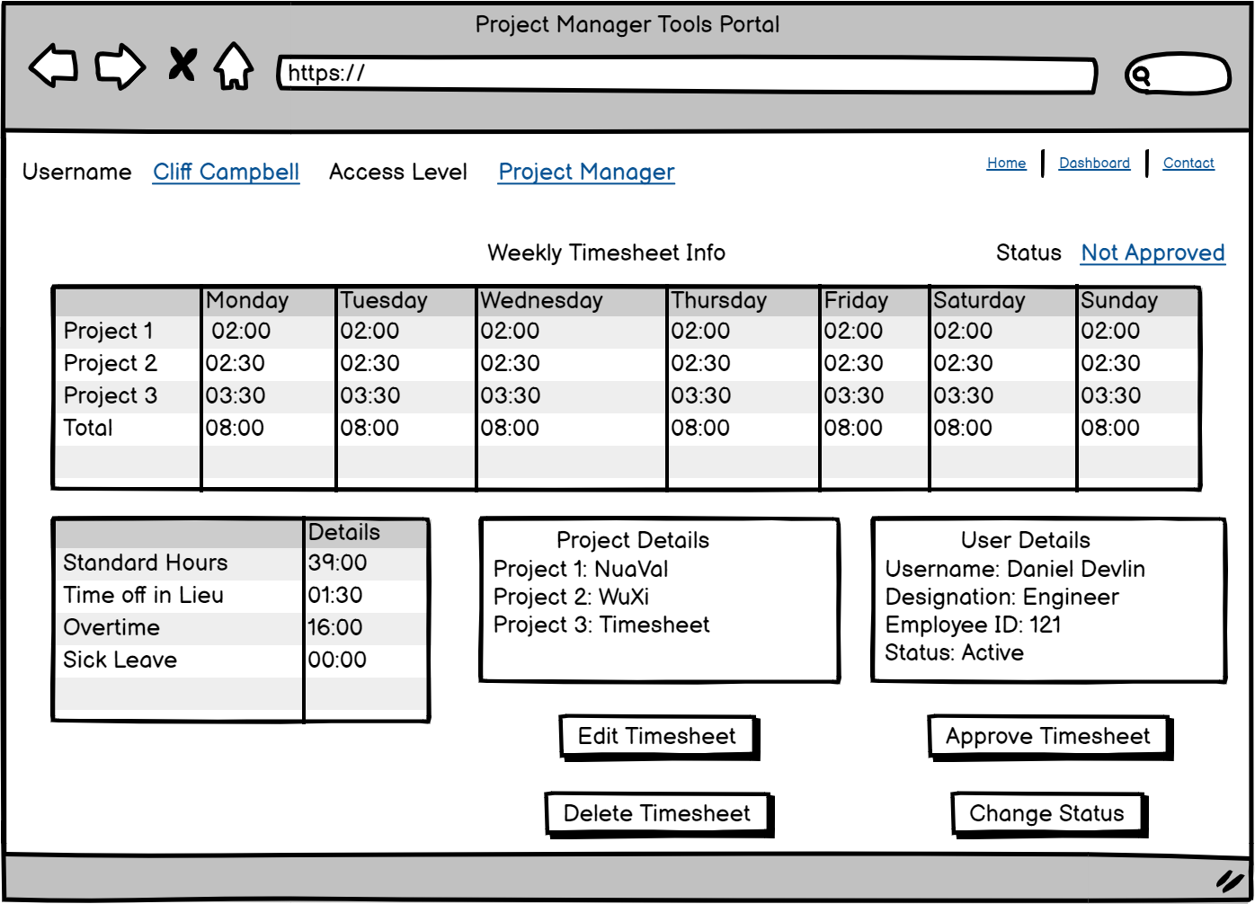

|  |  |  |
| --- | --- | --- |
| **No.** | **Requirement** | **Description** |
| 1 | Project Manager Tools Portal Page | This is an interactive page with all the tools necessary for the functioning of a project manager. |
| 2 | Home | The link will take the user to the main user portal where he can get the basic insights. |
| 3 | Dashboard | The link will take the user to the dashboard section where he can see the timesheets and other analytics. |
| 4 | Contact | The link will take the user to the contact section where the contact details for support will be present. |
| 5 | Edit Timesheet | By clicking this the user will be able to edit the timesheet information for the selected user on behalf of the selected user |
| 6 | Delete Timesheet | By clicking this the user will be able to delete the timesheet record for the selected record on behalf of the selected user. |
| 7 | Approve Timesheet | By clicking this the user will be able to approve one or more timesheets selected above for the selected user. |
| 8 | Edit User | By clicking this the user will be able to edit the details of the selected user on behalf of the user. |
| 9 | Assign Project | By clicking this the user will be able to assign a project to the selected user. |

### Regular User Portal

When a regular user logs in from the login page and if the credentials are valid with no access revoked from the admin side the user will land on to the regular user portal page. This page will contain a brief overview of the hours that he has worked. This graph will depend on the submitted timesheets that have been approved by the project manager. Also there will be a section with the list of all the projects that the user is linked with and he can select any one of the project to get more detailed information. This process is done by first selecting the project from the list and then clicking on my data button which will direct the user to a different

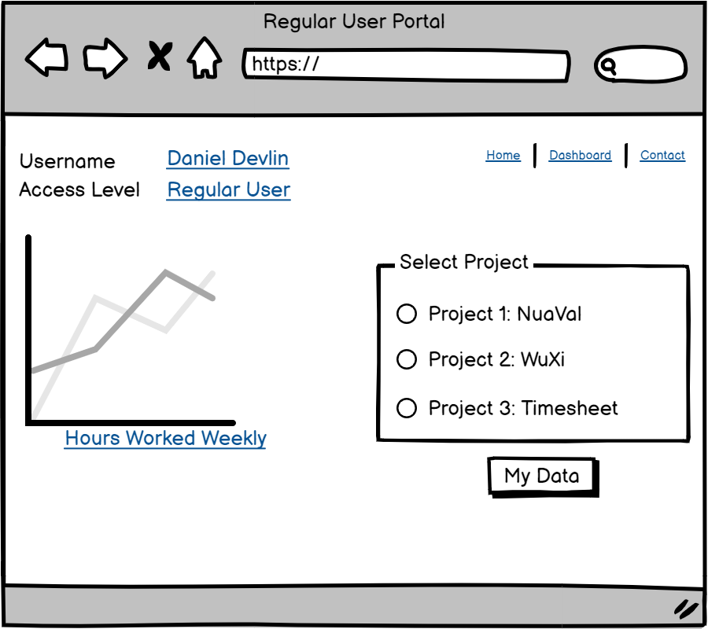

|  |  |  |
| --- | --- | --- |
| **No.** | **Requirement** | **Description** |
| 1 | Regular User Portal Page | This is an interactive page with the basic insights about the hours worked in real-time. |
| 2 | Home | The link will take the user to the main user portal where he can get the basic insights. |
| 3 | Dashboard | The link will take the user to the dashboard section where he can see the timesheets and other analytics. |
| 4 | Contact | The link will take the user to the contact section where the contact details for support will be present. |
| 5 | Select Project | This will provide a dropdown list of all the projects the selected user is linked with. |
| 6 | My Data | By clicking this the user will be able to view all the timesheets submitted for the selected project. |
| 7 | Hours Worked | This graph shows an overview of all the hours worked on different projects in a week in real-time. |

### Regular User Tools Portal

When the regular user logs in and then provide all the credentials that the system will check to validate. When clicked on the my data button on the user portal then the user will be presented with this user tools portal. Here the user will be able to view all the recently submitted timesheets and will have an option of archive where he can see all the old timesheet information. Here right next to the recently submitted timesheet there will be two actions that can be done on the timesheet straightaway. The eye like button will allows the user to view the timesheet as a pop-up window. The pen like button allows the user to edit the timesheet only if the timesheet hasn’t been approved yet. Here, the user will have the option to create timesheet by clicking on the create timesheet button. This will that the user to another page where the data could be inputted. There will also be a section showcasing the user details and also the project details showing all the projects that he is linked with.

|  |  |  |
| --- | --- | --- |
| **No.** | **Requirement** | **Description** |
| 1 | Regular User Portal Page | This is an interactive page with all the tools necessary for the functioning of a regular user. |
| 2 | Home | The link will take the user to the main user portal where he can get the basic insights. |
| 3 | Dashboard | The link will take the user to the dashboard section where he can see the timesheets and other analytics. |
| 4 | Contact | The link will take the user to the contact section where the contact details for support will be present. |
| 5 | Select Timesheet | By clicking this the user will be able to select the timesheet and view details of the selected timesheet. |
| 6 | Submit Timesheet | By clicking this the user will be able to view all the timesheets submitted for the selected project. |
| 7 | Edit Unapproved Timesheet | By clicking this if the user has selected an unapproved timesheet then he can edit the timesheet data and re-submit. |

### Regular User Timesheet

When the regular user clicks on create timesheet button on the regular user tools portal he is directed towards the timesheet portal where the user will be able to input the timesheet and will be able to edit the records. This page would be the same if the user is trying to edit any unapproved timesheets as well. After the user has filled in all the information or has finished editing then the user can click on the submit button and the timesheet will be sent forward to the project manager for approval. Here the user can also see his details and also the project details as a reference. Furthermore, the user will also be able to see the different categories under which his worked or non-worked hours lies in. Also, the user will be able to input the annual leave or sick leave info into the timesheet while submitting.

|  |  |  |
| --- | --- | --- |
| **No.** | **Requirement** | **Description** |
| 1 | Regular User Timesheet | This is the page where the user will input the timesheet data and will be able to submit the timesheet |
| 2 | Home | The link will take the user to the main user portal where he can get the basic insights. |
| 3 | Dashboard | The link will take the user to the dashboard section where he can see the timesheets and other analytics. |
| 4 | Contact | The link will take the user to the contact section where the contact details for support will be present. |
| 5 | Submit Timesheet | By clicking this the user will be able to submit a timesheet record for approval. |

### Regular User Timesheet (Non-NuaVal Project)

|  |  |  |
| --- | --- | --- |
| **No.** | **Requirement** | **Description** |
| 1 | Regular User Timesheet | This is the page where the user will input the timesheet data and will be able to submit the timesheet |
| 2 | Home | The link will take the user to the main user portal where he can get the basic insights. |
| 3 | Dashboard | The link will take the user to the dashboard section where he can see the timesheets and other analytics. |
| 4 | Contact | The link will take the user to the contact section where the contact details for support will be present. |
| 5 | Submit Timesheet | By clicking this the user will be able to submit a timesheet record for approval. |

### Supervisor User Portal

After the supervisor user logs into the system his credentials will be validated to check if the credentials are correct or not. After credentials check the user will be directed to the user portal where he will be able to view his recently submitted timesheet where he will have the option to view the submitted timesheet or edit a timesheet that is not approved. The user will also have the option to select a project from the dropdown list and then select a user that is linked to the selected project. Then when clicked on the user data button the user will be presented with the details of the user and all the timesheet submitted. Also, when clicked on the archive button the user will be able to view all the previously submitted timesheets. From this portal itself the user will be able to submit a new timesheet and input all the data and submit it for approval.

|  |  |  |
| --- | --- | --- |
| **No.** | **Requirement** | **Description** |
| 1 | Supervisor User Portal Page | This is an interactive page with a basic overview of the user details and only have view access and would not be able to edit anything. |
| 2 | Home | The link will take the user to the main user portal where he can get the basic insights. |
| 3 | Dashboard | The link will take the user to the dashboard section where he can see the timesheets and other analytics. |
| 4 | Contact | The link will take the user to the contact section where the contact details for support will be present. |
| 5 | Select Project | This is a dropdown list containing a list of all the projects from which the user can select a project. |
| 6 | Select User | This is a dropdown list containing a list of all the users linked with the selected project and the user will be able to select a user. |
| 7 | User Data | By clicking this the user will be redirected to another page with all the details of the selected user. |
| 8 | My Submitted Timesheets | This interactive box will showcase the timesheet data submitted by the user on a weekly basis and also will be able to see the status of the timesheet. |
| 9 | View Timesheet | By clicking this the user will be able to view the detailed view of the selected timesheet. |
| 10 | Submit Timesheet | By clicking this the user will be able to submit a timesheet record for approval. |

### Supervisor Tools Portal

When the user selects one of the timesheet from the list for the selected user and click on user data then he will be directed to the supervisor tools portal where he will be able to view the selected timesheet in details. This user only has read access and not write access which allows the user to only view data for verification purposes and would not be able to alter the data. On this portal the timesheet is available in details showcasing all the hours the user has worked on all the different projects in a week. Also his leave and other categories of working hours are also displayed here. Furthermore, the user will be able to see the selected user details and also will have access to the list that contains all the projects that the user is linked with.

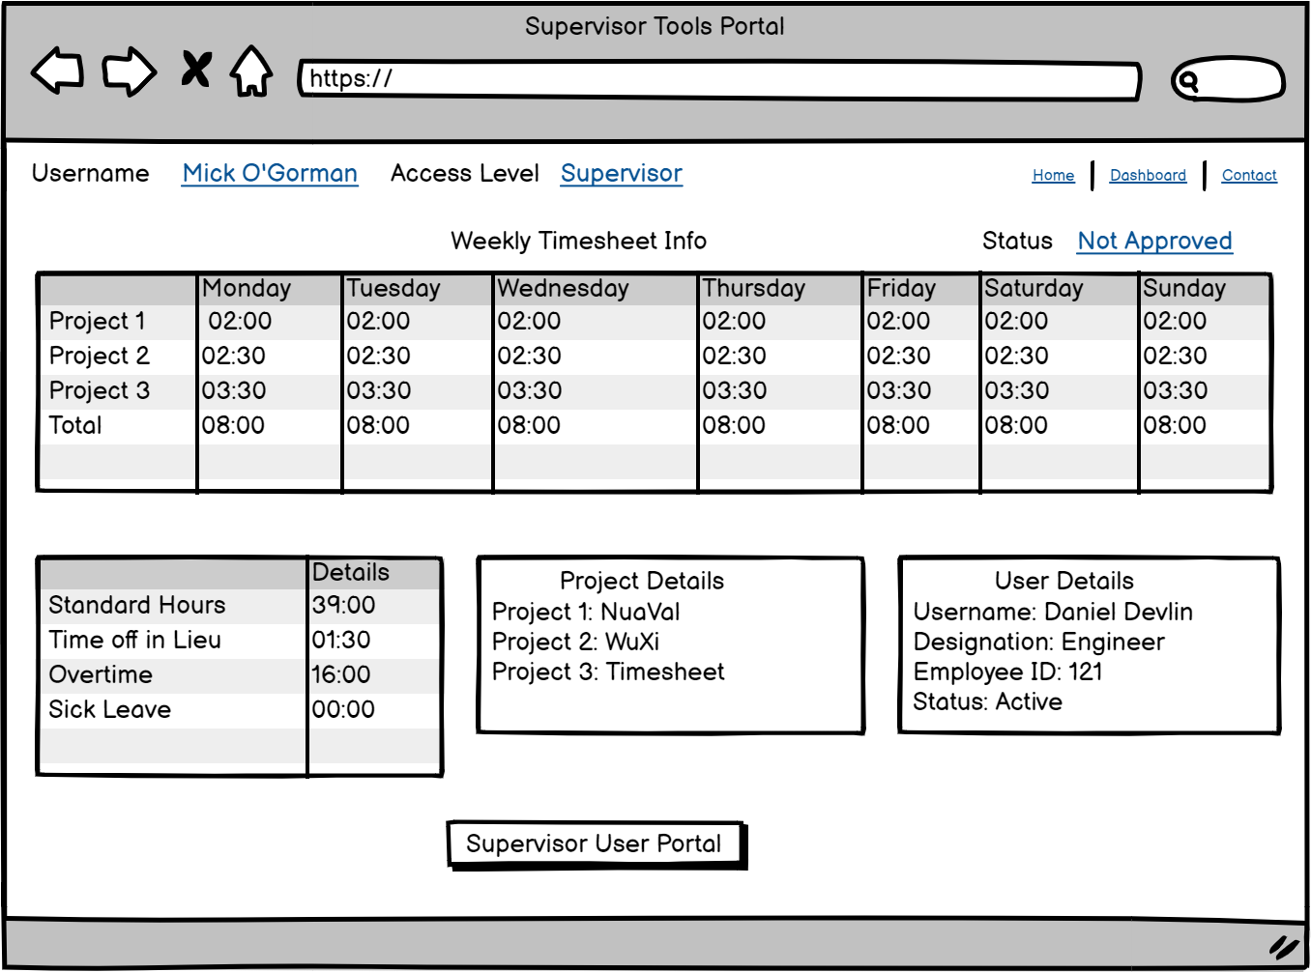

|  |  |  |
| --- | --- | --- |
| **No.** | **Requirement** | **Description** |
| 1 | Supervisor Tools Portal Page | This is an interactive page with a basic overview of the user details and will have the tools necessary for the functioning of the supervisor. |
| 2 | Home | The link will take the user to the main user portal where he can get the basic insights. |
| 3 | Dashboard | The link will take the user to the dashboard section where he can see the timesheets and other analytics. |
| 4 | Contact | The link will take the user to the contact section where the contact details for support will be present. |
| 5 | View My Timesheet | By clicking this the user will be able to go to the page where he can view all his submitted timesheets. |
| 6 | Detailed Timesheet Info | In this interactive box the user will be able to only view the selected timesheet for the selected user in details. |

# Software interface requirements

Data analysis environment (what is it, the output and where will it go)

Using the NuaVal Data

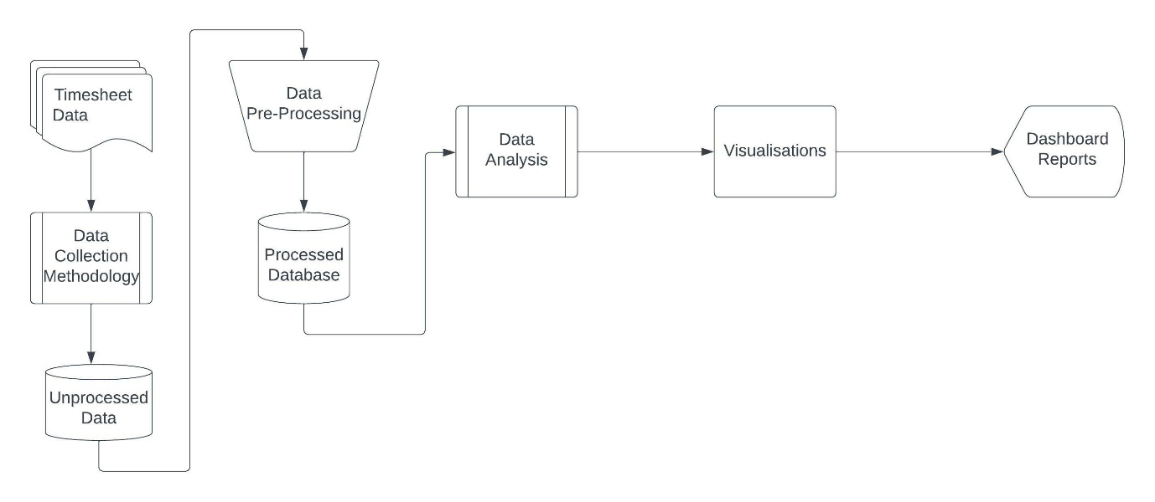

Using Non-NuaVal Data

# Non-functional requirements

## Security

There are different security regulations that must be followed for the preservation of the data protection regulations:

1. The application must be able to handle different layers of access for the different types of users.
2. There should be a secure login system that prevents any form of unauthorized access.
3. The data collected should be stored safely in a database and must be encrypted.
4. The user must be made aware of the data that is being collected and must be provided with the terms and conditions of using the application.
5. There should be a user agreement document that must be provided to the user in the beginning so that the user is aware of the data that the system is using and is able to view.

## Data Integrity

The software will have an authentication layer in the form of login page where different users have to log in and this layer will be responsible for the determination of the different types of users and will also provide a layer of security by not allowing the users without proper authentication to log into the system and will prevent these kind of users to get any form of access. Furthermore, there will be backups created for the data that is being stored so that if there is any data that gets lost or corrupted from the main database there will be a backup present to retrieve the information. Also, if any entity outside the authorised access wants to look at the data they have to get a clearance from the supervisor. Moreover, the different user types have different access levels to create a hierarchy and not provide unnecessary information to a user that is not relevant to the user type or allow access to tools that are irrelevant to the user type.

## Capacity

In the initial version of the software there would not be a lot of data present so the requirement for the data storage will be very less but in the later versions with more features implemented in the software the size of the storage section can be increased accordingly.

## Scalability

The application needs to be able to scale when demand on the system resources increases from both a responsive and data storage standpoint.

## Maintainability

The system will be easily maintainable and will be capable of being maintained cost-effective over its expected lifetime. The system will be able to incorporate additional requirements such as modifiability which will be provided by the power apps and we will be able to incorporate any new design features as an iterative process. Additionally, the system will have extensibility as well by providing the ability to cater to future changes in the application by implementing a flexible architecture and design. The application will have excellent endurance preventing expensive process of procuring large inflexible applications. The application will be adaptable and user inputs will be taken into consideration and the application will be modified accordingly.

## Usability

The application will be easy and straightforward to use. There will be different user types and each of the user will have different type of access allowing the segregation of access to the features of the application. Thus, allowing the user to not get confused and will only be presented with the options and features that are required by the user and nothing more. Furthermore, the application will have an easy to use and easy to understand user interface.

# Development Process

The development process will follow an agile approach. A backlog of tasks will be created and each sprint will take a subset of these tasks to be developed in the sprint. A sprint duration will be 3 weeks. At the start of the sprint a sprint planning session will be organised where the objective of the sprint will be decided and tasks from the backlog added to the sprint workload.

Part of each sprint will be to flesh out in more detail the concept wireframes in this document to actual ones that will be implemented and also flesh out the use – cases and business flow in more detail.

Some questions to be answered during these sessions are…

* Who will be the person approving the timesheets submitted by the Project Manager.
* Who will be the person approving the timesheets submitted by the Supervisor User.
* Where is the list of Project ID coming from and who will be responsible for maintaining the data?
* Discuss in detail the business flow around TOIL (Time off in Lieu)
* Rules and regulations will be added to the document as an iterative process.

# Appendix 1 – Commissioning process

The above workflow diagram provides an overview of what the business process will look and how it will be implemented in the new application. The application will consist of several technologies two of the main technologies used will be python flask framework as the Back End of the business process and the Microsoft Power Apps Platform for the Front End UI.

The above diagram describes the business work flow behind the application.

1. The process begins with getting the commissioning group together so that the project specification can be discussed in the first phase. Here, all the details and requirements of the project is discussed in a very detailed manner.
2. After getting the requirements of the project figured out then the verification of the processes required in the project will be verified by the commissioning group.
3. After the above two steps project manager schedules training and review for the engineers that will be included in the project.
4. The next step is the designing of the functional tests and begin the next phase where the designed functional tests should be implemented and teams are then created to work on the project. These teams then attend and oversee the tests and all these tests are then documented.
5. After documenting the tests they are verified and if any of the tests fails then comments are added to the test document and then iterated to pass the test and document again.
6. When all the tests are passed without any need for re-iteration then the process will be considered as completed.