**Integration Testing**

**User does not provide even one customer data file:**

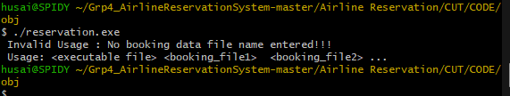

**User provides file name that doesn't exist in project directory:**

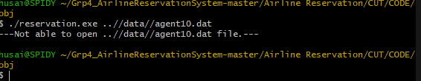

**User provides at least one customer data file:**

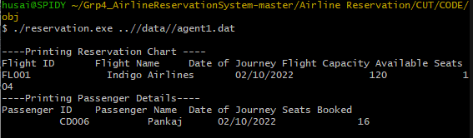18