**Remote Backup Utility**

**Software Requirement Specification (SRS) Document**

**Sprint 2 Implementation**

**Project Timeline: 12.10.2022 to 18.10.2022**

**INDEX**

1. Introduction

1.1 Purpose -------------------------------------------------- 4

1.2 Intended audience -------------------------------------------------- 4

1.3 Intended use -------------------------------------------------- 4

1.4 Scope -------------------------------------------------- 4

2. Overall description -------------------------------------------------- 5

2.1 Assumptions and dependency -------------------------------------------------- 5

3. System feature and requirements -------------------------------------------------- 5

3.1 Functionality -------------------------------------------------- 5

3.1.1 Full backup (files) —----------------------------------------------- 5

3.1.2 Full backup (Directories) -------------------------------------------------- 5

3.1.3 Incremental Backup (files) -------------------------------------------------- 5

3.1.4 Incremental Backup (Directories) ---------------------------------------------- 5

3.1.5 Versioned Backup (Files) ---------------------------------------------- 6

3.1.6 Versioned Backup (Directories) ---------------------------------------------- 6

3.1.7 Scheduled Backup(Files) -------------------------------------------------- 6

3.1.8 Scheduled Backup(Directories) ---------------------------------------- 6

3.2 System requirement -------------------------------------------------- 6

3.2.1 Tools to be used -------------------------------------------------- 6

3.3 System feature ------------------------------------------------ 6

4. Data Flow Diagram

4.1 DFD level 0 ------------------------------------------------ 8

4.2 DFD level 1 ------------------------------------------------ 9

**1.** **Introduction: -**

Performing system backup is crucial when it comes to managing important files on a regular basis.

A backup client is the source computer or node within a backup process that contains the data to be backed up on a destination storage server. A backup client is generally the end user’s computer or server in a network enabled backup environment.

**1.1** **Purpose**: **-**The purpose of this document is to show the requirements for Remote Backup Utilty, in which Program to be developed for file backup by establishing connection between client and server.

**1.2** **Intended Audience: -**This document is intended to be read by, Client.

**1.3** **Intended Use: -**

* Development Team
* Maintenance Team
* Clients

Since this a general-Purpose Program any one can access it.

**1.4** **Scope: -**This project aims to Establish Connection between server and Client for remote backup of files and directories. Socket programming is a way of connecting two nodes on a network to communicate with each other. One socket(node) listens on a particular port at an IP, while the other socket reaches out to the other to form a connection. The server forms the listener socket while the client reaches out to the server.

**2. Overall Description: -**

A backup client is the source computer or node within a backup process that contains the data to be backed up on a destination storage server. A backup client is generally the end user’s computer or server in a network enabled backup environment.

**2.1 Assumptions and Dependency: -**

* System should have Ubuntu Linux installed.
* · System should have either 4GB or more RAM.
* The service is used preferably on a desktop or laptop.

**3.System Features and Requirements: -**

**3.1 Functionality: -**

3.1.1 Full backup (files)

3.1.2 Full backup (Directories)

3.1.3 Incremental Backup (files)

3.1.4 Incremental Backup (Directories)

3.1.5 Versioned Backup (Files)

3.1.6 Versioned Backup (Directories)

3.1.7 Scheduled Backup(Files)

3.1.8 Scheduled Backup(Directories)

**3.2 System Requirements: -**

**3.2.1. Tools to be used:**

* Pthread Library
* C Unit Library
* C File Handling
* C Language
* System Programming
* Socket Programming

**3.3 System Features: -**

* Supportability:The system is easy to use.
* Design Constraints: The system is built using only C language.
* Usability:The Airline Reservation System application can be used to replace the old means. The system can be used by airlines and travel agents, the system will allocate the seats to the customers and will provide a report on allocated seats, unavailable seats and invalid entries.
* Reliability & Availability**:** The system is available 24/7 that is whenever the user would like to use the system, they can use it up to its functionalities.
* Performance: The system will work on the user’s terminal**.**

**4. DataFlow Diagram:**

**4.1 DFD Level 0 -**

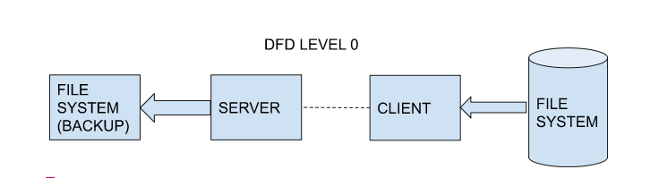

**4.1 DFD Level 1 -**

